|  |
| --- |
|  |
| C# Basics |
| .Net Framework (C# Basics) |

|  |
| --- |
| Jyot Hathi  1-22-2021 |

Contents

**(1)** **XML Comments:** 2

• **summary:** 2

• **remarks:** 2

• **returns:** 3

• **value:** 3

• **para:** 3

• **c:** 4

• **exception:** 4

**(2)** **Tuple and ValueTuple:** 5

• **Tuple:** 5

• **ValueTuble:** 6

# **XML Comments:**

* /// For XML Comments
* Compiler Generate special XML file, and intelligence sense Use That.

## **summary:**

* To Add Summary or information of the Element like class, Structs, Delegates any others.

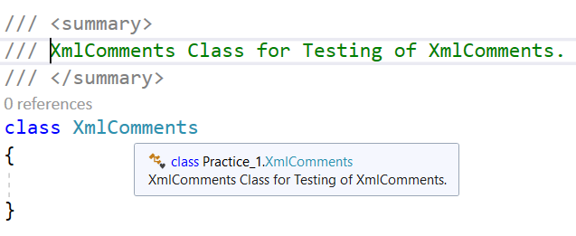

## **remarks:**

* To Add Brief Information of Type of Members.

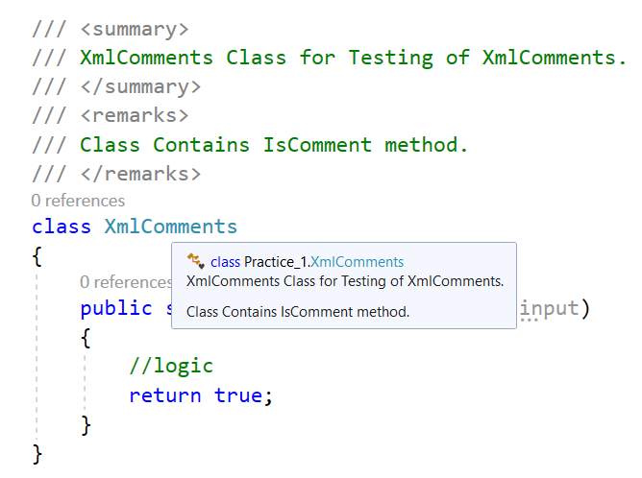

## **returns:**

* To Add Brief Information about what the function / delegate is return if conditional then can mention that too.

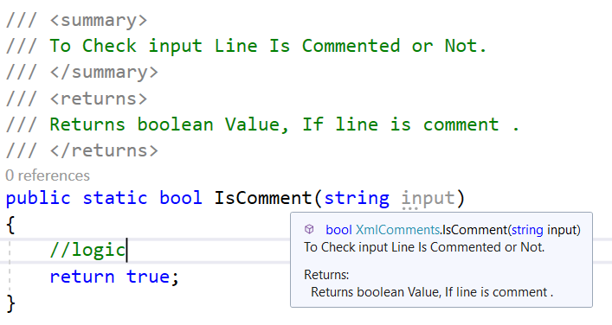

## **value:**

* Generally, it is use for property, as it has value which may user can set or get or both.

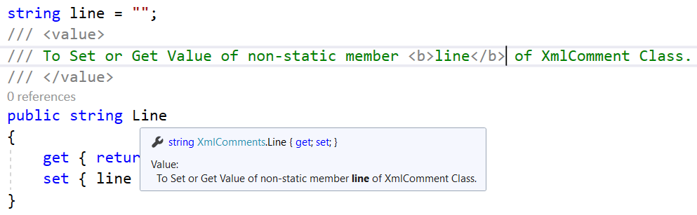

## **para:**

* It is used inside <remarks> or <returns> to separate or format long content.

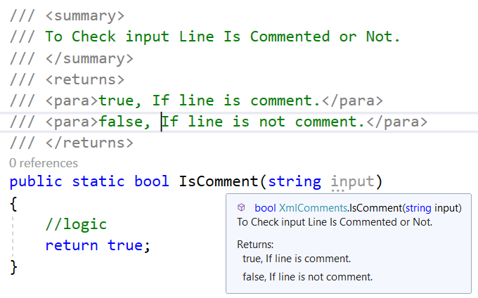

## **c:**

* To show font as a code (Specially Keywords).

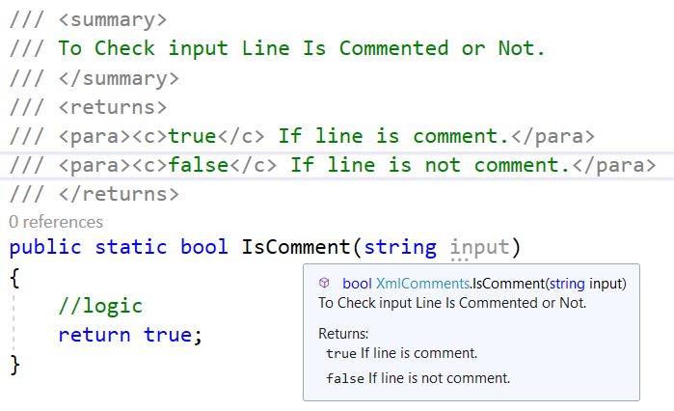

## **exception:**

* To Show and set reference of Exception, and exception details but exception details will not visible in intelligence sense.
* cref is attribute to set reference of Exception

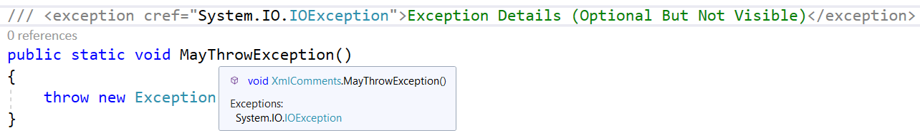

# **Tuple and ValueTuple:**

## **Tuple:**

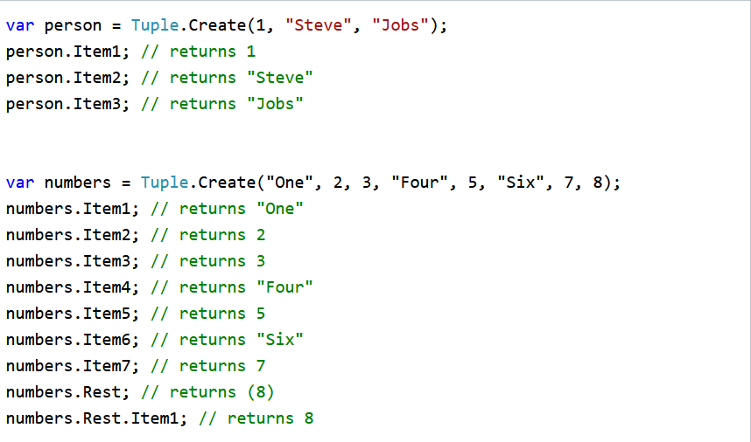

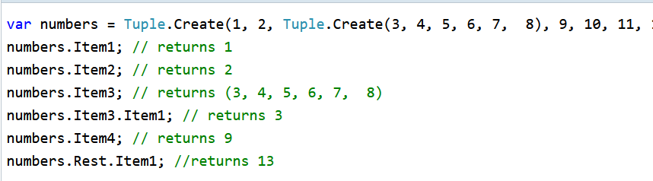

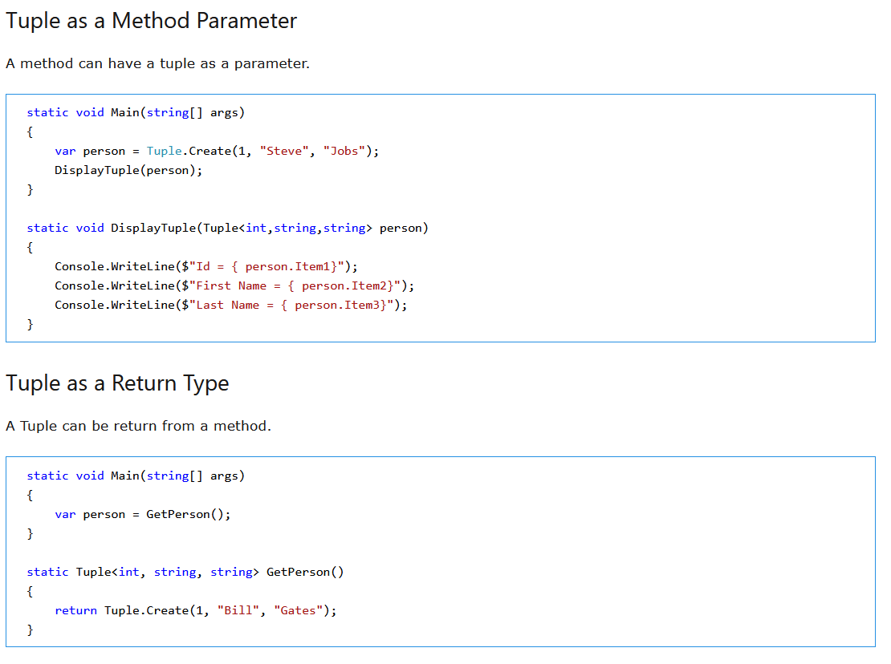

## **ValueTuble:**

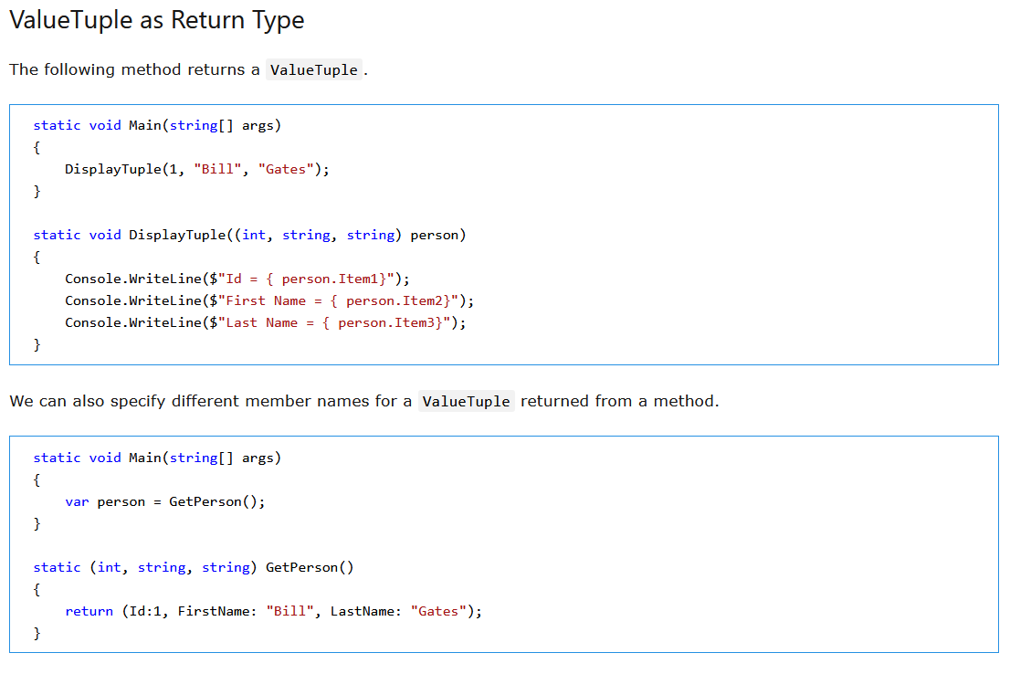

Note: ValueTuple is Value Type and Tuple is Reference Type So Use of ValueTuple is Beneficial compare of Tuple