Assignment 10.1
JYOTHI NADIPELLI
2303A52115
BATCH-40
Task Description #1 – Syntax and Logic Errors
Task: Use AI to identify and fix syntax and logic errors in a faulty
Python script.
Sample Input Code:
# Calculate average score of a student def calc_average(marks):
total = 0 for m in marks:
total += m average = total / len(marks) return avrage # Typo here marks = [85, 90, 78, 92] print("Average Score is ", calc_average(marks)
Expected Output:
- Corrected and runnable Python code with explanations of the fixes.
PROMPT AND CODE:
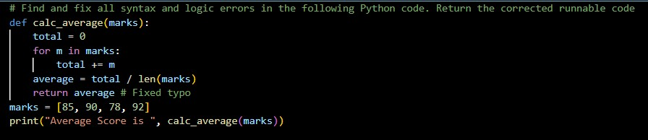
Task Description #2 – PEP 8 Compliance
Task: Use AI to refactor Python code to follow PEP 8 style
guidelines. Sample Input Code:
def area_of_rect(L,B) : return L*B print(area_of_rect(10,20))
Expected Output:
- Well-formatted PEP 8-compliant Python code.
PROMPT AND CODE:
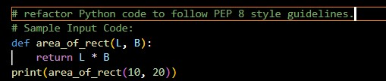
Task Description #3 – Readability Enhancement
Task: Use AI to make code more readable without changing its
logic.
Sample Input Code:
def c(x,y):
return x*y/100 a=200 b=15
print(c(a,b))
Expected Output:
- Python code with descriptive variable names, inline comments, and clear formatting.
PROMPT AND CODE:
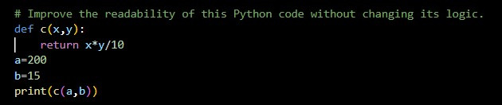
Task Description #4 – Refactoring for Maintainability
Task: Use AI to break repetitive or long code into reusable functions.
Sample Input Code:
students = ["Alice", "Bob", "Charlie"] print("Welcome", students[0]) print("Welcome", students[1]) print("Welcome", students[2])
Expected Output:
- Modular code with reusable functions.
PROMPT AND CODE:
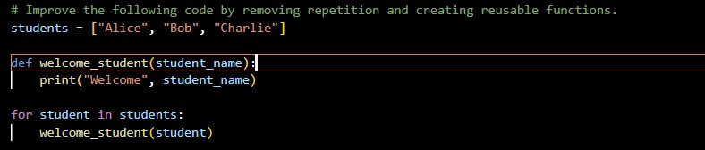
Task Description #5 – Performance Optimization
Task: Use AI to make the code run faster.
Sample Input Code: # Find squares of numbers nums = [i for i in range(1,1000000)] squares = [] for n in nums:
squares.append(n**2) print(len(squares))
Expected Output:
• Optimized code using list comprehensions or vectorized operations.
PROMPT AND CODE:
Task Description #6 – Complexity Reduction Task: Use AI to simplify overly complex logic.
Sample Input Code: def grade(score): if score >= 90:
return "A" else:
if score >= 80:
return "B" else: if score >= 70:
return "C" else: if score >= 60: return "D" else:
return "F"
Expected Output:
• Cleaner logic using elif or dictionary mapping.
PROMPT AND CODE:
