**AICTE Activity Report**

On

**Workshop on AI & ML**

# 

***Submitted in partial fulfilment of the Requirements for the award of***

***Bachelor of Engineering degree***

**in**

**Computer Science & Engineering**

By

**Name: Charishma Reddy *USN:* 1MS21CS040**

Under the Guidance of

**Dr Ganeshayya Siddaganti**

Assistant Professor

## M S Ramaiah Institute of Technology, Bangalore

### Department of Computer Science & Engineering

**Bangalore - 560054, Karnataka, India 2021-2025**

## CERTIFICATE

*This is to certify that the Social Activity entitled IEEE computer Society Bangalore Chapter is a record of the Social Activity(Programming workshop) for 100 point activity carried out by Jyothi Yadav* ***(USN :1MS21CS056)*** *under my guidance, in partial fulfilment of the requirements for the Bachelor of Engineering, Computer Science & Engineering from M S Ramaiah Institute of Technology, Bangalore for the academic years 2021-2025.*

### Dr Ganeshayya Siddaganti Dr R China Appala Naidu

*Asst. Professor Professor  & Head*

*Dept. of Computer Science & Engineering* *Dept. of Computer Science &*

*Engineering*

Place: Bangalore

Date:



### ACKNOWLEDGEMENT

I would like to express my sincere gratitude to the faculty members of RIT and my fellow students for their invaluable guidance and support during the workshop on AI & ML usage in robotics for school students. I extend my heartfelt thanks to Ramaiah School, Bangalore, for providing us with the opportunity to interact with and educate young minds. This experience has been an enriching journey, and I appreciate the encouragement and cooperation of all participants who contributed to making this initiative a success.

Furthermore, I would like to thank the school authorities for their hospitality and for facilitating the smooth conduct of the workshop. The collaboration between our institution and Ramaiah School created an environment conducive to learning and innovation. Special thanks to the students who actively participated, showing great enthusiasm and a willingness to explore the fascinating field of Artificial Intelligence and Machine Learning. This experience has also helped us as volunteers to enhance our leadership, communication, and teaching skills. The knowledge gained and shared through this workshop will undoubtedly have a lasting impact on both the students and the volunteers.

I would also like to express my sincere appreciation to the **Head of the Department of Computer Science and Engineering** for their constant encouragement and for creating a supportive environment that facilitated the successful execution of this initiative. Their commitment to promoting student-led outreach programs like this one has been truly inspiring. The department’s provision of resources, guidance on activity planning, and continuous monitoring ensured that this program aligned with its objectives. Their role in making this activity an enriching experience for both the participants and myself is deeply valued and highly appreciated.

Finally, I would like to acknowledge and thank all those who contributed directly or indirectly to the success of this program. I am grateful to the staff and peers who assisted in organizing the sessions, offering logistical support and moral encouragement. Their collaborative efforts ensured that the sessions ran smoothly and were impactful for the students. This activity would not have been possible without their assistance and enthusiasm. To everyone who played a role in this initiative, your contributions have been invaluable, and I am deeply appreciative of your support.

***Charishma Reddy Mallem***

### ABSTRACT

This report details the workshop conducted on the usage of Artificial Intelligence (AI) and Machine Learning (ML) in robotics for school students. The initiative was undertaken by RIT faculty and second-year students to educate school students at Ramaiah School, Bangalore, from January 25th to February 4th, 2023. The workshop aimed to introduce the fundamental concepts of AI and ML, their applications in robotics, and to engage students in hands-on activities, including idea presentations. This document covers the study on activities for societal needs, the benefits of social techno activities, implementation details, advantages, and outcome analysis of this initiative.

Artificial Intelligence and Machine Learning have become indispensable components of modern technology, revolutionizing various fields. The purpose of this workshop was to cultivate an interest in these emerging technologies among school students, ensuring that they gain foundational knowledge and hands-on experience. The workshop sessions were structured in a way that provided both theoretical insights and practical exposure, thereby fostering an engaging and interactive learning environment. Additionally, the report presents a comprehensive analysis of how social techno activities like this workshop contribute to community development and technical education. The outcomes and future scope of such initiatives are also discussed in detail, emphasizing the importance of promoting AI and ML literacy at the school level.

To ensure an engaging and interactive learning experience, the workshop incorporated live demonstrations, collaborative problem-solving activities, and real-world coding challenges. By applying concepts to practical scenarios, students were able to connect abstract programming principles with tangible outcomes, enhancing their understanding and confidence. The inclusion of peer discussions, instructor guidance, and step-by-step explanations created an inclusive learning environment that catered to students with varying levels of prior knowledge.

Beyond just technical learning, the workshop aimed to ignite curiosity and inspire students to explore careers in technology. By experiencing the power of programming firsthand, students gained insight into how software shapes industries such as healthcare, finance, cybersecurity, and artificial intelligence. The program successfully demonstrated that coding is not just about writing instructions for a computer—it is about solving real-world problems and driving innovation.



### CONTENTS

|  |  |  |
| --- | --- | --- |
|  |  |  |
| **Chapter**  **No** | **TITLE** | **Page No.** |
| 1 | INTRODUCTION  1.1. About the Social Techno activity  1.2. Outline of Social Techno activity | 1-2 |
| 2 | STUDY ON ACTIVITIES FOR SOCIETAL NEED  2.1 Description of Social Techno activities | 3 |
| 3 | BENEFITS OF SOCIAL TECHNO ACTIVITIES | 4 |
| 4 | DETAILS OF IMPLEMENTATION OF SOCIAL TECHNO ACTIVITY | 5 |
| 5 | ADVANTAGES/USES OF ACTIVITY | 6 |
| 6 | OUTCOME ANALYSIS OF SOCIAL ACTIVITY  5.1 Responses & Proofs of Social Techno Activity  5.2 Analysis of Social Techno Activity | 7-10 |
| 7 | CONCLUSION | 11 |
| 8 | REFERENCES | 12 |

### 1. INTRODUCTION

### Background

The rapid advancements in technology have transformed various sectors, including education. Artificial Intelligence (AI) and Machine Learning (ML) have become integral to numerous industries, and their applications in robotics are reshaping the future. To bridge the knowledge gap and introduce young students to these emerging technologies, an interactive workshop was conducted at Ramaiah School, Bangalore.

In the present era, AI and ML are being leveraged in numerous domains such as healthcare, finance, automation, and education. Robotics, in particular, has seen remarkable innovations with the integration of AI and ML. These technological advancements have enabled robots to perform complex tasks efficiently and adapt to dynamic environments. Introducing students to such transformative fields at an early stage not only fosters their curiosity but also prepares them for future careers in STEM fields. The increasing dependence on AI-driven solutions in various industries highlights the necessity of familiarizing students with these concepts at an early stage.

### Objective

The primary objective of this workshop was to provide school students with foundational knowledge of AI and ML, demonstrate their practical applications in robotics, and encourage innovative thinking through idea presentations. Additionally, the workshop aimed to instill problem-solving skills and critical thinking abilities among students, thereby nurturing their analytical capabilities. By engaging students in discussions and interactive exercises, we sought to demystify AI and ML concepts and highlight their real-world significance.

Through guided learning, students were encouraged to explore AI-driven robotics and understand its implications in various domains. The ultimate goal was to equip students with basic technical skills and inspire them to delve deeper into AI and ML studies. The workshop also served as a platform for students to interact with mentors and peers, fostering collaboration and teamwork. By the end of the sessions, students gained insights into AI-driven automation, machine learning models, and their applications in robotics, preparing them to explore advanced studies in technology.

### 2. STUDY ON ACTIVITIES FOR SOCIETAL NEED

Educational initiatives like this workshop play a crucial role in addressing societal needs by fostering technological awareness among young learners. The integration of AI and ML in education can enhance learning experiences, promote creativity, and prepare students for future technological advancements. Technology-driven educational activities are vital in shaping a knowledgeable and skilled workforce. By introducing AI and ML concepts to school students, we enable them to understand and explore real-world problems through an innovative lens.

The content was carefully crafted to ensure that complex programming concepts were broken down into simple and engaging lessons. The sessions included a mix of theory, hands-on coding exercises, interactive discussions, and problem-solving activities, making the learning process both educational and enjoyable. to help students develop logical thinking, problem-solving skills, and a curiosity for technology. Additionally, students were encouraged to share their knowledge with peers, extending the impact of the workshop beyond individual participation.

Robotics, being an interdisciplinary field, provides an excellent platform for students to apply their learning in diverse applications, including automation, healthcare, disaster management, and smart city development. Through this workshop, we addressed the growing need for digital literacy and AI education, ensuring that students receive early exposure to emerging technologies. Bridging the gap between theoretical knowledge and practical application, the activities conducted during the workshop served as a stepping stone for students interested in pursuing careers in technology-driven fields.

Furthermore, technological workshops like this contribute to societal progress by bridging the gap between academic learning and real-world applications. By introducing AI and ML concepts early, students develop a problem-solving mindset that can be applied to various societal challenges, such as healthcare, environmental sustainability, and smart city development. These activities also encourage interdisciplinary learning, integrating knowledge from fields like mathematics, science, and engineering. Additionally, fostering technological literacy at a young age ensures that future generations are well-equipped to drive innovation and contribute meaningfully to society. Overall, such initiatives play a vital role in preparing students to become responsible and skilled professionals in the digital age.

### 3. BENEFITS OF SOCIAL TECHNO ACTIVITIES

* Enhances students’ understanding of emerging technologies.
* Encourages problem-solving and critical thinking skills.
* Provides hands-on experience with real-world applications.
* Bridges the gap between academic learning and practical implementation.
* Fosters teamwork and collaboration among students.
* Promotes digital literacy and computational thinking.
* Instills confidence and motivation to pursue technology-related fields.
* Encourages innovation and creativity in problem-solving.

Social techno activities provide a platform for students to gain exposure to industry-relevant technologies, thus preparing them for future challenges. Such initiatives enable students to engage in experiential learning, where theoretical knowledge is reinforced through practical applications. Additionally, workshops like these enhance communication skills, teamwork, and leadership qualities among participants, thereby contributing to their holistic development.

In addition to fostering technical skills, social techno activities play a crucial role in developing essential soft skills such as teamwork, communication, and leadership. By participating in collaborative projects, students learn to express their ideas effectively, work efficiently in teams, and develop a problem-solving mindset. These activities also encourage students to think beyond textbooks and apply their knowledge in real-world scenarios, preparing them for future academic and professional challenges. Furthermore, such initiatives help bridge the gap between theoretical learning and industry requirements, ensuring that students gain relevant, hands-on experience that enhances their career prospects.

Moreover, engaging in social techno activities cultivates a sense of responsibility and innovation among students, encouraging them to explore creative solutions for real-world problems. These initiatives also promote inclusivity by making technology accessible to a broader audience, inspiring students from diverse backgrounds to pursue STEM fields.

### 4. DETAILS OF IMPLEMENTATION OF SOCIAL TECHNO ACTIVITY

The AI & ML workshop was systematically planned and executed to ensure effective knowledge transfer and engagement among students. The implementation involved multiple phases, including initial preparation, hands-on sessions, interactive discussions, and idea presentations.

Firstly, the workshop began with an **introductory session** where students were introduced to fundamental concepts of Artificial Intelligence (AI) and Machine Learning (ML). This session included real-world examples of AI applications in fields such as healthcare, finance, robotics, and automation. The objective was to familiarize students with the impact of AI and ML in daily life and spark curiosity about these emerging technologies.

This workshop was carefully structured to include both theoretical and practical components. The implementation process involved several key stages:

**Planning and Coordination**: The faculty and student volunteers collaborated to design a structured curriculum covering AI and ML fundamentals and their applications in robotics.

**Interactive Lectures**: Sessions included lectures on basic AI and ML concepts, showcasing real-world examples and interactive discussions.

**Hands-on Activities**: Students were introduced to practical applications of AI and ML in robotics through coding exercises and small projects.

**Idea Presentation**: Participants developed and presented innovative ideas, applying the knowledge gained throughout the workshop.

**Feedback and Evaluation**: The workshop concluded with an evaluation of student engagement and comprehension.

Overall, the structured implementation of the social techno activity ensured that students not only gained theoretical knowledge of AI & ML but also acquired practical experience through interactive sessions and project-based learning. The engagement of both students and volunteers in hands-on activities made the workshop an impactful and enriching educational initiative.

### 5. ADVANTAGES / USES OF ACTIVITY

The AI & ML workshop provided numerous advantages and practical applications for both school students and volunteers. By introducing young learners to artificial intelligence and machine learning concepts at an early stage, the workshop played a crucial role in shaping their understanding of emerging technologies. The hands-on sessions and interactive discussions helped students gain insights into real-world applications of AI and ML, which can influence their future career choices and academic interests. Below are some key advantages and uses of this activity:

**1. Early Exposure to AI & ML**

One of the significant advantages of this workshop was that it provided students with early exposure to AI and ML, concepts that are becoming increasingly relevant in today's world. Understanding these technologies at a young age prepares students for the digital era, enabling them to think analytically and solve problems efficiently. By demystifying AI and ML, the workshop encouraged students to explore these fields further, potentially influencing their academic and career paths.

**2. Practical Learning and Hands-On Experience**

Unlike traditional classroom teaching, this workshop focused on experiential learning. Students had the opportunity to engage in hands-on activities, including AI-based simulations, coding exercises, and robotics applications. This practical approach helped bridge the gap between theoretical knowledge and real-world applications, making the learning process more engaging and effective.

**3. Development of Problem-Solving Skills**

AI and ML are closely linked to problem-solving and automation. The workshop introduced students to various problem-solving techniques using AI-driven models. By analyzing real-world scenarios and working on AI-based solutions, students enhanced their logical thinking and analytical abilities. These skills are essential for future careers in technology, engineering, and data science.

**4. Encouragement of Innovation and Creativity**

The workshop provided a platform for students to think creatively and come up with innovative ideas. Through idea presentation sessions, students explored how AI and ML could be used in various domains, such as healthcare, smart cities, and automation.

**5. Enhancement of Communication and Teamwork**

Social techno activities like this workshop not only focus on technical skills but also emphasize the importance of communication and collaboration. Students were required to work in groups, discuss AI applications, and present their ideas. This collaborative approach helped improve their interpersonal skills, preparing them for future teamwork-oriented projects in their academic and professional lives.

**6. Bridging the Digital Divide**

In today’s digital age, there is a growing need for digital literacy among students. This workshop contributed to reducing the digital divide by introducing AI and ML to students who may not have had previous exposure to these technologies. By making AI education accessible at the school level, such initiatives help create equal opportunities for all students, regardless of their backgrounds.

**7. Increased Awareness of AI Ethics and Responsible Use**

AI and ML come with ethical concerns, such as data privacy, bias in AI models, and responsible usage. This workshop introduced students to these ethical considerations, helping them understand the importance of developing AI solutions responsibly. Teaching ethical AI practices at an early stage ensures that future developers and engineers prioritize fairness, transparency, and accountability in their work.

**8. Skill Development for Future Careers**

With AI and ML becoming integral to industries such as healthcare, finance, automation, and cybersecurity, learning these technologies early provides students with a competitive edge. The knowledge gained from this workshop can serve as a foundation for students who wish to pursue careers in STEM (Science, Technology, Engineering, and Mathematics) fields.

**9. Increased Interest in STEM Education**

By demonstrating how AI and ML can be applied in robotics and real-world problems, the workshop inspired students to explore STEM subjects with greater enthusiasm. Practical exposure to AI-driven technologies fosters curiosity, leading to increased participation in STEM-related academic programs and competitions.

### 6. OUTCOME ANALYSIS OF SOCIAL TECHNO ACTIVITY

The success of this workshop was evident in the enthusiasm and active participation of students. The outcomes included:

* Improved understanding of AI and ML applications in robotics.
* Enhanced confidence among students in presenting their ideas.
* Increased interest in pursuing technology-related education and careers.
* Strengthened collaboration between academic institutions and schools.

The AI & ML workshop conducted at Ramaiah School had a significant impact on both students and volunteers. The participating students gained foundational knowledge of artificial intelligence and machine learning, along with hands-on experience in robotics applications. This exposure helped enhance their problem-solving abilities, critical thinking skills, and curiosity about emerging technologies. Additionally, the interactive sessions fostered teamwork and collaboration, as students engaged in discussions and idea presentations. On the other hand, the volunteers benefited by refining their teaching, leadership, and communication skills. The workshop successfully bridged the gap between theoretical concepts and practical applications, inspiring students to explore AI and ML further. By integrating social techno activities like this into education, we can encourage young learners to become future innovators in the field of technology.

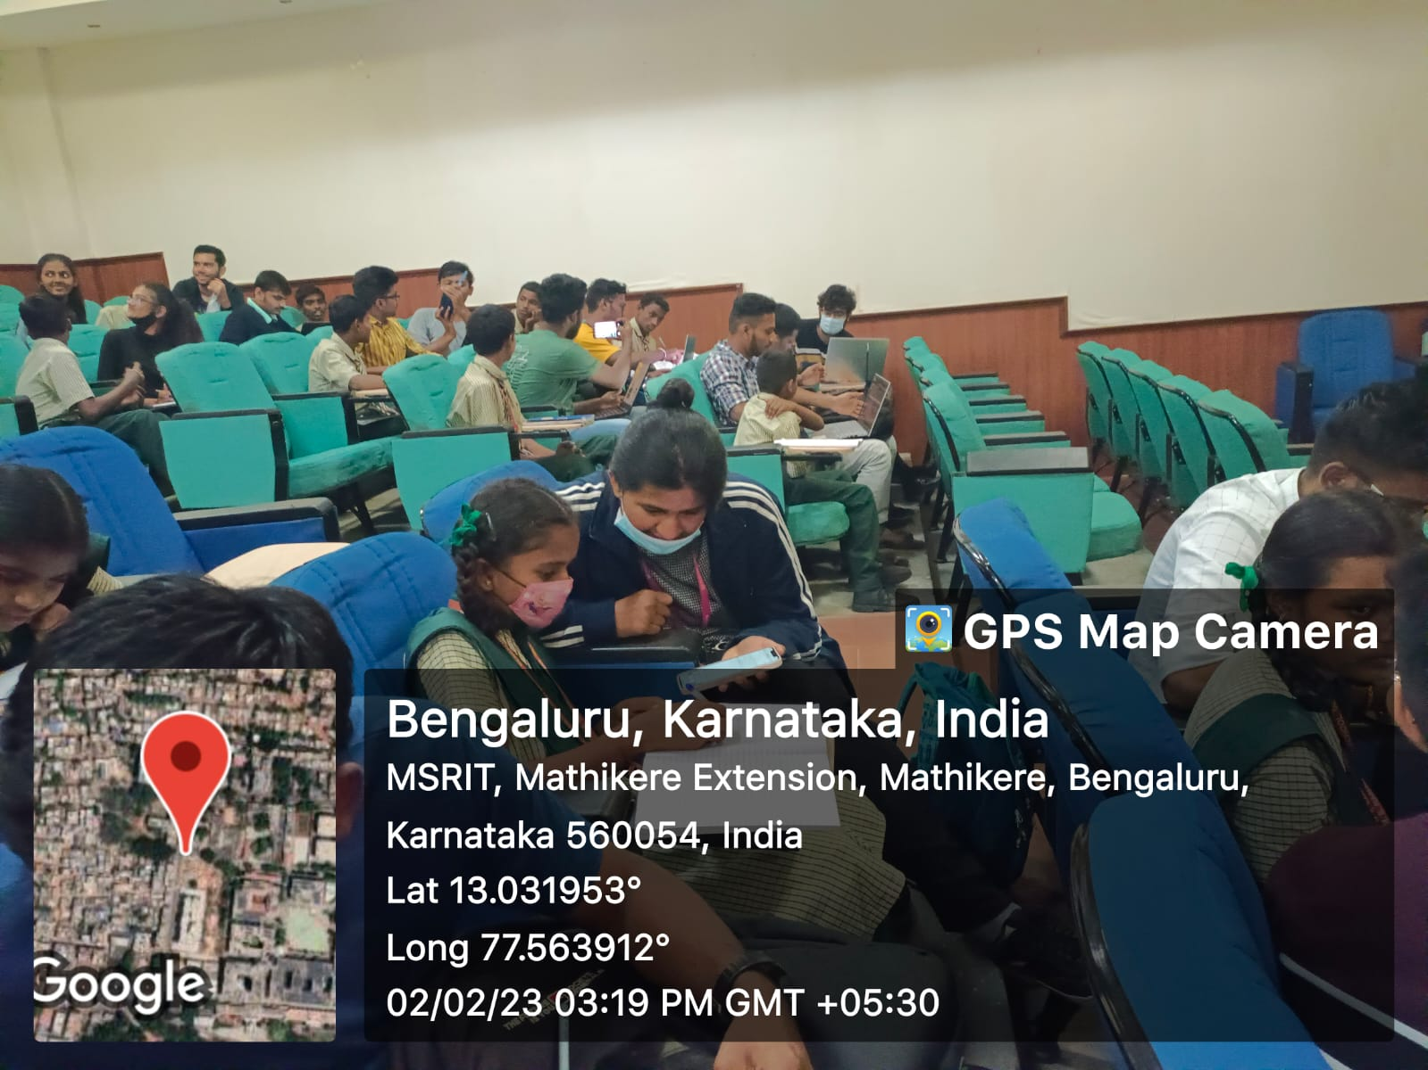

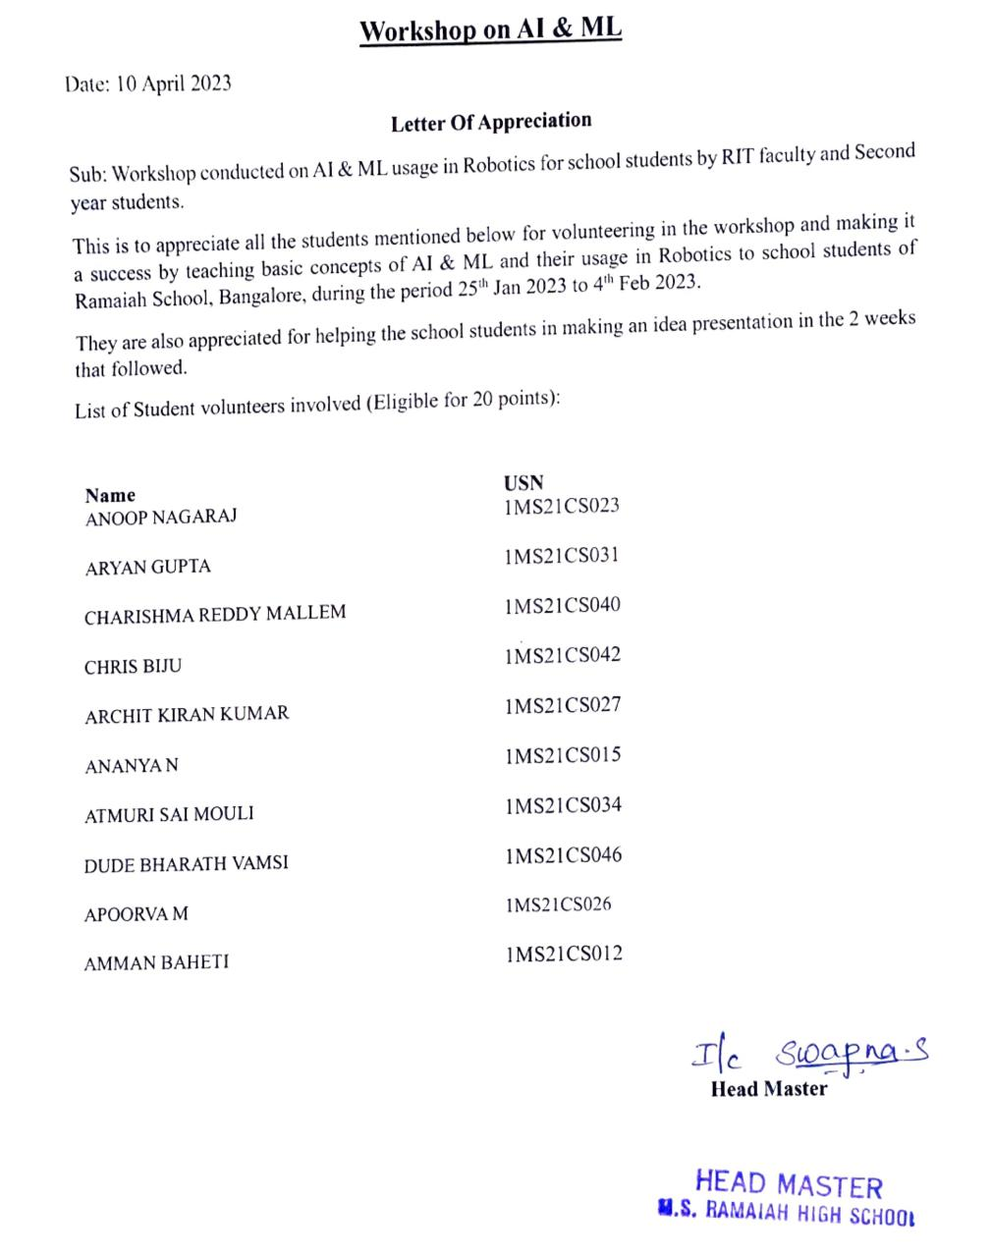

• Certificates were provided by the school for conducting sessions on the **IEEE Computer Society Programming Workshop.**

### 7. Conclusion

The workshop on **AI & ML usage in Robotics for school students** was a highly impactful initiative that successfully introduced young learners to the fascinating world of Artificial Intelligence and Machine Learning. Over the two-week period, students gained foundational knowledge, explored real-world applications, and engaged in interactive sessions that nurtured their curiosity and problem-solving abilities. The structured sessions not only provided theoretical insights but also included hands-on activities that allowed students to grasp complex concepts in an engaging and practical manner.

One of the most significant takeaways from the workshop was the enthusiasm displayed by the school students. Their willingness to learn, ask questions, and participate actively highlighted the growing interest in AI and ML among younger generations. The sessions on **idea presentation and implementation** further helped students develop creativity and critical thinking, encouraging them to think beyond conventional learning and apply their knowledge to real-life scenarios.

From the volunteers’ perspective, this workshop was equally beneficial. As second-year students, teaching AI and ML to school students required simplifying concepts and presenting them in an engaging manner. This not only strengthened our own understanding of the subject but also enhanced our communication, teamwork, and leadership skills. Conducting the workshop also provided us with valuable experience in **mentorship, technical education, and community engagement**, reinforcing the importance of knowledge-sharing and collaborative learning.

Furthermore, this initiative highlighted the significance of **social techno activities** in bridging the gap between academic learning and its practical applications. By organizing more such workshops, we can continue fostering an interest in technology at an early stage, ultimately preparing students for future opportunities in AI-driven industries. The feedback from the school students and faculty members was overwhelmingly positive, reinforcing the impact and effectiveness of this initiative.

Overall, this workshop not only benefited the school students but also empowered us as volunteers. It was a **mutually enriching experience** that contributed to personal and academic growth. Encouraging young minds to explore AI and ML ensures that future generations are well-equipped to **adapt, innovate, and lead** in an increasingly technology-driven world. This experience has been a stepping stone for further engagement in **socially impactful technological education**, and we look forward to conducting more such initiatives in the future.

### 8. REFERENCES

• **Russell, S., & Norvig, P. (2021).** *Artificial Intelligence: A Modern Approach (4th ed.).* Pearson Education.

A foundational book covering AI principles, machine learning, and robotics.

• **IEEE Robotics and Automation Society. (2023).** *AI and Machine Learning in Robotics: Transforming the Future of Automation.* Retrieved from <https://www.ieee-ras.org>

Discusses how AI and ML are shaping modern robotics applications.

• **Code.org. (2023).** *The Importance of Early AI Education for Students.* Retrieved from <https://www.code.org>

Highlights why AI literacy is crucial for students in today’s digital world.

• **Wang, P., & Raj, B. (2022).** *Machine Learning for Beginners: A Hands-On Guide.* MIT Press.

Provides introductory concepts on machine learning and its applications.

• **Koller, D., & Mitchell, R. (2022).** *Integrating AI and ML Education into School Curricula: Challenges and Opportunities.* *Journal of Educational Technology, 27(2), 89-104.*

Discusses the benefits of incorporating AI & ML in early education.

• **National Science Foundation (NSF). (2023).** *Encouraging STEM Learning through AI and Robotics.* Retrieved from <https://www.nsf.gov>

Examines the role of AI and robotics in STEM education.

• **Python Software Foundation. (2023).** *Machine Learning with Python: An Introduction for Beginners.* Retrieved from <https://www.python.org>

Offers insights into using Python for AI and ML applications.

• **World Economic Forum. (2023).** *The Future of Work: How AI & Robotics are Changing Education and Jobs.* Retrieved from <https://www.weforum.org>