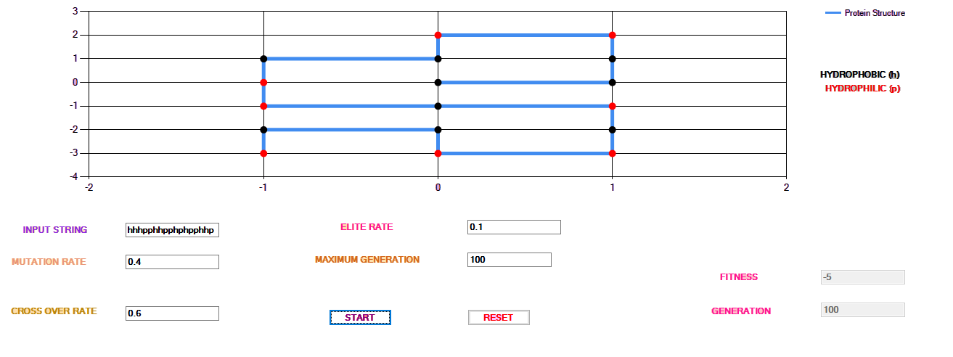

Step by step procedure

* Open myassignment (jyothi folder) using VB
* Load code
* Click start
* Give all the input values