ML Classification Project – Diabetes Prediction
Name: Jyothi
Internship: AI Internship
Task Number: Task 1 – ML Classification Project
Tools Used: Python, NumPy, Pandas, Matplotlib, Seaborn, Scikit-learn, Jupyter Notebook

1. Objective
The objective of this project is to develop a Machine Learning classification model to predict whether a person has diabetes based on medical attributes such as glucose level, BMI, insulin level, and age. The project aims to understand data preprocessing, model building, evaluation, and interpretation of results.

2. Dataset Description
The dataset used in this project is the Diabetes dataset containing medical diagnostic measurements of patients. The dataset consists of several input features and one output variable called Outcome.
- Outcome = 1 indicates the presence of diabetes.
- Outcome = 0 indicates the absence of diabetes.
The dataset includes the following features:
- Pregnancies
- Glucose
- BloodPressure
- SkinThickness
- Insulin
- BMI
- DiabetesPedigreeFunction
- Age
The dataset was loaded using the Pandas library for analysis and processing.
(Insert screenshot of dataset head output here)

3. Data Preprocessing
Data preprocessing was performed to improve data quality before training the model. Some columns contained zero values which are not medically valid. These values were replaced with the mean of the respective columns. Feature scaling was applied using StandardScaler to normalize the data and improve model performance.

4. Exploratory Data Analysis (EDA)
Exploratory Data Analysis was performed to understand the distribution of features and their relationship with the target variable. The following visualizations were created:
- Histogram to observe feature distribution
- Boxplot to analyze BMI variation with diabetes outcome
- Scatter plot to study relationships between features
- Bar plot to observe class distribution
These visualizations helped in understanding patterns present in the dataset.
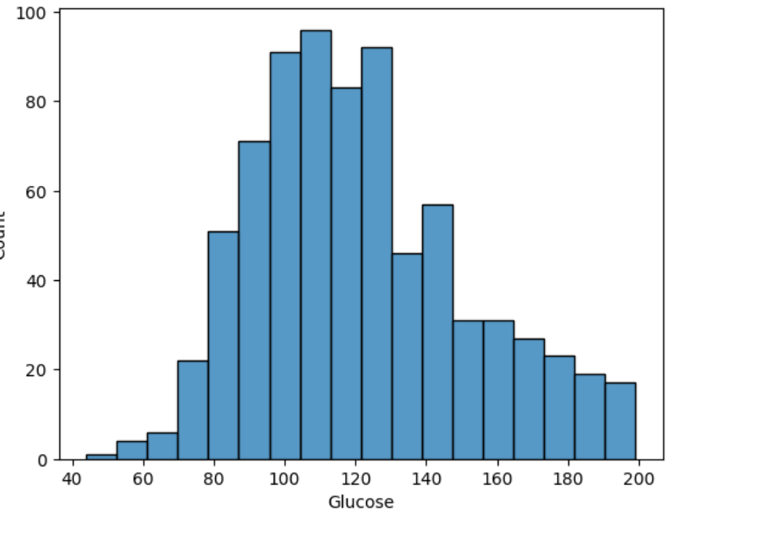
Figure 1: Histogram of Glucose Distribution.
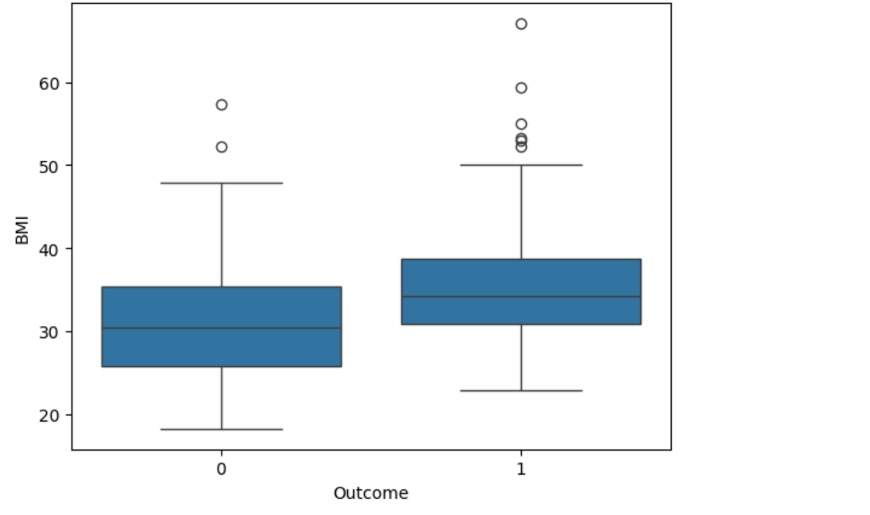
Figure 2: BMI Distribution by Outcome.

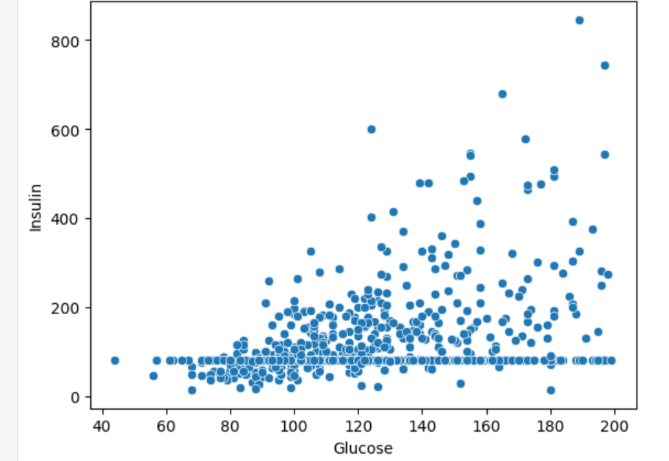

Figure 3: Scatter Plot of Glucose vs Insulin.
5. Model Building
The dataset was divided into training and testing sets using an 80:20 ratio. Logistic Regression was used as the classification algorithm due to its simplicity and effectiveness for binary classification problems. The model was trained using the training dataset after feature scaling.

6. Model Evaluation
The performance of the model was evaluated using accuracy score, precision, recall, and F1-score. A confusion matrix was also plotted to visualize correct and incorrect predictions.
The model achieved an accuracy of 76.6%, indicating good predictive performance for a baseline classification model.

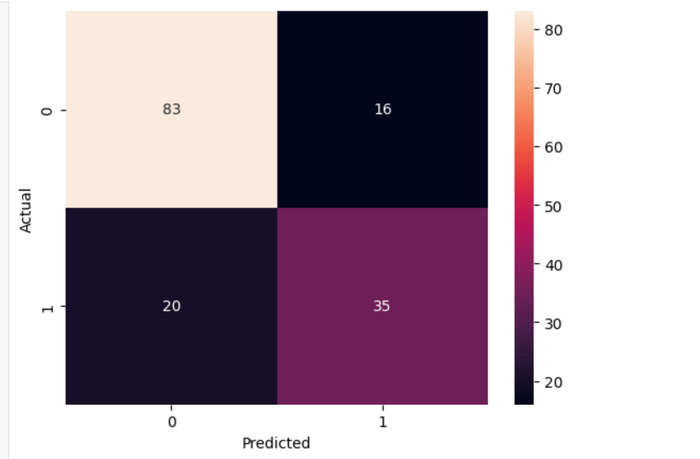

Figure 5: Confusion Matrix for Diabetes Classification Model.
7. Conclusion
In this project, a Machine Learning classification model was successfully developed to predict diabetes outcomes. Logistic Regression provided a reliable baseline performance. Future improvements may include using advanced algorithms, hyperparameter tuning, and cross-validation to improve prediction accuracy.

8. References
- Scikit-learn Documentation
- Python Documentation
- Diabetes Dataset (Kaggle).

