Diabetes Prediction Using Machine Learning
Name: Jyoti
Internship: AI Internship
Tools Used: Python, Jupyter Notebook, scikit-learn

1. Objective
The objective of this project is to improve the prediction accuracy of diabetes using advanced machine learning techniques. The task focuses on training a classification model and evaluating its performance using accuracy score and confusion matrix.
2. Dataset Description
The dataset used for this project is the Diabetes dataset, which contains several medical attributes used to predict whether a patient has diabetes or not.
The important features in the dataset include:
- Pregnancies
- Glucose
- Blood Pressure
- Skin Thickness
- Insulin
- BMI (Body Mass Index)
- Diabetes Pedigree Function
- Age
- Outcome (Target Variable)
The Outcome column indicates whether the patient is diabetic (1) or non-diabetic (0).
3. Dataset Preview
The dataset was loaded using the Pandas library, and the first five rows were displayed to understand the structure and feature distribution.
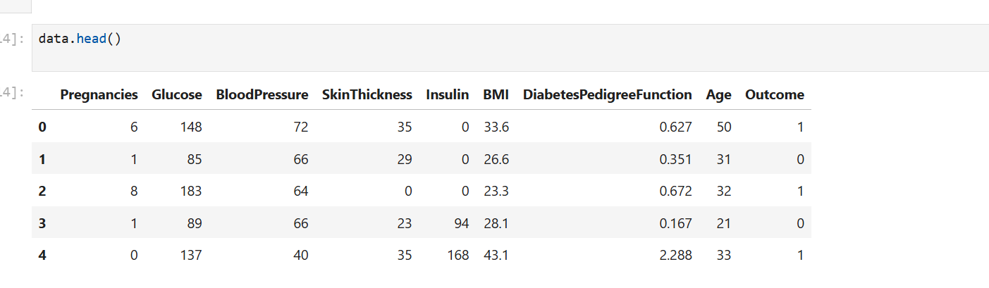
Figure 1: Dataset Preview.
4. Methodology
The following steps were performed in this task:
- Data loading using Pandas
- Separating input features (X) and target variable (y)
- Splitting the dataset into training and testing sets
- Training the Random Forest Classifier
- Evaluating the model using accuracy score
- Generating the confusion matrix
The dataset was split into 80% training data and 20% testing data.
5. Model Training
The Random Forest Classifier was used to train the model. Random Forest is an ensemble learning technique that combines multiple decision trees to improve prediction accuracy and reduce overfitting.
The model was trained using the training dataset and then tested on unseen test data.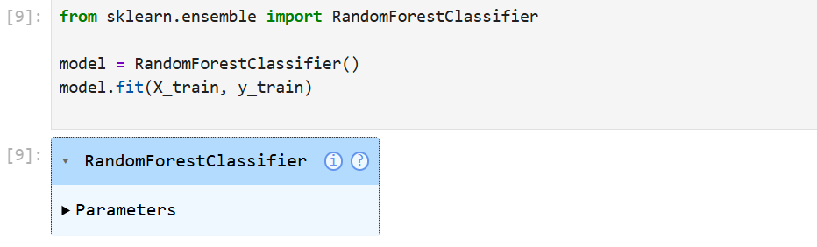
Figure 2: Model Training.
6. Accuracy Output
After training the model, predictions were made on the test dataset. The accuracy score was calculated to evaluate the model performance.
The model achieved an accuracy of:
Accuracy: (0.7402597402597403)
This indicates that the model correctly predicted approximately (accuracy × 100)% of the test cases.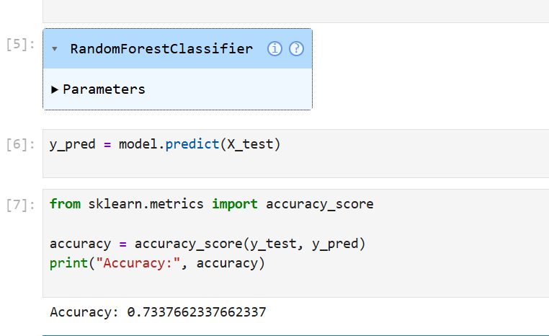
Figure 3: Accuracy Result.
7. Confusion Matrix
The confusion matrix was generated to evaluate classification performance in detail.
It shows:
- True Positives
- True Negatives
- False Positives
- False Negatives
The confusion matrix helps in understanding how well the model distinguishes between diabetic and non-diabetic cases.
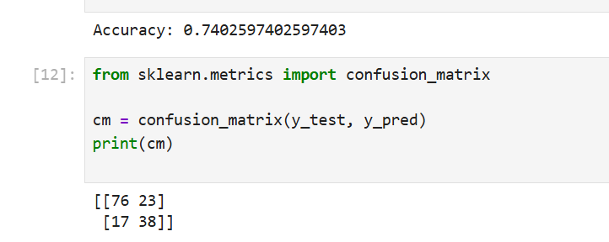
Figure 4: Confusion Matrix.
8. Conclusion
In this task, a Random Forest Classifier was implemented to improve diabetes prediction performance. The model achieved satisfactory accuracy and demonstrated effective classification capability.
The use of ensemble learning techniques such as Random Forest helped improve prediction reliability compared to basic classification models.
This task enhanced practical understanding of:
- Data preprocessing
- Model training
- Model evaluation
- Performance analysis.

