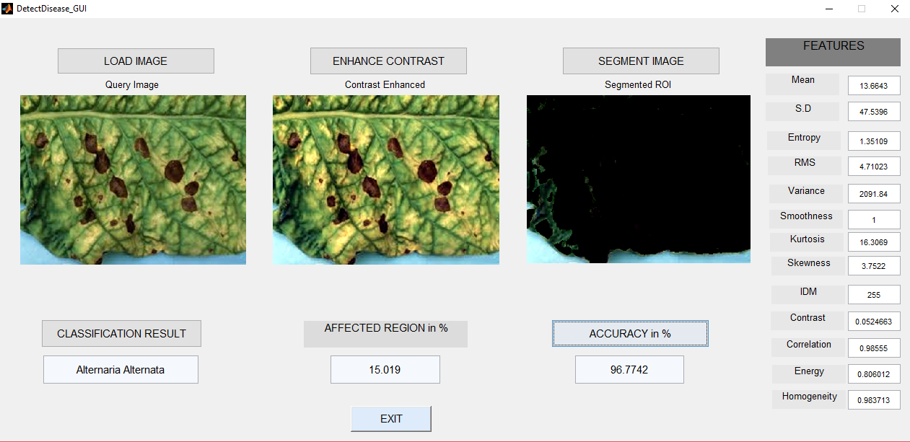

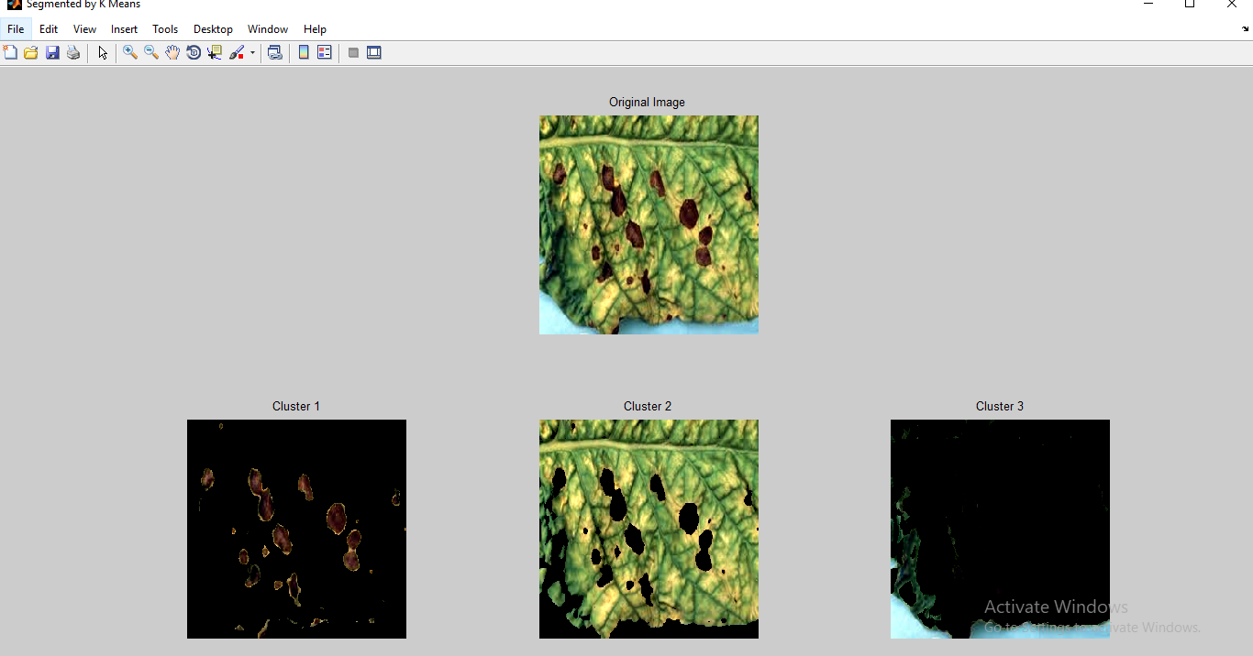

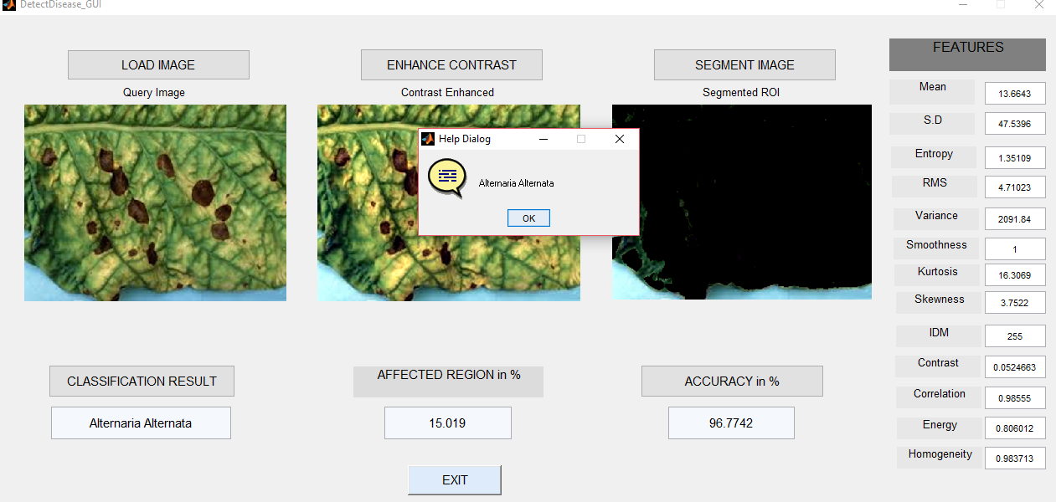

ans =

Affected Area is: 15.019%

Alternaria Alternata

ans =

Accuracy of Linear Kernel is: 90.3226%

ans =

Accuracy of Linear Kernel is: 82.2581%

ans =

Accuracy of Linear Kernel is: 87.0968%

ans =

Accuracy of Linear Kernel is: 85.4839%

ans =

Accuracy of Linear Kernel is: 85.4839%

ans =

Accuracy of Linear Kernel is: 90.3226%

ans =

Accuracy of Linear Kernel is: 87.0968%

ans =

Accuracy of Linear Kernel is: 87.0968%

ans =

Accuracy of Linear Kernel is: 88.7097%

ans =

Accuracy of Linear Kernel is: 85.4839%

ans =

Accuracy of Linear Kernel is: 88.7097%

ans =

Accuracy of Linear Kernel is: 46.7742%

ans =

Accuracy of Linear Kernel is: 85.4839%

ans =

Accuracy of Linear Kernel is: 88.7097%

ans =

Accuracy of Linear Kernel is: 91.9355%

ans =

Accuracy of Linear Kernel is: 85.4839%

ans =

Accuracy of Linear Kernel is: 82.2581%

ans =

Accuracy of Linear Kernel is: 74.1935%

ans =

Accuracy of Linear Kernel is: 87.0968%

ans =

Accuracy of Linear Kernel is: 93.5484%

ans =

Accuracy of Linear Kernel is: 83.871%

ans =

Accuracy of Linear Kernel is: 88.7097%

ans =

Accuracy of Linear Kernel is: 85.4839%

ans =

Accuracy of Linear Kernel is: 85.4839%

ans =

Accuracy of Linear Kernel is: 85.4839%

ans =

Accuracy of Linear Kernel is: 90.3226%

ans =

Accuracy of Linear Kernel is: 80.6452%

ans =

Accuracy of Linear Kernel is: 88.7097%

ans =

Accuracy of Linear Kernel is: 87.0968%

ans =

Accuracy of Linear Kernel is: 90.3226%

ans =

Accuracy of Linear Kernel is: 93.5484%

ans =

Accuracy of Linear Kernel is: 91.9355%

ans =

Accuracy of Linear Kernel is: 90.3226%

ans =

Accuracy of Linear Kernel is: 91.9355%

ans =

Accuracy of Linear Kernel is: 90.3226%

ans =

Accuracy of Linear Kernel is: 85.4839%

ans =

Accuracy of Linear Kernel is: 82.2581%

ans =

Accuracy of Linear Kernel is: 87.0968%

ans =

Accuracy of Linear Kernel is: 83.871%

ans =

Accuracy of Linear Kernel is: 83.871%

ans =

Accuracy of Linear Kernel is: 90.3226%

ans =

Accuracy of Linear Kernel is: 83.871%

ans =

Accuracy of Linear Kernel is: 83.871%

ans =

Accuracy of Linear Kernel is: 75.8065%

ans =

Accuracy of Linear Kernel is: 90.3226%

ans =

Accuracy of Linear Kernel is: 80.6452%

ans =

Accuracy of Linear Kernel is: 87.0968%

ans =

Accuracy of Linear Kernel is: 90.3226%

ans =

Accuracy of Linear Kernel is: 82.2581%

ans =

Accuracy of Linear Kernel is: 95.1613%

ans =

Accuracy of Linear Kernel is: 90.3226%

ans =

Accuracy of Linear Kernel is: 85.4839%

ans =

Accuracy of Linear Kernel is: 79.0323%

ans =

Accuracy of Linear Kernel is: 87.0968%

ans =

Accuracy of Linear Kernel is: 79.0323%

ans =

Accuracy of Linear Kernel is: 88.7097%

ans =

Accuracy of Linear Kernel is: 79.0323%

ans =

Accuracy of Linear Kernel is: 87.0968%

ans =

Accuracy of Linear Kernel is: 90.3226%

ans =

Accuracy of Linear Kernel is: 83.871%

ans =

Accuracy of Linear Kernel is: 85.4839%

ans =

Accuracy of Linear Kernel is: 90.3226%

ans =

Accuracy of Linear Kernel is: 91.9355%

ans =

Accuracy of Linear Kernel is: 87.0968%

ans =

Accuracy of Linear Kernel is: 88.7097%

ans =

Accuracy of Linear Kernel is: 90.3226%

ans =

Accuracy of Linear Kernel is: 77.4194%

ans =

Accuracy of Linear Kernel is: 83.871%

ans =

Accuracy of Linear Kernel is: 85.4839%

ans =

Accuracy of Linear Kernel is: 80.6452%

ans =

Accuracy of Linear Kernel is: 95.1613%

ans =

Accuracy of Linear Kernel is: 79.0323%

ans =

Accuracy of Linear Kernel is: 83.871%

ans =

Accuracy of Linear Kernel is: 82.2581%

ans =

Accuracy of Linear Kernel is: 88.7097%

ans =

Accuracy of Linear Kernel is: 88.7097%

ans =

Accuracy of Linear Kernel is: 80.6452%

ans =

Accuracy of Linear Kernel is: 79.0323%

ans =

Accuracy of Linear Kernel is: 90.3226%

ans =

Accuracy of Linear Kernel is: 91.9355%

ans =

Accuracy of Linear Kernel is: 96.7742%

ans =

Accuracy of Linear Kernel is: 87.0968%

ans =

Accuracy of Linear Kernel is: 85.4839%

ans =

Accuracy of Linear Kernel is: 87.0968%

ans =

Accuracy of Linear Kernel is: 88.7097%

ans =

Accuracy of Linear Kernel is: 82.2581%

ans =

Accuracy of Linear Kernel is: 87.0968%

ans =

Accuracy of Linear Kernel is: 74.1935%

ans =

Accuracy of Linear Kernel is: 83.871%

ans =

Accuracy of Linear Kernel is: 88.7097%

ans =

Accuracy of Linear Kernel is: 88.7097%

ans =

Accuracy of Linear Kernel is: 85.4839%

ans =

Accuracy of Linear Kernel is: 87.0968%

ans =

Accuracy of Linear Kernel is: 83.871%

ans =

Accuracy of Linear Kernel is: 88.7097%

ans =

Accuracy of Linear Kernel is: 87.0968%

ans =

Accuracy of Linear Kernel is: 25.8065%

ans =

Accuracy of Linear Kernel is: 80.6452%

ans =

Accuracy of Linear Kernel is: 90.3226%

ans =

Accuracy of Linear Kernel is: 95.1613%

ans =

Accuracy of Linear Kernel is: 82.2581%

ans =

Accuracy of Linear Kernel is: 82.2581%

ans =

Accuracy of Linear Kernel is: 88.7097%

ans =

Accuracy of Linear Kernel is: 83.871%

ans =

Accuracy of Linear Kernel is: 83.871%

ans =

Accuracy of Linear Kernel is: 83.871%

ans =

Accuracy of Linear Kernel is: 82.2581%

ans =

Accuracy of Linear Kernel is: 88.7097%

ans =

Accuracy of Linear Kernel is: 88.7097%

ans =

Accuracy of Linear Kernel is: 77.4194%

ans =

Accuracy of Linear Kernel is: 85.4839%

ans =

Accuracy of Linear Kernel is: 85.4839%

ans =

Accuracy of Linear Kernel is: 91.9355%

ans =

Accuracy of Linear Kernel is: 85.4839%

ans =

Accuracy of Linear Kernel is: 85.4839%

ans =

Accuracy of Linear Kernel is: 80.6452%

ans =

Accuracy of Linear Kernel is: 83.871%

ans =

Accuracy of Linear Kernel is: 90.3226%

ans =

Accuracy of Linear Kernel is: 85.4839%

ans =

Accuracy of Linear Kernel is: 79.0323%

ans =

Accuracy of Linear Kernel is: 93.5484%

ans =

Accuracy of Linear Kernel is: 85.4839%

ans =

Accuracy of Linear Kernel is: 90.3226%

ans =

Accuracy of Linear Kernel is: 88.7097%

ans =

Accuracy of Linear Kernel is: 80.6452%

ans =

Accuracy of Linear Kernel is: 85.4839%

ans =

Accuracy of Linear Kernel is: 87.0968%

ans =

Accuracy of Linear Kernel is: 90.3226%

ans =

Accuracy of Linear Kernel is: 79.0323%

ans =

Accuracy of Linear Kernel is: 83.871%

ans =

Accuracy of Linear Kernel is: 90.3226%

ans =

Accuracy of Linear Kernel is: 74.1935%

ans =

Accuracy of Linear Kernel is: 87.0968%

ans =

Accuracy of Linear Kernel is: 87.0968%

ans =

Accuracy of Linear Kernel is: 88.7097%

ans =

Accuracy of Linear Kernel is: 75.8065%

ans =

Accuracy of Linear Kernel is: 72.5806%

ans =

Accuracy of Linear Kernel is: 80.6452%

ans =

Accuracy of Linear Kernel is: 79.0323%

ans =

Accuracy of Linear Kernel is: 87.0968%

ans =

Accuracy of Linear Kernel is: 95.1613%

ans =

Accuracy of Linear Kernel is: 79.0323%

ans =

Accuracy of Linear Kernel is: 77.4194%

ans =

Accuracy of Linear Kernel is: 82.2581%

ans =

Accuracy of Linear Kernel is: 80.6452%

ans =

Accuracy of Linear Kernel is: 82.2581%

ans =

Accuracy of Linear Kernel is: 90.3226%

ans =

Accuracy of Linear Kernel is: 51.6129%

ans =

Accuracy of Linear Kernel is: 95.1613%

ans =

Accuracy of Linear Kernel is: 83.871%

ans =

Accuracy of Linear Kernel is: 83.871%

ans =

Accuracy of Linear Kernel is: 83.871%

ans =

Accuracy of Linear Kernel is: 93.5484%

ans =

Accuracy of Linear Kernel is: 85.4839%

ans =

Accuracy of Linear Kernel is: 88.7097%

ans =

Accuracy of Linear Kernel is: 83.871%

ans =

Accuracy of Linear Kernel is: 83.871%

ans =

Accuracy of Linear Kernel is: 87.0968%

ans =

Accuracy of Linear Kernel is: 85.4839%

ans =

Accuracy of Linear Kernel is: 61.2903%

ans =

Accuracy of Linear Kernel is: 90.3226%

ans =

Accuracy of Linear Kernel is: 85.4839%

ans =

Accuracy of Linear Kernel is: 93.5484%

ans =

Accuracy of Linear Kernel is: 83.871%

ans =

Accuracy of Linear Kernel is: 25.8065%

ans =

Accuracy of Linear Kernel is: 90.3226%

ans =

Accuracy of Linear Kernel is: 90.3226%

ans =

Accuracy of Linear Kernel is: 30.6452%

ans =

Accuracy of Linear Kernel is: 91.9355%

ans =

Accuracy of Linear Kernel is: 85.4839%

ans =

Accuracy of Linear Kernel is: 90.3226%

ans =

Accuracy of Linear Kernel is: 83.871%

ans =

Accuracy of Linear Kernel is: 82.2581%

ans =

Accuracy of Linear Kernel is: 80.6452%

ans =

Accuracy of Linear Kernel is: 88.7097%

ans =

Accuracy of Linear Kernel is: 87.0968%

ans =

Accuracy of Linear Kernel is: 80.6452%

ans =

Accuracy of Linear Kernel is: 90.3226%

ans =

Accuracy of Linear Kernel is: 87.0968%

ans =

Accuracy of Linear Kernel is: 79.0323%

ans =

Accuracy of Linear Kernel is: 82.2581%

ans =

Accuracy of Linear Kernel is: 85.4839%

ans =

Accuracy of Linear Kernel is: 88.7097%

ans =

Accuracy of Linear Kernel is: 96.7742%

ans =

Accuracy of Linear Kernel is: 43.5484%

ans =

Accuracy of Linear Kernel is: 79.0323%

ans =

Accuracy of Linear Kernel is: 91.9355%

ans =

Accuracy of Linear Kernel is: 85.4839%

ans =

Accuracy of Linear Kernel is: 79.0323%

ans =

Accuracy of Linear Kernel is: 91.9355%

ans =

Accuracy of Linear Kernel is: 90.3226%

ans =

Accuracy of Linear Kernel is: 83.871%

ans =

Accuracy of Linear Kernel is: 80.6452%

ans =

Accuracy of Linear Kernel is: 83.871%

ans =

Accuracy of Linear Kernel is: 74.1935%

ans =

Accuracy of Linear Kernel is: 90.3226%

ans =

Accuracy of Linear Kernel is: 75.8065%

ans =

Accuracy of Linear Kernel is: 72.5806%

ans =

Accuracy of Linear Kernel is: 38.7097%

ans =

Accuracy of Linear Kernel is: 91.9355%

ans =

Accuracy of Linear Kernel is: 88.7097%

ans =

Accuracy of Linear Kernel is: 85.4839%

ans =

Accuracy of Linear Kernel is: 85.4839%

ans =

Accuracy of Linear Kernel is: 95.1613%

ans =

Accuracy of Linear Kernel is: 90.3226%

ans =

Accuracy of Linear Kernel is: 82.2581%

ans =

Accuracy of Linear Kernel is: 83.871%

ans =

Accuracy of Linear Kernel is: 88.7097%

ans =

Accuracy of Linear Kernel is: 85.4839%

ans =

Accuracy of Linear Kernel is: 90.3226%

ans =

Accuracy of Linear Kernel is: 80.6452%

ans =

Accuracy of Linear Kernel is: 80.6452%

ans =

Accuracy of Linear Kernel is: 83.871%

ans =

Accuracy of Linear Kernel is: 83.871%

ans =

Accuracy of Linear Kernel is: 83.871%

ans =

Accuracy of Linear Kernel is: 85.4839%

ans =

Accuracy of Linear Kernel is: 83.871%

ans =

Accuracy of Linear Kernel is: 80.6452%

ans =

Accuracy of Linear Kernel is: 93.5484%

ans =

Accuracy of Linear Kernel is: 91.9355%

ans =

Accuracy of Linear Kernel is: 88.7097%

ans =

Accuracy of Linear Kernel is: 88.7097%

ans =

Accuracy of Linear Kernel is: 74.1935%

ans =

Accuracy of Linear Kernel is: 87.0968%

ans =

Accuracy of Linear Kernel is: 82.2581%

ans =

Accuracy of Linear Kernel is: 85.4839%

ans =

Accuracy of Linear Kernel is: 79.0323%

ans =

Accuracy of Linear Kernel is: 80.6452%

ans =

Accuracy of Linear Kernel is: 90.3226%

ans =

Accuracy of Linear Kernel is: 87.0968%

ans =

Accuracy of Linear Kernel is: 88.7097%

ans =

Accuracy of Linear Kernel is: 75.8065%

ans =

Accuracy of Linear Kernel is: 85.4839%

ans =

Accuracy of Linear Kernel is: 75.8065%

ans =

Accuracy of Linear Kernel is: 83.871%

ans =

Accuracy of Linear Kernel is: 87.0968%

ans =

Accuracy of Linear Kernel is: 88.7097%

ans =

Accuracy of Linear Kernel is: 91.9355%

ans =

Accuracy of Linear Kernel is: 85.4839%

ans =

Accuracy of Linear Kernel is: 91.9355%

ans =

Accuracy of Linear Kernel is: 82.2581%

ans =

Accuracy of Linear Kernel is: 88.7097%

ans =

Accuracy of Linear Kernel is: 91.9355%

ans =

Accuracy of Linear Kernel is: 75.8065%

ans =

Accuracy of Linear Kernel is: 96.7742%

ans =

Accuracy of Linear Kernel is: 72.5806%

ans =

Accuracy of Linear Kernel is: 83.871%

ans =

Accuracy of Linear Kernel is: 82.2581%

ans =

Accuracy of Linear Kernel is: 91.9355%

ans =

Accuracy of Linear Kernel is: 85.4839%

ans =

Accuracy of Linear Kernel is: 87.0968%

ans =

Accuracy of Linear Kernel is: 80.6452%

ans =

Accuracy of Linear Kernel is: 88.7097%

ans =

Accuracy of Linear Kernel is: 87.0968%

ans =

Accuracy of Linear Kernel is: 83.871%

ans =

Accuracy of Linear Kernel is: 83.871%

ans =

Accuracy of Linear Kernel is: 83.871%

ans =

Accuracy of Linear Kernel is: 90.3226%

ans =

Accuracy of Linear Kernel is: 90.3226%

ans =

Accuracy of Linear Kernel is: 85.4839%

ans =

Accuracy of Linear Kernel is: 87.0968%

ans =

Accuracy of Linear Kernel is: 90.3226%

ans =

Accuracy of Linear Kernel is: 88.7097%

ans =

Accuracy of Linear Kernel is: 90.3226%

ans =

Accuracy of Linear Kernel is: 82.2581%

ans =

Accuracy of Linear Kernel is: 85.4839%

ans =

Accuracy of Linear Kernel is: 90.3226%

ans =

Accuracy of Linear Kernel is: 91.9355%

ans =

Accuracy of Linear Kernel is: 82.2581%

ans =

Accuracy of Linear Kernel is: 85.4839%

ans =

Accuracy of Linear Kernel is: 88.7097%

ans =

Accuracy of Linear Kernel is: 88.7097%

ans =

Accuracy of Linear Kernel is: 75.8065%

ans =

Accuracy of Linear Kernel is: 96.7742%

ans =

Accuracy of Linear Kernel is: 77.4194%

ans =

Accuracy of Linear Kernel is: 96.7742%

ans =

Accuracy of Linear Kernel is: 88.7097%

ans =

Accuracy of Linear Kernel is: 80.6452%

ans =

Accuracy of Linear Kernel is: 83.871%

ans =

Accuracy of Linear Kernel is: 80.6452%

ans =

Accuracy of Linear Kernel is: 93.5484%

ans =

Accuracy of Linear Kernel is: 88.7097%

ans =

Accuracy of Linear Kernel is: 91.9355%

ans =

Accuracy of Linear Kernel is: 77.4194%

ans =

Accuracy of Linear Kernel is: 82.2581%

ans =

Accuracy of Linear Kernel is: 90.3226%

ans =

Accuracy of Linear Kernel is: 87.0968%

ans =

Accuracy of Linear Kernel is: 85.4839%

ans =

Accuracy of Linear Kernel is: 87.0968%

ans =

Accuracy of Linear Kernel is: 83.871%

ans =

Accuracy of Linear Kernel is: 87.0968%

ans =

Accuracy of Linear Kernel is: 90.3226%

ans =

Accuracy of Linear Kernel is: 77.4194%

ans =

Accuracy of Linear Kernel is: 87.0968%

ans =

Accuracy of Linear Kernel is: 88.7097%

ans =

Accuracy of Linear Kernel is: 83.871%

ans =

Accuracy of Linear Kernel is: 80.6452%

ans =

Accuracy of Linear Kernel is: 85.4839%

ans =

Accuracy of Linear Kernel is: 88.7097%

ans =

Accuracy of Linear Kernel is: 83.871%

ans =

Accuracy of Linear Kernel is: 35.4839%

ans =

Accuracy of Linear Kernel is: 83.871%

ans =

Accuracy of Linear Kernel is: 83.871%

ans =

Accuracy of Linear Kernel is: 83.871%

ans =

Accuracy of Linear Kernel is: 83.871%

ans =

Accuracy of Linear Kernel is: 91.9355%

ans =

Accuracy of Linear Kernel is: 87.0968%

ans =

Accuracy of Linear Kernel is: 82.2581%

ans =

Accuracy of Linear Kernel is: 85.4839%

ans =

Accuracy of Linear Kernel is: 82.2581%

ans =

Accuracy of Linear Kernel is: 93.5484%

ans =

Accuracy of Linear Kernel is: 79.0323%

ans =

Accuracy of Linear Kernel is: 83.871%

ans =

Accuracy of Linear Kernel is: 83.871%

ans =

Accuracy of Linear Kernel is: 95.1613%

ans =

Accuracy of Linear Kernel is: 85.4839%

ans =

Accuracy of Linear Kernel is: 91.9355%

ans =

Accuracy of Linear Kernel is: 88.7097%

ans =

Accuracy of Linear Kernel is: 83.871%

ans =

Accuracy of Linear Kernel is: 91.9355%

ans =

Accuracy of Linear Kernel is: 79.0323%

ans =

Accuracy of Linear Kernel is: 95.1613%

ans =

Accuracy of Linear Kernel is: 88.7097%

ans =

Accuracy of Linear Kernel is: 88.7097%

ans =

Accuracy of Linear Kernel is: 91.9355%

ans =

Accuracy of Linear Kernel is: 87.0968%

ans =

Accuracy of Linear Kernel is: 88.7097%

ans =

Accuracy of Linear Kernel is: 83.871%

ans =

Accuracy of Linear Kernel is: 91.9355%

ans =

Accuracy of Linear Kernel is: 85.4839%

ans =

Accuracy of Linear Kernel is: 54.8387%

ans =

Accuracy of Linear Kernel is: 93.5484%

ans =

Accuracy of Linear Kernel is: 90.3226%

ans =

Accuracy of Linear Kernel is: 88.7097%

ans =

Accuracy of Linear Kernel is: 91.9355%

ans =

Accuracy of Linear Kernel is: 87.0968%

ans =

Accuracy of Linear Kernel is: 87.0968%

ans =

Accuracy of Linear Kernel is: 91.9355%

ans =

Accuracy of Linear Kernel is: 88.7097%

ans =

Accuracy of Linear Kernel is: 83.871%

ans =

Accuracy of Linear Kernel is: 93.5484%

ans =

Accuracy of Linear Kernel is: 85.4839%

ans =

Accuracy of Linear Kernel is: 90.3226%

ans =

Accuracy of Linear Kernel is: 79.0323%

ans =

Accuracy of Linear Kernel is: 90.3226%

ans =

Accuracy of Linear Kernel is: 80.6452%

ans =

Accuracy of Linear Kernel is: 56.4516%

ans =

Accuracy of Linear Kernel is: 51.6129%

ans =

Accuracy of Linear Kernel is: 91.9355%

ans =

Accuracy of Linear Kernel is: 90.3226%

ans =

Accuracy of Linear Kernel is: 90.3226%

ans =

Accuracy of Linear Kernel is: 80.6452%

ans =

Accuracy of Linear Kernel is: 88.7097%

ans =

Accuracy of Linear Kernel is: 80.6452%

ans =

Accuracy of Linear Kernel is: 82.2581%

ans =

Accuracy of Linear Kernel is: 80.6452%

ans =

Accuracy of Linear Kernel is: 83.871%

ans =

Accuracy of Linear Kernel is: 88.7097%

ans =

Accuracy of Linear Kernel is: 90.3226%

ans =

Accuracy of Linear Kernel is: 87.0968%

ans =

Accuracy of Linear Kernel is: 83.871%

ans =

Accuracy of Linear Kernel is: 87.0968%

ans =

Accuracy of Linear Kernel is: 88.7097%

ans =

Accuracy of Linear Kernel is: 83.871%

ans =

Accuracy of Linear Kernel is: 96.7742%

ans =

Accuracy of Linear Kernel is: 85.4839%

ans =

Accuracy of Linear Kernel is: 85.4839%

ans =

Accuracy of Linear Kernel is: 95.1613%

ans =

Accuracy of Linear Kernel is: 83.871%

ans =

Accuracy of Linear Kernel is: 90.3226%

ans =

Accuracy of Linear Kernel is: 83.871%

ans =

Accuracy of Linear Kernel is: 88.7097%

ans =

Accuracy of Linear Kernel is: 83.871%

ans =

Accuracy of Linear Kernel is: 83.871%

ans =

Accuracy of Linear Kernel is: 80.6452%

ans =

Accuracy of Linear Kernel is: 80.6452%

ans =

Accuracy of Linear Kernel is: 85.4839%

ans =

Accuracy of Linear Kernel is: 87.0968%

ans =

Accuracy of Linear Kernel is: 93.5484%

ans =

Accuracy of Linear Kernel is: 91.9355%

ans =

Accuracy of Linear Kernel is: 77.4194%

ans =

Accuracy of Linear Kernel is: 77.4194%

ans =

Accuracy of Linear Kernel is: 40.3226%

ans =

Accuracy of Linear Kernel is: 88.7097%

ans =

Accuracy of Linear Kernel is: 88.7097%

ans =

Accuracy of Linear Kernel is: 90.3226%

ans =

Accuracy of Linear Kernel is: 80.6452%

ans =

Accuracy of Linear Kernel is: 75.8065%

ans =

Accuracy of Linear Kernel is: 83.871%

ans =

Accuracy of Linear Kernel is: 87.0968%

ans =

Accuracy of Linear Kernel is: 85.4839%

ans =

Accuracy of Linear Kernel is: 83.871%

ans =

Accuracy of Linear Kernel is: 95.1613%

ans =

Accuracy of Linear Kernel is: 85.4839%

ans =

Accuracy of Linear Kernel is: 83.871%

ans =

Accuracy of Linear Kernel is: 80.6452%

ans =

Accuracy of Linear Kernel is: 85.4839%

ans =

Accuracy of Linear Kernel is: 88.7097%

ans =

Accuracy of Linear Kernel is: 83.871%

ans =

Accuracy of Linear Kernel is: 32.2581%

ans =

Accuracy of Linear Kernel is: 88.7097%

ans =

Accuracy of Linear Kernel is: 75.8065%

ans =

Accuracy of Linear Kernel is: 90.3226%

ans =

Accuracy of Linear Kernel is: 82.2581%

ans =

Accuracy of Linear Kernel is: 80.6452%

ans =

Accuracy of Linear Kernel is: 83.871%

ans =

Accuracy of Linear Kernel is: 72.5806%

ans =

Accuracy of Linear Kernel is: 87.0968%

ans =

Accuracy of Linear Kernel is: 85.4839%

ans =

Accuracy of Linear Kernel is: 69.3548%

ans =

Accuracy of Linear Kernel is: 88.7097%

ans =

Accuracy of Linear Kernel is: 90.3226%

ans =

Accuracy of Linear Kernel is: 93.5484%

ans =

Accuracy of Linear Kernel is: 80.6452%

ans =

Accuracy of Linear Kernel is: 90.3226%

ans =

Accuracy of Linear Kernel is: 87.0968%

ans =

Accuracy of Linear Kernel is: 87.0968%

ans =

Accuracy of Linear Kernel is: 82.2581%

ans =

Accuracy of Linear Kernel is: 87.0968%

ans =

Accuracy of Linear Kernel is: 79.0323%

ans =

Accuracy of Linear Kernel is: 91.9355%

ans =

Accuracy of Linear Kernel is: 87.0968%

ans =

Accuracy of Linear Kernel is: 88.7097%

ans =

Accuracy of Linear Kernel is: 95.1613%

ans =

Accuracy of Linear Kernel is: 93.5484%

ans =

Accuracy of Linear Kernel is: 90.3226%

ans =

Accuracy of Linear Kernel is: 91.9355%

ans =

Accuracy of Linear Kernel is: 90.3226%

ans =

Accuracy of Linear Kernel is: 83.871%

ans =

Accuracy of Linear Kernel is: 90.3226%

ans =

Accuracy of Linear Kernel is: 82.2581%

ans =

Accuracy of Linear Kernel is: 85.4839%

ans =

Accuracy of Linear Kernel is: 83.871%

ans =

Accuracy of Linear Kernel is: 79.0323%

ans =

Accuracy of Linear Kernel is: 87.0968%

ans =

Accuracy of Linear Kernel is: 88.7097%

ans =

Accuracy of Linear Kernel is: 87.0968%

ans =

Accuracy of Linear Kernel is: 87.0968%

ans =

Accuracy of Linear Kernel is: 83.871%

ans =

Accuracy of Linear Kernel is: 90.3226%

ans =

Accuracy of Linear Kernel is: 88.7097%

ans =

Accuracy of Linear Kernel is: 77.4194%

ans =

Accuracy of Linear Kernel is: 80.6452%

ans =

Accuracy of Linear Kernel is: 85.4839%

ans =

Accuracy of Linear Kernel is: 90.3226%

ans =

Accuracy of Linear Kernel is: 95.1613%

ans =

Accuracy of Linear Kernel is: 82.2581%

ans =

Accuracy of Linear Kernel is: 79.0323%

ans =

Accuracy of Linear Kernel is: 93.5484%

ans =

Accuracy of Linear Kernel is: 77.4194%

ans =

Accuracy of Linear Kernel is: 88.7097%

ans =

Accuracy of Linear Kernel is: 83.871%

ans =

Accuracy of Linear Kernel is: 88.7097%

ans =

Accuracy of Linear Kernel is: 88.7097%

ans =

Accuracy of Linear Kernel is: 82.2581%

ans =

Accuracy of Linear Kernel is: 85.4839%

ans =

Accuracy of Linear Kernel is: 88.7097%

ans =

Accuracy of Linear Kernel is: 80.6452%

ans =

Accuracy of Linear Kernel is: 90.3226%

ans =

Accuracy of Linear Kernel is: 83.871%

ans =

Accuracy of Linear Kernel is: 90.3226%

ans =

Accuracy of Linear Kernel is: 58.0645%

ans =

Accuracy of Linear Kernel is: 72.5806%

ans =

Accuracy of Linear Kernel is: 93.5484%

ans =

Accuracy of Linear Kernel is: 85.4839%

ans =

Accuracy of Linear Kernel is: 88.7097%

ans =

Accuracy of Linear Kernel is: 79.0323%

ans =

Accuracy of Linear Kernel is: 90.3226%

ans =

Accuracy of Linear Kernel is: 87.0968%

ans =

Accuracy of Linear Kernel is: 82.2581%

ans =

Accuracy of Linear Kernel is: 77.4194%

ans =

Accuracy of Linear Kernel is: 82.2581%

ans =

Accuracy of Linear Kernel is: 87.0968%

ans =

Accuracy of Linear Kernel is: 87.0968%

ans =

Accuracy of Linear Kernel is: 80.6452%

ans =

Accuracy of Linear Kernel is: 88.7097%

ans =

Accuracy of Linear Kernel is: 80.6452%

ans =

Accuracy of Linear Kernel is: 87.0968%

ans =

Accuracy of Linear Kernel is: 29.0323%

ans =

Accuracy of Linear Kernel is: 82.2581%

ans =

Accuracy of Linear Kernel is: 87.0968%

ans =

Accuracy of Linear Kernel is: 90.3226%

ans =

Accuracy of Linear Kernel is: 88.7097%

ans =

Accuracy of Linear Kernel is: 79.0323%

ans =

Accuracy of Linear Kernel is: 88.7097%

ans =

Accuracy of Linear Kernel is: 82.2581%

ans =

Accuracy of Linear Kernel is: 83.871%

ans =

Accuracy of Linear Kernel is: 88.7097%

ans =

Accuracy of Linear Kernel is: 75.8065%

ans =

Accuracy of Linear Kernel is: 87.0968%

ans =

Accuracy of Linear Kernel is: 91.9355%

ans =

Accuracy of Linear Kernel is: 83.871%

ans =

Accuracy of Linear Kernel is: 83.871%

ans =

Accuracy of Linear Kernel is: 83.871%

ans =

Accuracy of Linear Kernel is: 85.4839%

ans =

Accuracy of Linear Kernel is: 79.0323%

ans =

Accuracy of Linear Kernel is: 83.871%

ans =

Accuracy of Linear Kernel is: 91.9355%

ans =

Accuracy of Linear Kernel is: 88.7097%

ans =

Accuracy of Linear Kernel is: 96.7742%

ans =

Accuracy of Linear Kernel with 500 iterations is: 96.7742%

>>