**Project Diary**

**TITLE**: **Face generation and identification based on feature description**

ROLL NO 2451-16-737-002

**NAME: N. Shalini Reddy**



**Guide : Professor V.Ashwini Kumar**

**B.E 4/4 - IT, Sem-1**

Department of Information Technology

M.V.S.R Engineering College

**PROJECT**

**DIARY**

**Statement of problem:**

As a sub-domain of text-to-image synthesis, text-to-face generation has huge potentials in public safety domain. For example, In Investigation, witness or victim of the crime provides the description of an attacker or any other source of information related to crime. Witness plays a very important role to give valuable information regarding the crime. Sometimes the attacker face image is not available. In such cases, an artist help is taken to generate face sketch from the description given by the witness. Employing artist for face sketch generation is time consuming and tedious tasks.

This application led us to come up with an idea of automation of conceptual sketching. How will it be if a computer can draw a sketch of a person based on description of features of that person? So to make it possible we took up a project which has three modules. Speech to text synthesis,Text to face generation,Comparing face features with database images.

**Scope of work**:

The first module involves conversion of voice into text. When a person describes the features of the target person that audio description is converted into text format using python’s speech recognition module.

The second module involves face generation when text is given as input. There is an interesting concept known as GANs (generative adversarial **network)** which is an evolving technology being constructed mainly for face generation, detection and recognition. When an input text is given to this GAN it converts the text into vector array format and gives this vector as input to generator model of GAN. The generator model generates an image based on the input and gives related output images.

The third module is face comparison and retrieval of matched face information. Once the faces are generated using GANs, the victim or the source person is asked to identify the target person. After identifying, that target face is compared with a face database and retrieve the faces along with information which most accurately matches with the target face. There are different technologies for face recognition but the accurate method suitable for our project is using CNNs or one/zero shot learning.

This project will be useful in almost every field, but it could be more helpful to police department and also film industry to generate animated faces based on the character description in novels.

**Aim of project:**

The main purpose of our system is to generate faces based on the described features and to retrieve the information of the generated face(if the generated face is target face)or to compare the generated face with database faces and to retrieve the faces along with their information which most accurately suits the generated face.

**Existing System:**

VoxSigma API for speech to text converting is a product of **Vocapia** Research company. VoxSigma API can not only convert the input speech into text but also perform language identification and speech-text alignment. Other interesting features of the API is that it can add punctuation to the output text.

The main steps in this system is to generate faces and to compare them with database faces.The steps for face generation are as follows:The textual description is encoded into a summary vector using an LSTM network **Embedding.**Thereafter, the embedding is passed through the Conditioning Augmentation block (a single linear layer) to obtain the textual part of the latent vector (uses VAE like reparameterization technique) for the GAN as input. The second part of the latent vector is random Gaussian noise. The latent vector so produced is fed to the generator part of the GAN, while the embedding is fed to the final layer of the discriminator for conditional distribution matching. The training of the GAN progresses layer by layer at increasing spatial resolutions. The new layer is introduced using the fade-in technique to avoid destroying previous learning.

**Proposed System:**

Our aim is to generate faces for any type of face dataset with high accuracy by using Fully Trained GAN which produces high quality images.

The below images are output of existing system.

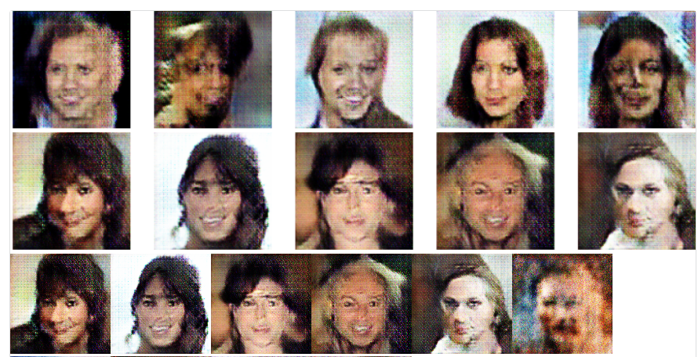

Now that we have generated a rough image or a sketch that correlates with the user descriptions, the target is now set to match these sketches with the images that are stored in the existing databases.

It is easy for humans to look at the sketch and match with the images by simply having a glance at the sketches. But, when it comes to machines it is very hard. The sketches or images may have different transformations, distortions, scene conditions, viewing angles. Our algorithm should be very robust to all these conditions.

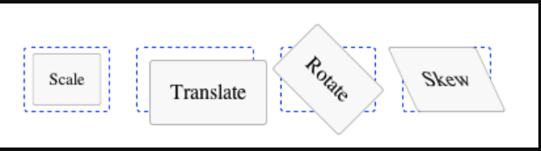

Most often recognition is done by extracting local features of object and trying to match them with features of unknown object. For this we make use of Feature Based Image Matching using SIFT.

First the user has to load an image. When the drawing has been finished or the appropriate representative has been loaded, the retrieval process is started. The feature vector is generated. In some cases large differences can occur among images in simple size or resolution. For this, during feature vector generation, we make use of Scale Invariant Feature Transform (SIFT), which includes Scale-space construction, Keypoint localization, Orientation assignment, Keypoint descriptor, Key point matching.

Then using the retrieval subsystem a search is executed in the previously indexed database.

For the retrieval the distance based search was used with Minkowski distance, or the Euclidean distance. As a result of searching a result set is raised, which appears in the user interface on a systematic form. Based on the result set we can again retrieve using another descriptor with different nature.

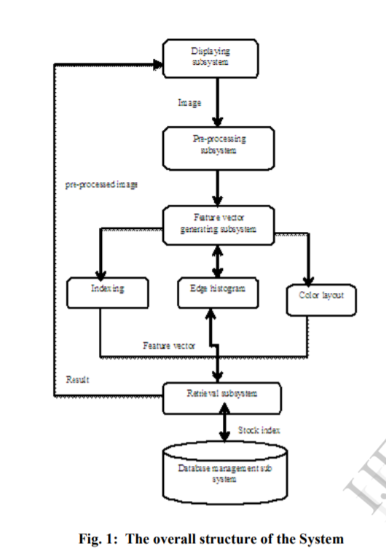

This is the general overall structure of the Image Matching subsystem.

In the above figure, Indexing, Edge Histogram and color Layout can be achieved using SIFT. Because, SIFT process includes the following steps.

1. Constructing a Scale Space
   1. Gaussian Blur
   2. Difference of Gaussian
2. Key point Localization
   1. Local Maxima/Minima
   2. Key point Selection
3. Orientation Assignment
   1. Calculate Magnitude & Orientation
   2. Create Histogram of Magnitude & Orientation
4. Keypoint Descriptor
5. Feature Matching

**Student’s Request for Guide**

We the students of 4/4 IT Sem-1 here by request you to guide our Major Project , “**Face generation and identification based on feature description".**

S.no. Name Roll No Signature

1. N.Shalini Reddy 2451-16-737-002

1. A.Jyothi 2451-16-737-008
2. K.Vinay Kumar 2451-16-737-009

-----------------------------------------------------------------------------------------

**Guide’s Consent**

I V. Ashwini Kumar, here by give my consent to guide the Major Project “**Face generation and identification based on feature description”*,*** with a batch of students that made a request above.

Date: 09-08-2019

Name: V.Ashwini Kumar

Designation: Associate Professor

Department of Information Technology

**Guide’s Signature and Date**

**Work Plan Sheet**

**Activities**

Introduction and selection of the domain

Selection of project and guide

Statement of problem and abstract submission

Requirement specification and Literature survey

Review Meet

Discussion of the project with guide and team members and Module Design

Understanding the block diagram and preparation of project diary and report

members and Module Design

Finalising the report along with power point presentation.

Project Demonstration

25/7 01/8 08/8 22/8 27/8 5/9 12/9 3/10 27/10

Signature and date of the guide

**Project Seminar Sheet** Page 1 of 9

Date: 25-07-2019

Timing: 2:15pm-4:15pm

|  |  |  |  |
| --- | --- | --- | --- |
| **S.NO** | **Activity** | **Activity Details** | **Remarks** |
| 1.    2. | Introduction to main project and selection of team members.  Domain Selection | There was an Introduction about the main project that was understood thoroughly and a team of 3 were selected for the project.  Surfed the net for a list of projects based on Internet of Things. |  |

**Signature of the Candidate**

**Guide’s signature and Date**

**Project Seminar Sheet** Page 2 of 9

Date: 01-08-2019

Timing: 2:15pm-4:15pm

|  |  |  |  |
| --- | --- | --- | --- |
| **S.NO** | **Activity** | **Activity Details** | **Remarks** |
| 1.  2. | Selection of the project.  Selection of the Guide | Surfed the net for a list projects based on image synthesis, classification and retrieval**.**  We approached V.Ashwini Kumar sir to assist us for the project and he approved it. |  |

**Signature of the Candidate**

**Guide’s signature and Date**

**Project Seminar Sheet** Page 3 of 9

Date: 08-08-2019

Timing: 2:15pm-4:15pm

|  |  |  |  |
| --- | --- | --- | --- |
| **S.NO** | **Activity** | **Activity Details** | **Remarks** |
| 1.  2. | Abstract Submission to the Guide  Statement of Problem | Some features of the project are corrected and the abstract is submitted to the guide.  Thoroughly went through the abstract of the project and understood the principle used behind it. |  |

**Signature of the Candidate**

**Guide’s signature and Date**

**Project Seminar Sheet** Page 4 of 9

Date: 22-08-2019

Timing: 2:15pm-4:15pm

|  |  |  |  |
| --- | --- | --- | --- |
| **S.NO** | **Activity** | **Activity Details** | **Remarks** |
| 1.    2. | Requirements Specification.  Literature Survey | Found out about the technologies used in the project and their use in general.  Collected the previous data of all the technologies used and studied them in detail. |  |

**Signature of the Candidate**

**Guide’s signature and Date**

**Project Seminar Sheet** Page 5 of 9

Date: 27-08-2019

Timing: 2:15pm-4:15pm

|  |  |  |  |
| --- | --- | --- | --- |
| **S.NO** | **Activity** | **Activity Details** | **Remarks** |
| 1. | Review Meet | A review meet was conducted to present the project idea. |  |

**Signature of the Candidate**

**Guide’s signature and Date**

**Project Seminar Sheet** Page 6 of 9

Date: 05-09-2019

Timing: 2:15pm-4:15pm

|  |  |  |  |
| --- | --- | --- | --- |
| **S.NO** | **Activity** | **Activity Details** | **Remarks** |
| 1.    2. | Discussion of project with the guide and among the team members.  Module design | Discussed about the Aim and Objective of the project in detail and cleared all the doubts and planned precisely what we are supposed to do.  Gathered all the information and the requirements related to the project and planned on what to do. |  |

**Signature of the Candidate**

**Guide’s signature and Date**

**Project Seminar Sheet** Page 7 of 9

Date: 12-09-2019

Timing: 2:15pm-4:15pm

|  |  |  |  |
| --- | --- | --- | --- |
| **S.NO** | **Activity** | **Activity Details** | **Remarks** |
| 1.  2. | Understanding the working of Block Diagram.  Preparation of Project Diary and Project Report | Understood the functioning and working of the Block diagram of each module.  The project diary consisting of the work we did till the date of presentation and the Project report consisting of the literature survey and the working principle of the project was prepared. |  |

**Signature of the Candidate**

**Guide’s signature and Date**

**Project Seminar Sheet** Page 8 of 9

Date: 3-10-2019

Timing: 2:15pm-4:15pm

|  |  |  |  |
| --- | --- | --- | --- |
| **S.NO** | **Activity** | **Activity Details** | **Remarks** |
| 1. | Finalizing the report along with ppt. | We approached our guide to show the contents and the format of the report and finalized it.  The power point presentation was also prepared as per the given template. |  |

**Signature of the Candidate**

**Guide’s signature and Date**

**Project Seminar Sheet** Page 9 of 9

Date: 27-10-2019

Timing: 2:15pm-4:15pm

|  |  |  |  |
| --- | --- | --- | --- |
| **S.NO** | **Activity** | **Activity Details** | **Remarks** |
| 1.    2. | Submission of project diary and project report  Demonstration of the project. | The required project diary and project report was submitted that contains all the details of the work done.  Presented the project via ppt. |  |

**Signature of the Candidate**

**Guide’s signature and Date**