PIZZA SALES - SQL QUERIES
A. KPI’s
- Total Revenue
select SUM(total_price) as Total_Revenue from pizza_sales;
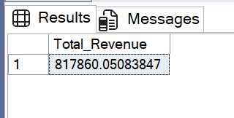

- Average Order Value
SELECT SUM(total_price) / COUNT(DISTINCT order_id) AS Avg_Order_Value
from pizza_sales;
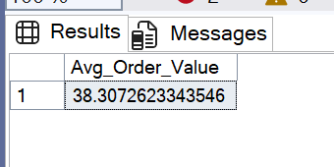

3. Total Pizzas Sold
SELECT SUM(quantity) as Total_Pizza_Sold from pizza_sales
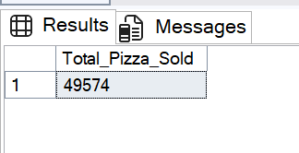

4. Total Orders
SELECT COUNT(DISTINCT order_id) as Total_Orders from pizza_sales
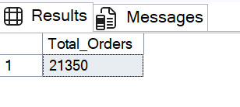
5. Average Pizzas Per Order
SELECT CAST(
CAST(
SUM(quantity) AS DECIMAL(10,2)) /
CAST(
COUNT(DISTINCT order_id) AS DECIMAL(10,2)) AS DECIMAL(10,2)) as Avg_Pizza_Sold from pizza_sales
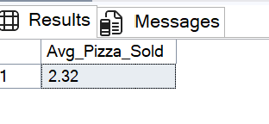
B. Daily Trend for Total Orders
SELECT DATENAME(DW, order_date) as Order_Day,
COUNT(DISTINCT order_id) as Total_Orders from pizza_sales
GROUP BY DATENAME(DW, order_date)
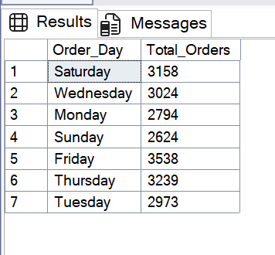
C. Monthly Trend for Orders
SELECT DATENAME(MONTH, order_date) as Order_Month,
COUNT(DISTINCT order_id) as Total_Orders from pizza_sales
GROUP BY DATENAME(MONTH, order_date)
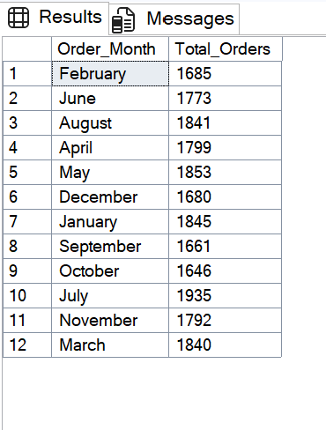
D. % of Sales by Pizza Category
SELECT pizza_category,
SUM(total_price) as Total_Category_Sales,
SUM(total_price) * 100 / (SELECT SUM(total_price) FROM pizza_sales) AS Percentage_TPC
from pizza_sales
GROUP BY pizza_category
ORDER BY Total_Category_Sales DESC

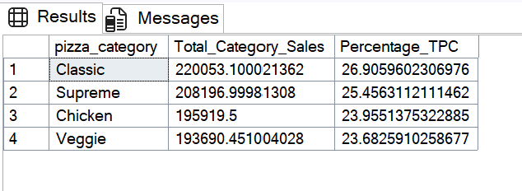

E. % of Sales by Pizza Size
SELECT pizza_size,
CAST(SUM(total_price) AS DECIMAL (10,2)) as Total_PS_Sales ,
CAST(SUM(total_price) * 100 / (SELECT SUM(total_price) FROM pizza_sales) AS DECIMAL(10,2)) AS Percentage_TPS
from pizza_sales
GROUP BY pizza_size
ORDER BY Percentage_TPS DESC
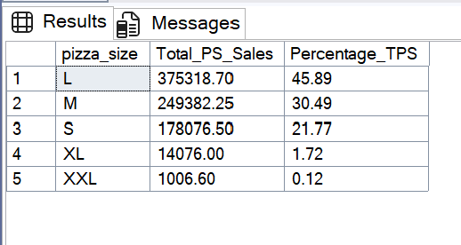

F. Total Pizzas Sold by Pizza Category
SELECT pizza_category, SUM(quantity) as Total_Quantity_Sold
FROM pizza_sales
GROUP BY pizza_category
ORDER BY Total_Quantity_Sold DESC
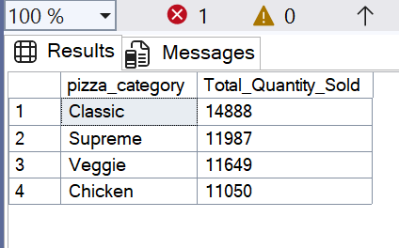

G. Top 5 Pizzas by Revenue
SELECT TOP 5 pizza_name, SUM(total_price) as Total_Revenue from pizza_sales
GROUP BY pizza_name
ORDER BY Total_Revenue DESC
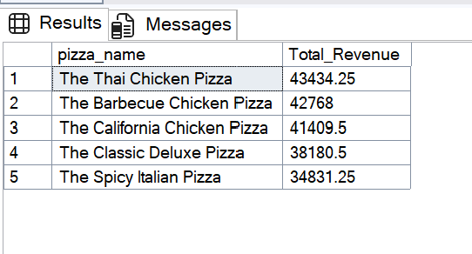
H. Bottom 5 Pizzas by Revenue
SELECT TOP 5 pizza_name, SUM(total_price) as Total_Revenue from pizza_sales
GROUP BY pizza_name
ORDER BY Total_Revenue ASC
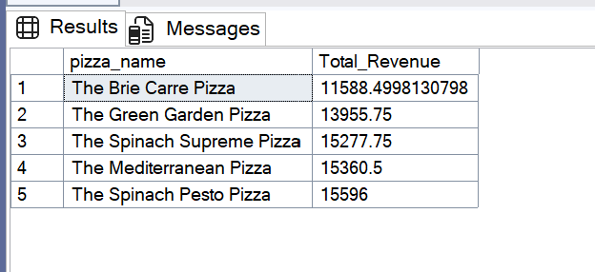
I. Top 5 Pizzas by Quantity
SELECT TOP 5 pizza_name, SUM(quantity) as Total_Quantity from pizza_sales
GROUP BY pizza_name
ORDER BY Total_Quantity DESC
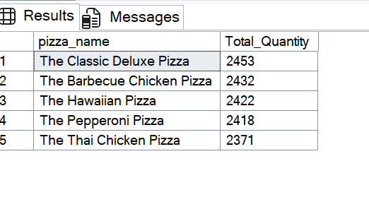
J. Bottom 5 Pizzas by Quantity
SELECT TOP 5 pizza_name, SUM(quantity) as Total_Quantity from pizza_sales
GROUP BY pizza_name
ORDER BY Total_Quantity ASC
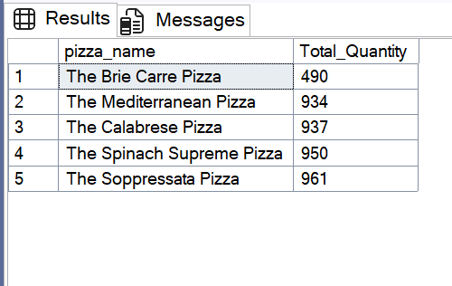
K. Top 5 Pizzas by Total Orders

SELECT TOP 5 pizza_name, COUNT(DISTINCT order_id) as Total_Orders from pizza_sales
GROUP BY pizza_name
ORDER BY Total_Orders DESC
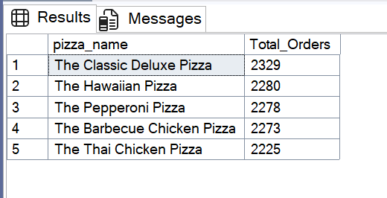
L. Bottom 5 Pizzas by Total Orders
SELECT TOP 5 pizza_name, COUNT(DISTINCT order_id) as Total_Orders from pizza_sales
GROUP BY pizza_name
ORDER BY Total_Orders ASC
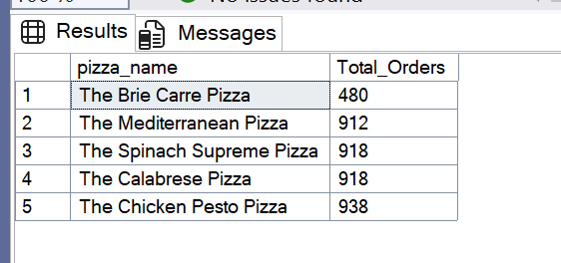

NOTE
If you want to apply the filters to the above queries you can use WHERE clause. Follow some of below examples,

For January month filter

SELECT pizza_category,
SUM(total_price) as Total_Category_Sales,
SUM(total_price) * 100 / (SELECT SUM(total_price) FROM pizza_sales WHERE MONTH(order_date) = 1) AS Percentage_TPC
from pizza_sales
WHERE MONTH(order_date) = 1
GROUP BY pizza_category
ORDER BY Total_Category_Sales DESC

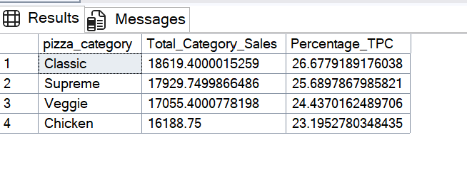
For 1st Quarter filter

SELECT pizza_size,
CAST(SUM(total_price) AS DECIMAL (10,2)) as Total_PS_Sales ,
CAST(SUM(total_price) * 100 / (SELECT SUM(total_price) FROM pizza_sales WHERE DATEPART(QUARTER, order_date) = 1) AS DECIMAL(10,2)) AS Percentage_TPS
from pizza_sales
WHERE DATEPART(QUARTER, order_date) = 1
GROUP BY pizza_size
ORDER BY Percentage_TPS DESC

