Send direct message from cmpe-272-hw2-Twitter-Service

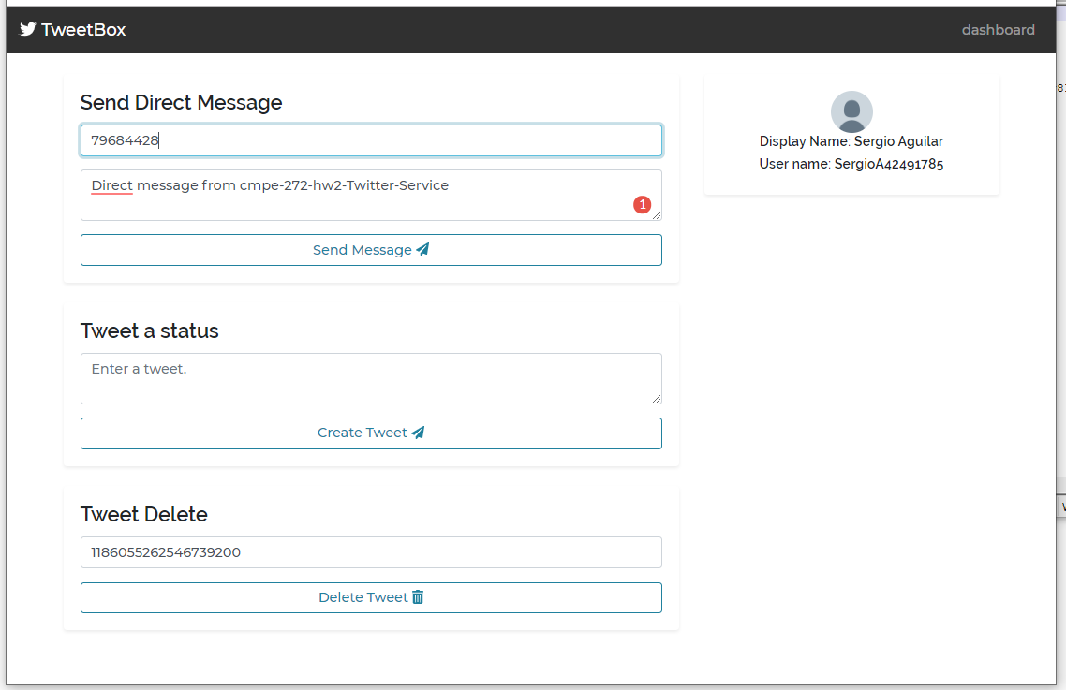

Message successfully created

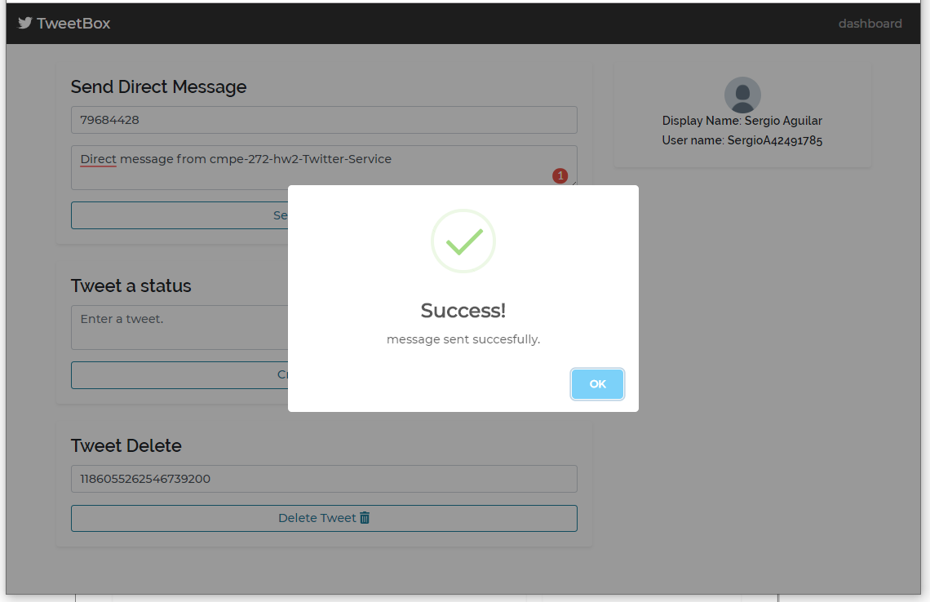

Message created and reflected on tweeter dashboard

