CONTENTS

1.) INTRODUCTION TO PYTHON AND DJANGO

2.) CREATING A BLOG USING DJANGO
- INTRODUCTION
- INSTALLING DJANGO AND VIRTUAL ENVIRONMENT
- CREATING A PROJECT[BLOG]
- DEVELOPMENT SERVER
- DJANGO MODELS
- DJANGO ADMIN
- DJANGO APPS
- DJANGO URLS
- DJANGO VIEWS AND TEMPLATES
- DJANGO FORMS AND STATIC FILES
- APPLICATIONS OF BLOG WEBSITE
- CHALLENGES TO BLOG WEBSITE
- CONCLUSION

3.) REFERENCES

PAGE 4
INTRODUCTION TO PYTHON AND DJANGO

Python is a interpreted high-level programming language for general purpose programming. It was created by Guido van Rossum in 1991.It is a free software available in the internet.
Python. Python is very popular for it’s easy learning syntax. Most of the popular data mining operations etc are done on python.
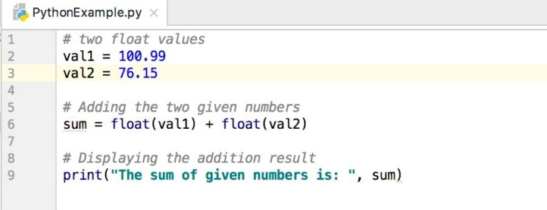
A sample python program
ADVANTAGES OF PYTHON
- Extensive support libraries
- Integration Feature
- Productivity
- Modular

PAGE 5

DJANGO

Django is a free and a open-source web framework, written in python which follows model-view architectural pattern.It is maintained by Django Software Foundation, an independent organization.Using django we can create powerful webpages.

ADVANTAGES OF DJANGO

Fast: This has been designed in a way to help the developers make an application as fast as possible. From idea, production to release, Django helps in making it both cost effective and efficient. Thus it becomes an ideal solution for developers having a primary focus on deadlines.
Fully Loaded: It works in a way that includes dozens of extras to help with user authentication, site maps, content administration, RSS feeds and much more such things. These aspects help in carrying out the web development process completely.
Secure: When you are doing it in Django, it is ensured that developers don’t commit any mistakes related to security. Some of the common mistakes include SQL injection, cross-site request forgery, clickjacking and cross-site scripting. To manage effectively usernames and passwords, the user authentication system is the key.
Scalable: To meet the heaviest traffic demand, the benefits of Django framework can be seen. Therefore, the busiest sites use this medium to quickly meet the traffic demands.
Versatile: Content management, scientific computing platforms, and even big organizations, all these aspects are very efficiently managed by the use of Django.

PAGE 6
CREATING A BLOG USING DJANGO

- INTRODUCTION

Blog is a regularly updated website which is run by a individual or a group of individuals, often written in informal style. Blog provides a platform where users can come and share their ideas by writing a article in that blog. We have got some popular blog websites namely Quora, Github etc. Blog websites enable users to share their views on a particular topic for example politics, movies, sports, technical stuff etc.

One feature which makes “DJANGO” a standout framework is that it contains a inbuilt database that the user has to configure to his/her needs. This database has a superuser facility that promotes security and has inbuilt forms that can just be imported which facilitates flexibility of the framework. Static files like javascript , HTML are available inside Django which promotes efficient design making of the website.Django follows model-based architecture.

- INSTALLING DJANGO AND VIRTUAL ENVIRONMENT
Before django is installed, Python and pip should be installed along first. The latest version of python (3.6.5) is already available as a complete package with pip 9.0.1. Python is available as a free software in the internet.

VIRTUAL ENVIRONMENT
Before installing Django we need to create and install a virtual environment...
Virtualenv will isolate Python/Django setup on a per-project basis.
All the user need to do is find a directory in which he/she wants to create the virtualenv home directory, for example. On Windows, it might look like C:\Users\Name\ (where Name is the name of your login).

C:\Users\Name\directory_name> python -m venv myvenv

The command above will create a directory called myvenv (or whatever name you chose) that contains our virtual environment (basically a bunch of directory and files).
Start your virtual environment by running:
command-line
C:\Users\Name\directory_name> myvenv\Scripts\activate

PAGE 7
INSTALLING DJANGO
Before installing django we need to install pip which is already available,users using lower version can install using the following command
C:\Users\Name\directory_name>python install pip
Now run the following command….
pip install -r requirements.txt
The user will be getting a complete installation of all packages

(myvenv) ~$ pip install -r requirements.txt
Collecting Django~=2.0.6 (from -r requirements.txt (line 1))
Downloading Django-2.0.6-py3-none-any.whl (7.1MB)
Installing collected packages: Django
Successfully installed Django-2.0.6
- CREATING A PROJECT
After installing django, the user can start his/her project by going to the command prompt and typing the following command

C:\Users\Name\directory_name>django startproject myblog
This following command will create a project directory named ‘myblog’ in the migrated directory. The created project directory contains the following files inbuilt to accommodate the functioning of the project, they are:

myblog/
manage.py
myblog/
__init__.py
settings.py
urls.py
PAGE 8
wsgi.py
There are about 6 different files present in the project directory which includes
manage.py: A command-line utility that lets the user interact with this Django project in various ways.
The inner myblog/directory is the actual Python package for the project. Its name is the Python package name you’ll need to use to import anything inside it (e.g. myblog.urls).
myblog/__init__.py: An empty file that tells Python that this directory should be considered a Python package.
myblog/settings.py: Settings/configuration for this Django project. Django settings will tell you all about how settings work.
myblog/urls.py: The URL declarations for this Django project; a “table of contents” of the user’s Django-powered site.
myblog/wsgi.py: An entry-point for WSGI-compatible web servers to serve the project.

- DEVELOPMENT SERVER
To see if the project has been successfully created ...type the following command
C:\Users\Name\directory_name\blog2share>python manage.py runserver
The user will be able to see something like this…
Performing system checks...
System check identified no issues (0 silenced).
September 1, 2014 - 11:32:30
Django version 2.0.5, using settings 'myblog.settings'
PAGE 9
Starting development server at http://127.0.0.1:8000/
Quit the server with CTRL-BREAK.
The user can view the following by opening the browser

- DJANGO MODELS
A model is the single, definitive source of information about your data. It contains the essential fields and behaviors of the data you’re storing. Generally, each model maps to a single database table.
The basics:
Each model is a Python class that subclasses django.db.models.Model.
Each attribute of the model represents a database field.
With all of this, Django gives you an automatically-generated database-access API; see Making queries.
The project directory contains a file models.py in which the objects are declared and initialized for example:
A class article is declared with objects title,slug,body,photo which are of different datatypes like TextField,ImageField etc..
This enables the user to use different dataypes as shown….
PAGE 10
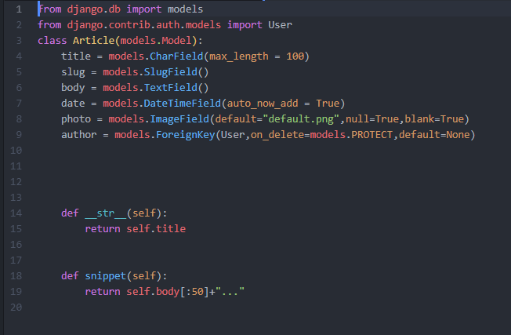
These objects are the fields for the model. Each field is specified as a class attribute mapping to the database column.Perform the following commands

C:\Users\Name\directory_name\myblog>python manage.py makemigrations
C:\Users\Name\directory_name\myblog>python manage.py migrate
The result will be as follows…….
migrating wsgi,contrib.auth,models…
title,slug,body,photo,author…..
migrations successfully completed
- DJANGO ADMIN

To control the input and the output flow of the project the user can make use of the django admin, the following code is added to the myblog/admins.py file. We are importing the model ARTICLES as written before in the models.py file and registering it under a administration

PAGE 11

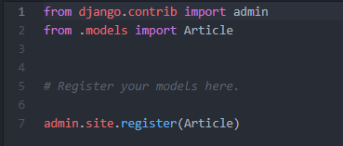

Run the python manage.py runserver and go to 127.0.0.1/admin portal then the user will be able to see this
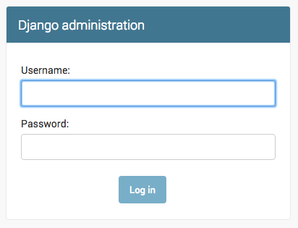

- DJANGO APPS

Apps are sub-models present in the database that in-herit the attributes of the models[OBJECTS]. The user can create as many models as he/she can and can attach the apps to the corresponding files.
To create an app go to the command line and type the following commands
A blog general requires 2 parts
- ARTICLE LIST AND DISPLAY
- ACCOUNTS AND USER LOGIN
So the user can create 2 apps – ‘articles’ and ‘accounts’

C:\Users\Name\directory_name\blog2share>django startapp articles
C:\Users\Name\directory_name\blog2share>django startapp accounts
The user can open the project directory and can see two sub-directories ‘articles’ and ‘accounts’ are created with the same files present before along with a additional file named apps.py in both the app sub-directories which contain the information regarding to each of the applications.
PAGE 12
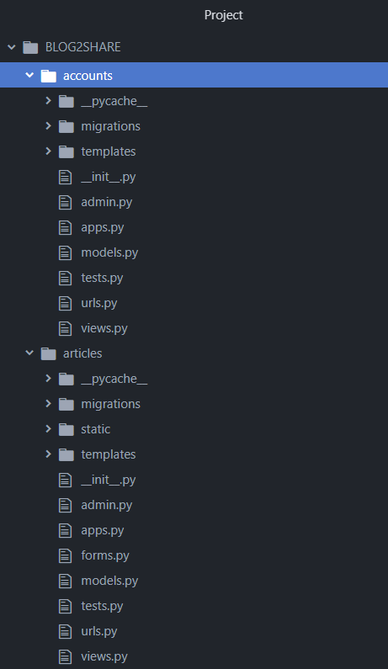

- DJANGO URLS
The urls.py file present in the project directory enables the user to define the
PAGE 13
localhost urls according to the requirements and insert data and redirect in that particular url. The user can insert new urls in the urls.py file.
A SMALL EXAMPLE:
mysite/urls.py
from django.urls import path, include
from django.contrib import admin

urlpatterns = [
path('admin/', admin.site.urls),
]
now the user runs the server and goes to 127.0.0.1/admin it will take the user to this page

admin.site.urls refer to the admin.py page where the suitable view and template has been defined to the database in sync to the url.

- DJANGO VIEWS
A view function, or view for short, is simply a Python function that takes a Web request and returns a Web response. This response can be the HTML contents of a Web page, or a redirect, or a 404 error, or an XML document, or an image . . . or anything, really. The view itself contains whatever arbitrary logic is necessary to return that response. This code can live anywhere you want, as long as it’s on your Python path.The convention is to put views in a file called views.py, placed in your project or application directory.
PAGE 14
EXAMPLE OF VIEWS:
from django.http import HttpResponse
import datetime
def current_datetime(request):
now = datetime.datetime.now()
html = "<html><body>It is now %s.</body></html>" % now
return HttpResponse(html)
This view is attached in the urls.py (admin.site.urls) where the function code logic will act accordingly to the url.
- DJANGO TEMPLATES
Being a web framework, Django needs a convenient way to generate HTML dynamically. The most common approach relies on templates. A template contains the static parts of the desired HTML output as well as some special syntax describing how dynamic content will be inserted.
A Django project can be configured with one or several template engines Django ships built-in backends for its own template system, creatively called the Django template language (DTL).
Django defines a standard API for loading and rendering templates regardless of the backend. Loading consists of finding the template for a given identifier and preprocessing it, usually compiling it to an in-memory representation. Rendering means interpolating the template with context data and returning the resulting string.
Django’s contrib apps that include templates like django.contrib.admin use the DTL.
Both the generic support for template engines and the implementation of the Django template language live in the django.template namespace
The user creates a folder name templates and inserts the styling and desgining html files under the template FOLDER. The user can directly link the views to the
PAGE 15
templates and combined to the urls.py file making the coding complete for the database.

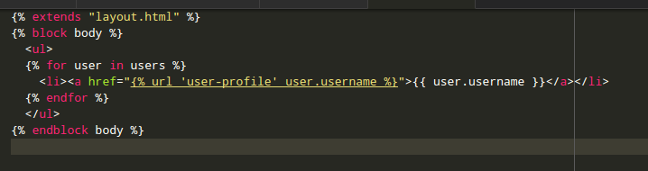

This template for example is attached to the view and is directly connected to the database.The user can see it’s functioning by going to the localhost url that he/she has designed according to the requirements.
- DJANGO FORMS
In django, using the models the user can define the attributes of the models defined in the models.py. When rendering an object in Django, we generally
GET HOLD OF IT IN A VIEW PASS IT TO A TEMPLATE CONTEXT and expand it to html markup using template variables.
We can build our forms in the respective sub-directory apps{ACCOUNTS, ARTICLES}. Each of the sub-directories have a forms.py present which enables the user to model and render the objects to the template context.
EXAMPLE:
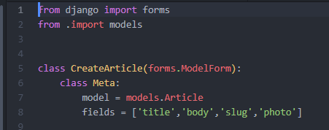

PAGE 16
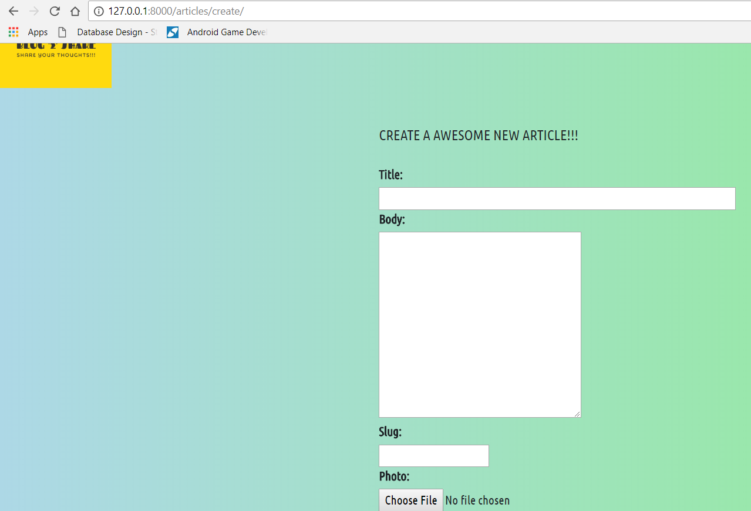
The form can be futher designed with more authenticity by using static files like HTML,CSS,JAVASCRIPT etc giving it a authentic look.
- STATIC FILES IN DJANGO
Static files like HTML,CSS,JAVASCRIPT have a very vital role in designing the webpages and giving it a very much beautiful look.Luckily,Django has all the static files modules inbuilt in it that enables it to use all the staticfiles, insert and delete as per the requirements.
VIEWING THE SETTINGS.PY file….

PAGE 17
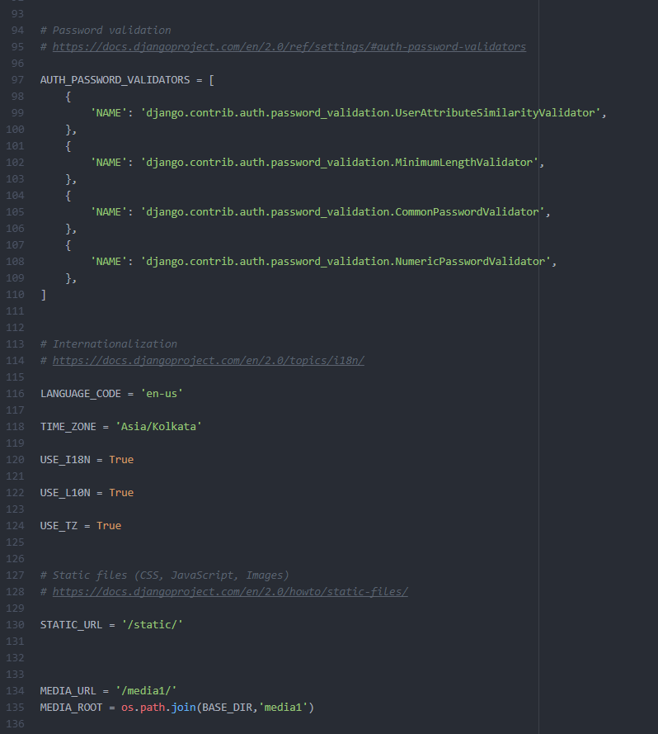

Settings.py file contains a line ‘STATIC_URL = ‘/static/’
which implies all the static files are stores in the directory static created by the user ,this enables the user to use advanced modules like BOOTSTRAP etc and directly attach to the html templates using the following syntax…
"{% static '/PATH/' %}"
django has another line MEDIA_URL and MEDIA_ROOT which enables the user to insert and delete media files such as .png etc. MEDIA_URL defines the root directory where all the media files are stored, this ensures that all the media files automatically get stored to the particular file directory.
MEDIA_ROOT makes sure that the database attaches the MEDIA_URL to it’s
PAGE 18
schema so that whenever a attribute of IMAGEFIELD is defined , it automatically points to the folder defined in the MEDIA_URL module.
User can also save the time-zone of the database by changing the TIME_ZONE to the specific GMT timezones available.
- DJANGO CODE
PROJECT NAME:BLOG2SHARE
ARTICLES APP
1)MODELS.PY
from django.db import models
class Article(models.Model):
title = models.CharField(max_length = 100)
slug = models.SlugField()
body = models.TextField()
date = models.DateTimeField(auto_now_add = True)
photo = models.ImageField(default="default.png",null=True,blank=True)
author = models.ForeignKey(User,on_delete=models.PROTECT,default=None)
def __str__(self):
return self.title
def snippet(self):
return self.body[:50]+"..."
2)ADMIN.PY
from django.contrib import admin
from .models import Article
admin.site.register(Article)
PAGE 19
3)FORMS.PY
from django.contrib import admin
from .models import Article
# Register your models here.
admin.site.register(Article)

4)VIEWS.PY
from django.shortcuts import render,redirect
from .models import Article
from django.http import HttpResponse
from django.contrib.auth.decorators import login_required
from .import forms

def article_list(request):
articles = Article.objects.all().order_by('date')
return render(request,'articles/article_list.html',{'articles':articles})
def article_detail(request,slug):
#return HttpResponse(slug)
article = Article.objects.get(slug=slug)
return render(request,'articles/article_detail.html',{'article':article})
@login_required(login_url="/accounts/login/")
def article_create(request):

PAGE 20
if request.method == 'POST':
form = forms.CreateArticle(request.POST,request.FILES)
if form.is_valid():
instance = form.save(commit = False)
instance.author = request.user
instance.save()
return redirect('articles:list')
form = forms.CreateArticle()
return render(request,'articles/article_create.html',{'form':form})
5)TEMPLATES
a)articles_create.html
{% extends 'base_layout.html' %}
{% block content %}
<div class = "create-article">
<style media="screen">
#id_title{
width: 100%; }
label{ width: 100%;}
#id_thumbnail{ width: 100%;}
</style>
<h2>CREATE A AWESOME NEW ARTICLE!!!</h2>
<br>

PAGE 21
<form class="site-form" action="{% url 'articles:create' %}" method="post" enctype="multipart/form-data">
{% csrf_token %}
{{form}}
<input type="submit" value="CREATE">
</form>
</div>
{% endblock %}
b)article_list.html
{% extends "base_layout.html" %}
{% block content %}
<style>
.article{
border: 2px solid red;
margin-bottom: 1.5em;
border-radius: 10px;
box-shadow: 5px 10px grey; } </style>
<h1 style="font-family: 'Open Sans Condensed', sans-serif;">ARTICLE LIST</h1>
<hr>
<div class="articles">
{% for article in articles %}
<div class="article">
<h2><a href="{% url 'articles:detail' slug=article.slug %}">{{article.title}}</a></h2>

PAGE 22
<p>{{article.snippet}}</p>
<p>{{article.date}}</p>
<p class="author">POSTED BY {{article.author.username}}</p>
</div>
{% endfor %}
</div>
{% endblock %}
c)articles_detail.html
{% extends 'base_layout.html' %}
{% load static from staticfiles %}
{% block content %}
<link rel="stylesheet" href="{% static 'css/bootstrap-grid.min.css' %}">
<div class="container">
<div class="article_detail">
<div class="article">
<img src="{{article.photo.url}}"/>
<h2>{{article.title}}</h2>
<p>{{article.body}}</p>
<p>{{article.date}}</p>
</div>
</div>
</div>
{% endblock %}
PAGE 23
ACCOUNTS APP
1)VIEWS.PY
from django.shortcuts import render,redirect
from django.contrib.auth.forms import UserCreationForm,AuthenticationForm
from django.contrib.auth import login,logout
# Create your views here.
def signup_view(request):
if request.method == 'POST':
form = UserCreationForm(request.POST)
if form.is_valid():
user = form.save()
#log the user in
login(request,user)
return redirect('articles:list')
else:
form = UserCreationForm()
return render(request,'accounts/signup.html',{'form':form})
def login_view(request):
if request.method == 'POST':
form = AuthenticationForm(data=request.POST)
if form.is_valid():
#log in user

PAGE 24
user = form.get_user()
login(request,user)
if'next' in request.POST:
return redirect(request.POST.get('next'))
return redirect('articles:list')
else:
form = AuthenticationForm()
return render(request,'accounts/login.html',{'form':form})
def logout_view(request):
if request.method == 'POST':
logout(request)
return redirect('articles:list')

2)URLS.PY
from django.urls import path
from .import views
app_name="accounts"
urlpatterns = [
path('accounts/signup/',views.signup_view,name = "signup"),
path('accounts/login/',views.login_view,name = "login"),
path('accounts/logout/',views.logout_view,name = "logout"),
]

PAGE 25
3)TEMPLATES
a)LOGIN.HTMl
{% extends 'base_layout.html' %}
{% block content %}
<style media="screen">
#id_username{
width: 100%; }
#id_password{
width: 100%; }
button{ padding: : 1em; }
</style>
<h1 style="font-size:2em">LOGIN</h1>
<hr>
<form class="site-form" action="{% url 'accounts:login' %}" method="post">
{% csrf_token %}
{{form}}
{% if request.GET.next %}
<br>
<input type="hidden" name="next" value="{{request.GET.next}}"> <br>
{% endif %}
<br>
<br>

PAGE 26
<button type="submit" value="="Login">LOGIN</button>
</form>
{% endblock %}
b)SIGNUP.HTML
{% extends 'base_layout.html' %}
{% block content %}
<style media="screen">
span .helptext{ width: 100%;}
label{
width: 100%;
}
#id_username, #id_password1, #id_password2{
width: 100%;
}
</style>
<h1>SIGN UP</h1>
<hr>
<form class="site-form" action="/accounts/signup/" method="post">
{% csrf_token %}
{{form}}
<br>

PAGE 27
<button type="submit" value="="Signup">SIGNUP</button>
</form>
{% endblock %}

- APPLICATIONS OF BLOG
Blog are websites where people of the same ideas,interests come and share their knowledge. Not only on the personal side but blog websites have a prominent role in the industrial,medical,business,political fields.
BUSINESS: Companies often use blog as a medium to gather feedback from their customers which enable them to provide service to them more readily. EX: swiggy,ola etc
MEDICAL: Medical industries who supply medicines to hospitals take the official feedback regarding their service of liability to the hospitals,patients etc.
POLITICAL: Organizations like GHMC have set up blog websites to the people so that they can express their personal opinion as well as post a complaint. EX: GHMC hyderabad has set up a blog in their website.
INDUSTRIAL: Industries who trade and purchase on a large scale use blog websites to negotiate deals,fix prices , collection of details, feedback,service etc
- CHALLENGES TO BLOG WEBSITES
One of the major challenges to blog websites include growing traffic, producing quality content, Encouraging reader interaction etc.
GROWING TRAFFIC:
Growing traffic and increasing the number of readers is a common problem Writing blog posts without any response can give the impression of speaking to an empty room, often discouraging writers from future blogging.
PRODUCING QUALITY CONTENT:
However, one of the major problems of blogging is the challenge of producing quality content, day after day. After several months of writing, it may be difficult to come up with new, fresh ideas that are engaging and compelling.
PAGE 28
ENCOURAGING READER’S INTERACTION:
e discouraging situation for bloggers to spend a significant of time crafting and posting a quality article, and not receive any feedback from readers.
CONCLUSION
Using django framework we have created a blog website using a powerful database , login and signup facility. Creating articles on a large scale and also attaching media files such as images, videos in order to make the articles look authentic.
BLOG websites can be used for personal opinions, marketing and feedback, sharing knowledge as well as for political reforms too….

PAGE 29
REFERENCES
WEBSITES
- https://djangogirls.org/
- https://docs.djangoproject.com/en/2.1/
- https://www.javatpoint.com/django-tutorial
- https://www.javatpoint.com/django-project
- https://www.youtube.com/watch?v=n-FTlQ7Djqc&list=PL4cUxeGkcC9ib4HsrXEYpQnTOTZE1x0uc

BOOKS:
DJANGO BY EXAMPLE [WRITTEN BY ANTONIO MELE]

PAGE 30

