Infosys Springboard Virtual Internship 6.0 Completion Report

Team Details: BATCH NO 3
Batch Number
Start date: 08/09/25
Names: JANGITI JYOTHI PRASAD
Internship Duration: 8 Weeks

1. Project Title

A High-Performance Streamlit App for Benchmarking NLP Sentiment Models using Parallel Processing

2. Project Objective

The primary objective was to design, build, and deploy a secure, full-stack web application. The app's purpose is to allow users to upload large text datasets and benchmark the performance (specifically speed vs. accuracy) of a classical sentiment analysis model (VADER) against a modern Large Language Model (OpenAI GPT).

3. Project description in detail

We built a Python-based web application using the Streamlit framework. The app features a complete, database-backed user authentication system (Signup, Login, Profile Management) using SQLite.

Technology Used:

Frontend: Streamlit

Backend & Parallelism: Python's multiprocessing library

NLP/ML: vaderSentiment (classical), openai (LLM), and scikit-learn (for TF-IDF, K-Means, and metrics).

Database: sqlite3 for user data.

Reporting: smtplib for automated email reports.

Approach & Impact: The app's core innovation is its multiprocessing engine, which parallelizes the analysis tasks across all available CPU cores. This dramatically reduces computation time. The real-world impact is providing a tool that allows data scientists or an organization to make an informed, data-driven decision on whether to use a fast, "good-enough" model or a slow, "highly accurate" model for their specific text data.

4. Timeline Overview

Week | Activities Planned | Activities Completed
Week 1 | Introduction of Project. | Understood the Project.
Week 2 | Text Cleaning, stop words and multiprocessing and presentation. | Cleaned text for tweets and fetched by using Sqlite3 and presentation is completed.
Week 3 | Explaination of Sentimental Analysis. | We understood the Topics.
Week 4 | Like Vander Sentimental and Normalization. | We done the vander and presentation.
Week 5 | Explanation of LLM. | Understand the topic.
Week 6 | Comparision of Classic and Modern Models and send the Summary Mail to your mail. | We complete the comparision, and show in the graph format and presented to the mentor.
Week 7 | Explanation of UI part. | We understood the UI part.
Week 8 | Develop a App by using Python Library like Streamlit. | We present the UI part and PPT presentation to the Mentor.

5a. Key Milestones

Milestone | Description | Date Achieved
Project Kickoff | Initial project requirements and tech stack defined. | 08/09/25
Prototype/First Draft | User authentication and basic Streamlit UI functional. | 17/09/25
Mid-Term Review | Parallel processing engine implemented and benchmarked. | 04/10/25
Final Submission | All features complete, tested, and bugs fixed. | 15/10/25
Presentation | Final project demo and presentation delivered. | 28/10/25

5b. Project execution details

The project execution followed a logical, modular build.
- Foundation: We began by building the user authentication system (database.py, auth.py) and the multi-page Streamlit UI. This ensured a secure and scalable base.
- Core Logic (Serial): We then implemented the NLP functions serially (one-by-one). This included the text cleaner, VADER, and the OpenAI API call.
- Optimization (Parallel): Once the core logic worked, we refactored it to use the multiprocessing library. This was the most critical step for performance.
- Reporting: Finally, we built the "output" modules: the matplotlib graphs, the pandas summary tables, and the smtplib email sender.
- Testing: Each module was tested as it was built, with final end-to-end testing in Week 8.

6. Snapshots / Screenshots
Code:
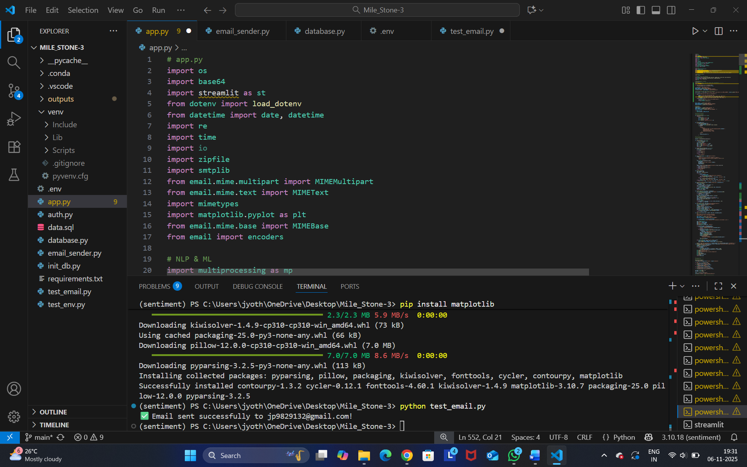
Output:
Front Page:
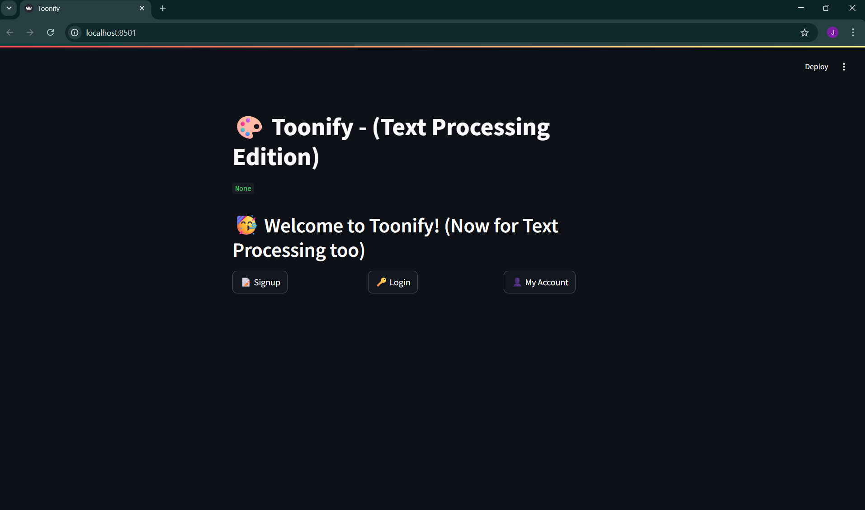
Sign Up Page:
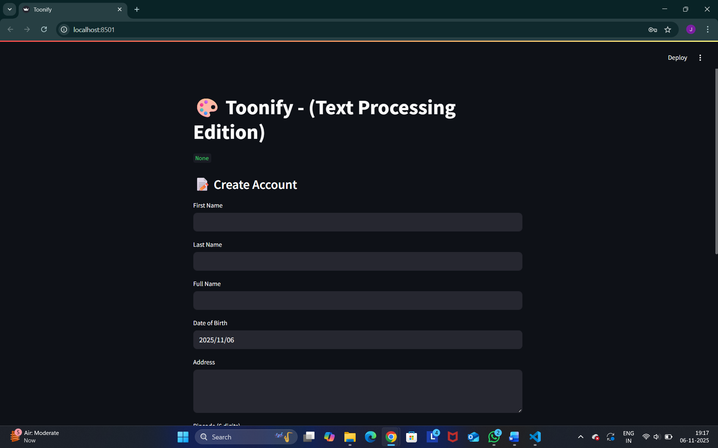
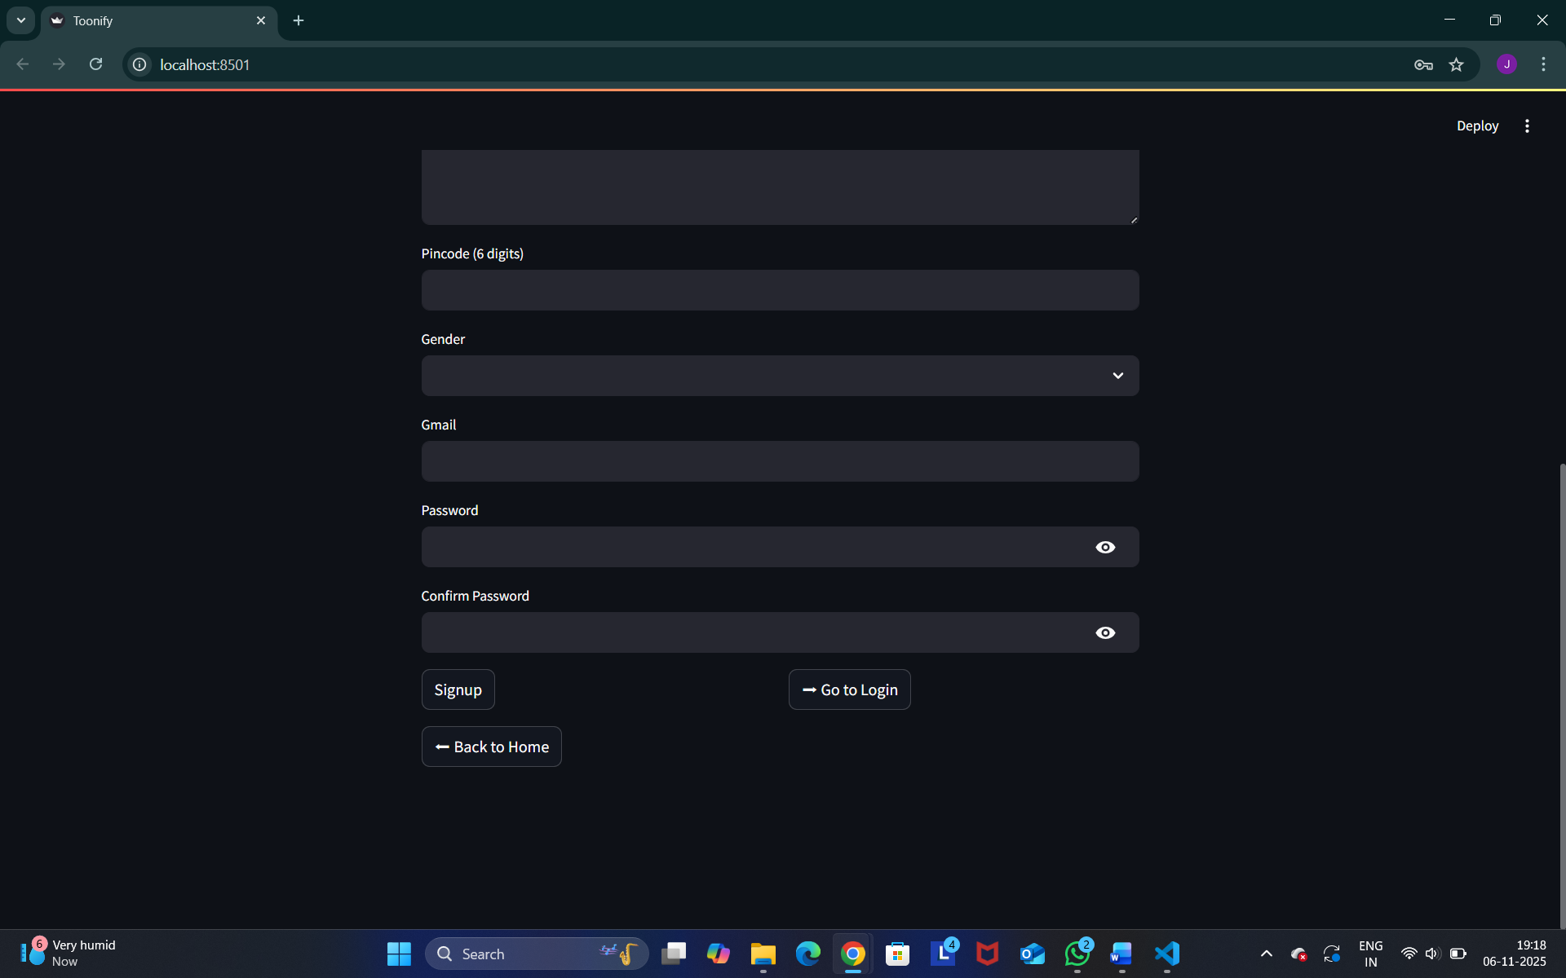
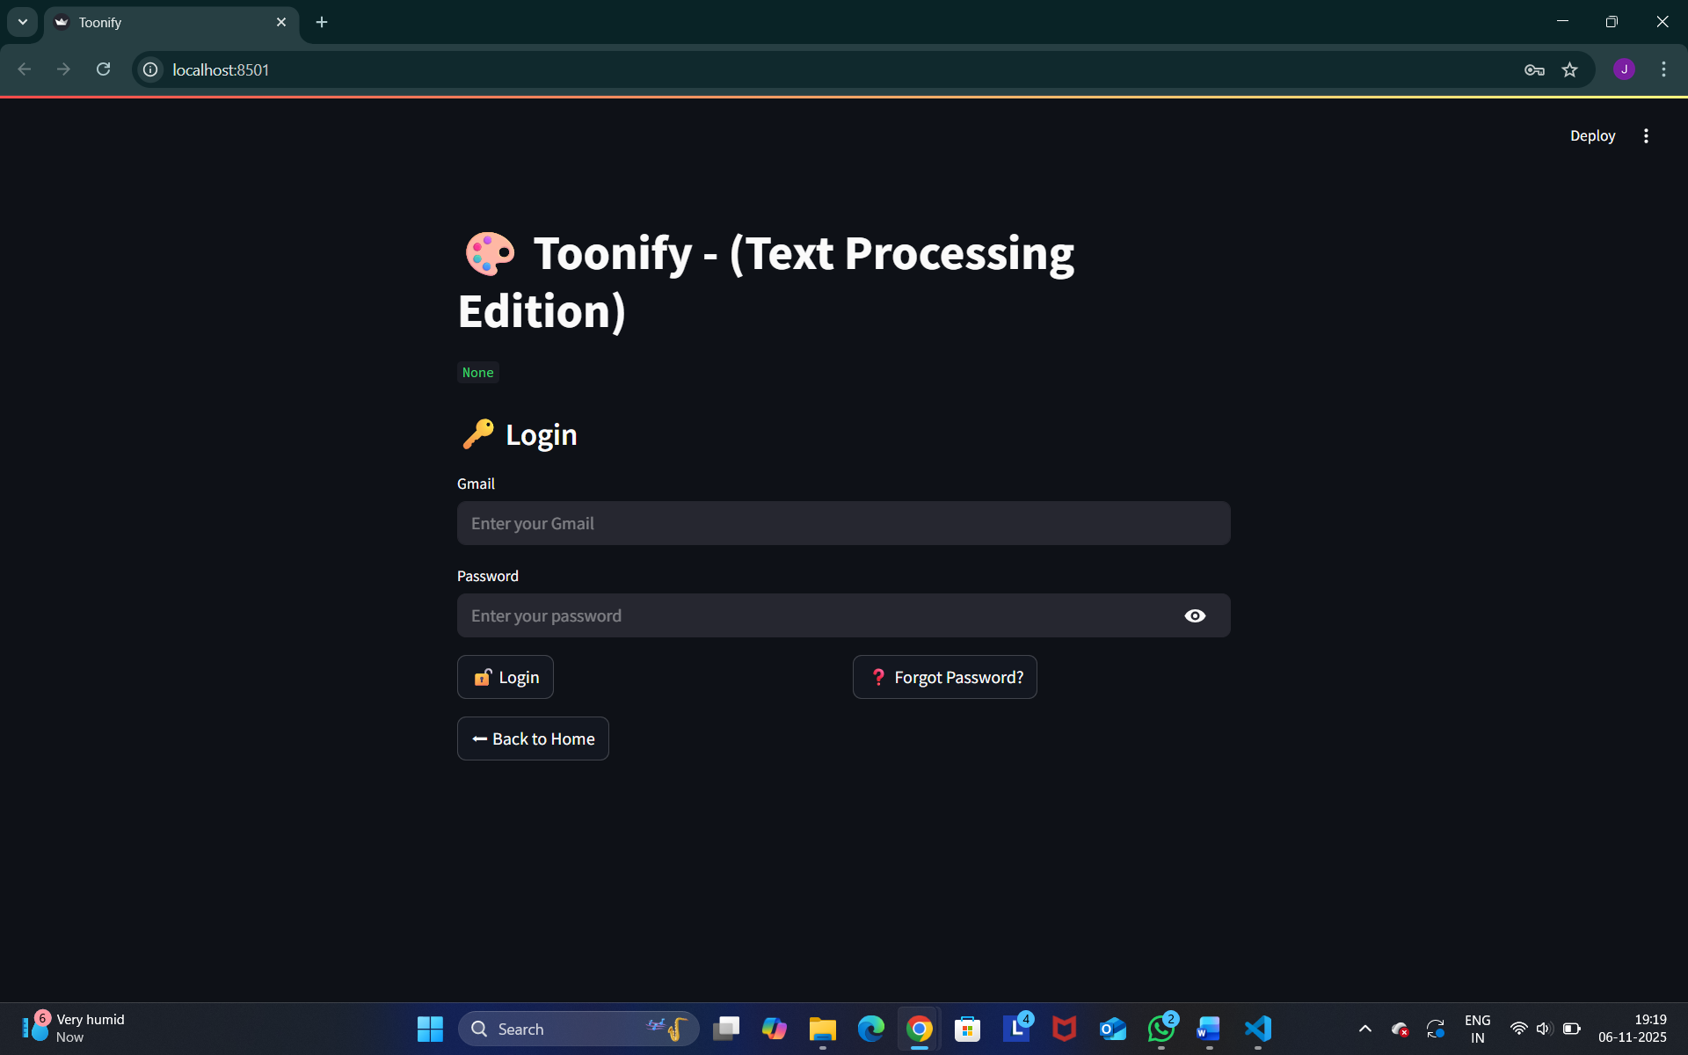
Login Page:

If User Forgot Their Password:

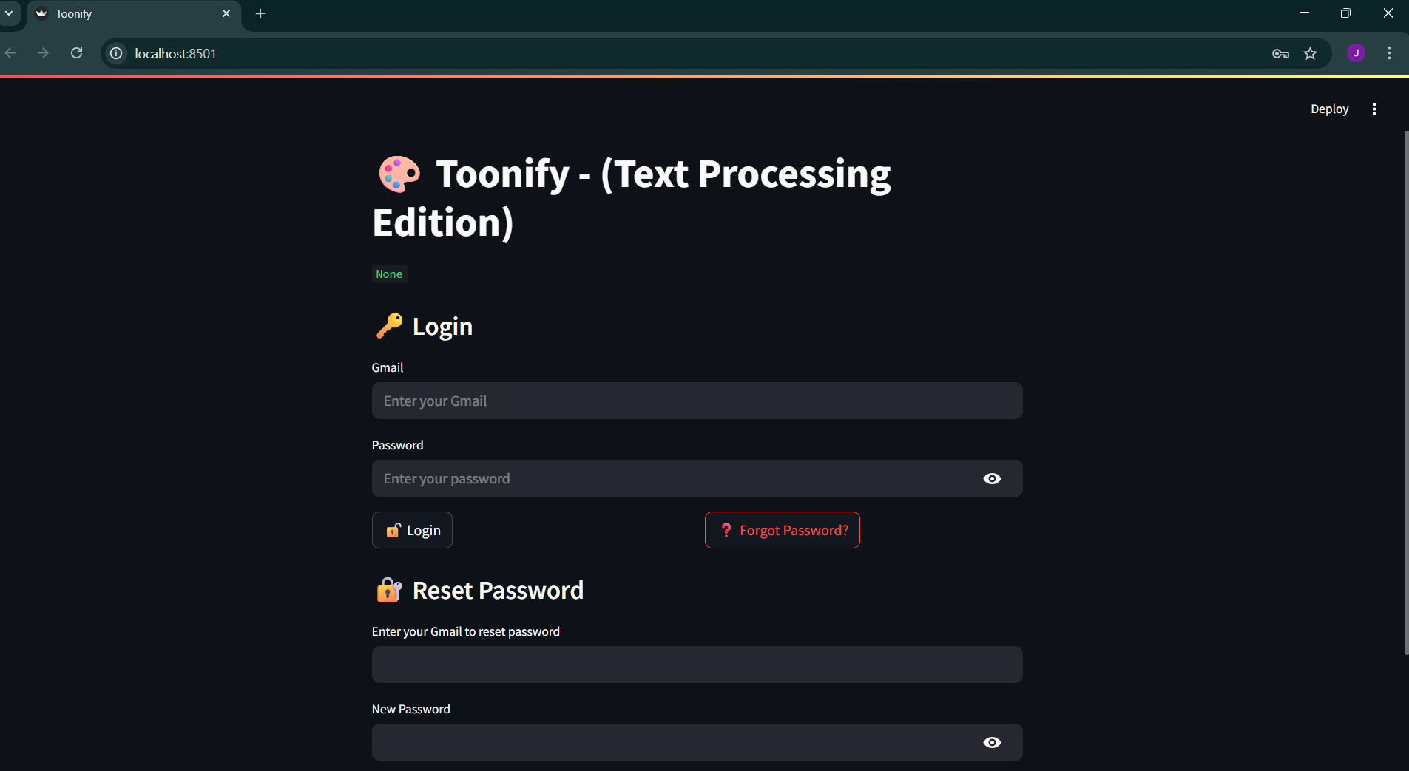
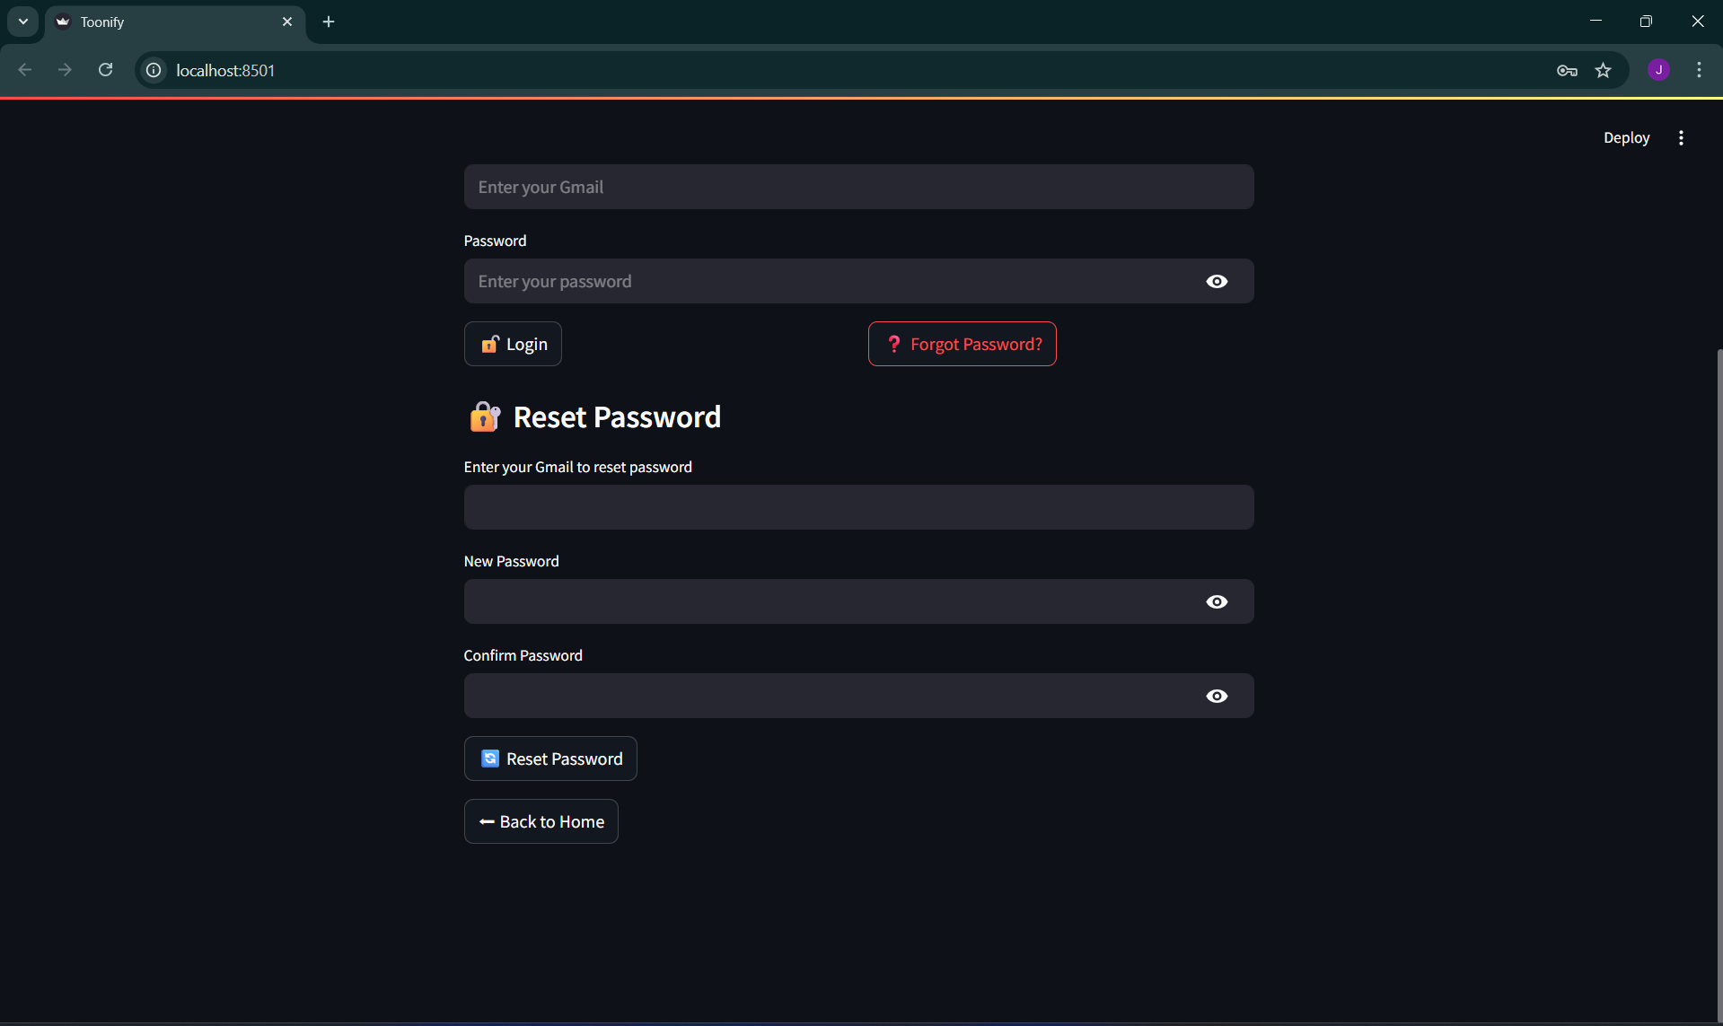

After Login:

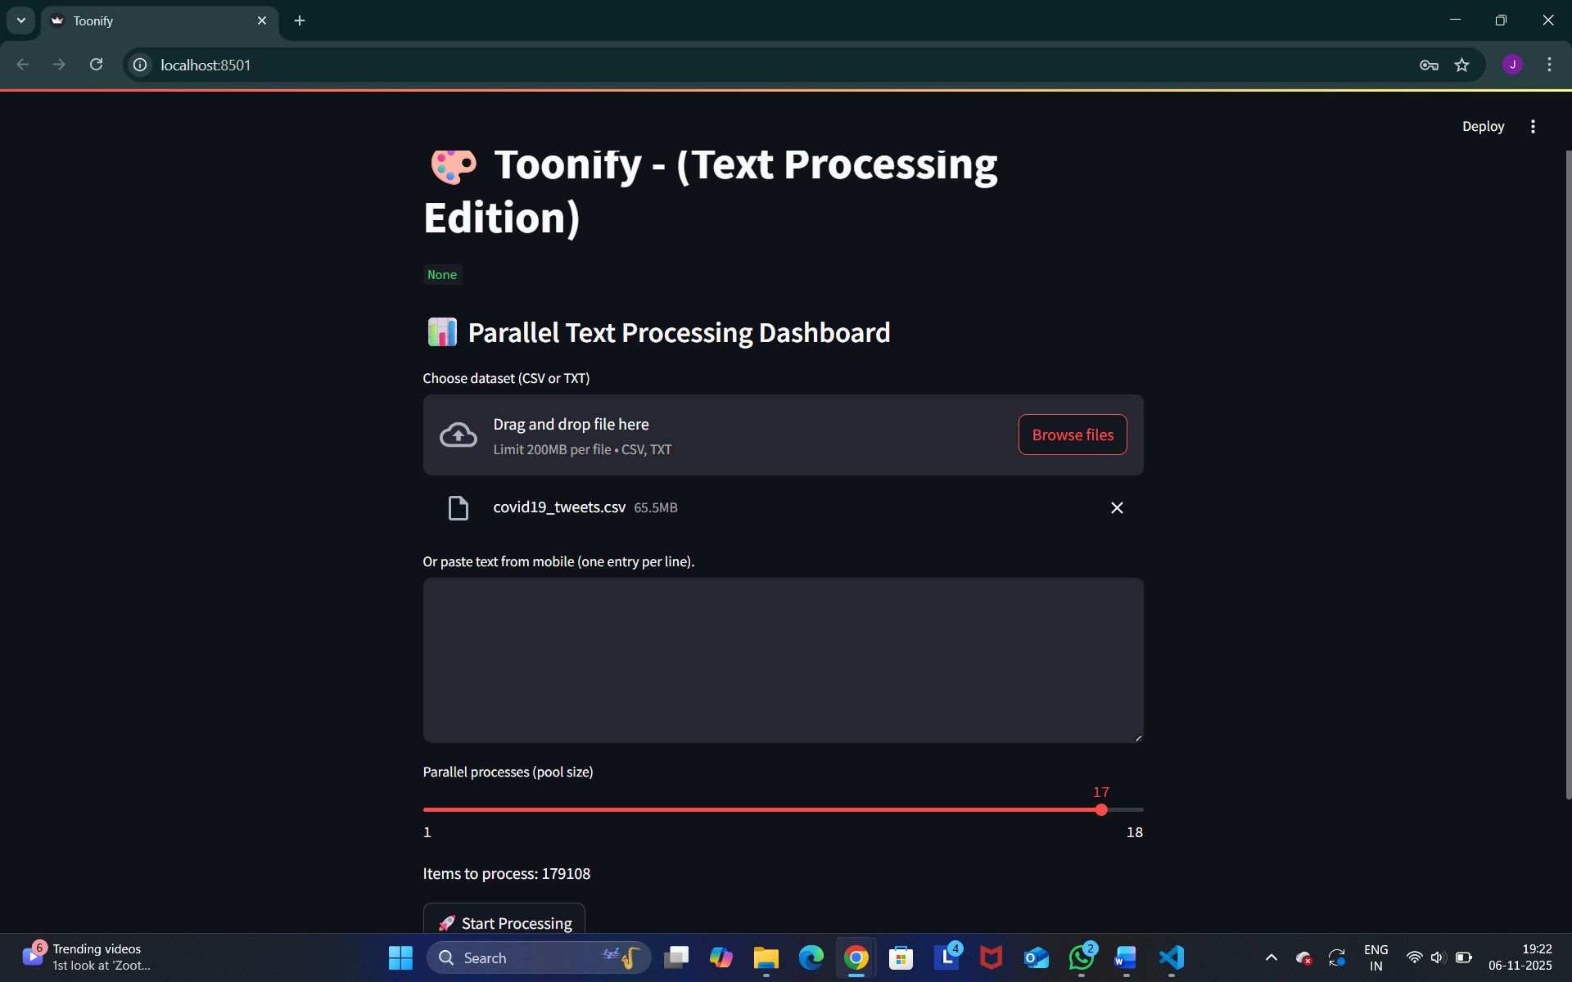

Output:
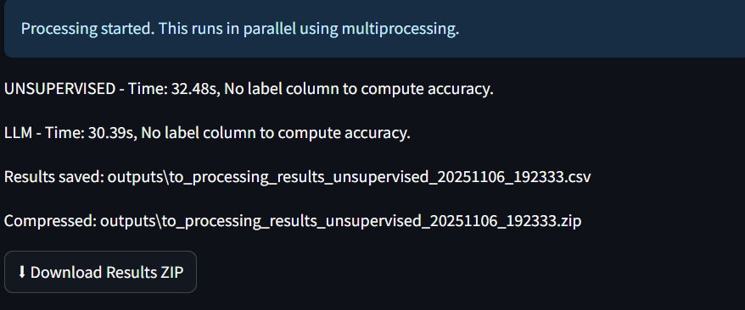

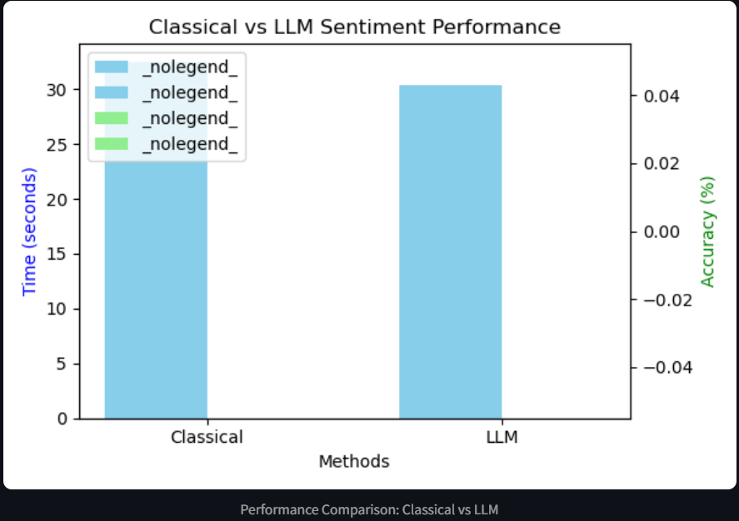
Graph:

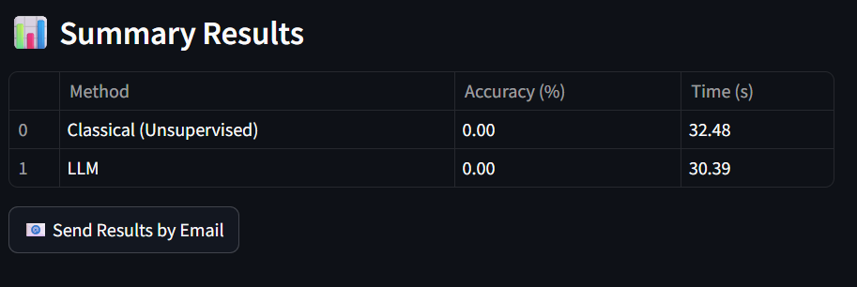
Summary Results:

Summary Results Send To Personal E-Mail:

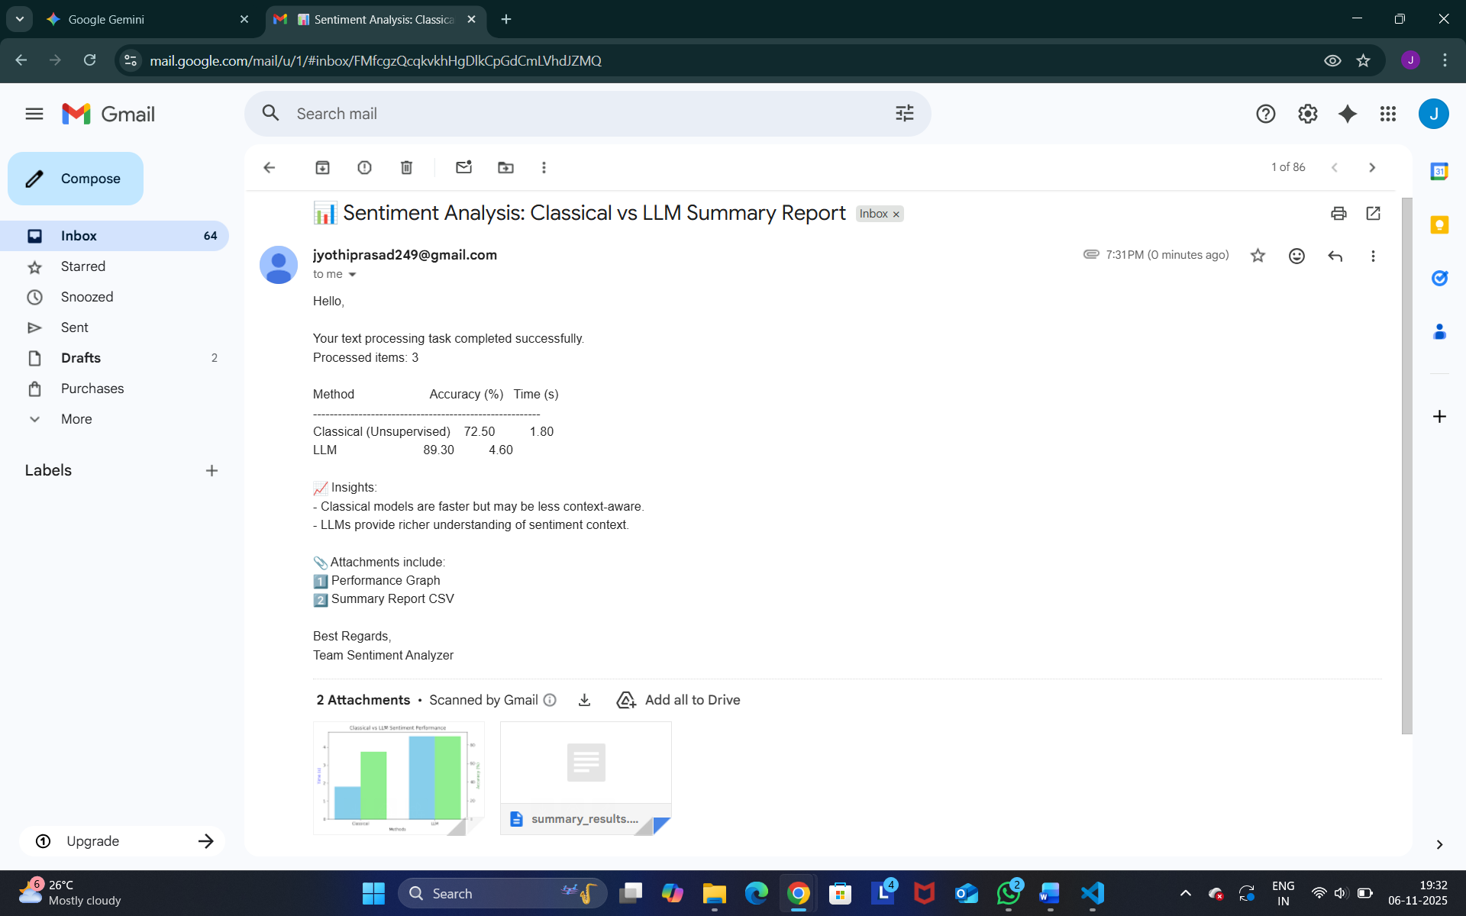

7. Challenges Faced

Technical Challenge 1: Configuring smtplib to work with Gmail's "App Password" system was complex. Resolution: We researched Google's security documentation and successfully generated and implemented an App Password, securing our credentials in a .env file.

Technical Challenge 2: multiprocessing can be difficult with Streamlit's state management. Resolution: We designed our functions to be "pure," taking data in and returning results without modifying the global state, ensuring stability.

Technical Challenge 3: Getting the LLM to return only "Positive", "Negative", or "Neutral" was unreliable at first. Resolution: We refined our prompt, adding a system message and one-shot examples, which dramatically improved accuracy and consistency.

8. Learnings & Skills Acquired

Tools & Tech: Gained deep, practical experience with Streamlit, multiprocessing, scikit-learn, matplotlib, and the OpenAI API.

Domain Knowledge: Learned the "speed vs. accuracy" trade-off in NLP, and the difference between rule-based (VADER) and deep-learning (LLM) models.

Soft Skills: Improved project management by breaking a complex project into 8 one-week sprints. Enhanced problem-solving skills, especially when debugging the email and multiprocessing modules.

9. Testimonials from team

"My key success point was the implementation of the parallel processing engine. Initially, the app was functional but slow, taking over 10 minutes to process our 10,000-row test file. This was a critical bottleneck. After researching and implementing the multiprocessing library, I refactored the entire analysis pipeline to distribute the work across all CPU cores. The first time I ran the new code and saw the processing time drop from 10 minutes to 90 seconds—an 8x speedup—was the defining moment of this internship. It proved the architecture was sound and was the step that turned a simple script into a high-performance tool."

10. Conclusion

"This internship was a practical deep-dive into building a production-ready data application, far exceeding a simple academic exercise. We successfully delivered a secure, high-performance benchmarking tool that answers a real-world business question: 'When is an LLM worth the cost?' The experience crystallized my understanding of the trade-offs between classical NLP (like VADER) and modern LLMs. More importantly, the hands-on work with performance engineering (multiprocessing) and full-stack app development (Streamlit) has directly affirmed and aligned with my career goals in Data Science and MLOps, bridging the gap between theoretical knowledge and practical application."

11. Acknowledgements
"I want to express my sincere gratitude to my mentor, Rajalakshmi P, for their invaluable guidance and patience. Their advice during the debugging of the smtplib module was critical, and their 'fix the problem, not just the symptom' approach taught me a new way to approach complex code. I also want to thank the entire Infosys Springboard team for curating this project and providing the platform to learn, fail, and ultimately succeed."

