SBA 2

Jyothika S B- 211470

1.Write a program to reverse the String (use char[] or String built in method)

Program

package sba2;
import java.util.*;
public class Question1 {

public static void main(String[] args)
{
int i,j;
Scanner sc = new Scanner(System.in);
System.out.println("Enter the String");
String s1 = sc.next();
char[] arr = s1.toCharArray();
char[] arr2 = new char[arr.length];
j=arr.length-1;
for(i=0;i<arr.length;i++)
{
arr2[i]=arr[j];
j--;
}
System.out.println("The elements in Reversed string array are: ");
for(i=0;i<arr2.length;i++)
{
System.out.print(arr2[i]+" ");
} System.out.println();
StringBuilder s = new StringBuilder();
for (i = 0; i < arr2.length; i++)
{
s.append(arr2[i]);
}
String reversed = s.toString();
System.out.println("The reversed array in string format is "+reversed);
}
}

Output

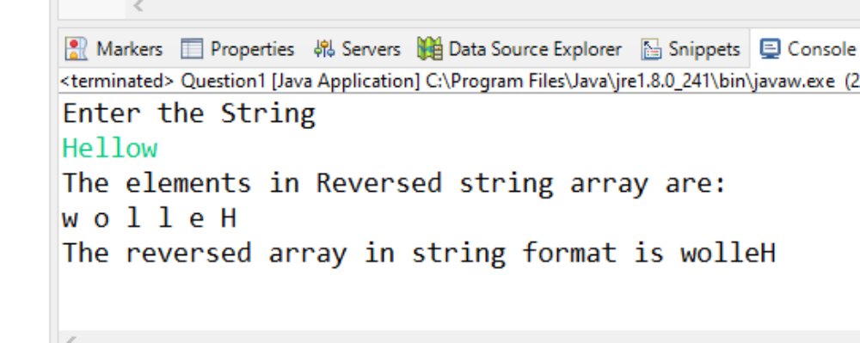

2.Write programs to depict the usage of contains(), length(), replace(), concat(), equals()

Program

package sba2;
public class Question2 {

public static void main(String[] args) {
//concat
String s="java";
s=s.concat(" Program");
System.out.println(s);

System.out.println(" ");
//equals
String s1="abc";
String s2="abc";
String s3=new String("pqr");
String s4="xyz";
System.out.println(s1.equals(s2));
System.out.println(s1.equals(s3));
System.out.println(s1.equals(s4));

System.out.println(" ");
//contains
String str = "hello world";
String str1 = "hello";
String str2 = "java";
System.out.println("hello is contains in the hello world so it is " + str.contains(str1));
System.out.println("java is not in the hello world so it is " + str.contains(str2));

System.out.println(" ");
//replace
String str5 = "abcd";
String replace = str5.replace('b', 'x');
System.out.println(str5);
System.out.println("Replaced by "+ replace);

System.out.println(" ");
//Length
String s11="Good";
String s22="Morning";
System.out.println("string length is: "+s11.length());
System.out.println("string length is: "+s22.length());
}

}

Output

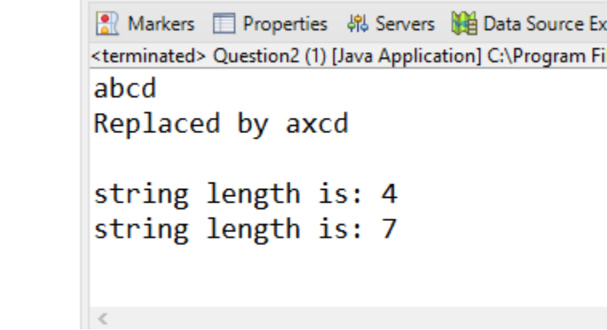

3. Write a customized Exception class for a Banking project

Program

package sba2;

public class Question3 {

public static void main(String[] args)

{ try

{ int initial=200;

int balance=0;

System.out.println(" "+(initial/balance));

}

catch(ArithmeticException e)

{ System.out.println("Arithmetic Exception:balance is zero");

}

finally

{ System.out.println("Try again later");

}

}

}

Output

