5.04.2024

Write a python program to import and export data using Pandas library functions

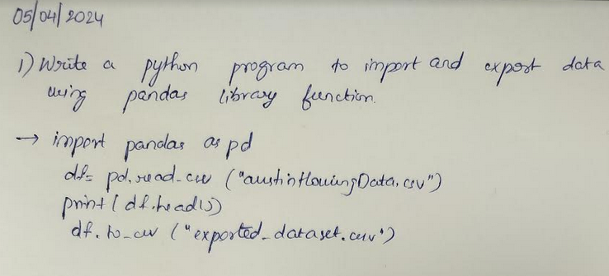

# -*- coding: utf-8 -*-

#JYOTHIKA C N

#1BM21CS083

import pandas as pd

df=pd.read_csv("austinHousingData.csv")

print(df.head())

df.to_csv("exported_dataset.csv")

Output:

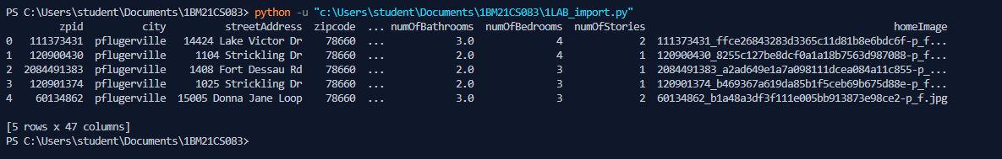

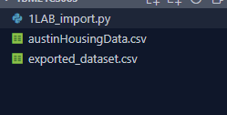

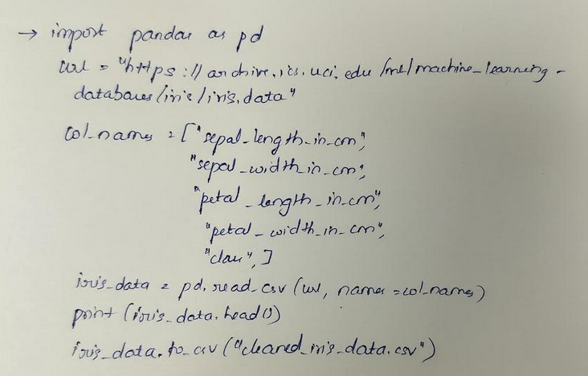

import pandas as pd

url = "https://archive.ics.uci.edu/ml/machine-learning-databases/iris/iris.data"

col_names = ["sepal_length_in_cm",

            "sepal_width_in_cm",

            "petal_length_in_cm",

            "petal_width_in_cm",

            "class"]

iris_data = pd.read_csv(url, names=col_names)

print(iris_data.head())

iris_data.to_csv("cleaned_iris_data.csv")

Output:

