To run this project double click on ‘run.bat’ file to get below screen

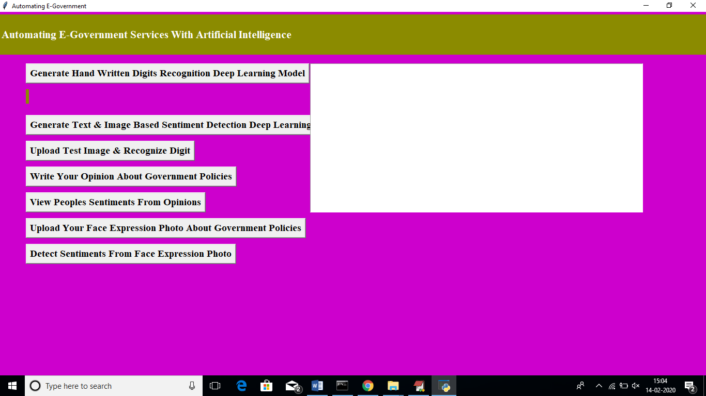

In above screen click on ‘Generate Hand Written Digits Recognition Deep Learning Model’ button to generate CNN digits recognition model

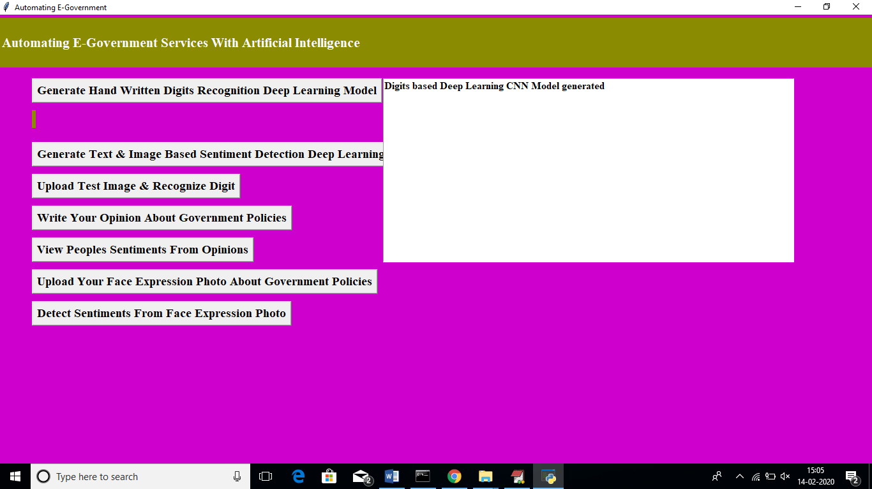

In above screen we can see digits model generated and CNN layer details you can see black console

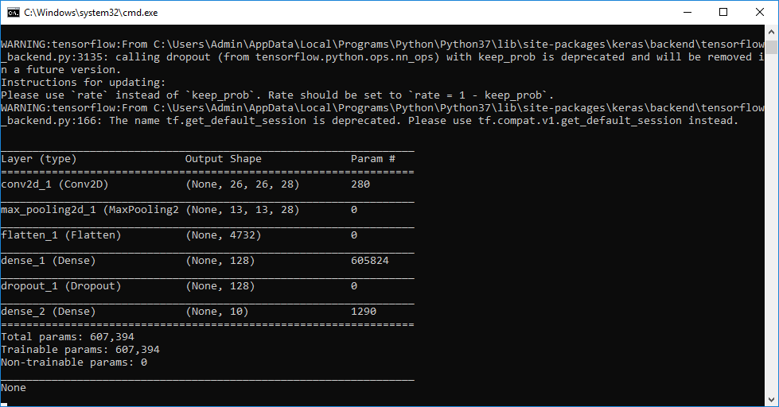

In above screen we can see Conv2d means convolution or CNN generate image features layer from different size as first layer generate with image size 26, 26 and second generated with 13 and 13 and goes on. Now click on ‘Generate Text & Image Based Sentiment Detection Deep Learning Model’ button to generate CNN for text and image based sentiment detection model.

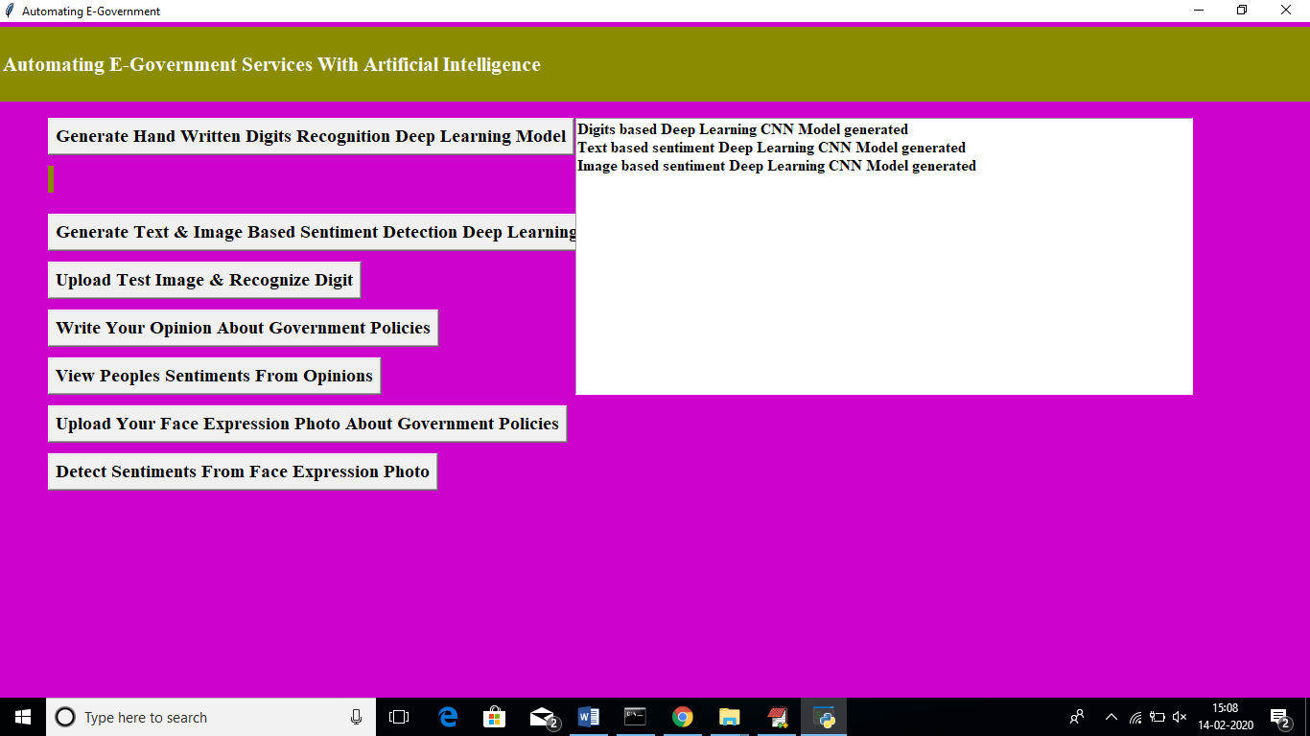

In above screen we can see text and image based CNN model generated. See black screen for more details

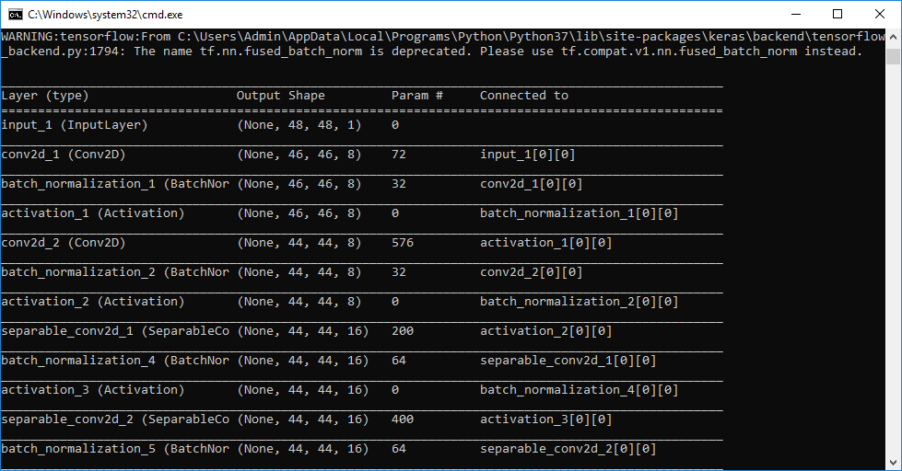

Now click on ‘Upload Test Image & Recognize Digit’ button to upload digit images and to get name of that digit. All digit images saved inside testImages folder

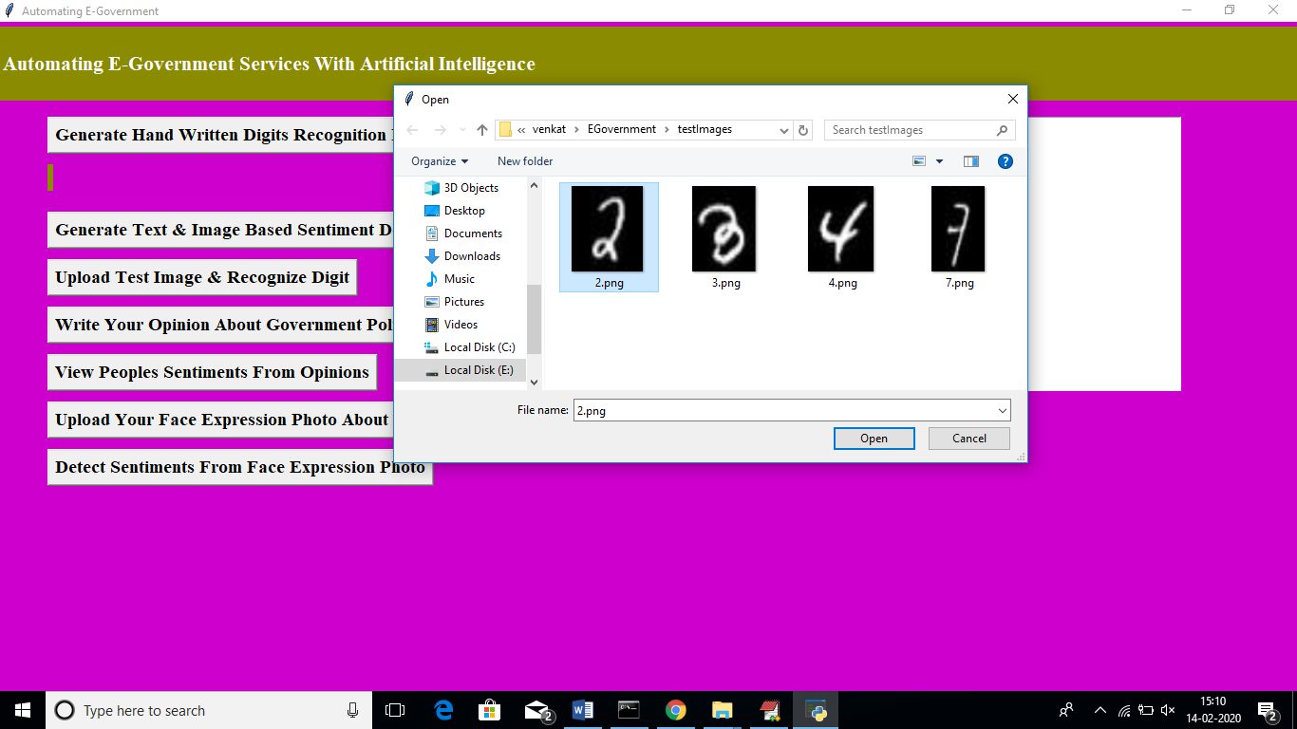

In above screen I am uploading image which contain digit 2 and below is the output of detection

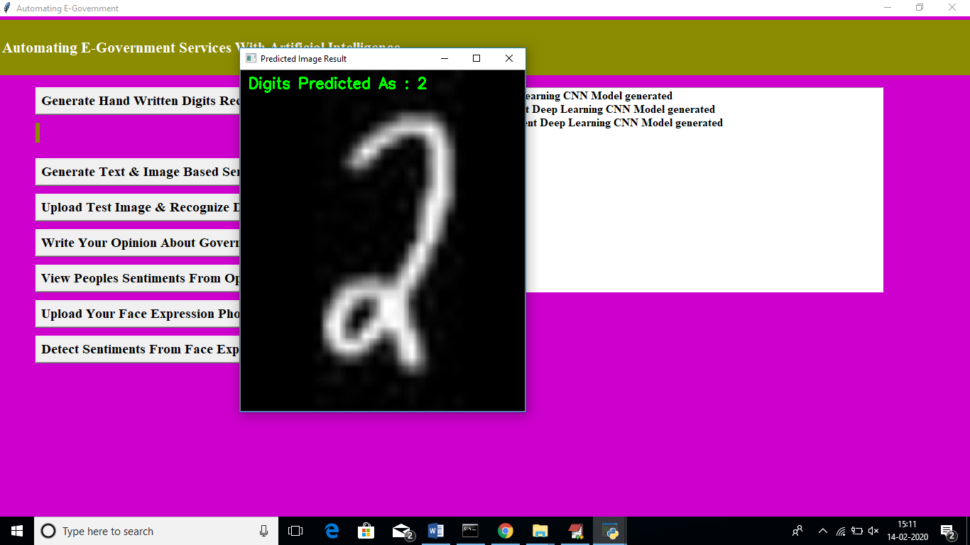

In above screen we can see Digits Predicted as: 2. Now click on ‘Write Your Opinion About Government Policies’ button to write some comments on government policy

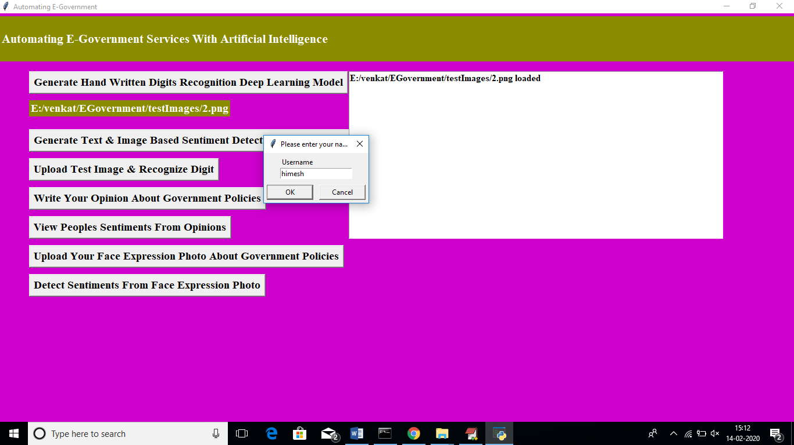

In above screen before writing opinions we need to write username after writing username click ok button to get below screen

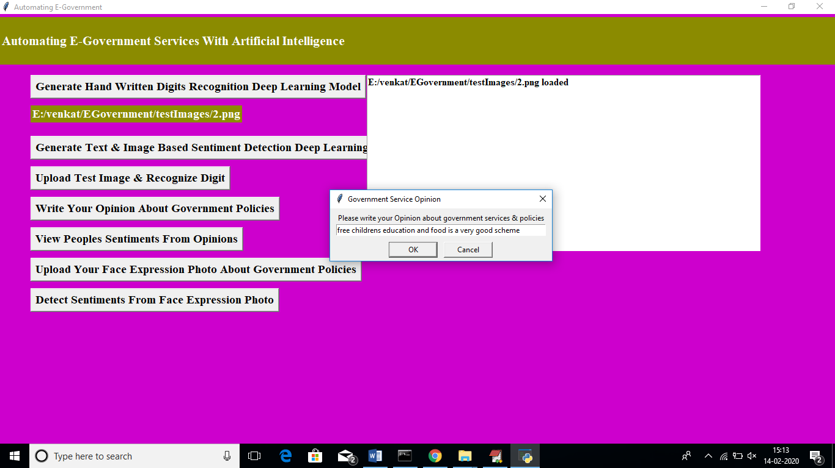

In above screen I wrote some comment on some scheme and application detect sentiment from it as positive or negative. Now click on ‘View Peoples Sentiments From Opinions’ button to view all opinions from past users.

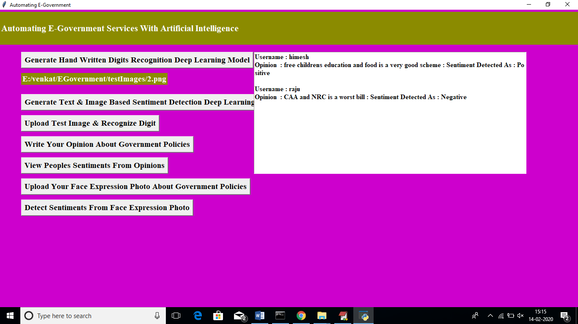

In above screen text area we can see opinions from all users and in first opinion we got sentiment detected as positive which means user is satisfy with that scheme and for second opinion we got sentiment as negative which means user not happy. Similarly user can upload their image with facial expression which describe whether user is happy or angry

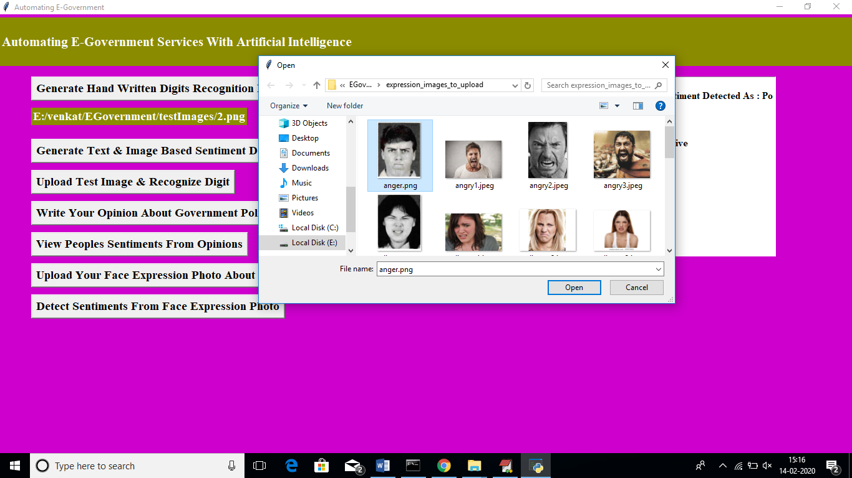

In above screen I am uploading one anger face image and then application ask to write username and referring scheme name. similarly any number of users can upload their images. Now click on ‘Detect Sentiments From Face Expression Photo’ button to get all images and its detected sentiments



In above screen we can see all images with facial expression are identified with their sentiments. In dialog box also we can see sentiment result.

Similarly you can enter any number of comments or facial images to detect their sentiments