

Functional Safety Concept Lane Assistance

**Document Version: 1.0**

**Released on 2018-05-22**



# 

# Document history

|  |  |  |  |
| --- | --- | --- | --- |
| Date | Version | Editor | Description |
| 18-May-2018 | 0.1 | Jyothikumar | Initial Draft |
| 22-May-2018 | 1.0 | Jyothikumar | First attempt |
|  |  |  |  |
|  |  |  |  |
|  |  |  |  |

# Table of Contents

Document history

Table of Contents

Purpose of the Functional Safety Concept

Inputs to the Functional Safety Analysis

Safety goals from the Hazard Analysis and Risk Assessment

Preliminary Architecture

Description of architecture elements

Functional Safety Concept

Functional Safety Analysis

Functional Safety Requirements

Refinement of the System Architecture

Allocation of Functional Safety Requirements to Architecture Elements

Warning and Degradation Concept

# Purpose of the Functional Safety Concept

The purpose of Functional Safety Concept document is to identify system high level requirements and allocate them to different parts of the item architecture without going into technical detail. Finally to prove that a system actually meets requirements, they have to be verified and validated.

# Inputs to the Functional Safety Concept

## Safety goals from the Hazard Analysis and Risk Assessment

|  |  |
| --- | --- |
| **ID** | **Safety Goal** |
| Safety_Goal_01 | The vibrating torque of steering wheel should be reduced to acceptable range. |
| Safety_Goal_02 | The functional time of the LKA should be reduced. |
| Safety_Goal_03 | The LDW function shall be turned off when driving on *off road conditions*. |
| Safety_Goal_04 | The LKA function shall be deactivated when the camera sensor stopped working and driver should be warned about the deactivation ( car dashboard ) |

## Preliminary Architecture

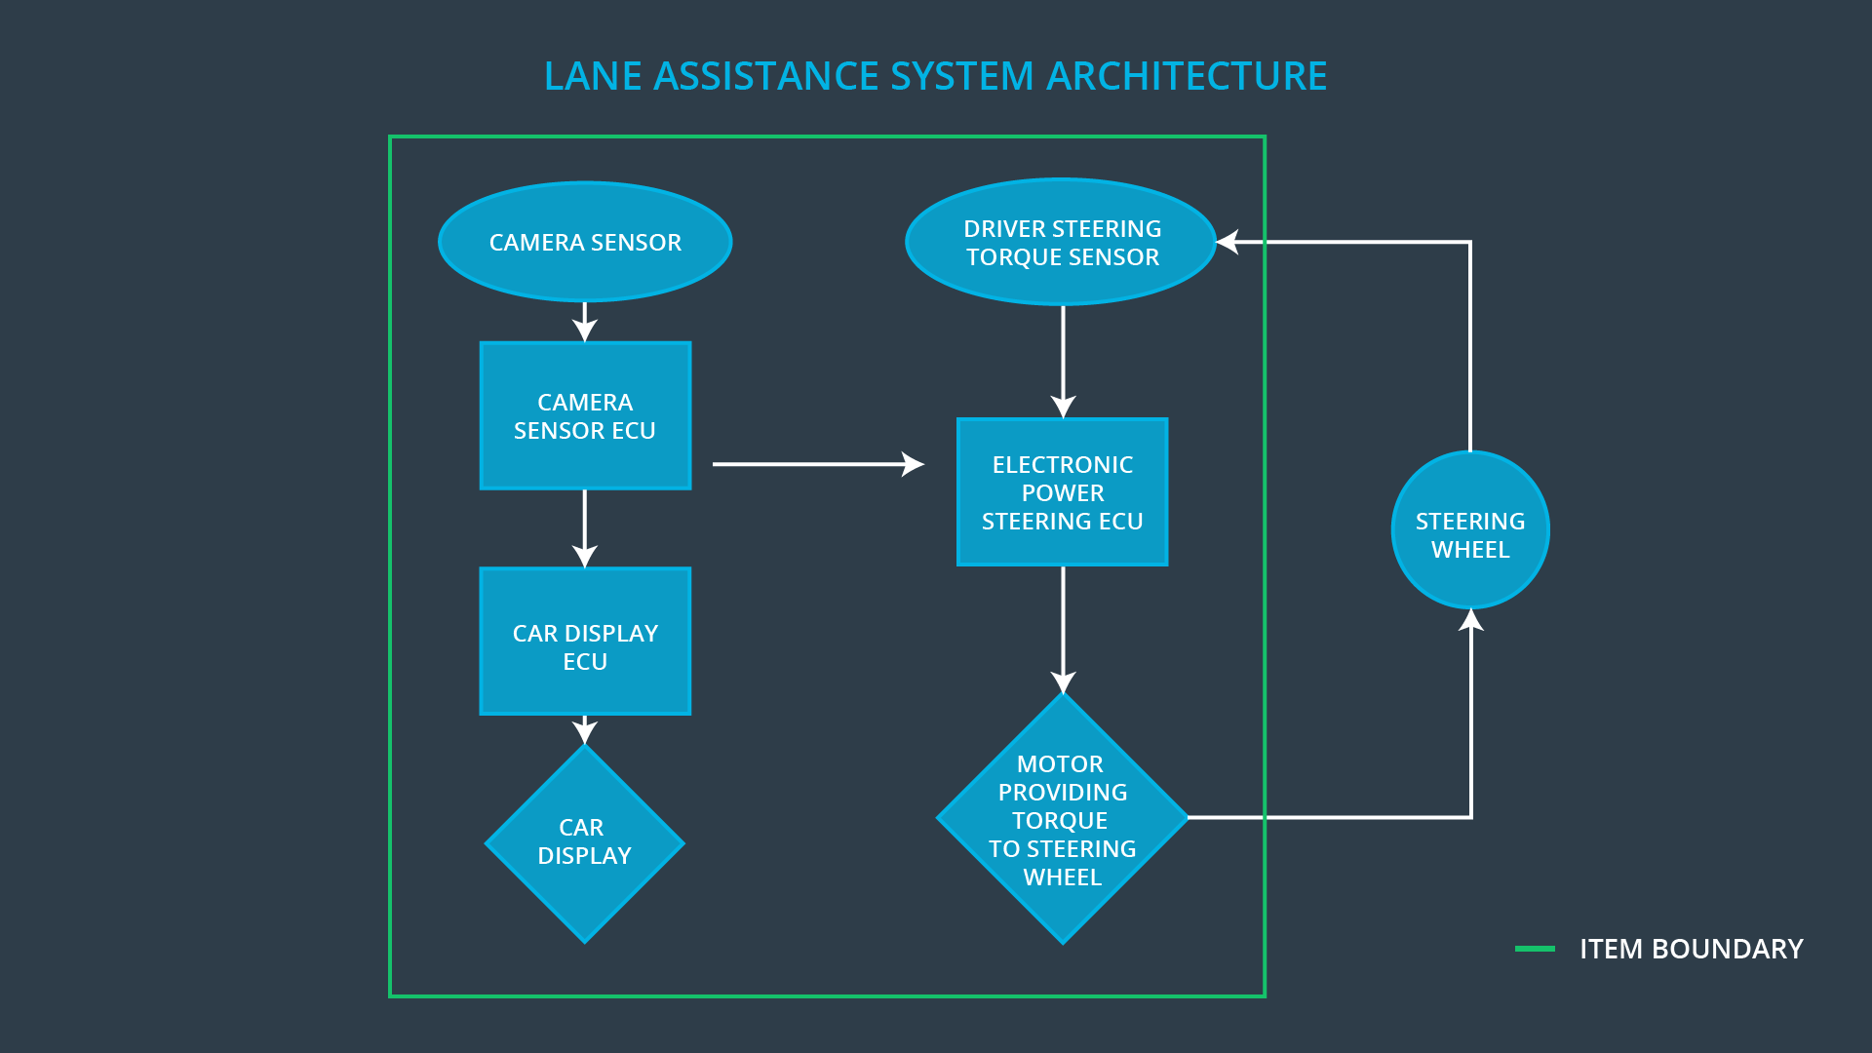

### Description of architecture elements

|  |  |
| --- | --- |
| **Element** | **Description** |
| Camera Sensor | Sensor responsible for capturing road images and provide them to the Camera Sensor ECU |
| Camera Sensor ECU | Electronic Control Unit (ECU) responsible for calculates the deviation from center lane and request for oscillation torque(LDW) |
| Car Display | Displays status of (active/inactive) LDW & LKA function. |
| Car Display ECU | Electronic Control Unit (ECU) responsible for displaying status of (active/inactive) LDW & LKA function on the Car Display. |
| Driver Steering Torque Sensor | Sensor responsible for measuring the torque applied on driver wheel |
| Electronic Power Steering ECU | Electronic Control Unit (ECU) responsible for calculating extra torque need to be applied for LKA function and vibrates steering wheel when LDW is activated. |
| Motor | An electric motor that applies the torque indicated by the Electronic Power Steering ECU to the steering wheel. |

# Functional Safety Concept

The functional safety concept consists of:

* Functional safety analysis
* Functional safety requirements
* Functional safety architecture
* Warning and degradation concept

## Functional Safety Analysis

|  |  |  |  |
| --- | --- | --- | --- |
| **Malfunction ID** | **Main Function of the Item Related to Safety Goal Violations** | **Guidewords (NO, WRONG, EARLY, LATE, MORE, LESS)** | **Resulting Malfunction** |
| Malfunction_01 | Lane Departure Warning (LDW) function shall apply an oscillating steering torque to provide the driver a haptic feedback | MORE | The Lane departure warning function applies an oscillating torque with very high torque amplitude. (above the limit) |
| Malfunction_02 | Lane Departure Warning (LDW) function shall apply an oscillating steering torque to provide the driver a haptic feedback | MORE | The lane departure warning function applies an oscillating torque with very high torque frequency (above limit) |
| Malfunction_03 | Lane Keeping Assistance (LKA) function shall apply the steering torque when active in order to stay in ego lane | NO | The lane keeping assistance function is not limited in time duration which leads to misuse as an autonomous driving function. |
| Malfunction_04 | Lane Keeping Assistance (LKA) function shall apply the steering torque when active in order to stay in ego lane | WRONG | The lane keeping assistance function is activated randomly when camera sensor is not working. |

## Functional Safety Requirements

Lane Departure Warning (LDW) Requirements:

|  |  |  |  |  |
| --- | --- | --- | --- | --- |
| **ID** | **Functional Safety Requirement** | **ASIL** | **Fault Tolerant Time Interval** | **Safe State** |
| Functional  Safety  Requirement  01-01 | The lane keeping item shall ensure that the lane departure oscillating torque amplitude is below Max_Torque_Amplitude. | C | 50 ms | Turn Off System |
| Functional  Safety  Requirement  01-02 | The lane keeping item shall ensure that the lane departure oscillating torque frequency is below Max_Torque_Frequency | C | 50 ms | Turn Off System |

Lane Departure Warning (LDW) Verification and Validation Acceptance Criteria:

|  |  |  |
| --- | --- | --- |
| **ID** | **Validation Acceptance**  **Criteria and Method** | **Verification Acceptance**  **Criteria and Method** |
| Functional  Safety  Requirement  01-01 | Validate that the Max_Torque_Amplitude chosen is low enough that the driver does not loss control over the car and high enough to be detected by driver. | Verify that the system does turn off within a fault tolerant time interval, if Max_Torque_Amplitude is exceeded. |
| Functional  Safety  Requirement  01-02 | Validate that the Max_Torque_Frequency chosen is low enough that the driver does not loss control over the car and high enough to be detected by driver. | Verify that the system does turn off within a fault tolerant time interval, if Max_Torque_Frequency is exceeded. |

Lane Keeping Assistance (LKA) Requirements:

|  |  |  |  |  |
| --- | --- | --- | --- | --- |
| **ID** | **Functional Safety Requirement** | **ASIL** | **Fault Tolerant Time Interval** | **Safe State** |
| Functional  Safety  Requirement  02-01 | The electronic power steering ECU shall ensure that the lane keeping assistance torque is applied for only Max_Duration | B | 500 ms | Turn Off System |
| Functional  Safety  Requirement  02-01 | The electronic power steering ECU shall be deactivated​ ​when​ ​the​ ​electronic​ ​power steering​ ​ECU​ ​detects​ ​the​ ​camera sensor​ ​is​ ​not​ ​working. | B | 50 ms | Turn Off System |

Lane Keeping Assistance (LKA) Verification and Validation Acceptance Criteria:

|  |  |  |
| --- | --- | --- |
| **ID** | **Validation Acceptance**  **Criteria and Method** | **Verification Acceptance**  **Criteria and Method** |
| Functional  Safety  Requirement  02-01 | Validate that the value chosen for Max_Duration dissuades drivers from taking their hands off the wheel. | Verify that the system does turn off within a fault tolerant time interval, if the lane keeping assistance ever exceeds Max_Duration |
| Functional  Safety  Requirement  02-02 | Validate​ ​that Lane​ ​Keeping assistance​ ​shall​ ​be​ ​deactivated when​ ​the​ ​camera​ ​sensor​ ​stop working. | Verify that the system does turn off within a fault tolerant time interval, if the camera sensor stopped working. |

## Refinement of the System Architecture

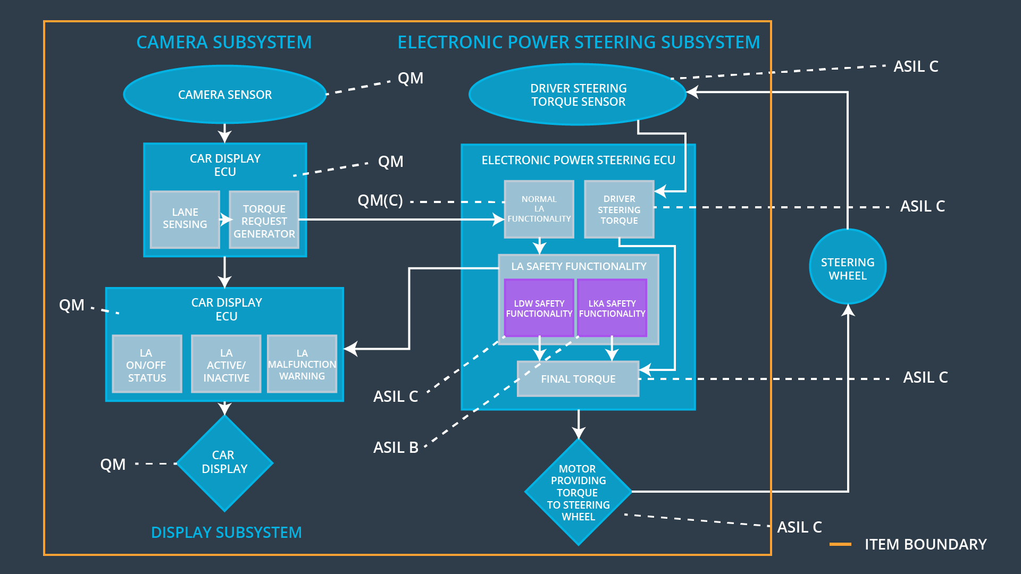

## Allocation of Functional Safety Requirements to Architecture Elements

|  |  |  |  |  |
| --- | --- | --- | --- | --- |
| **ID** | **Functional Safety Requirement** | **Electronic Power Steering ECU** | **Camera ECU** | **Car Display ECU** |
| Functional  Safety  Requirement  01-01 | The lane keeping item shall ensure that the lane departure oscillating torque amplitude is below Max_Torque_Amplitude. | **X** |  |  |
| Functional  Safety  Requirement  01-02 | The lane keeping item shall ensure that the lane departure oscillating torque frequency is below Max_Torque_Frequency | **X** |  |  |
| Functional  Safety  Requirement  02-01 | The electronic power steering ECU shall ensure that the lane keeping assistance torque is applied for only Max_Duration | **X** |  |  |
| Functional  Safety  Requirement  02-02 | The electronic power steering ECU shall be deactivated​ ​when​ ​the​ ​electronic​ ​power steering​ ​ECU​ ​detects​ ​the​ ​camera sensor​ ​is​ ​not​ ​working. | **X** |  |  |

## Warning and Degradation Concept

|  |  |  |  |  |
| --- | --- | --- | --- | --- |
| **ID** | **Degradation Mode** | **Trigger for Degradation Mode** | **Safe State invoked?** | **Driver Warning** |
| WDC-01 | Turn off LDW functionality | Malfunction_01,  Malfunction_02 | Yes | Turn on warning light of the LDW functionality |
| WDC-02 | Turn off LKA functionality | Malfunction_03,  Malfunction_04 | Yes | Turn on warning light of the LKA functionality |