

Low Level Design

**Admin Block Diagram :**

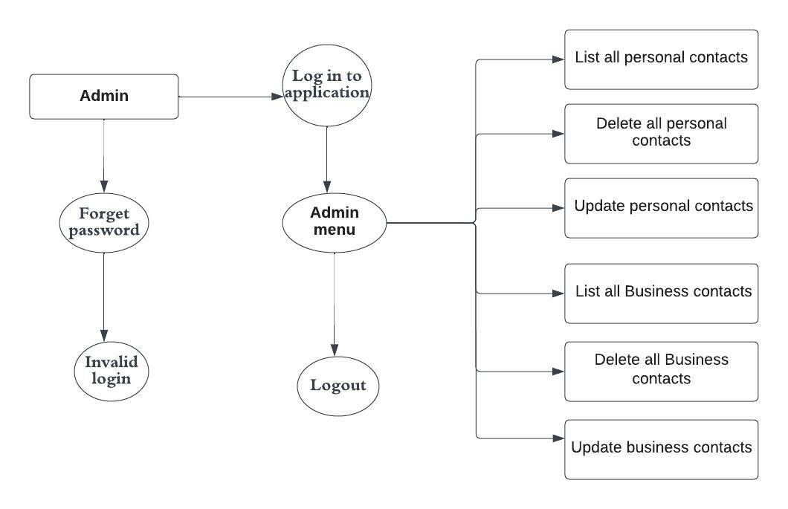

**Users Login:**

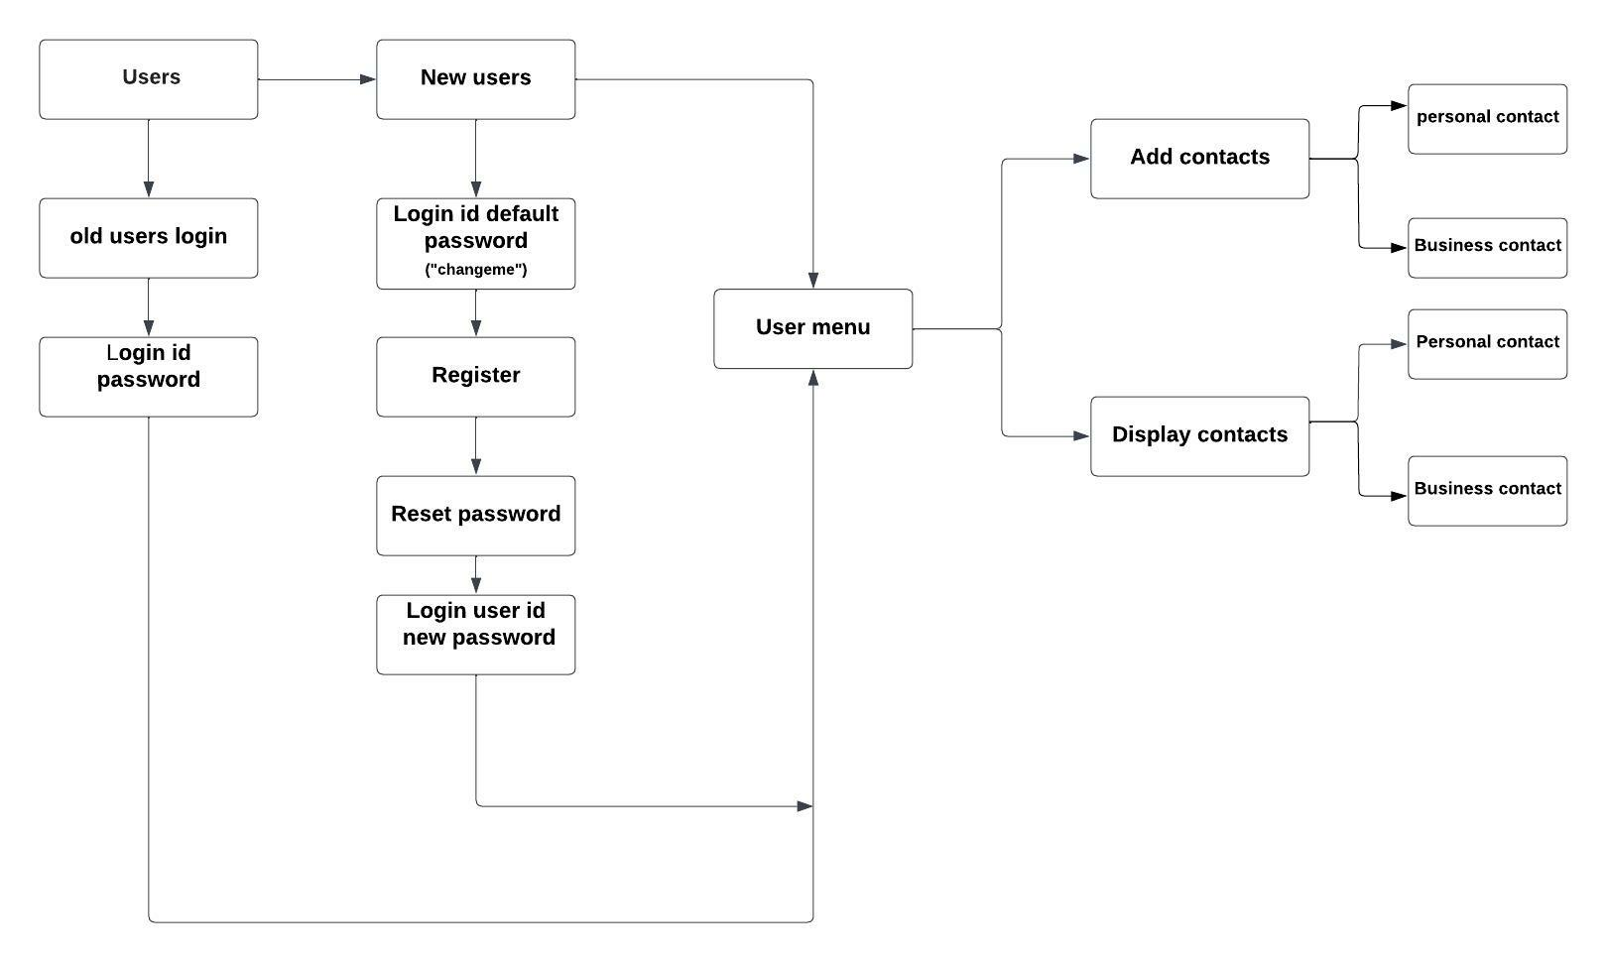

**Document Control :**

|  |  |  |  |  |  |  |  |  |  |  |  |  |  |  |  |  |
| --- | --- | --- | --- | --- | --- | --- | --- | --- | --- | --- | --- | --- | --- | --- | --- | --- |
|  | |  | |  | | |  | |  | |  | |  | |  | |
| Double Tree Hotel Billing | | | | | | | | | | | | | | | | |
| Guided by –  **Aliasger Mulla** | |  | |  | | |  | |  | |  | |  | |  | |
| **Date** | | **Version** | | **Author** | | **Brief Description of Changes** | | | | | | | **Approver Signature** | | | |
| 20-10-2022 | | 1.0 | | Pavithra,  Haritha,  Chaithanya,  Jyothipriya,  Manasa. | | User id, User login,  Admin login  Contact type,  Contact Details. | | | | | | |  | | | |
|  | |  | |  | |  | | | | | | |  | | | |
|  | |  | |  | |  | | | | | | |  | | | |

**Index**

1. Introduction ------------------------------------------------ 4

1.1 Intended audience ------------------------------------------------ 4

1.2 Project purpose ------------------------------------------------ 4

1.3 Key project objective ------------------------------------------------ 4

1.4 Project scope and limitation ------------------------------------------------ 4

1.5 Functional overview ------------------------------------------------ 4

1.5.1Header files ------------------------------------------------ 5

1.5.2 Functions ------------------------------------------------ 6

2. Design overview ------------------------------------------------ 6

2.1 Design objective ------------------------------------------------ 8

2.2 Design alternative ------------------------------------------------ 8

2.3 User interface paradigms ------------------------------------------------ 8

2.4 Error detection/ Exceptional Handling ------------------------------------------------ 8

2.5 Performance ------------------------------------------------ 8

2.6 Maintenance ------------------------------------------------ 8

3.. Detailed system design -----------------------------------------------10

4. Environment description ------------------------------------------------10

4.1 Time zone support ------------------------------------------------11

4.2 Language support ------------------------------------------------11

4.3 User desktop requirement ------------------------------------------------11

4.4 Server-side requirement ------------------------------------------------11

4.4.1Deployment consideration ----------------------------------------------- 11

4.4.2 Integration requirements ------------------------------------------------11 4.4.3Network -------------------------------------------------11

4.5 Configuration ------------------------------------------------11 4.5.1 Operating system ------------------------------------------------11

**1.Introduction: -**

* 1. **Intended Audience: -**

The document is intended to be read by, Client.

* 1. **Project Purpose: -**

The purpose of Contact Dictionary is to implement the dictionary of contacts in which we store the information of all personal and business contacts. It enables the user to add, update, delete and list all the personal and business contacts. This application includes name, mobile number, email id, contact id, date of birth, emergency contact, designation, company website. In this application we can store all attributes of all personal contacts and business contacts.

* 1. **Key Project Objectives: -**

1. Allow User for registrations
2. Allow users to login
3. Validates personal data (first name, last name, Phone Number1, Phone Number2 , Email id1, Email id2 & Emergency Contact number)
4. Allow admin to update, delete and List all the personal and business contacts.
5. Allow the user to add new contact, display contacts i.e., either personal or business contact.

**1.4 Project scope and limitation: -**

This Contact Dictionary focus on the development of an information system that will automate Exact contact details of user.

1. It will generate contact id for every new user after login into the application.
2. The software will display all the contact information either the contact is business contact or Personal contact.
3. For security and privacy of the management, the Contact Dictionary allows users containing contact id with correct user id and password for login into the application.
4. The system will store and recognize user login details.

**1.5 Functional Overview: -**

1.5.1 Following header files are included in the program:

1. #include <stdio.h>
2. #include <stdlib.h>
3. #include<string.h>
4. #include<struct.h>
5. #include<functions.h>
6. #include<macros.h>

1.5.2. Following functions are included in the program:

1. **Application process:** Insert the data to identify and manage the **contact** details by Registration, Admin login, user login, contact id, contact type
2. **Admin login:** The admin can login into the Contact by using the following information.

* Login id
* Password

1. **Admin menu:** By using the admin credentials admin can login into the Contact Dictionary. The below information that admin should follow

* List all personal contacts
* List all business contacts
* Delete personal contacts
* Update personal contacts
* Delete personal contacts
* Update business contacts

1. **User Registration:** The new user will login to Contact Dictionary by using username and default password “Changeme” after successful registration the user can change the password by using the following steps

* Reset password
* Give username and new password
* New password will update successfully.
* Otherwise, it will give invalid user.

1. **User login:**  After successful registration of the user, the users can login to the Contact Dictionary by using user id and password. The users can view the user menu as follows

* Add contact
* Display contact

1. **Add Contacts:** They are two types of contacts Personal contact & Business Contact.

**Personal Contact:**

The personal contact are as follows Contact id, First Name, Last Name, Phone Number1, WhatsApp number, Phone Number 2, Email id1, emailid2, Emergency Number & Address

**Business Contact:**

The Business contact are as follows Contact id, First Name, Last Name, Phone Number1, WhatsApp number, Phone Number 2, Email id1, emailid2, Emergency Number, Address, Company, Role/Designation

1. **Display Contact:** They are two types of contacts Personal contact & Business Contact.

**Personal Contact:**

The personal contact are as follows Contact id, First Name, Last Name, Phone Number1, WhatsApp number, Phone Number 2, Email id1, emailid2, Emergency Number & Address

**Business Contact:**

The Business contact are as follows Contact id, First Name, Last Name, Phone Number1, WhatsApp number, Phone Number 2, Email id1, emailid2, Emergency Number, Address, Company, Role/Designation.

1. **Maintenance file:** Application information like contact details of user can be maintained in text files

* **Admin.txt -** where the admin information is present.
* **User.txt** - where the user information is present.
* **BusinessContact.txt -** where all the user business contacts are present.
* **PersonalContact.txt -** where all the user personal contacts are present.

1. **Validations:** under validations we must be follow the instructions such as
2. In Contact Id we should consider only digits, if any other display appropriate message on the console.
3. The First Name and Last Name should be only in alphabets.
4. The Phone Number should be in 10 digits.
5. The Email Id should Comprises of Alpha numerical + @gmail.com.
6. The Contact should be only personal and Business Contact.
7. **Environment Description: -**

**2.1 Time Zone Support: -** IST

**2.2 Language Support: -** English

**2.3 User Desktop Requirements: -**

a. 64-bit processor, 1 GHz or faster

b. At least 2 GB free hard drive space

c. At least 1 GB RAM

**2.4 Server-Side Requirements: -**

1. 32 64-bit processor, 1 GHz or faster
2. At least 1 GB free hard drive space
3. At least 1GB RAM

4.4.1. Deployment Considerations: -

System is easy to deploy

4.4.2. Integration Requirements: -

a. Language: - C

b. Tools: - Valgrind, Makefile, Ctags

c. Complier: - gcc, vi, editor

d. Linux Environment

4.4.3. Network: - End to End

**4.5 Configuration: -**

4.4.1. Operating System: - Linux environment