# Linear Regression

**Tasks**:

1. Create at least two simple linear regression models, each of them has one different independent variable (you may transform the raw independent variable into different formats, such as to conduct a logarithmic transformation or combine two variables into a new variable such as Size = width * height). You may consider one variable as Size, and another one as Width. Create a scatter plot for showing the relationship between the independent variable and the dependent variable for each model, and also showing the linear regression line in the same plot. Calculate the error of the prediction with test data.

Importing required packages

Importing given data set using pandas packages and saving it in data frame

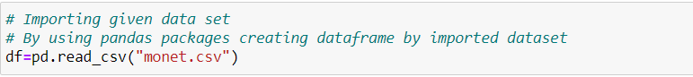

Checking whether given data frame has any null values or not

Creating a new column using given columns in the dataset

Getting top five rows from the given data set

Getting bottom five rows from tail in data frame

**Regression plot for Size and Price :**

Creating a regression plot for a dependent variable (Price) and independent variable(Size) by using seaborn package. The confidence interval is none. Here x-axis is Size and y-axis is Price.

By using sklearn package and importing train_test_split so that we use 80% of the given data for training and 20% for testing.

Using sklearn packages and by importing r2_score and mean_squared_error functions we are calculating the co-efficient of determined prediction

Getting coefficient of the linear regression model and error values of the data. Creating a scatter plot using test data with dependent and independent variables.

Calculating root mean square error

**Problem 2**

Creating a regression plot monet data for columns price and height, dependent and independent variables.

**Multi Linear Regression**

Creating corr for the data and dummy values for the signed column, creating new data with new values which were binary values.

The new data split into 80% for the test data and 20% for the train data, for the predicted values.

The price as independent and ["SIGNED","PICTURE","SIZE","SIGNED_0","SIGNED_1"]

Dependent variable.

The score values and the error values of the data.

