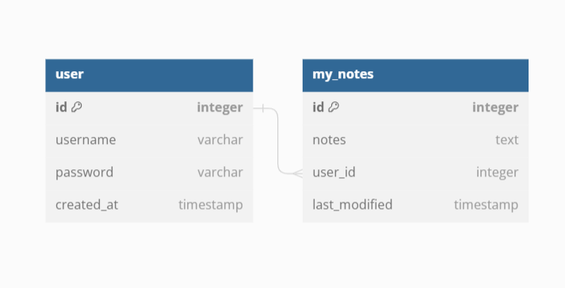

Frontend -🡪 to install node packages ---- run

npm install

Backend -🡪 to install python libs ---- run

pip install -r requirements.txt

Run below commands if connecting to a new database

python manage.py makemigrations

python manage.py migrate

To bring frontend and backend services up, run the following commands

Frontend – npm start

Backend – python manage.py runserver