Financial Distress Predictor
Project Report

Content:
1.Business Problem...........................................................1
2.Data Description............................................................2
3.Data Exploration............................................................5
3.1 Missing Value Exploration...................................5
3.2 Distribution...........................................................5
3.3 Relation between Response and
Predictor Variables...............................................6
4. Data Pre-Processing....................................................8
4.1 Data Cleansing.....................................................8
4.2 Data Reduction..........................................................9
4.2.1 Dimension Reduction........................................9
4.2.2 Row Reduction/ Sampling................................11
5. Modeling Techniques.................................................12
6. Model Assessment..............................................13
7. Business Value...........................................................18
Figures:
Fig.1 Data Dictionary..........................................................5
Fig.2. Missing Values Report...............................................5
Fig.3. Missing Values Pattern.............................................5
Fig.4. Distribution..............................................................6
Fig.5. Revolving Utilization Vs SeriousDelinquencies2yrs7
Fig.6. Credit History Vs. SeriousDlqin2yrs.......................8

Fig.7. Principal Component Analysis................................10

Fig.8. Correlation Matrix..................................................10

Fig.9. Principal Components, Eigen Vectors, Scree Plot...11

Fig.10. Models with Misclassification Rates.....................13

Fig11. ROC Curve for Decision Tree................................14

Fig.12. Confusion Matrix for Decision Trees....................15

Fig.13. Decision Matrix....................................................17

Fig.14. Small Tree View of Final Model..........................17

Fig.15. Decision Tree model - ROC curve.......................18

Fig.16. Decision Tree model - Column Contribution report...19

Fig.17. Decision Tree model - Leaf Report.......................20

- Business Problem:
Background:
Banks generally validate the financial strength of the customer using different methods like:
Credit and Finance Risk Predictive Modelling & Management
Credit Risk Analysis and Modelling
Credit Risk Scoring
The analysis is important for the financial institutions for decision making. They rely on the results from different models to grant loans and estimate the scope of business that can be established with a customer.
Problem statement:
Existing models consider factors like income, credit history, payment history to calculate the credit score. There is not much focus on the aspect of customers being delinquent of not paying back the loan.
In the “Financial Distress predictor”, the probability of a customer being delinquent (not paying back the loan) is predicted, depending on which banks can take a decision of granting or not granting the loan.
Project Approach:
The data is broad for this scenario. It includes information from third parties, internal database of banks. The dataset used for implementing the model is taken from kaggle. SEMMA approach is followed in implementing the project.
Executive summary: The data is explored, cleansed, reduced and transformed before building the model. Different models are built on the data and the misclassification rates are compared. Cost analysis is used for assessment of the models.
Some interesting Points:
Predictors with high influence on response variable: Revolving Utilization
The age variable is binned, as a part of data exploration.
Out of all the models, Decision tree and bootstrap forest had lowest misclassification rates.
Decision tree is chosen, because of its simplicity and ease for implementation.
- Data Description:
From the applicant’s background the following information is usually collected: age, gender, income, number of dependents, etc. And then the following questions from applicants credit history are especially interesting: ”Has the applicant already a credit?”, How much did he borrow?, Has the applicant ever delayed his payment?, If so, how many days late?, Does he ask for another credit as well?, etc. The variables entering the model should be chosen carefully, as the amount of the data may be vast indeed and thus computationally problematic. The dataset has about 150k consumer’s information from the bank. The response variable of interest which would be predicted with the model is "Serious Delinquencies in 2 years". This is a dichotomic variable with values 0 meaning creditworthy and 1 meaning not creditworthy. We have 10 variables in the dataset which would help predict the response.
Variable Name | Description | Type
SeriousDlqin2yrs | Person experienced 90 days past due delinquency or worse | Y/N
RevolvingUtilizationOfUnsecuredLines | Total balance on credit cards and personal lines of credit except real estate and no installment debt like car loans divided by the sum of credit limits | percentage
Age | Age of borrower in years | integer
NumberOfTime30-59DaysPastDueNotWorse | Number of times borrower has been 30-59 days past due but no  worse in the last 2 years. | integer
DebtRatio | Monthly debt payments, alimony, living costs divided by monthy gross income | percentage
MonthlyIncome | Monthly income | real
NumberOfOpenCreditLinesAndLoans | Number of Open loans (installment like car loan or mortgage) and Lines of credit (e.g. credit cards) | integer
NumberOfTimes90DaysLate | Number of times borrower has been 90 days or more past due. | integer
NumberRealEstateLoansOrLines | Number of mortgage and real estate loans including home equity  lines of credit | integer
NumberOfTime60-89DaysPastDueNotWorse | Number of times borrower has been 60-89 days past due but no worse in the last 2 years. | integer
NumberOfDependents | Number of dependents in family excluding themselves (spouse, children etc.) | integer
Fig.1 Data Dictionary
- Data Exploration:
This was the first step in our data analysis wherein we understood and described the data using various visualizations and summary tables. We looked for patterns, trends, similarities, and outliers in the dataset thereby extracting knowledge from the data. Also,
  - Missing Value Exploration:
Missing values are a common occurrence in most of the datasets as not always we have complete information of all variables for a record. This is evident in our dataset as well, with missing values in two of the variables: Monthly Income and Number of Dependents. From figure 3, we observe that whenever Number of Dependents is missing, we have missing values in Monthly income too. About 1/6th of the dataset has missing values in Monthly income and as this is a considerable amount of data, it would be discussed further in Data Pre-Processing section.
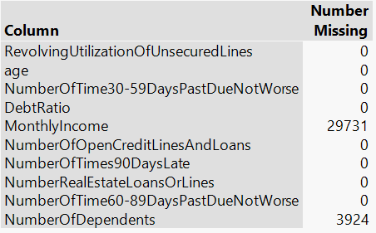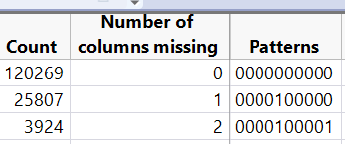
Fig.2. Missing Values Report Fig.3. Missing Values Pattern

  - Distribution:
With the distribution plot below, we observed that Revolving Utilization Of Unsecured Lines variable has values greater than 1 which is ideally not possible as it is by definition, percentage of balance left on credit lines. And, the variables Monthly Income and Debt Ratio have outliers as seen in the outlier box plots in fig.4.
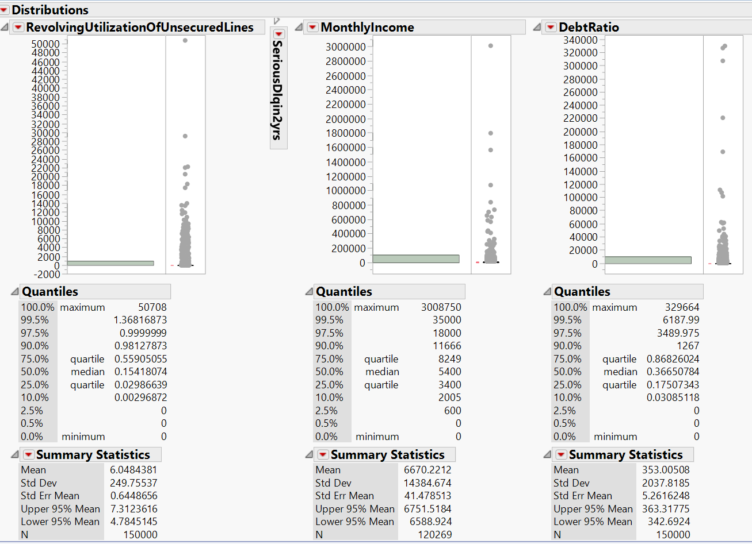
Fig.4. Distribution

  - Relation between Response and Predictor Variables:
We visualized the response variable SeriousDlqin2yrs against different predictor variables to understand the relationship and their role in interpreting a delinquency. From the graph in fig.5. we understand that the lesser the revolving utilization of Unsecured Lines, the higher are the chances for the customer to be creditworthy or non-delinquent. So, a customer who has less % of his credit limit utilized is considered more creditworthy.
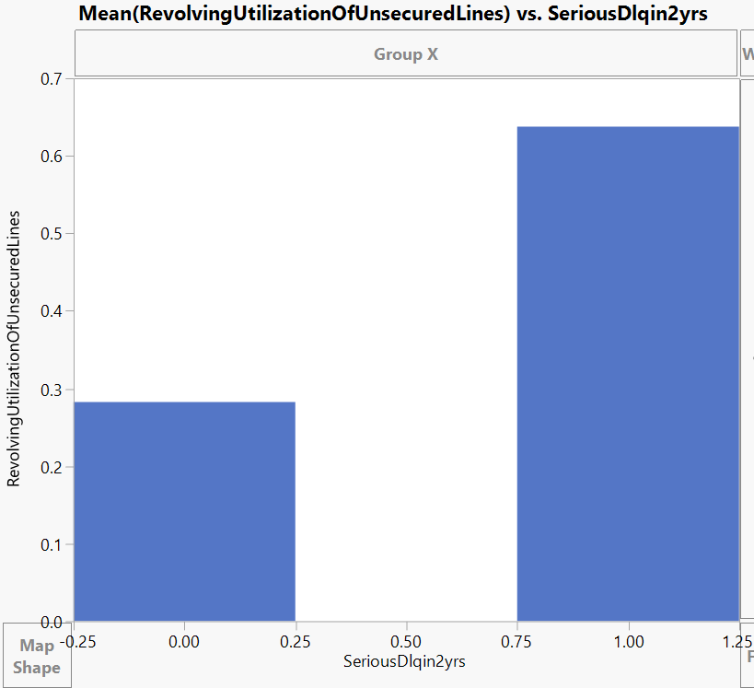
Fig.5. Revolving Utilization Vs SeriousDelinquencies2yrs

We also observed significant relationship between the response variable and the predictors: number of times 30-59 days past due date, number of times 30-59 days past due date, number of times 90 days late, all these represent the number of times a customer failed to pay 30-90 days or more past the due date. The graph in fig.6. shows that these three predictor variables have higher values when the customer is at default or SeriousDelinquencies2yrs=1.
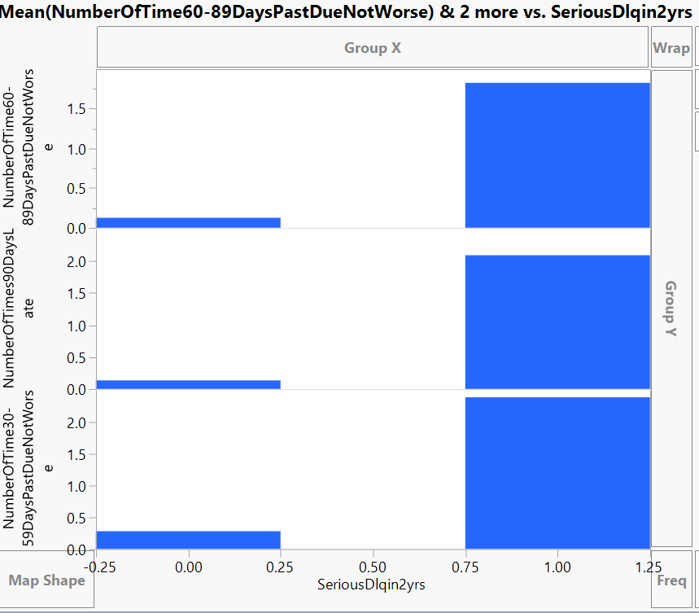
Fig.6. Credit History Vs. SeriousDlqin2yrs

4. Data Pre-Processing
  - Data Cleansing:
After exploring the data, we noticed that there are a few inconsistencies, missing values and outliers within the data which need to be cleansed for an efficient model to be developed. The following steps have been performed to cleanse the data:
- We changed the Modelling type of response variable “SeriousDlqin2yrs” to Nominal from Continuous as it is a dichotomous variable.
- To fix the inconsistencies in variable Revolving Utilization Of Unsecured Lines, we excluded all rows where this variable’s value is greater than 1.
- To fix the missing values in the variable “NumberOfDependents”, we excluded rows with missing values in this variable as it was a very small fraction of the complete dataset.
- We created bins for the variable “Age” and a new column called Age_Category was created ranging from 0 (0-10 years) to 9 (100-110 years).
- To fix the missing values in variable “MonthlyIncome”, we imputed monthly income using median of the MonthlyIncome in its’ corresponding Age_Category. This approach was implemented considering the fact that Age_Category had a consequential impact on “MonthlyIncome”.
- We fixed the outliers in the variable “DebtRatio” (threshold being 295) by setting all the outlier values greater than threshold value to 295.
- In order to fix the outliers in the variable “MonthlyIncome” which are greater than $200k, we excluded them from the dataset.

  - Data Reduction:
The second step in our data cleansing activity is data reduction. We performed this in terms of both dimension and rows.
    - Dimension Reduction:
Too many variables make a model complex and would not work well on new data sets. To overcome this issue, Principal Component Analysis comes handy. It reduces a set of numerical variables by removing the overlap of information between these variables and transforms them into a smaller number of numerical variables that contain most of the information. These new variables are called Principal Components. The fig.7. best explains this method pictorially.
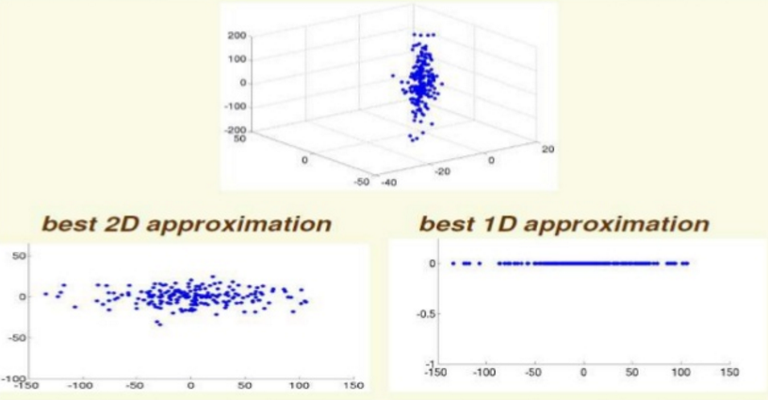
Fig.7. Principal Component Analysis
The first step to perform Principal Component Analysis is to identify the correlated variables. We performed multivariate analysis and identified three highly correlated variables: number of times 30-59 days past due date, number of times 30-59 days past due date, number of times 90 days late. As seen in the correlation matrix below in fig.8, these three variables have high values of correlation coefficients which implies that these carry almost same or redundant information.
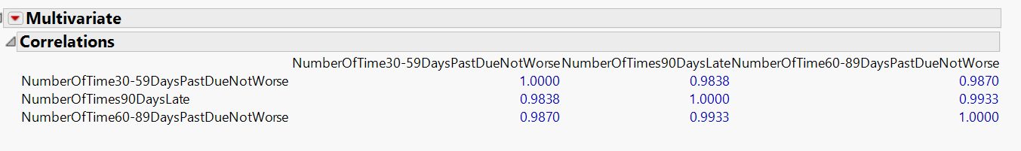
Fig.8. Correlation Matrix
Then, upon running Principal Component Analysis on Correlations for these three variables, we get three Principal components along with their Eigen values and percent of variance they define as shown in fig.9. The first Principal component explains 99.204% of variance, the second explains 0.583% and the third explains 0.213%. Using the “Proportion of Variance Explained Criterion”, we specify that about 99% of variability is kept and hence select only one Principal Component as the first component explains 99.204% of variability.
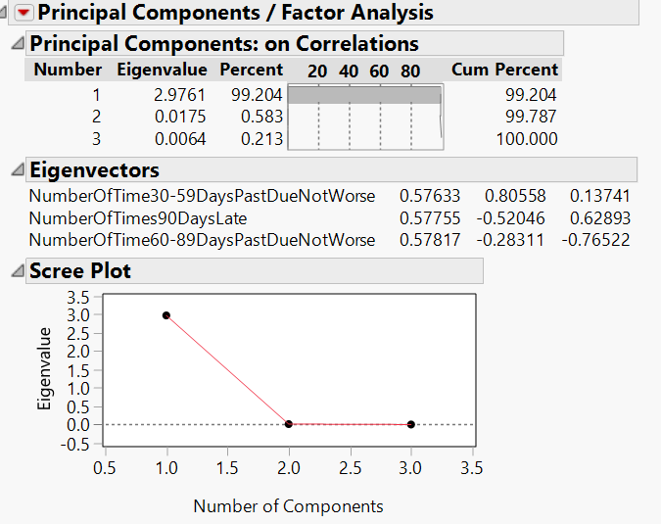
Fig.9. Principal Components, Eigen Vectors, Scree Plot
    - Row Reduction/ Sampling:
When variables of interest are too infrequent or rare in the data set, sampling on the variable’s focal group helps in building unbiased models. In our dataset, we have only 1/15th of data with delinquencies or SeriousDlqin2yrs =1. So, the delinquent class is the rare group in the dataset and should be stratified while sampling.
We sampled the dataset with 0.6, 0.5, 0.4 proportions in training, validation and test respectively and 0.50 proportion of focal group “SeriousDlqin2yrs” =1 in the resulting dataset.

5. Modeling Techniques:
Once the data was ready to be modelled, we have run several classification models to predict the outcome variable ‘SeriousDlqin2yrs’. It is a categorical predictor variable as below:
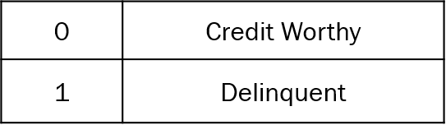
The project focused on the predictive power of the model based on the Delinquent category because the cost involved with misclassification of this category is very high. As the outcome variable is a categorical variable we had below modeling techniques to choose from:
1) Nominal Logistic
2) Bootstrap Forest
3) Decision Tree
4) Boosted Tree
5) Neural Net
The metric for initial model selection was primarily the misclassification rate of the rare class “SeriousDlqin2yrs”=1 and also the overall Misclassification Rate. These misclassification rates were evaluated using the confusion matrix generated in each of the models. Based on the chosen prediction metric, the two best models that were selected are “Decision Tree” with 10 splits and “Bootstrap forest”. These models gave the minimum misclassification rate for the rare class i.e. we could accurately predict the delinquency or customers at default.

Model | Overall Misclassification Rate |  |  | Misclassification Rate for SeriousDlqin2yrs = 1
Model | Training | Validation | Test | Training | Validation | Test
Nominal Logistic | 0.2503 | 0.2400 | 0.2383 | 0.2684 | 0.2781 | 0.2816
Decisison Tree with 10 | 0.2343 | 0.2672 | 0.2685 | 0.2053 | 0.2115 | 0.2196
Decisison Tree with 16 splits | 0.2342 | 0.1663 | 0.1673 | 0.3228 | 0.3239 | 0.3424
Decisison Tree with 20 splits | 0.2340 | 0.1667 | 0.1676 | 0.3221 | 0.3239 | 0.3413
Bootstrap Forest | 0.2192 | 0.2349 | 0.2352 | 0.2149 | 0.2306 | 0.2196
Boosted Tree | 0.2277 | 0.1764 | 0.1757 | 0.2952 | 0.3053 | 0.3030
Neural Net with 1 Layer 8 Nodes & TanH function | 0.4980 | 0.0615 | 0.0163 | 0.9960 | 0.9960 | 0.9920
Neural Net with 1 Layer 5 Nodes & TanH function | 0.4976 | 0.0602 | 0.0605 | 0.9930 | 0.9880 | 0.9910
Neural Net with 1 Layer 3 Nodes & TanH function | 0.5000 | 0.0604 | 0.0604 | 1.0000 | 1.0000 | 1.0000
Fig.10. Models with Misclassification Rates
6.Model Assessment:
We used various measures for model assessment to final choose the best model for predicting the outcome variable.
- Receiver Operator Curve (ROC)
It illustrates the performance of a Binary Classifier system as its discrimination threshold is varied on the curve. The curve is created by plotting the true positive rate (TPR) against the false positive rate (FPR) at various threshold settings. The true-positive rate is also known as sensitivity, recall or probability of detection [1] in machine learning. The false-positive rate is also known as probability of false alarm [1] and can be calculated as (1 − specificity).

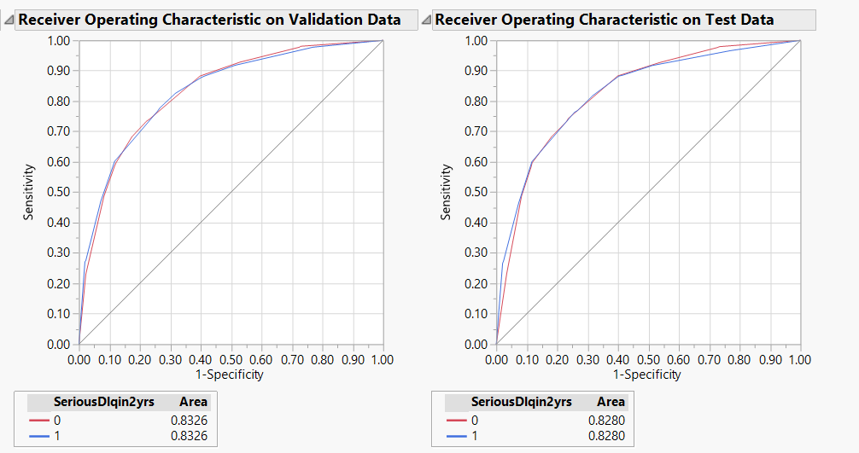
Fig11. ROC Curve for Decision Tree

An area under the curve(AUC) suggests the predictive power of the model.
The below table illustrates it:
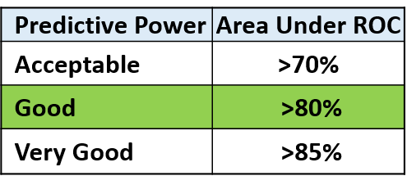
An AUC of >80% suggests a good model and our decision tree gives a AUC of 82.8%. Hence can be classified as a good model.
- Confusion Matrix
We can derive various statistics from the confusion matrix to compute predictive power of our
model such as:
1) Sensitivity
2) Specificity
3) PV+
4) PV-
For Decision Tree Model:
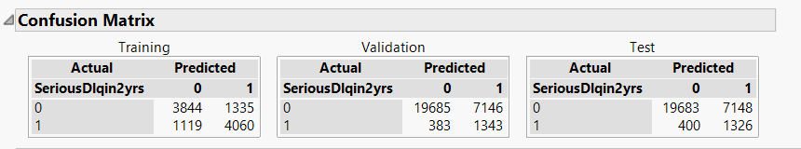
Fig.12. Confusion Matrix for Decision Trees
Measures on Test:
Sensitivity: 19683 / (19683+7148) = 0.734
Specificity: 1326 / (1326+400) = 0.77
We can see that the model has good sensitivity and specificity ranges.
Misclassification Rate of 1(Delinquent):400/400+1326 = 0.23 or 23%
We will further see that by using the profit matrix we can reduce the misclassification rate further.
- Profit Matrix
The profit matrix allows us to specify expected profit or costs associated with
correct or incorrect classification decisions.
It can be utilized for :
- We use the profit matrix to help our model to make better decisions
- We can compare different models using the profit matrix.
To create a profit matrix we took the following assumptions:
1) Interest rates sourced from Wells Fargo Bank
2) All loans are fixed housing loans of amount of $100,000
3) When a customer defaults the complete loan amount is defaulted
4) Rate of interesr is at 4.95 % and loan duration is set at 5 years for all customers
Calculations:
P=$100,000
R=5.95%
N=5 Years
For a True positive we gain the interest for the loan amount given .
Interest= (P(1+R/100)^N)-P
= $33,822
For a False positive the company looses out on the complete amount i.e P therby a loss of $P.
Cost=-$100,000
For a False Negative and True Negative we are classifying them as a Deliquent customer and hence no cost is associated as no loan is given out in these scenarios.
We might in business scenario have actual opportunity cost associated with it as given.
We translate the above calculation to simple ratio and use it on the profit matrix as below:

Specified Profit Matrix
Actual | Decision
Actual | 0 | 1
0 | 0.34 | 0
1 | -1 | 0

By specifying the profit matrix we can train our model better. Below are the results when the profit matrix is specified:
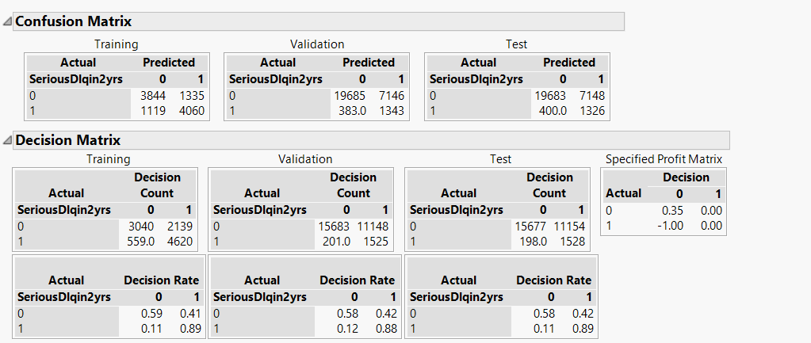
Fig.13. Decision Matrix

We can see there is a trade-off between the over misclassification rate and misclassification rate of 1 when we specify the profit matrix. The Misclassification Rate of 1(Delinquent) is greatly reduced by using the profit matrix
Misclassification Rate of 1:
198/198+1528 = 0.11 or 11%
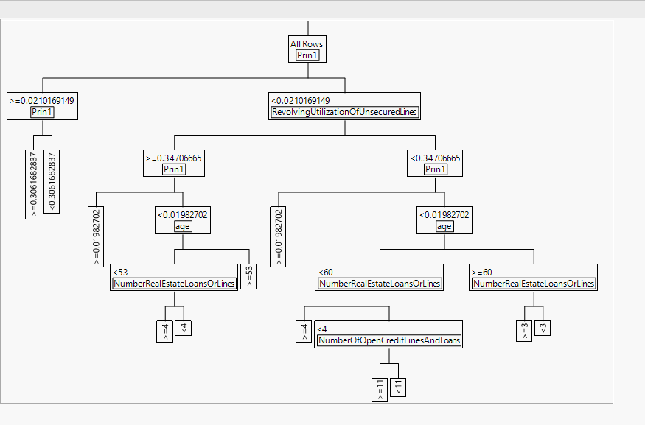
Fig.14. Small Tree View of Final Model
We choose Decision Tree as our final model for the predictions. It has good prediction power and other advantages as listed below.
Advantages of Decision Tree Model:
1) Easy to interpret
2) Main contributors easily identified from the leaf report
7.Business Value:
Our Decision Tree model does add value to the business, because it provides following advantages. First, the ROC curve of the model shows that the area under the curve (AUC) is 0.8446, which is close to 1 and much better than the naive rule with an AUC of 0.5. Obviously, our model can better distinguish the delinquent customers from the non-delinquent ones than the baseline model does.

Fig.15. Decision Tree model - ROC curve

Second, the Decision Tree model is easier to understand for both technical and business people. The Tree graph intuitively shows all split groups and split criteria, while the Column Contribution report demonstrates the importance of all predictors.

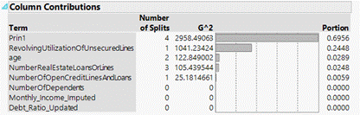
Fig.16. Decision Tree model - Column Contribution report

Third, with a few predictors, the bank can determine whether a customer is in good shape. As shown in the Column Contribution report, there are four most important contributors to delinquent cases: the principal component of the number of times the customer was delinquent in the past (“Prin1”), the revolving utilization rate (“RevolvingUtilizationOfUnsecureLines”), customer’s age (“age”), and the number of real estate loan or lines the customer has (“NumberRealEstateLoanOrLines”). Among them, the principal component is the biggest contributor with 69.56% contribution, followed by the revolving utilization rate (24.48%), the age (2.89%) and the number of real estate loan or lines (2.48%).

The Leaf Report below implies the critical values of these four predictors. For example, if the value of the principal component is greater than 0.02, the customer will have over 82% chance to default on a loan in the future. Similarly, if the customer is younger than 53 and has a revolving utilization rate above 0.3 and more than 4 real estate loans or lines, this customer is also dangerous and should be paid close attention to.

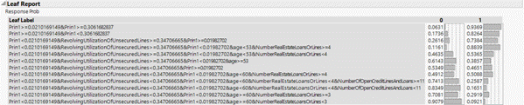
Fig.17. Decision Tree model - Leaf Report

The model could be used for different purposes. When a new customer applies for a loan, with the given measures, the lender can examine the probability that this borrower would be delinquent and determine whether to grant loan to him, reducing potential risk and staying on the safe side. For existing customers, the model can help predict their financial health status with existing credit history, allowing the bank to monitor its portfolio, identify future risk, contain the risk as early as possible, and maintain the sustainability of its business.
In conclusion, the model provides great accuracy in classifying delinquent customers. However, the gathered dataset exhibits limited information about customer characteristics. We believe the model would be further improved if additional information, such as customer’s gender, loan amount, and length of credit history, would be available.

