UNIT-1: HTML5 AND WEB PAGE STRUCTURE
Tutorial Task 1: Create My First Web Page
Problem Statement: Create a simple HTML webpage that displays a welcome message and demonstrates the basic structure of an HTML document.
Output:
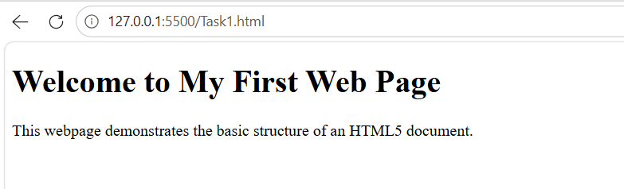

Tutorial Task 2: Personal Profile Page
Problem Statement: Develop an HTML webpage displaying personal details including name, photograph, educational qualifications, hobbies, and contact information.
Output:
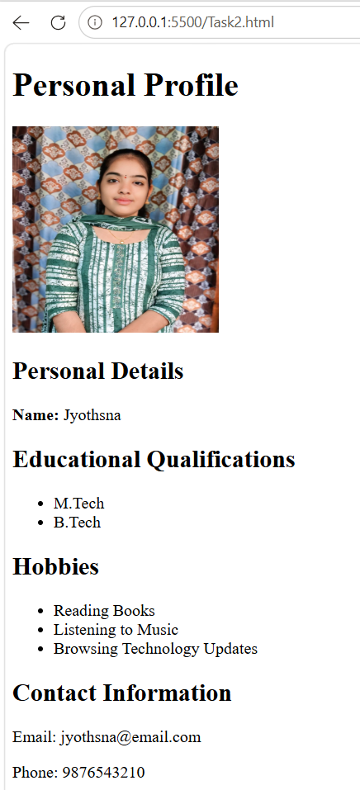

Tutorial Task 3: Text Formatting Demonstration
Problem Statement: Create a webpage demonstrating the use of headings, paragraphs, bold, italic, underline, superscript, and subscript tags.
Output:
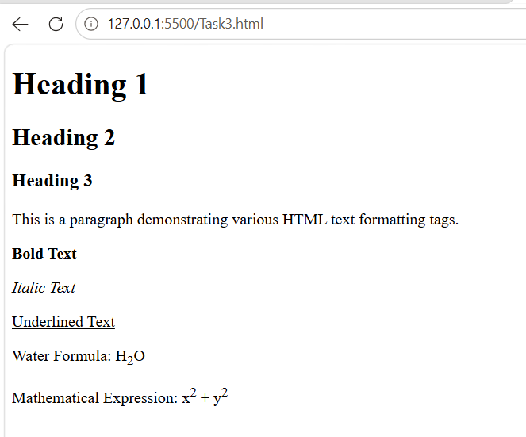

Tutorial Task 4: Hyperlink Navigation Page
Problem Statement: Develop a webpage containing internal and external hyperlinks for navigating between pages and websites.
Output:
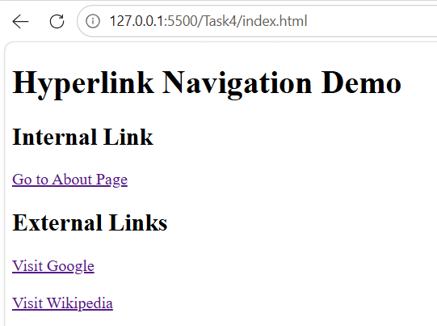
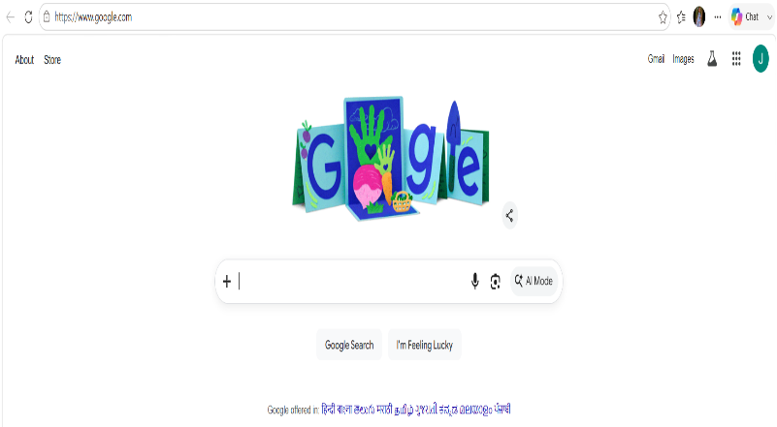
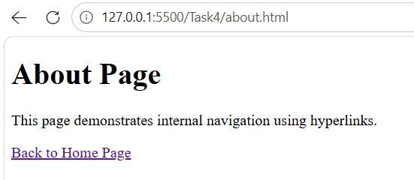

Tutorial Task 5: Ordered and Unordered Lists
Problem Statement: Create a webpage demonstrating ordered lists, unordered lists, and nested lists for organizing information.
Output:
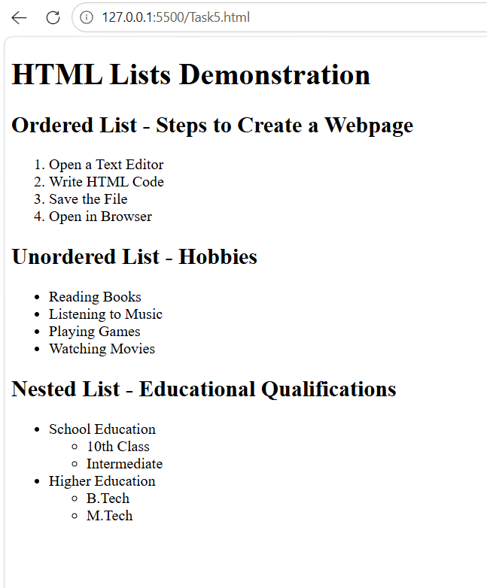
Tutorial Task 6: Image Gallery Page
Problem Statement: Design a webpage displaying multiple images with captions and alternative text descriptions.
Output:
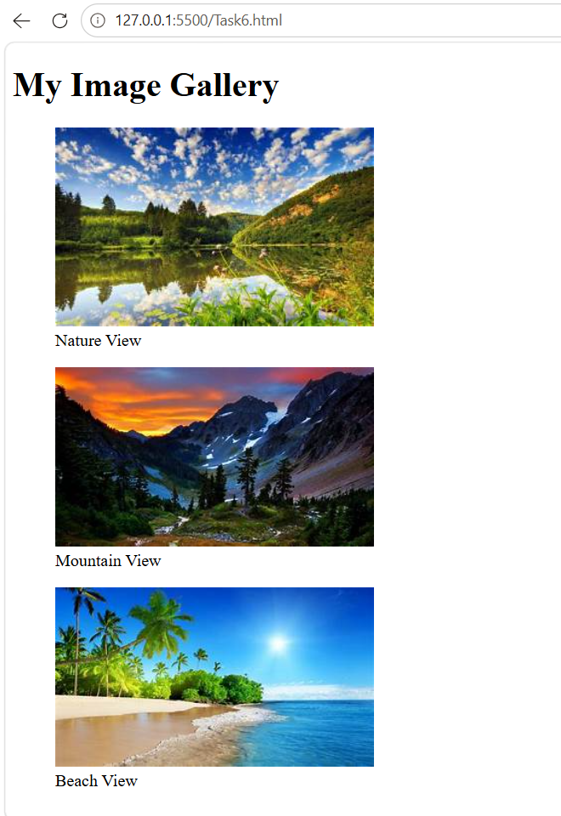

Tutorial Task 7: College Information Page
Problem Statement: Create a webpage presenting information about a college including vision, mission, departments, and facilities.
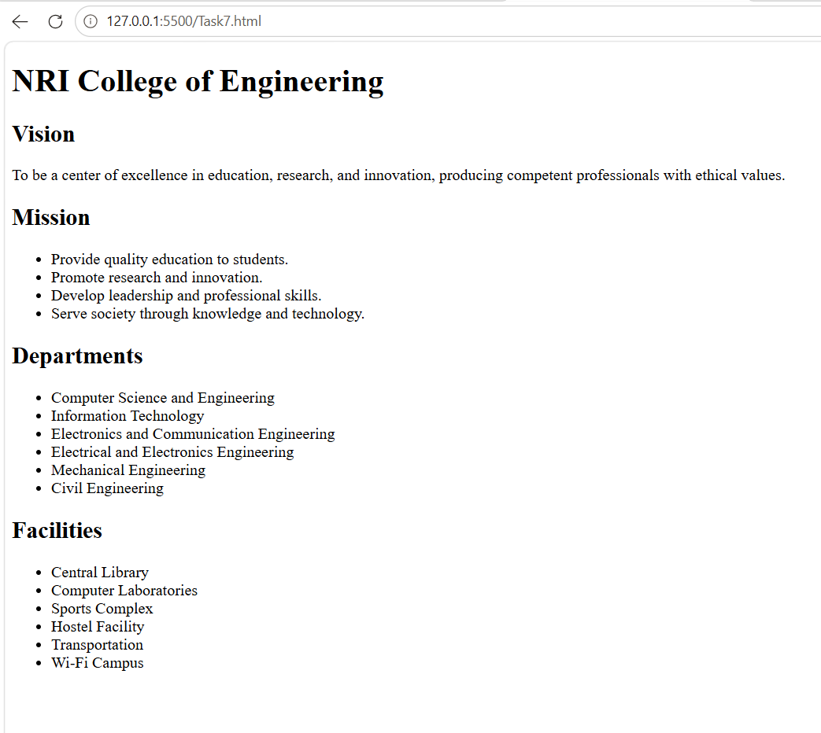
Output:

Tutorial Task 8: Department Profile Page
Problem Statement: Develop a webpage describing a department, faculty members, laboratories, and academic programs.
Output:
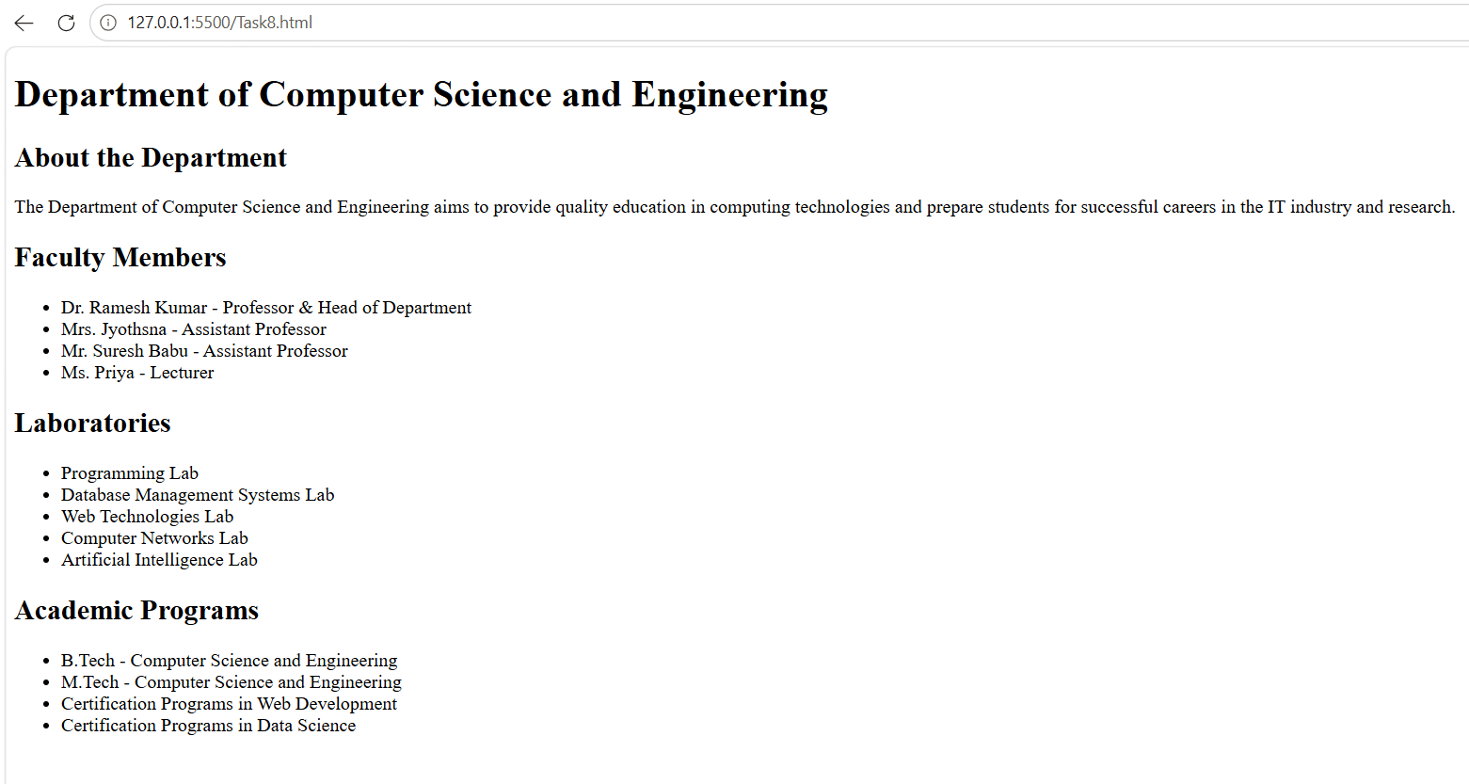
Tutorial Task 9: Student Biodata Page
Problem Statement: Create a webpage presenting a student's academic and personal information in a structured format.
Output:
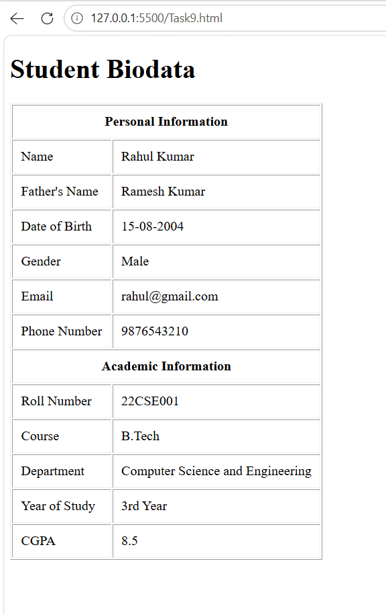

Tutorial Task 10: Resume Web Page
Problem Statement: Design a professional resume webpage containing educational qualifications, technical skills, projects, and achievements.
Output:
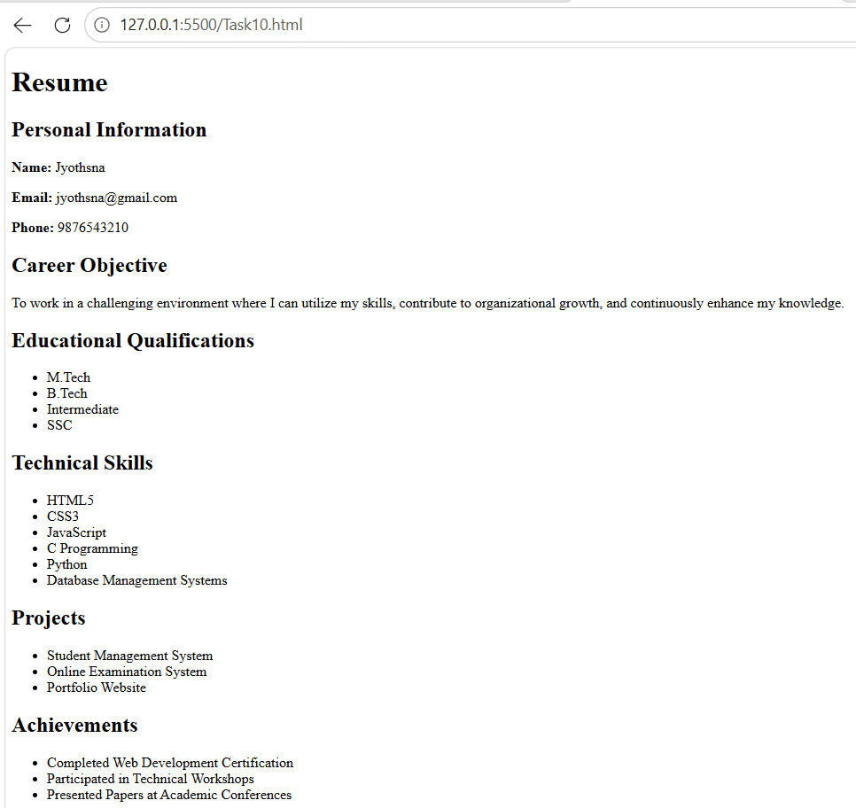
Tutorial Task 11: Student Timetable using Tables
Problem Statement: Create a timetable webpage using HTML tables to represent weekly academic schedules.
Output:
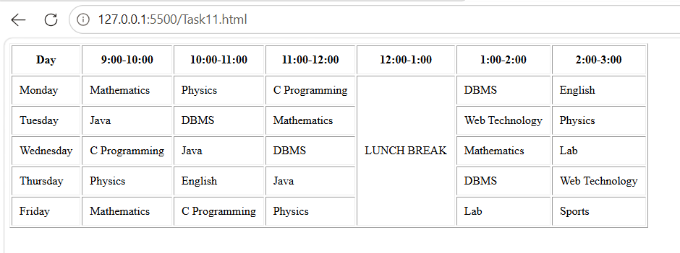
Tutorial Task 12: Student Marks Sheet
Problem Statement: Develop a webpage displaying marks obtained in different subjects using table structures.
Output:
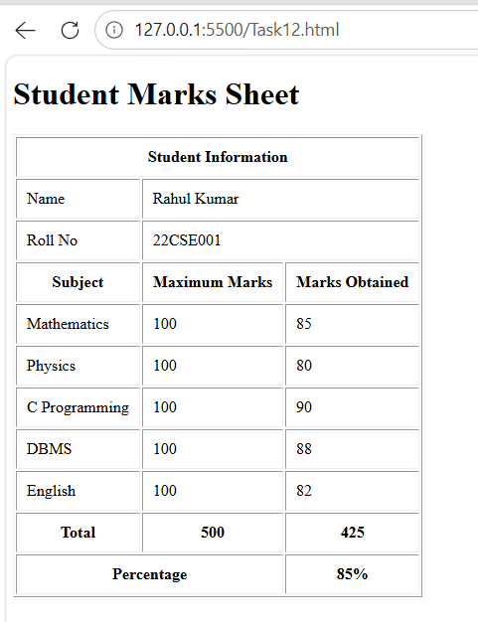
Tutorial Task 13: College Admission Form
Problem Statement: Create an admission form using HTML form controls such as text boxes, radio buttons, checkboxes, and dropdown lists.
Output:
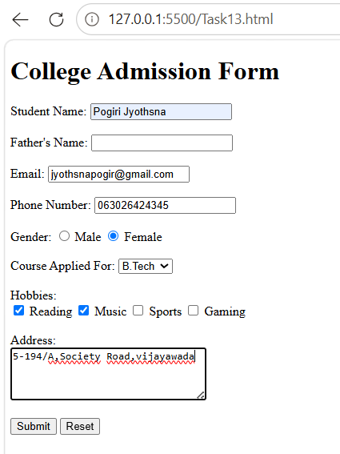
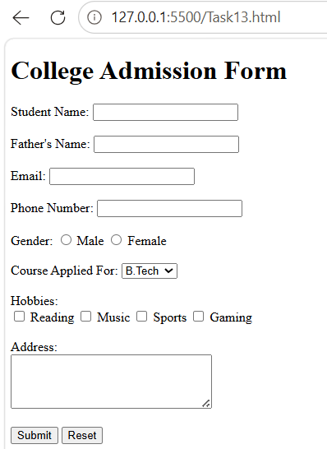

Tutorial Task 14: Contact Form
Problem Statement: Design a contact form that collects user information including name, email, phone number, and message.
Output:
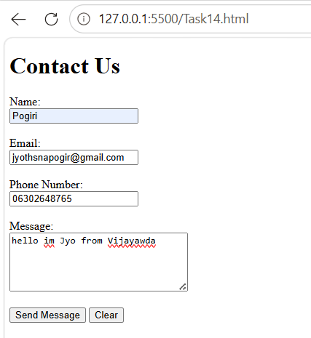
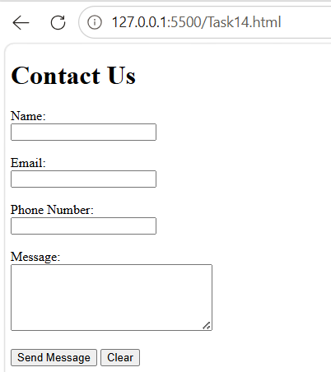
Tutorial Task 15: Feedback Form
Problem Statement: Develop a webpage containing a feedback form to collect user opinions and suggestions.
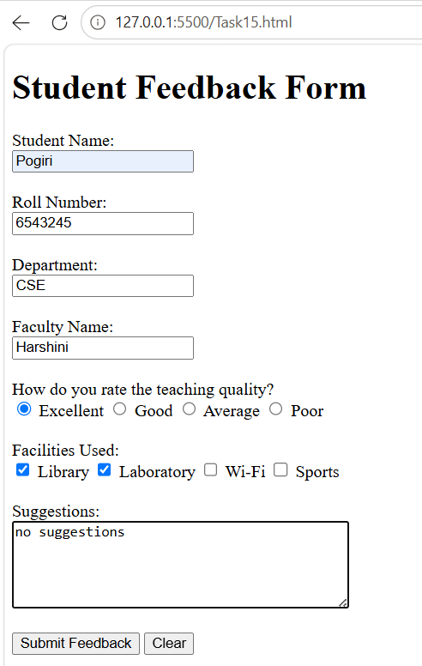
Output:
