🧠 AI-Powered Follicle Monitoring and Analysis
Technical Documentation
- Introduction
1.1 Problem Statement:
- Manual measurement of ovarian follicles in ultrasound scans is time-consuming, prone to error, and subjective.
- The goal of this project is to automate follicle segmentation, measurement, and maturity analysis using deep learning — improving accuracy and assisting clinicians in IVF treatment planning.

  - Objective:
- To develop a deep learning-based solution capable of detecting, segmenting, and measuring ovarian follicles from ultrasound video
with high precision and clinical reliability.
  - Business Objective:
- Automate follicle detection and size measurement (in mm).
- Minimize human error and improve diagnostic consistency.
- Real-time follicle monitoring support for IVF clinicians.

- System Requirements:

2.1 Hardware Requirements:
Component | Minimum Specification
Processor | Intel i5 or higher
RAM | 8 GB/16GB
Storage | 20 GB free space
GPU | T4

2.2 Software Requirements:

Component | Specification
OS | Windows 10/11
Programming Language | Python 3.10
Frameworks | Ultralytics YOLOv8, OpenCV, Pandas, Streamlit
Libraries | Torch, NumPy, Pillow, ReportLab
Deployment Tool | Streamlit
IDE | Google Colab / Spyder

3. Data Collection and Understanding:
3.1 Dataset Source:
- Ultrasound scan videos were collected from YouTube medical repositories.
- Frames were extracted, annotated, and used to train YOLOv8m-seg.

3.2 Data Annotation:
- Annotated using Roboflow with the free polygon tool for precise follicle boundaries.
- Classes: Single class – Follicle.
- Splits: Train 70%, Validation 20%, Test 10%.
- Annotation tool used: Free polygon segmentation.

3.3 Dataset Overview

Split | Images | percentage
Train | 287 | 70%
Validation | 82 | 20%
Test | 41 | 10%

4. Data Information & Dictionary:

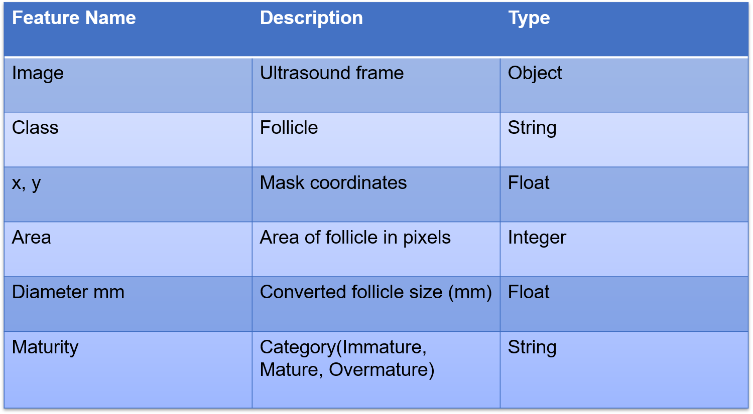

5. Exploratory Data Analysis (EDA):
- EDA was conducted on annotated datasets to understand the size distribution and variation of follicles.
- histogram of follicle area shows most follicles between 15–25 mm.
- Mask overlays confirm accurate polygon boundaries.
- Checked for missing or corrupted frames and replaced them.
- Key Observation: Follicles appear in varying intensity; boundary contrast is low in some cases — demanding robust augmentation.

6. Data Preprocessing:
Steps performed before model training:
- Frame Extraction – Converted all ultrasound videos to image frames.
- Annotation Validation – Verified each mask polygon in Roboflow.
- Normalization – Scaled pixel values to 0–1.
- Resizing – All images resized to 640×640.
- Augmentation – Applied:
  - Mosaic
  - HSV adjustments
  - Shear
  - Translate
  - Perspective shift
- Pixel Calibration – Average calibration determined as 6.10 px/mm using scale line detection.

7. Model Building:
- Model Used: YOLOv8m-seg (Ultralytics)
- Objective: Perform instance segmentation of ovarian follicles from ultrasound video frames.
Training Parameters
- Model Type: YOLOv8m-seg
- Task: Instance Segmentation
- Transfer Learning: From COCO pre-trained weights
- Dataset: /content/Follicle_instance-Segmentation-2
- Image Size: 640x640
- Epochs: 60
- Batch size: 16
- Optimizer: AdamW
- Augmentations: Mosaic, HSV, Shear, Translate, Scale, Perspective
- Hardware: Tesla T4 GPU
- Framework: Ultralytics YOLOv8
Outcome:
- Model successfully learned to identify follicle boundaries and return mask regions for mm-based measurement.

- Model Evaluation & Accuracy

Metric | Box | Mask
Precision | 0.898 | 0.870
Recall | 0.902 | 0.914
mAP@50 | 0.951 | 0.947
mAP@50-95 | 0.727 | 0.736

Interpretation:
- Detection accuracy (mAP@50) = 95.1%
- Fine-grained segmentation accuracy (mAP@50–95) = 73.6%
- Balanced precision and recall show model generalization and reliability.

9. Model Comparison:

Metric | Baseline YOLOv8m | Tuned YOLOv8m(Final) | Improvement
Box Precision(p) | 0.888 | 0.898 | +1.1%
Box Recall (R) | 0.931 | 0.902 | -2.9%
Box mAP@50 | 0.948 | 0.951 | +0.3%
Box mAP@50-95 | 0.720 | 0.727 | +0.7%
Mask Precision | 0.882 | 0.870 | -1.2%
Mask Recall | 0.925 | 0.914 | -1.1%
Mask mAP@50 | 0.944 | 0.947 | +0.3%
Mask mAP@50-95 | 0.733 | 0.736 | +0.3%

Interpretation from Model Accuracy Comparison:
- The tuned YOLOv8m-seg achieved higher accuracy and faster convergence.
- mAP@50 improved to 0.951 (95%), indicating excellent object detection accuracy.
- Fine-grained segmentation (mAP@50–95 = 0.736) ensures precise follicle boundary detection.
- The model generalizes well across different ultrasound sources.

10. Model Deployment Strategy:
Platform: Streamlit Local App
Environment: follicleenv (Python 3.10)
Key Features:
- Upload ultrasound video (.mp4)
- Real-time segmentation & follicle measurement (mm)
- Output: Annotated video + CSV report
- One-click .bat launcher for clinicians
- PDF export using ReportLab
Pipeline:
- Upload Video → Frame Processing
- YOLOv8m Inference → Mask Extraction
- Contour Drawing → Diameter Calculation
- Save Outputs (Video + CSV)
Output Video:
- Contours with green follicle boundaries and mm labels.

11. Challenges:
- Low-contrast ultrasound frames leading to ambiguous follicle boundaries.
- High GPU dependency for fast inference.
- Variable lighting and scaling across different videos.
- Handling overlapping follicles during segmentation.
- Calibration error propagation in mm conversion.

12. Future Scope:
- Real-time video tracking using GPU acceleration.
- 3D follicle volume estimation from multi-angle scans.
- Integration with hospital EMR for automated storage.
- Ovulation prediction using AI-based follicle growth modelling.

13. Results Summary:

Aspect | Result
Model Type | YOLOv8m-seg
Detection Accuracy(mAP@50) | 95.1%
Segmentation Accuracy(mAP@50-95) | 73.6%
Processing Speed | 15.9ms/frame (GPU)
Calibration | 6.10 px/mm
Output | Annotated Video + CSV

14. Conclusion:
- The YOLOv8m-seg-based AI-powered follicle monitoring system achieved high precision (95%) and robust segmentation (73%) across ultrasound data.
- It effectively detects and measures follicle size in mm, enabling clinicians to analyse ovarian follicle development efficiently.
- This solution lays the foundation for AI-driven follicular growth tracking and IVF treatment support systems.

