Fix the bugs
Code:
<html lang="en">
<head>
<title>Document guvi</title>
</head>
<body>

<div>
Lorem ipsum dolor sit amet consectetur adipisicing elit.
<div>
<div>
Guvi Geek Network
</div>
</body>
</html>

Use certain HTML elements to display the following in a HTML page
Code:
<body>
<ul>
<li>Programming Language</li>
<ul>
<li>JavaScript</li>
<ol type=a>
<li>Angular</li>
<li>React</li>
<li>Vue.js</li>
</ol>
<li>Python</li>
<ol type=a>
<li>Django Framework</li>
<li>Flask Framework</li>
</ol>
<li>Java</li>
<ol type=a>
<li>Spring </li>
<li>Maven</li>
<li>Hibernate</li>
</ol>
</ul>
<li>Database</li>
<ul>
<li>MySQL</li>
<li>MongoDB</li>
<li>Cansandra</li>
</ul>
</ul>

</body>

Output:
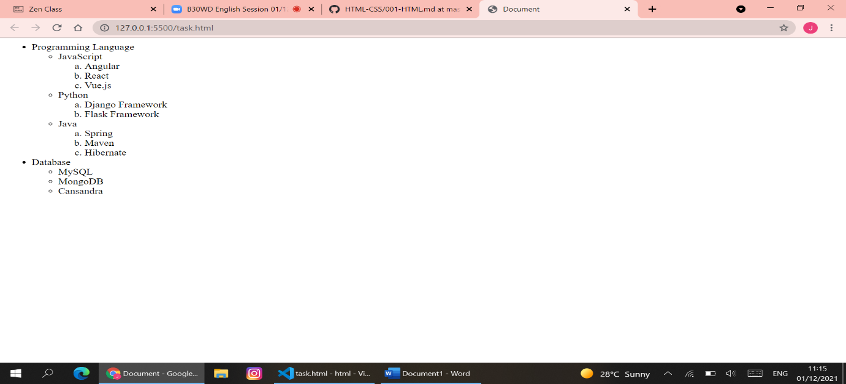

Create an element that helps you to open the https://google.com in separate new tab
Code:
<body>
<a href="https://google.com/" target="_blank">Google</a>

</body>

In your, HTML page add the below line and Highlight it without using any CSS.
- "HTML & CSS is awesome"
Code:
<body>
<div style="background-color:red">
"HTML & CSS is awesome"
</div>

</body>
Use the table tag to design given image Click here.
Code:
<body>
<table border="2" cellspacing="0" cellpadding="5">
<tr>
<th rowspan="2" align="center">State of Health</th>
<th colspan="2">Fasting Value</th>
<th>After Eating</th>

</tr>
<tr>
<td align="center">Minimum</td>
<td align="center">Maximum</td>
<td align="center">2 hours after</td>
</tr>
<tr>
<td align="center">Healthy</td>
<td align="center">70</td>
<td align="center">100</td>
<td align="center">Less than 100</td>
</tr>
<tr align="center">
<td>Pre-Diabetes</td>
<td>101</td>
<td>126</td>
<td>140 to 200</td>
</tr>
<tr align="center">
<td>Diabetes</td>
<td>More than 126</td>
<td>N/A</td>
<td>More than 200</td>
</tr>
</table>

</body>

Output:
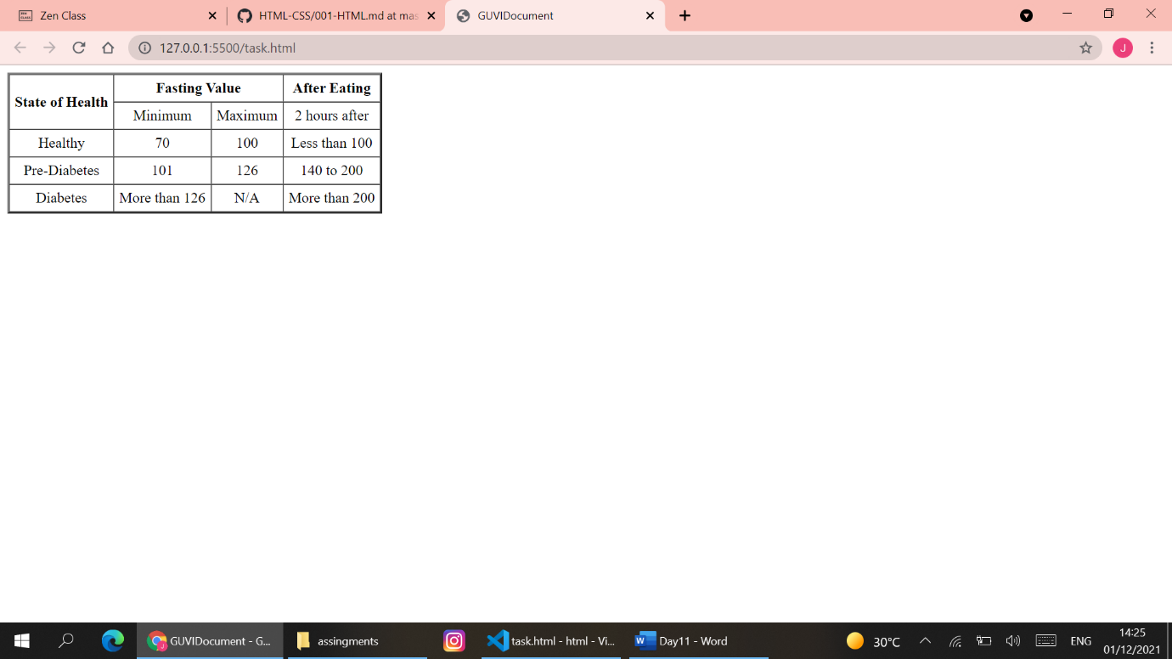

In the form, add two radio buttons with grouping them for employee type(Salaried and own business)
Code:
<body>
<lable for="Salaried">Salaried</lable>
<input type="radio" ><br>
<lable for="Own Business">Own Business</lable>
<input type="radio" >
</body>
Output:
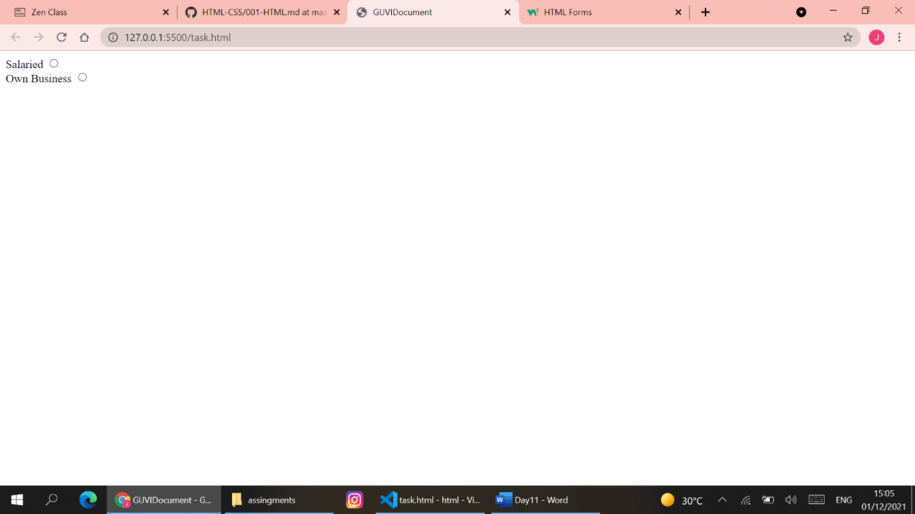

Write HTML input tags snippet to show default values for all Form elements.
Code:
<form action="#">
<lable for="city">City</lable>
<input type="text" name="city" value="Hyderabad">
<input type="submit" value="submit" name="submit">
</form>

Output:
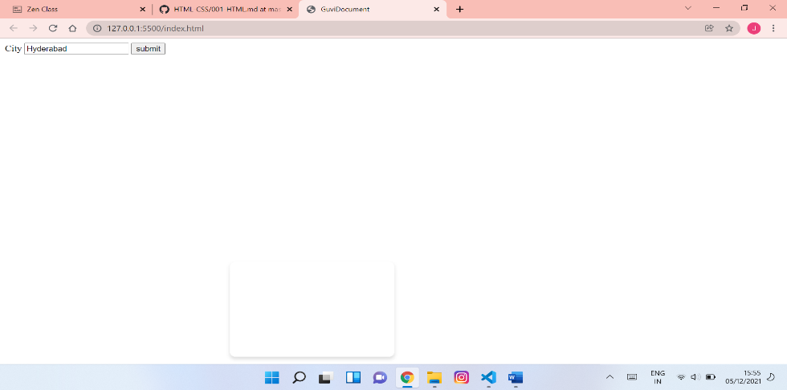
Design a contact us form with all fields as required.
Code:
<body>

<header>
Contact Us
</header>
<form>
<label for="name">Name</label>
<input type="text" name="name">
<label for="phone">Phone</label>
<input type="text" name="phone"><br>

<label for="email">Email</label>
<input type="email" name="email"><br>
<label for="message">Message</label><br>
<textarea name="message" rows="5" cols="50"></textarea><br>
<input type="submit" name="submit" value="submit">
</form>

header{
background-color:rgb(31, 170, 170);
font-size:x-large;
padding-left:30px;
border: 3px solid black;
width: 430px;
}
form{
padding-top: 10px;
border-bottom: 3px solid black;
border-left: 3px solid black;
border-right: 3px solid black;
padding-left: 10px;
background-color:palevioletred;
width: 450px;
}
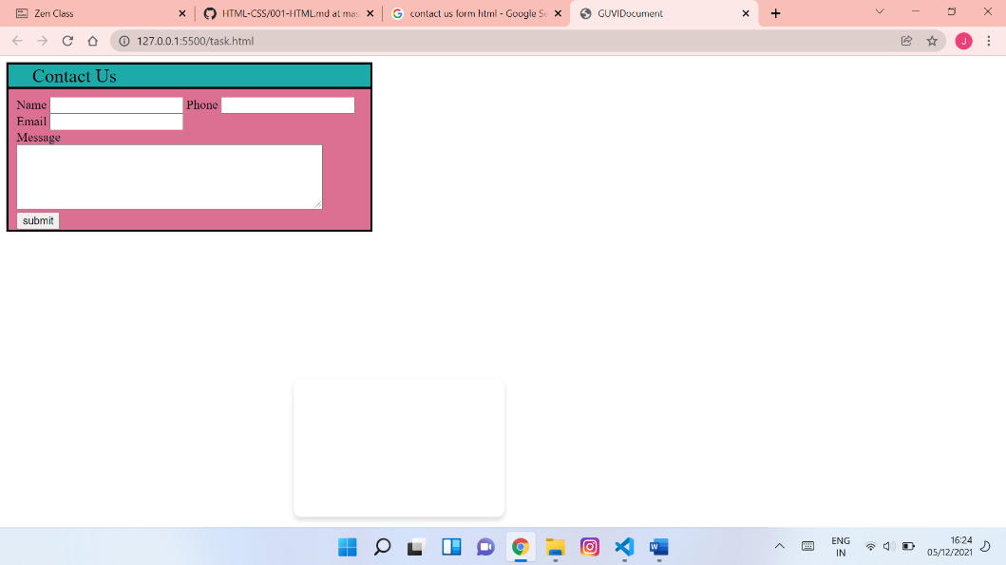
Form:
Code:
<body>
<div id="total">
<header>
Yes! I want to subscribe to Mag-O-Zine
</header>

<table id="one">
<tr>
<td><input type="text" name="first_name" ></td>
<td><input type="text" name="last_name"></td>
</tr>
<tr>
<td><lable for="first_name">First Name</lable></td>
<td><lable for="last_name">Last Name</lable></td>
</tr>
</table>
<table id="two">
<tr>
<td><input type="text" name="address"></td>
</tr>
<tr>
<td><lable for="adress">Address</lable></td>
</tr>
</table>
<table id="three">
<tr>
<td> <input type="city" name="city"></td>
<td><input type="text" name="state"></td>
<td> <input type="text" name="zip"></td>
</tr>
<tr>
<td> <lable for="city">City</lable></td>
<td><lable for="state">State</lable></td>
<td><lable for="zip">Zip</lable></td>
</tr>
<table>

<div id="content">
Subscribe for:
<input type="checkbox">
<lable for="1 year($19.95)">1 year($19.95)</lable>
<input type="checkbox">
<lable for="2 year($35.00)">2 year($35.00)</lable><br>
Send me more information about:<br>
<input type="checkbox">
<lable for="Computer_Zine">Computer_Zine</lable><br>
<input type="checkbox">
<lable for="fishing_Zine">Fishing_Zine</lable><br>
<input type="checkbox">
<lable for="Cat_O_Zine">Cat_O_Zine</lable><br>
</div>

</div>

header{
background-color: red;
font-size:x-large;
padding-left:30px;
}
#total{
border: 2px solid black;
padding-left:10px;
padding-right:10px;
width: 530px;
padding-top: 10px;
padding-bottom: 10px;
}
#content{
font-size:larger;
font-weight:bold;
}
#one{
width: 600px;;
}
input[type=text]{
border:white solid;
border-bottom: black solid;

}

