CREATING A TO-DO LIST APP:

Offered by **Smart Internz**



**TEAM ID:** LTVIP2023TMID08239

Marisa Jyothsna Gayathri(20NM1A04A3)-Team Leader

Karri Pravallika(20NM1A0473)-Team Member

Padamati Lakshmi Sree(20NM1A04C5)-Team Member

Gudisey Nikitha Priyanka(20NM1A0465)-Team Member

**INTRODUCTION:**

 TO-DO list is a list of tasks you need to complete or things that you want to do. Most typically, they’re organised in order of priority. Traditionally, they’re written on a piece of paper or post it notes and act as a memory aid.

**PROJECT DESCRIPTION:**

The Todo App is a web application that allows users to create and manage their daily tasks or to-do lists. Users can add new tasks, mark tasks as completed, and delete tasks. The app provides a user-friendly interface and uses JavaScript, HTML, CSS, and Bootstrap for its implementation.

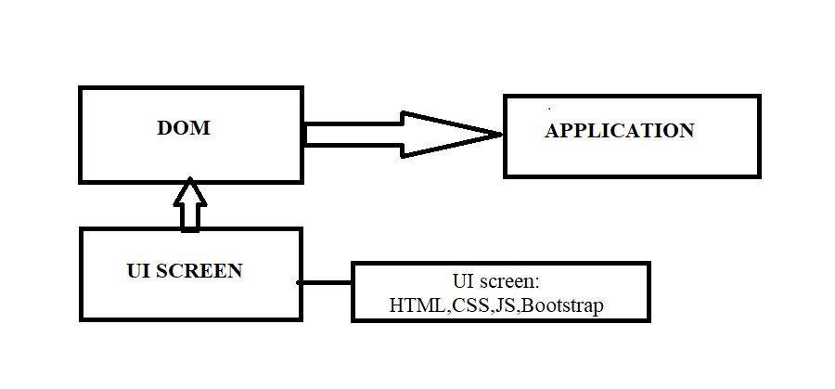**TECHNICAL ARCHITECTURE:**

**PROJECT OBJECTIVES:**

By the end of this project, you will be able to:

1. Create a responsive and interactive user interface using HTML, CSS, and JavaScript.

2. Implement functionality to add, complete, and delete tasks using JavaScript.

3. Provide filtering options to view tasks based on their status.

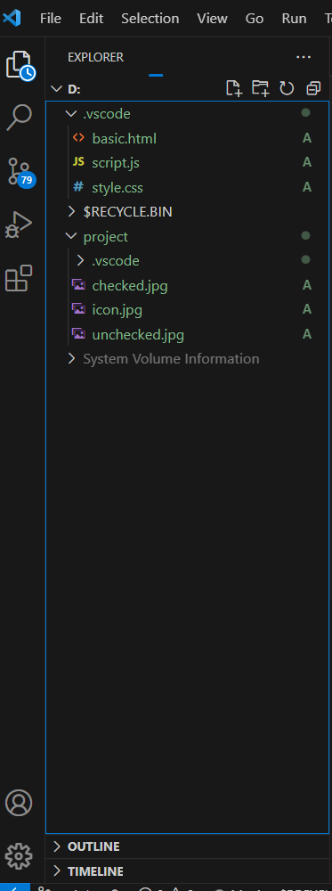**PROJECT FLOW:**

**PROJECT STRUCTURE:**

**1. Set up the project structure**

- Create a new project folder for the Todo App.

- Inside the project folder, create the necessary HTML, CSS, and JavaScript files.

- Set up the basic HTML structure in the index.html file.

- Link the CSS stylesheet and JavaScript file to the index.html file.

**2. HTML File(index.html):**

* Contains the basic structure of the app’s user interface.
* Includes references to the CSS and JavaScript files.

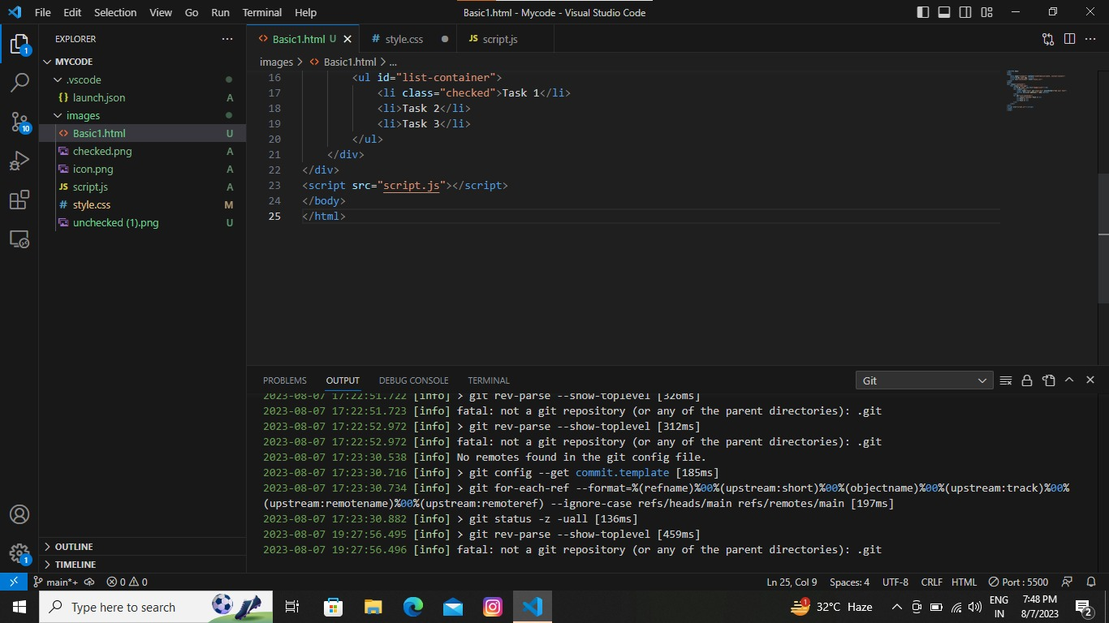The below figure 1 shows the HTML code used to create TO-DO list app:

Figure 1: HTML Code

**3. CSS File (styles.css):**

* Defines the styling and layout of the user interface.
* Formats fonts, colours, backgrounds, buttons, and input fields.

The below figure 2 shows the CSS code to apply styles:

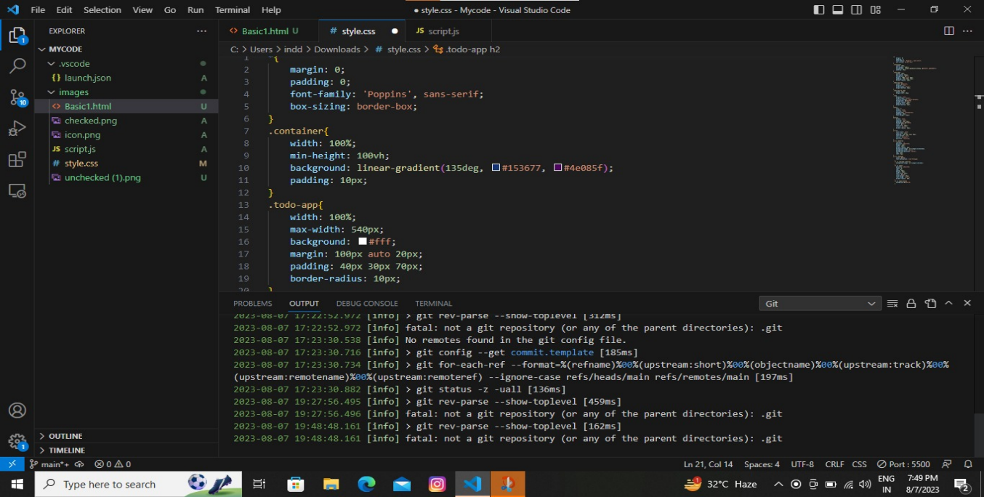

Figure 2: CSS Code

**4. JavaScript files(script.js):**

* Implements the functionality of the app, handling user interactions and data retrieval.
* Contains event listeners to capture user actions, such as clicking the search button.

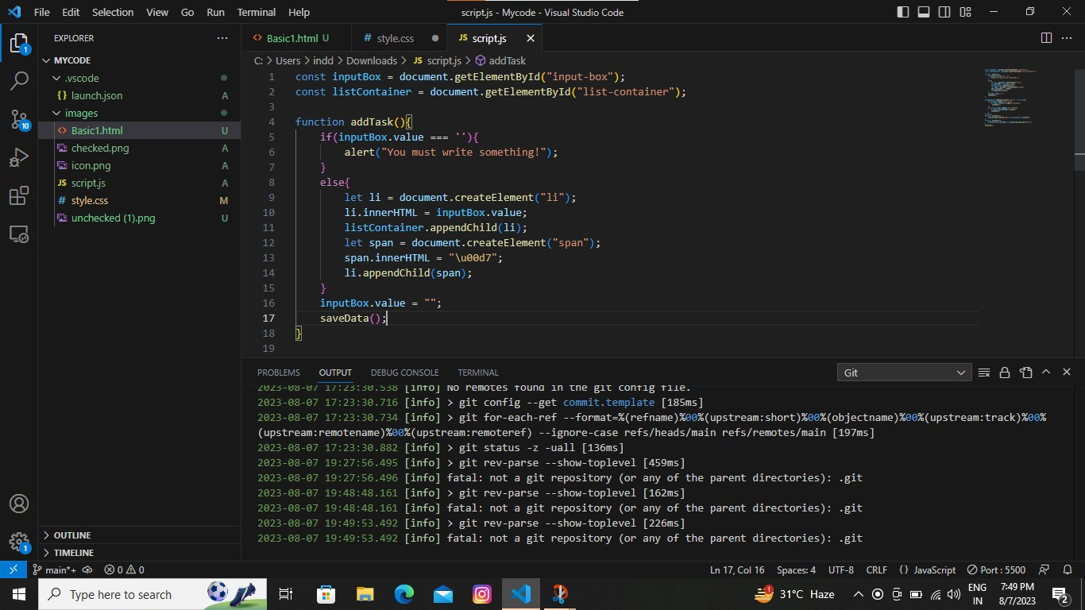The below figure 3 shows the JavaScript code used to handle adding, completing, and deleting tasks:

Figure 3: JavaScript

**STEPS TO CREATE TO-DO LIST APP USING STUDIO CODE:**

* Open Visual Studio code app.
* Go to extensions and install live server.
* Open file click on open folder and create a new folder.
* Add new file in explorer within code folder using extension .html
* Dump the HTML code in the given file.
* Add another files with extensions .css and .js
* Dump the codes in the following files.
* Go to HTML code and right click to select live server.
* To execute the codes, Click on Go live
* Code starts debugging and output will be displayed.
* Click on “add a task” to add a new task.
* Click on task name to mark as completed.
* And click on cross mark to remove the task.

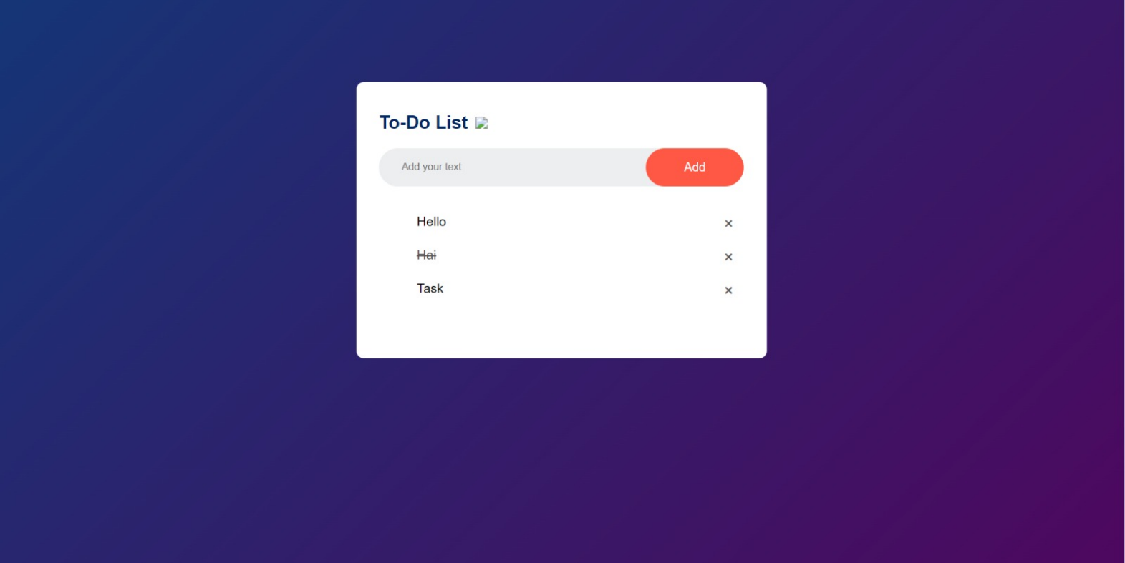**PROJECT OUTCOME:**

**CONCLUSION:**

The Todo App provides a simple and intuitive interface for managing daily tasks. It demonstrates using JavaScript, HTML, CSS, and Bootstrap to create an interactive web application. The project structure allows for easy modification and extension of the functionality. Feel free to explore and enhance the app further to suit your needs.

**GITHUB LINK:**

<https://github.com/Jyothsnagayathri/To-Do_list>