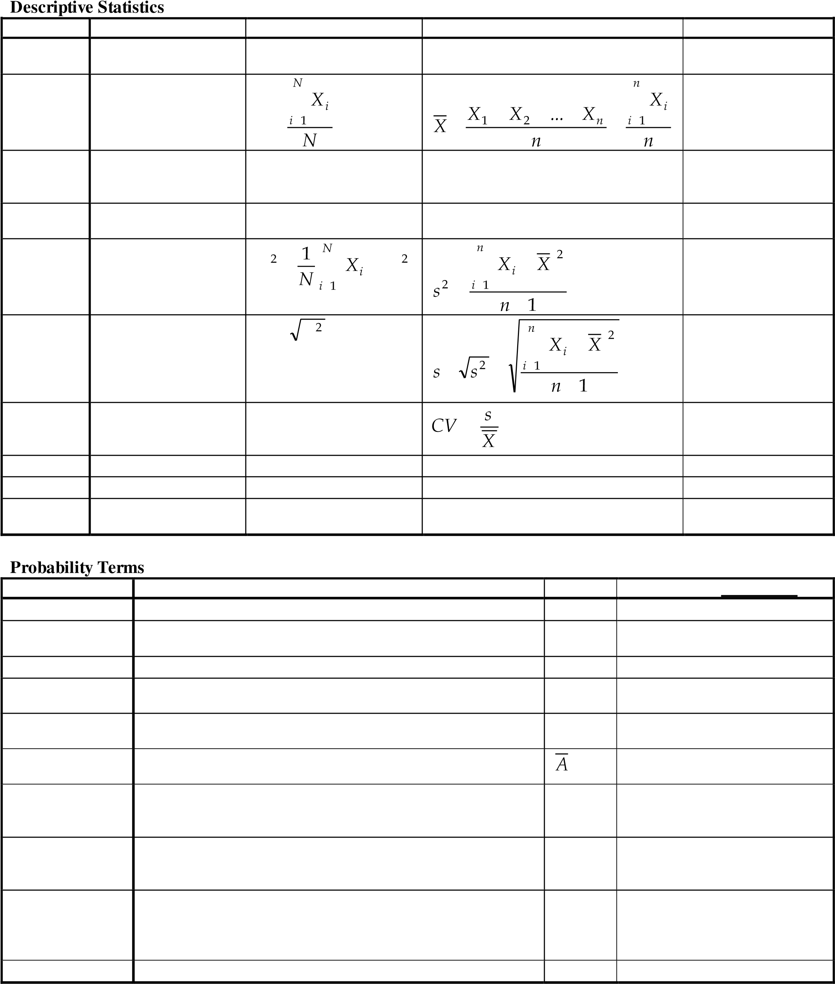

|  |  |  |  |
| --- | --- | --- | --- |
| **If events A and B are NOT mutually** | | | |
|  |  |  |  |
|  |  |  |  |
| *A* |  |  |  |
|  |  |  |  |
|  |  |  |  |
| **Bayes'**  **Law** | *P A B*  *P B* |  |  |
|  | |  | |
|  | |
|  | *B*  *B B* |  |  |
|  | | | |

|  |  |  |
| --- | --- | --- |
| **If events A and B are mutually** | | |
|  |  |  |
|  |  |  |
| *A* |  |  |
|  |  |  |
|  |  |  |

**Probability Rules**

**General probability rules**

**1)**

**2)**

**3)**

**n**

**Random Variables and Distributions Uniform Distribution**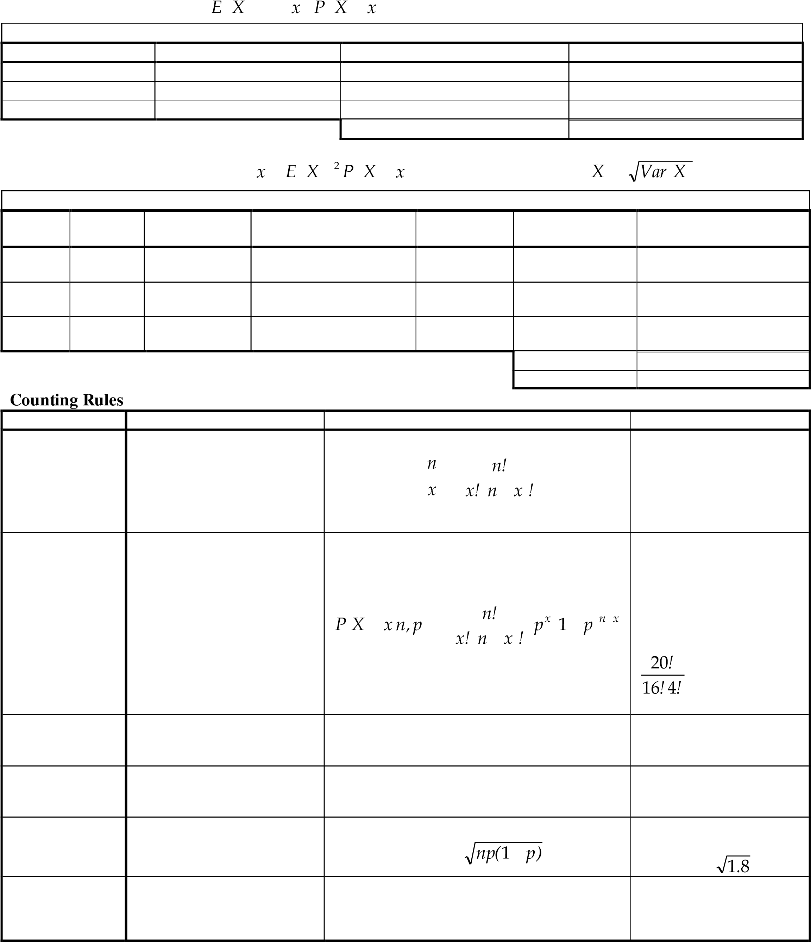

|  |  |  |
| --- | --- | --- |
|  |  |  |
|  | *b*  *a*  *X*  2 |
|  | 2 *b a* 2  *X*  12 |
|  | *b a*  *X*  12 |
| **falls**  **c d** |  |

**Normal Distribution**

|  |  |  |  |
| --- | --- | --- | --- |
|  | | z | 0.00 0.01 0.02 0.03 0.04 0.05 0.06 0.07 0.08 0.09 |
|  | | 0.0 | .0000 .0040 .0080 .0120 .0160 .0199 .0239 .0279 .0319 .0359 |
|  | | 0.1 | .0398 .0438 .0478 .0517 .0557 .0596 .0636 .0675 .0714 .0753 |
|  | | 0.2 | .0793 .0832 .0871 .0910 .0948 .0987 .1026 .1064 .1103 .1141 |
|  | | 0.3 | .1179 .1217 .1255 .1293 .1331 .1368 .1406 .1443 .1480 .1517 |
|  | | 0.4 | .1554 .1591 .1628 .1664 .1700 .1736 .1772 .1808 .1844 .1879 |
|  | | 0.5 | .1915 .1950 .1985 .2019 .2054 .2088 .2123 .2157 .2190 .2224 |
|  | | 0.6 | .2257 .2291 .2324 .2357 .2389 .2422 .2454 .2486 .2517 .2549 |
|  | | 0.7 | .2580 .2611 .2642 .2673 .2704 .2734 .2764 .2794 .2823 .2852 |
|  | | 0.8  0.9  1.0  1.1 | .2881 .2910 .2939 .2967 .2995 .3023 .3051 .3078 .3106 .3133  .3159 .3186 .3212 .3238 .3264 .3289 .3315 .3340 .3365 .3389  .3413 .3438 .3461 .3485 .3508 .3531 .3554 .3577 .3599 .3621  .3643 .3665 .3686 .3708 .3729 .3749 .3770 .3790 .3810 .3830 |
| 1 *x* 2 *f X x*  2  2  1  *e* | |
|  | | 1.2 | .3849 .3869 .3888 .3907 .3925 .3944 .3962 .3980 .3997 .4015 |
|  | | 1.3  1.4  1.5 | .4032 .4049 .4066 .4082 .4099 .4115 .4131 .4147 .4162 .4177  .4192 .4207 .4222 .4236 .4251 .4265 .4279 .4292 .4306 .4319  .4332 .4345 .4357 .4370 .4382 .4394 .4406 .4418 .4429 .4441 |
| *X Z* | |
|  | | 1.6 | .4452 .4463 .4474 .4484 .4495 .4505 .4515 .4525 .4535 .4545 |
|  | | 1.7  1.8  1.9  2.0 | .4554 .4564 .4573 .4582 .4591 .4599 .4608 .4616 .4625 .4633  .4641 .4649 .4656 .4664 .4671 .4678 .4686 .4693 .4699 .4706  .4713 .4719 .4726 .4732 .4738 .4744 .4750 .4756 .4761 .4767  .4772 .4778 .4783 .4788 .4793 .4798 .4803 .4808 .4812 .4817 |
| *a b*  *P a X b P Z* | |
|  | | 2.1  2.2  2.3 | .4821 .4826 .4830 .4834 .4838 .4842 .4846 .4850 .4854 .4857  .4861 .4864 .4868 .4871 .4875 .4878 .4881 .4884 .4887 .4890  .4893 .4896 .4898 .4901 .4904 .4906 .4909 .4911 .4913 .4916 |
|  | |
|  |  |
|  |  | 2.4  2.5 | .4918 .4920 .4922 .4925 .4927 .4929 .4931 .4932 .4934 .4936  .4938 .4940 .4941 .4943 .4945 .4946 .4948 .4949 .4951 .4952 |
|  |
|  |  | 2.6  2.7 | .4953 .4955 .4956 .4957 .4959 .4960 .4961 .4962 .4963 .4964  .4965 .4966 .4967 .4968 .4969 .4970 .4971 .4972 .4973 .4974 |
|  |
|  |  | 2.8  2.9 | .4974 .4975 .4976 .4977 .4977 .4978 .4979 .4979 .4980 .4981  .4981 .4982 .4982 .4983 .4984 .4984 .4985 .4985 .4986 .4986 |
|  |
|  |  | 3.0 | .4987 .4987 .4987 .4988 .4988 .4989 .4989 .4989 .4990 .4990 |

**Correlation**

|  |  |
| --- | --- |
| **The Central Limit Theorem** | **Continuity Correction** |

*p)*

*(*

*np*

1

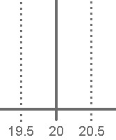

|  |  |
| --- | --- |
| **Sampling Distribution of the Mean** | **Sampling Distribution of a Proportion** |

*p*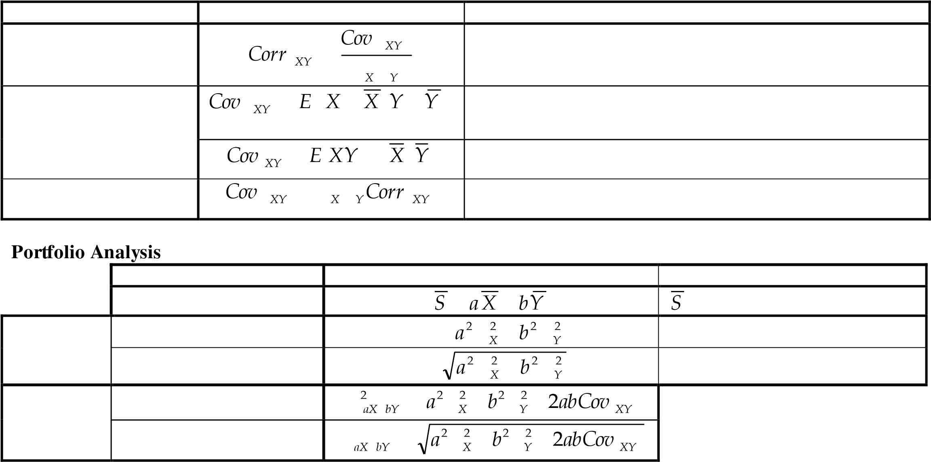

*n*

***p***

*n*

*p*

*p*

1

|  |  |  |  |  |  |
| --- | --- | --- | --- | --- | --- |
|  |  | **t-table** | | | |
| d. f. | 0.100 | 0.050 0.025 0.010 0.005 | | | |
| 1 | 3.078 | 6.314 12.706 31.821 63.656 | | | |
| 2 | 1.886 | 2.920 | 4.303 | 6.965 | 9.925 |
| 3 | 1.638 | 2.353 | 3.182 | 4.541 | 5.841 |
| 4 | 1.533 | 2.132 | 2.776 | 3.747 | 4.604 |
| 5 | 1.476 | 2.015 | 2.571 | 3.365 | 4.032 |
| 6 | 1.440 | 1.943 | 2.447 | 3.143 | 3.707 |
| 7 | 1.415 | 1.895 | 2.365 | 2.998 | 3.499 |
| 8 | 1.397 | 1.860 | 2.306 | 2.896 | 3.355 |
| 9 | 1.383 | 1.833 | 2.262 | 2.821 | 3.250 |
| 10 | 1.372 | 1.812 | 2.228 | 2.764 | 3.169 |
| 11 | 1.363 | 1.796 | 2.201 | 2.718 | 3.106 |
| 12 | 1.356 | 1.782 | 2.179 | 2.681 | 3.055 |
| 13 | 1.350 | 1.771 | 2.160 | 2.650 | 3.012 |
| 14 | 1.345 | 1.761 | 2.145 | 2.624 | 2.977 |
| 15 | 1.341 | 1.753 | 2.131 | 2.602 | 2.947 |
| 16 | 1.337 | 1.746 | 2.120 | 2.583 | 2.921 |
| 17 | 1.333 | 1.740 | 2.110 | 2.567 | 2.898 |
| 18 | 1.330 | 1.734 | 2.101 | 2.552 | 2.878 |
| 19 | 1.328 | 1.729 | 2.093 | 2.539 | 2.861 |
| 20 | 1.325 | 1.725 | 2.086 | 2.528 | 2.845 |
| 21 | 1.323 | 1.721 | 2.080 | 2.518 | 2.831 |
| 22 | 1.321 | 1.717 | 2.074 | 2.508 | 2.819 |
| 23 | 1.319 | 1.714 | 2.069 | 2.500 | 2.807 |
| 24 | 1.318 | 1.711 | 2.064 | 2.492 | 2.797 |
| 25 | 1.316 | 1.708 | 2.060 | 2.485 | 2.787 |
| 26 | 1.315 | 1.706 | 2.056 | 2.479 | 2.779 |
| 27 | 1.314 | 1.703 | 2.052 | 2.473 | 2.771 |
| 28 | 1.313 | 1.701 | 2.048 | 2.467 | 2.763 |

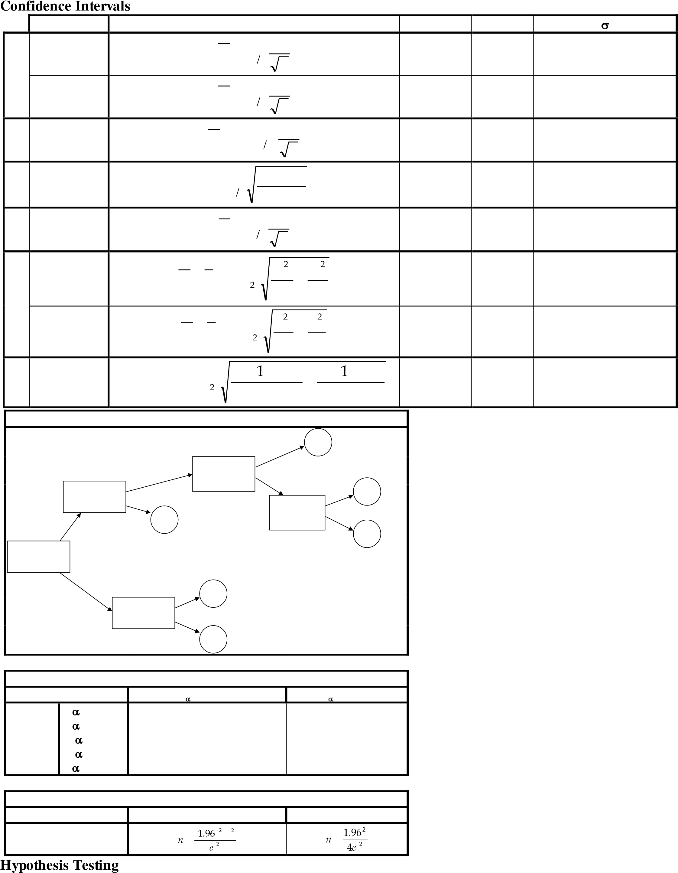

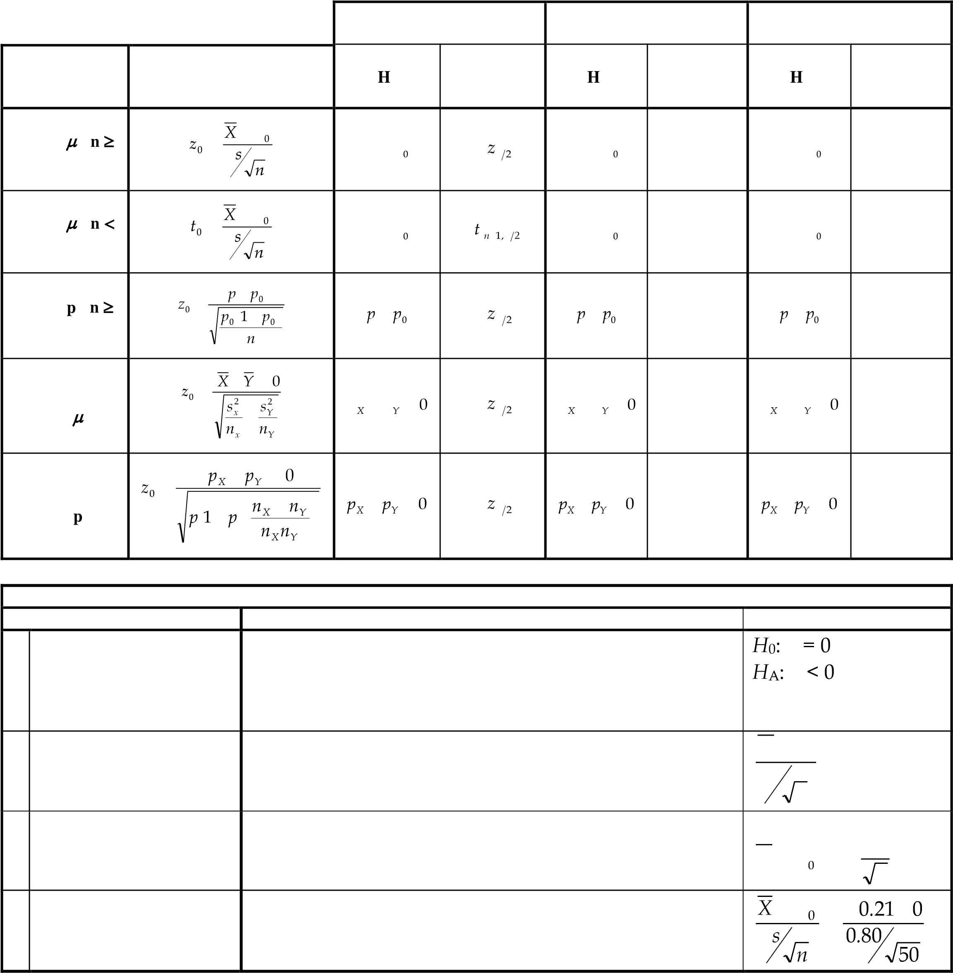

**Regression**

|  |  |  |  |  |  |  |  |  |  |  |  |  |  |  |  |
| --- | --- | --- | --- | --- | --- | --- | --- | --- | --- | --- | --- | --- | --- | --- | --- |
|  | | |  |  | | **Regression Statistics** | | | | | | | | | |
|  | | |  |
|  | | |  |
|  | | |  |
|
|  | | | 0 |  | | | | | | | | | |
|  | | | | | | | | | |
| 0 | | | 0 |
|  | | | 1 |  | | | | | | | | | |
|  | | | | | | | | | |
| 1 | | | 1 |
|  |  |  | | | | | | | |  |  | | |  |  |
| **n** | *Y* | *n*  *Yi i* 1 | | |  | |  |  |  | **R** | |  | *R*2 | *SSE* 1 |
|
| *TSS* |
| *n* | | |
|  | *Yi* | 0 1*x*1*i* | | | *x*  2 2*i* | | *x*  3 3*i* | *...* | *x k ki* | **R** | |  | *R* | *R*2 |
| **i**  **Y**  **Y** | *i* | *Yi Yi* | | |  | |  |  |  | **R** |  |  | *R*2 | *SSE* |
| *n k* 1  1 |
|
| *SST* |
| *n* 1 |
|  | *TSS* | *n*  *Yi i* 1 | | | 2  *Y* | |  |  |  |  |  |  | *s* | *SSE* |
|
| *n k* 1 |
|  | *SSE* | *n*  *Yi i* 1 | | | 2  *Yi* | |  |  |  | **t**  *H* 0 *:*  *H A :* | 1  1 | 0  0 | *t*0 | 0  1 |
| *s* 1 |
|  | *MSE* | *SSE* | | | | |  |  |  | **p**  *H* 0 *:*  *H A :* | 1  1 | 0  0 | **p** | *P T t*0 |
| *n k* 1 | | | | |
|  | *SSR* | *n* 2  *Yi Y*  *i* 1 | | | | |  |  |  | **F** |  |  | *MSR* | |
|
| *F*  *MSE*  *n k* 1 *R*2 | |
|  | *MSR* | *SSR k* | | | | |  |  |  |
| *k* 1 *R*2 | |