**Abstract**

**Wireless Audio Amplifier with Multiple Receiver**

Arman Hossain Jyoti Chakma

ID: 18702012 ID: 18702044

Session: 2017-18 Session: 2017-18

University of Chittagong University of Chittagong

Date of Submission: 15/10/2019

The main purpose of our projects is to make acoustic system more easily with modern technology. By transmitting wirelessly and receiving through antennas and get amplified sound with amplifier [1]. We have microphone [2] connected in transmitter circuit and a speaker [3] associated in amplifier circuit which is directed from receiver circuit. The main part of this project is the multiple receiver [4] options. If we need, we can extend the number of receiver by simply adding a receiver circuit. When we need to record a seminar or conference or the lecture of our classes, in order to getting clear sound quality, this project provide extra receiver circuit for adding in camera or video recorder audio input. The other mentionable feature is both the transmitter and receiver are rechargeable. We can also use this audio amplification system [5] in all state, it is no matter whether AC or DC. The transmitter provide the long range capabilities [6] transmitting [7] the radio waves [8] and for that we can use this in a

huge conference room. The range of the distance between the speaker and the audience should be not more than 20meter. An amplifier circuit is used to amplifier through audio devices like loud speaker. It works with almost all devices [9].

By frequency modulation [10], we can communicate a long range. FM is the process of transmitting signal. In the transmitter circuit, by frequency modulation we can be easily transmit signal via antenna. And on the other hand, we can get this signal via antenna [11]. The receiver demodulates [12] the modulated signal hence we get the real signal from the receiver circuit. We can use this audio amplifier project in our classroom. We can record seminar, conferences and also class lectures from the direct line of microphone. For that we get the clear sound in recording or videos. The major features of this project is the multiple receiver options. We can add receiver easily by connecting a receiver module when we need to extend.

**Introduction**

In the very beginning of our university life, we faced a problem. In our first year class room, the students of the back bench can’t hear the lecture of the standing teacher. They are much far from the front desk of the teacher and there was no sound system in the room. This was our motivation for this project.

Then, we decided to solve this problem. We made an idea for solving this sound problem. We consider the several parameters like size of the room, difference between speaker and audience and also sound quality for recording seminars or conferences.

We moved on this project with wireless technology. By frequency modulation (FM) we can easily communicate with speaker and the audience. We had 2 solution for this problem. The microphone can be static or moveable. In case we wanted dynamic system, we chose moveable microphone. For that, the audience can hear by speaker, no matter where the speaker is.

This project serves more advantages than others. Because though it has a transmitter but we can use multiple receiver. Suppose we need to record a seminar or conference or simply a lecture of a university class, if we record from other source like camera, audio tape recorder, the sound isn’t clear in video or audio record. The problem is about the sound quality. So, the solution is to record the original sound from the microphone to have clear sound quality. So, if we record the original sound of a speaker, the sound will be clear enough.

**FM – How It Works**

FM [13] stands for Frequency Modulation. In this wireless communication system [14], sound is transmitted by the changes in frequency [15]. Frequency modulation (FM) is the process of transmitting information. It works mainly on the basis of two operation [16]. They are:

* Frequency Modulation
* Frequency Demodulation

**Frequency Modulation**

Modulation means change [17]. We can have radio wave from conversion of data by the process of modulation. It is also known as carrier signal [18]. We can generate FM signals using frequency modulation either direct or indirectly.

**Frequency Demodulation**

Demodulation means bringing original form [19]. Bring off the original signal which is modulated to carrier is called demodulation. Modulated wave is demodulated for further use.

**Features**

Our project has many interesting features. As mentioned above, for several reasons…

* **Portability:** We have both portable transmitter and receiver.
* **Installation:** For the portability of the circuits, it can be easily installed in almost all size of room.
* **User**-**Experience:** All user can use easily because of having not much options in transmitter and receiver.
* **Rechargeable**: Both the transmitter and receiver are rechargeable.
* **Long Range:** It will works about 20m long.
* **High Sound Quality in Camera Video (Conference Room):** By recording the sound from direct microphone, it can serve very high quality sound in camera video.
* **Record Sound in Presentation Video (Seminar Room):** We can record easily from direct microphone.
* **Compatibility:** It works almost all devices.

**Transmitter Analysis**

Transmitter is the sender of signal. It transmits data wirelessly [20]. A FM transmitter uses the principles of frequency [21] modulation to transmit sound supplied at its input.

For clear understanding, let us consider a microphone [22] and inside there is a capacitive sensor [23]. It produces signal according to the change of air pressure [24]. Using a NPN-transistor [25] by using the inductor and variable capacitor [26] can form the oscillating tank circuit [27]. If the current is passed at the inductor and variable capacitor then the tank circuit will oscillate at a frequency of FM modulation. An oscillator helps in generating radio frequency [28] carrier waves. The tank circuit is used to store energy for oscillations [29]. The input audio signal from the mic is connected to the base of the transistor [30] which modulates the tank circuit in FM format. For fine modification, the variable capacitor is used to change the resonant frequency [31]. From the antenna, the modulated signal is radiated as radio waves [32].

The block diagram for transmitter is given below:

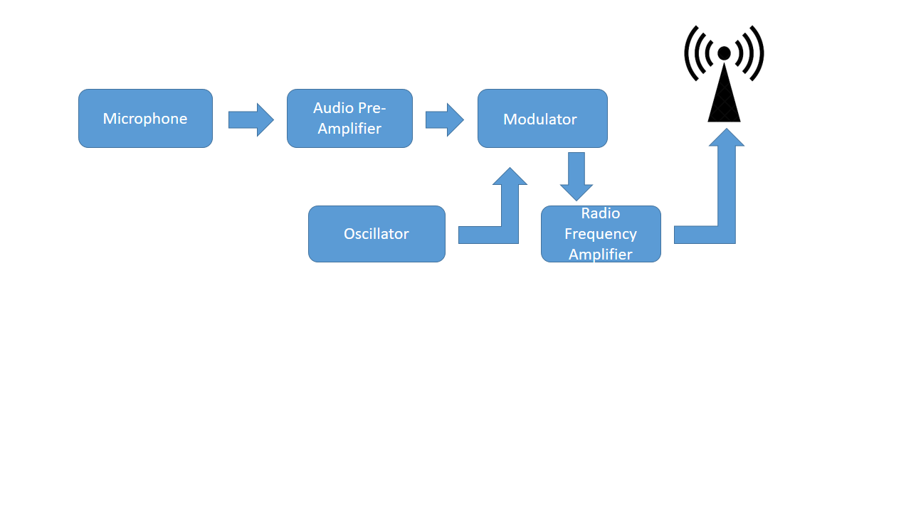

**Fig 1:** Block Diagram of Transmitter

**Receiver Analysis**

A FM receiver is an electronic device that receives radio waves and converts the information. An antenna is used to catch the desired frequency waves [33]. In receiver circuit, there is an oscillator part. The oscillator [34] output will have the same frequency as the received signal from the antenna.

The block diagram of receiver is given below:

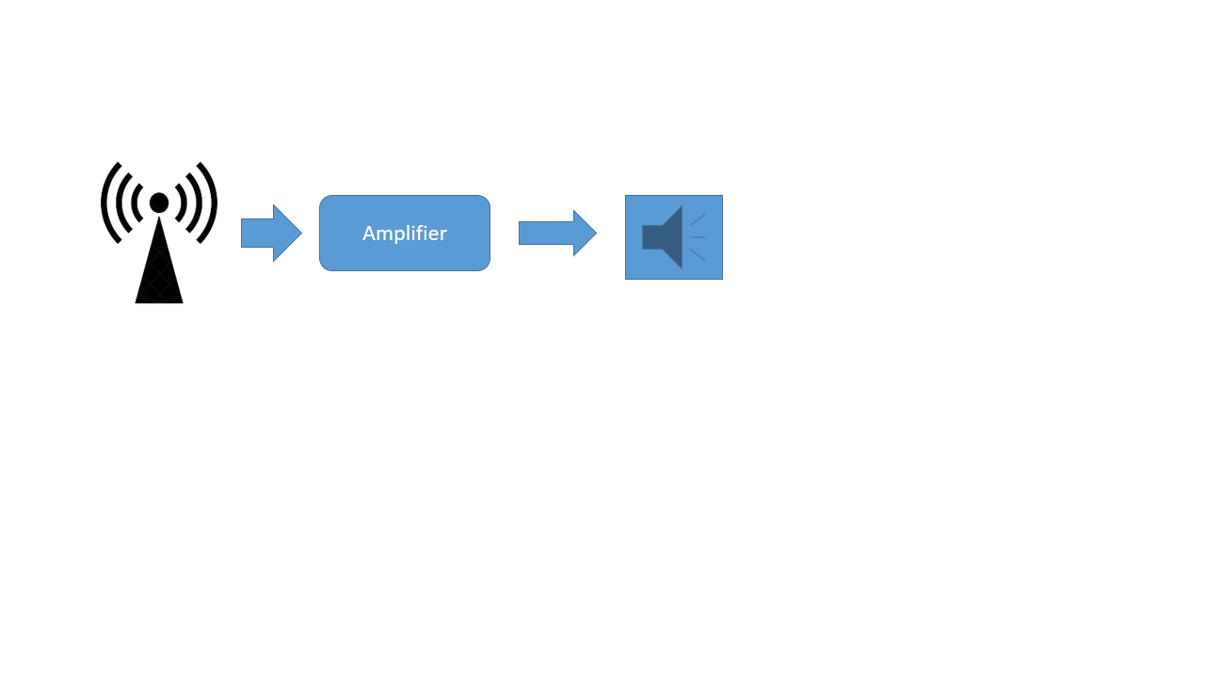

**Fig 2:** Block Diagram of Receiver

**Audio Amplifier**

Amplifier is a device which produce and increase the version of the input signal. The transmitter transmits sound from the microphone and the receiver received that signal. Audio amplifiers are commonly used devices because they have ability to amplify a relatively small input signal. The difference between input and output signal is known as gain [35] of the amplifier. The

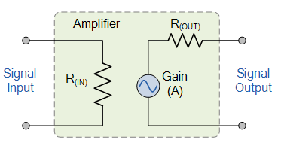

**Fig 3:** Ideal Amplifier

The circuit is describe as when a small input signal go to the amplification [36] stage, the input voltage is low but the voltage of output is much higher.

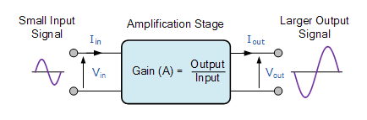

**Fig 4**: Amplifier Gain

**Why Antenna is required**

An antenna works like catching words, pictures, information passing by in a holding hand. It is a metal rod that catches radio waves and turn them into electrical signal [37]. This type of antenna sometimes called receivers. A transmitter is different kind of antenna [38] that does the opposite work of a receiver. It turns electrical signal into radio waves.

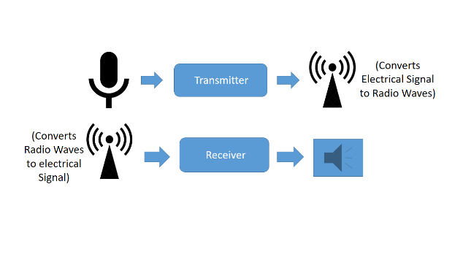

**Fig 5:** Works of Antenna

So, in wireless communication [39] antenna is required to transmit signal from transmitter and receive that signal in receiver. Antenna help us to send signal over the air and on the other hand, it receives this signal for future use.

**Future Development**

This project can be developed in near future. Many features can be added here. Some suggestions are:

* Better loudness can be developed
* It can be fully wireless since we have some wire for dynamic microphone [40]

**Advantages of FM**

1. Amplitude of signal is remain same
2. Provide good sound quality
3. Well defined service areas for given power
4. Less Radiated power
5. FM is constant to signal level variation. Any variation in signal level doesn’t affect the output as long as the receiver is able to cope up with the signal level. This makes it ideal for two-way radio communication.
6. FM is also constant to noise and interference.
7. It is easier to apply modulation at a low level power stage of a transmitter.
8. The reliability of this audio amplifier is also high.

**Disadvantages of FM**

1. Much more Bandwidth
2. More complicated receiver and transmitter
3. There are some amount of noise that can’t be filter.

**Application**

There are numerous application of this project.

* FM Communication
* Teaching, Conferencing, Monitoring
* Record Audio Sound with Camera or other external devices
* In Function, competitions, Parties, Speeches

**Conclusion**

We have discussed everything about our project, but most of our discussions are based on theoretical knowledge. When we go to implement that practically, we find huge difference between expectations versus reality. Many reasons are responsible behind that. Firstly, we don’t have all components available in the local market such as the transistor 2N3904, and specific valued some capacitors and inductors. Because of theoretical and practical characteristics, we can’t do our project as expected. We make PCB design on Diptrace software and printed in a board. We are working on it. We will be able to solve those problem and complete the project.

**PCB Design (Separate 3 Circuits)**

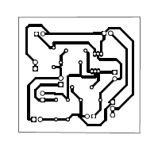

**Fig PCB-1:** PCB Design for Transmitter

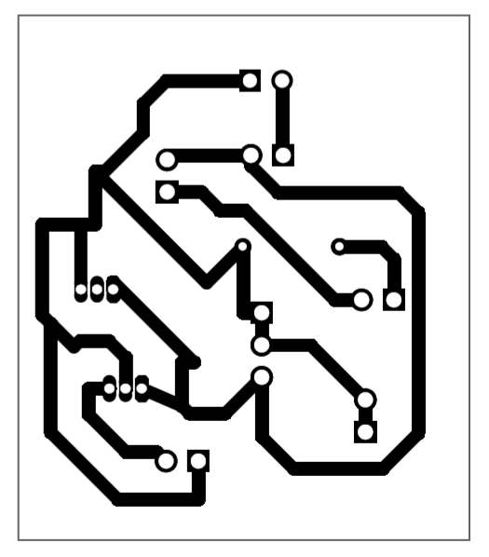

**Fig PCB-2:** PCB Design for Receiver

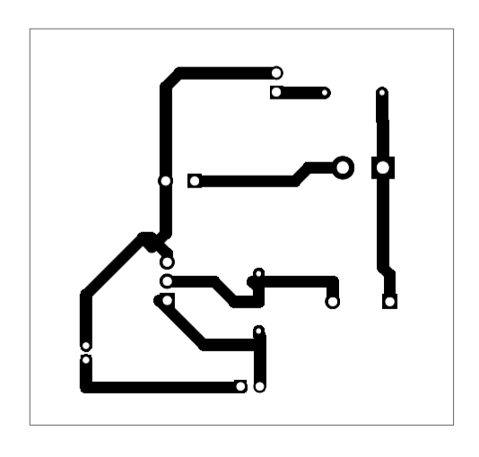

**Fig PCB-3:** PCB Design for Amplifier

**References:**

[1] Electronics Tutorial, “Introduction to Amplifier”, [Online], Available: <https://www.electronics-tutorials.ws/amplifier/amp_1.html> [Accessed October 06, 2019]

[2] Tech Target, “What is Microphone?”, [Online], Available: <https://whatis.techtarget.com/definition/microphone> [Accessed October 06, 2019]

[3] Physics, “How do speakers works?”, [Online], Available: <http://www.physics.org/article-questions.asp?id=54> [Accessed October 08, 2019]

[4] Quora,”Hwy is Fm mono signal is , more clear than Fm streo signal?”, [Online], Available: <https://www.quora.com/Why-is-the-FM-mono-signal-more-clear-than-the-FM-stereo-signal-at-long-distances> [Accessed October 06, 2019]

[5] Audiology online, “Frequency Modulation for Children and Normal Hearing”, [Online], Available: <https://www.audiologyonline.com/articles/frequency-modulation-fm-systems-for-1166> [Accessed October 06, 2019]

[6] Elctroschamatics, “Long Range FM Transmitter”, [Onlinbe], Available: <https://www.electroschematics.com/long-range-fm-transmitter/> [Accessed October 08, 2019]

[7] Instructables, “How to make FM transmitter?” [Online], Available: <https://www.instructables.com/id/How-to-Make-FM-Transmitter/> [Accessed October 08, 2019]

[8] Live Science, “What are Radio Waves?”. [Online], Available: <https://www.livescience.com/50399-radio-waves.html> [Accessed October 06, 2019]

[9] Audiology Online, “Wireless FM for improving understanding in noise ”, [Online], Available: <https://www.audiologyonline.com/ask-the-experts/wireless-fm-systems-for-improving-353> [Accessed October 06, 2019]

[10] David B. Rutledge, ”The Electronics of Radio”, page-310 (1999)

[11] Slyusar V.I., “60 years of electrically small antenna theory”, (2017)

[12] Electronics Notes, “Demodulation”, [Online], Available: <https://www.electronics-notes.com/articles/radio/modulation/amplitude-modulation-am-demodulation-detection.php> [Accessed October 07, 2019]

[13] Overstock, “Tips on using FM transmitter”, [online], Available: <http://www.overstock.com/guides/tips-on-using-fm-transmitters> [Accessed October 06, 2019]

[14] Techopedia, “Wireless Communication”, [Online], Available: <https://www.techopedia.com/definition/10062/wireless-communications>[Accessed October 06, 2019]

[15] TechTarget, “What is Frequncy?” [Online], Available: <https://whatis.techtarget.com/definition/frequency> [Accessed October 06, 2019]

[16] Bayt, “What are FM operations?”, [Online], Available: <https://specialties.bayt.com/en/specialties/q/313984/what-are-fm-operations/> [Accessed October 06, 2019]

[17] Haykin, Simon, ”Communication System”, 4th Ed, ( 2011)

[18] TechTarget, “Carrier Signal”, [Online], Available: <https://searchnetworking.techtarget.com/definition/carrier-signal> [Accessed October 08, 2019]

[19] Science Direct, “Demodulation”, [Online], Available: <https://www.sciencedirect.com/topics/engineering/demodulation> [Accessed October 8, 2019]

[20] Tutorialspoint, “Wireless Communication- Overview”, [Online], Available: <https://www.tutorialspoint.com/wireless_communication/wireless_communication_overview.htm> [Accessed October 06, 2019]

[21] Physics Forums, “Principal Frequencies of a waveform”, [Online], Available: <https://www.physicsforums.com/threads/principal-frequencies-of-a-waveform.813330/> [Accessed October 06, 2019]

[22]Explain That Stuff, “How do Microphone works?”, Available: <https://www.explainthatstuff.com/microphones.html> [Accessed October 06, 2019]

[23] Rapid Tables, ”Capacitor”, [Online], Available: <https://www.rapidtables.com/electric/capacitor.html> [Accessed October 06, 2019]

[24] Nikolas Vryzas, “Embedding Sound Localization and spatial audio interaction through coincident microphone arrays”, ResearchGate, October, 2015

[25] Explain that stuff, “How do transistor Works?”, [Online], Available: <https://www.explainthatstuff.com/howtransistorswork.html> [Accessed October 06, 2019]

[26] Electronics Tutorial, “Introduction to Capacitors”, [Online], Available: <https://www.electronics-tutorials.ws/capacitor/cap_1.html> [Accessed October 06, 2019]

[27] Electrical Basic Projects, “How tank circuit works”, [Online], Available: <http://www.electricalbasicprojects.com/how-tank-circuit-works-tank-circuit-working-principle/> [Accessed October 06, 2019]

[28] Davies, “Handbook of Condition Monitoring”, (1997)

[29] Merriam Webster, “Oscillation”, [Online], Available: <https://www.merriam-webster.com/dictionary/oscillation> [Accessed October 06, 2019]

[30] Vardalas, John, “Twists and Turns in the development of the transistor”, page-277 (2015)

[31] Ecsxtal, “What is resonant frequency?”, [Online], Available: <https://ecsxtal.com/news-resources/video-learning/126-everything-you-need-to-know-about-quartz-crystal-resonators/129-understanding-resonant-frequency> [Accessed October 06, 2019]

[32] Wikipedia, “Radio Wave”, [Online], Available: <https://en.wikipedia.org/wiki/Radio_wave> [Accessed October 06, 2019]

[33] Bakshi, K.A; A.V. Bakshi, “Electronics Measurement Systems”, page-(4-14)

[34] Science Direct, ”Oscilation”, [Online], Available: <https://www.sciencedirect.com/topics/chemistry/oscillation> [Accessed October 06, 2019]

[35] All About Circuit, “Amplifier Gain”, [Online], Available: <https://www.allaboutcircuits.com/textbook/semiconductors/chpt-1/amplifier-gain/>[Accessed October 06, 2019]

[36] How Stuff Works, “How Radio Works?”, [Online], Available: <https://electronics.howstuffworks.com/radio8.htm> [Accessed October 06, 2019]

[37] Electronics Club, “AC, DC and Electrical Signals”, [Online], Available: <https://electronicsclub.info/acdc.htm> [Accessed October 06, 2019]

[38] Elliot Robert S.,”Antenna Theory and Design”, 1st Ed. Page-3

[39] Timeline, “The Silicon Engine”, [Online], Available: <https://www.computerhistory.org/siliconengine/timeline/> [Accessed October 06, 2019]

[40] Quora, “How does Dynamic Microphone Works”, Available: <https://www.quora.com/How-do-microphones-work> [Accessed October 06, 2019]