Blinkit Sales Data Analysis using SQL

Author: Jyoti Rekha Dutta

Tools Used: MS SQL Server, Excel

# PROJECT OBJECTIVE:

This project analyzes grocery sales data from Blinkit using SQL. The objective is to clean the data, extract KPIs, and gain insights across different categories such as fat content, item type, outlet size and location.

# VIEWING ALL IMPORTED DATA:

The following query is used to view the complete Blinkit dataset after importing it into the SQL Server environment:

SELECT * FROM blinkit_data

# DATA CLEANING:

Cleaning the Item_Fat_Content field ensures data consistency and accuracy in analysis. The presence of multiple variations of the same category (e.g., LF, low fat vs. Low Fat) can cause issues in reporting, aggregations, and filtering. By standardizing these values, we improve data quality, making it easier to generate insights and maintain uniformity in our datasets.

1. UPDATE blinkit_data

SET Item_Fat_Content =

CASE

WHEN Item_Fat_Content IN ('LF', 'low fat') THEN 'Low Fat'

WHEN Item_Fat_Content = 'reg' THEN 'Regular'

ELSE Item_Fat_Content

END

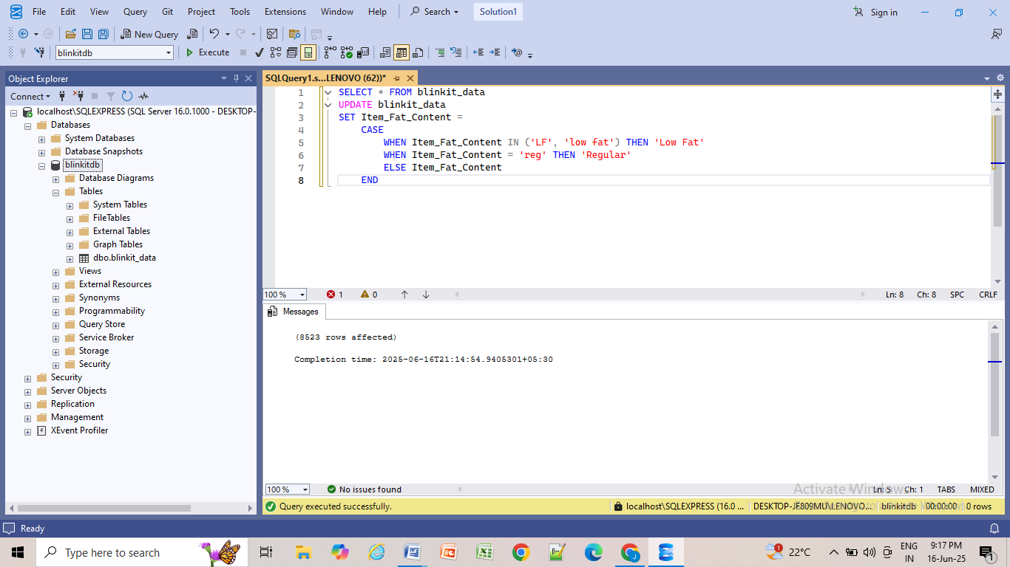

2. SELECT DISTINCT(Item_Fat_Content) FROM blinkit_data

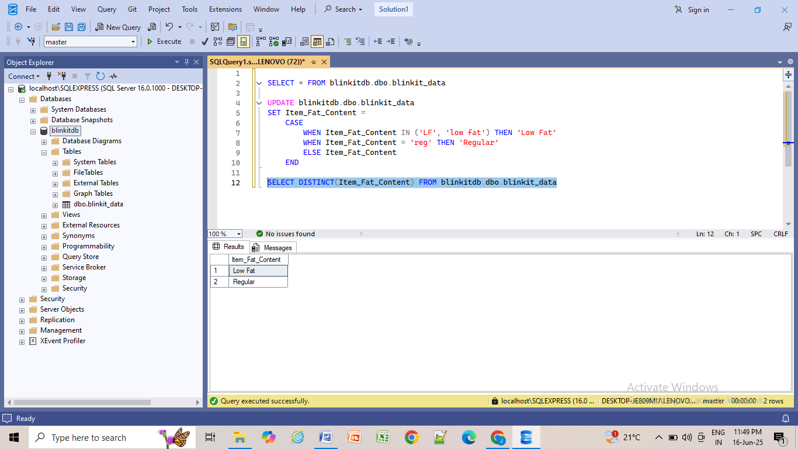

# KPI REQUIREMENT:

1. TOTAL SALES:

SELECT CAST(SUM(Sales)/1000000 AS DECIMAL(10,2)) AS Total_Sales_Million

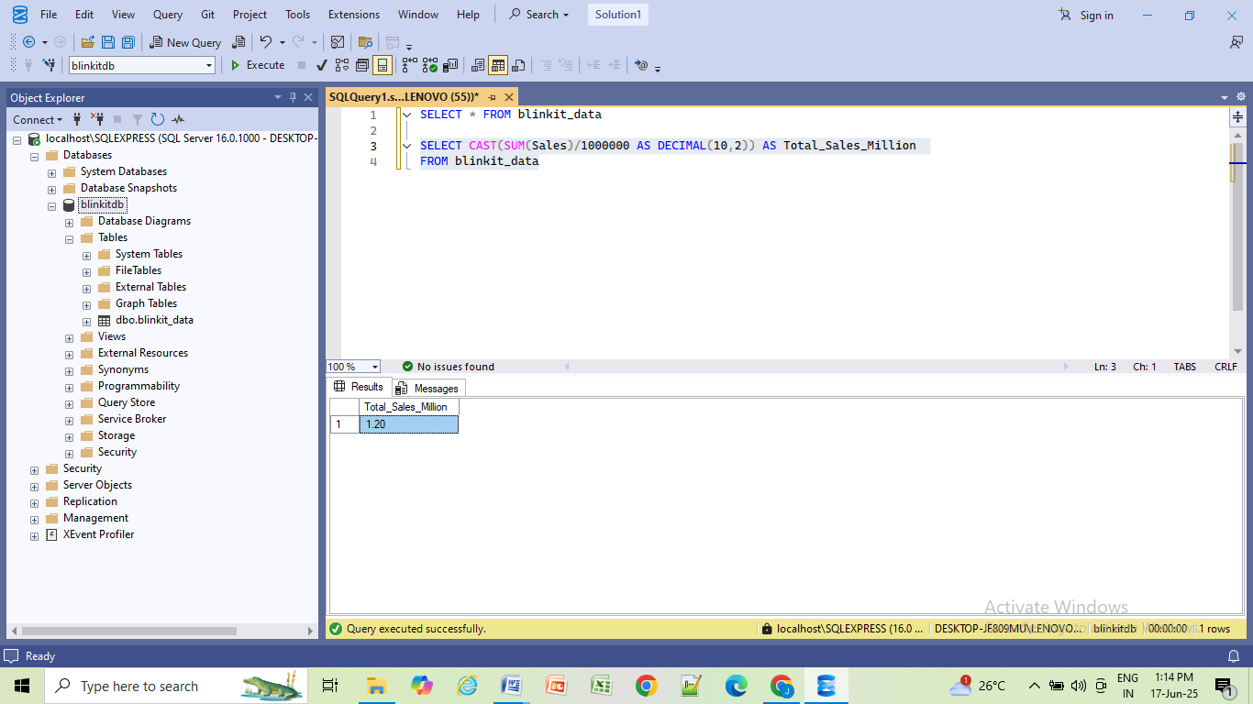FROM blinkit_data

2. AVERAGE SALES

SELECT CAST(AVG(Sales) AS int)AS Avg_Sales FROM blinkit_data

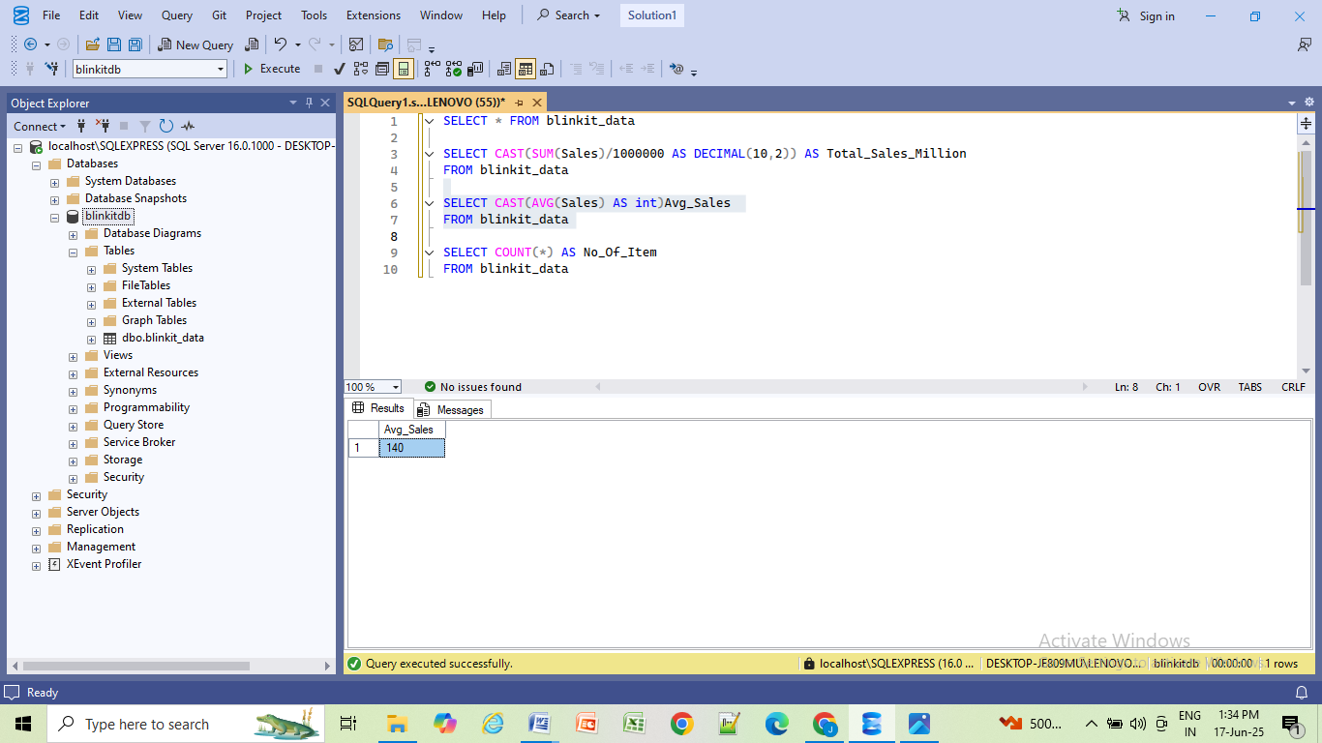

3. NO OF ITEMS

SELECT COUNT(*) AS No_Of_Item FROM blinkit_data

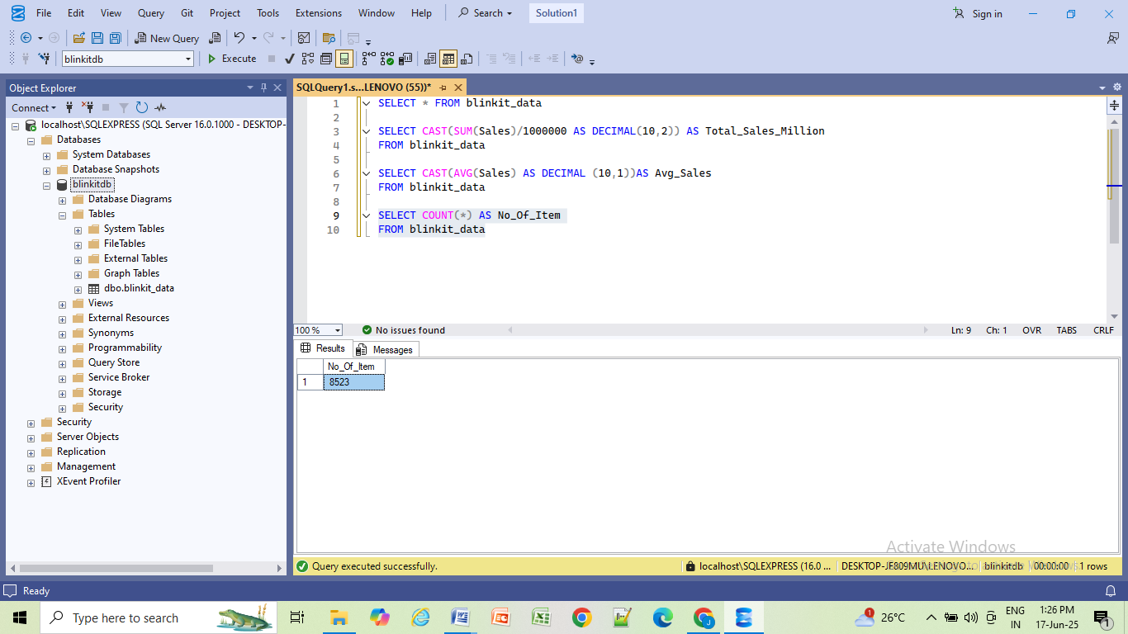

4. AVERAGE RATING

SELECT CAST(AVG(Rating) AS decimal(10,1)) AS Avg_Rating

FROM blinkit_data

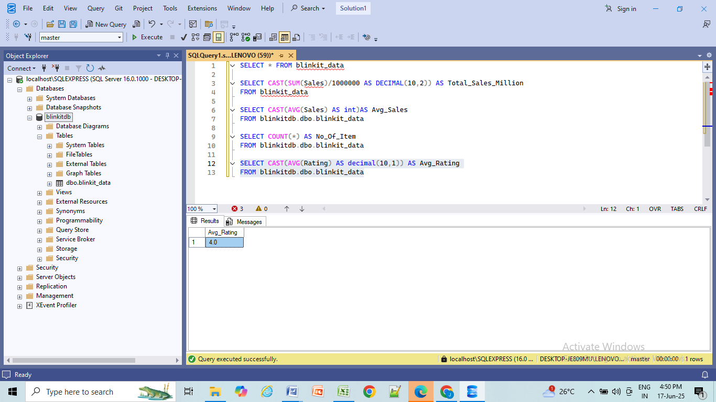

# TOTAL SALES BY FAT CONTENT:

SELECT Item_Fat_Content,CAST(SUM(Sales) AS DECIMAL (10,2)) AS Total_Sales

FROM blinkit_data

GROUP BY Item_Fat_Content

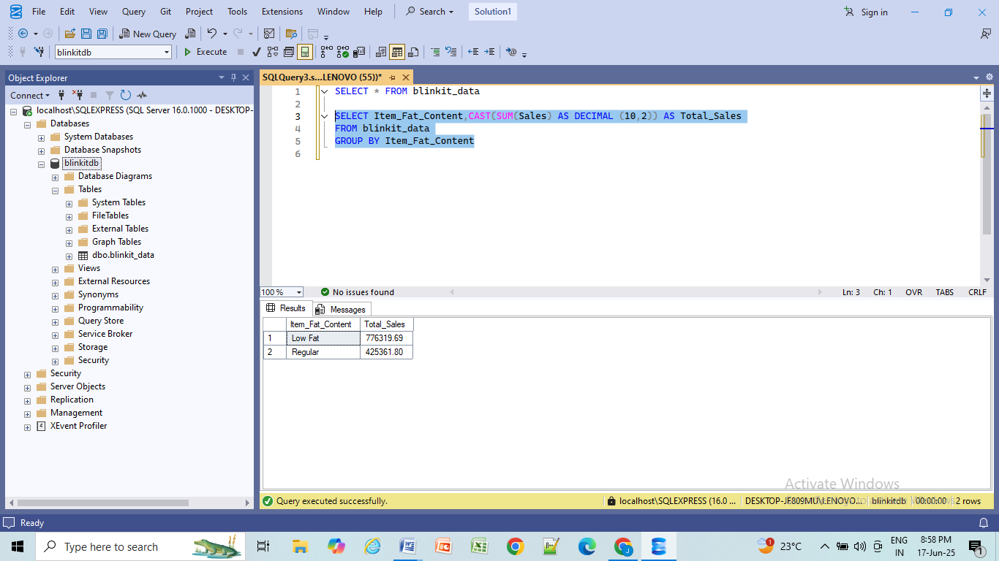

Additional KPI Metrics By Fat Content:

In this section, we assess how key performance indicators (KPIs) such as **Average Sales**, **Number of Items**, and **Average Rating** vary based on the different categories of Item fat content.

SELECT

Item_Fat_Content,

CAST(SUM(Sales) AS DECIMAL(10,2)) AS Total_Sales,

CAST(AVG(Sales) AS DECIMAL(10,2)) AS Avg_Sales,

COUNT(*) AS Number_of_Item,

CAST(AVG(Rating) AS DECIMAL(10,2)) AS Avg_Rating

FROM blinkit_data

GROUP BY Item_Fat_Content

ORDER BY Total_Sales DESC;

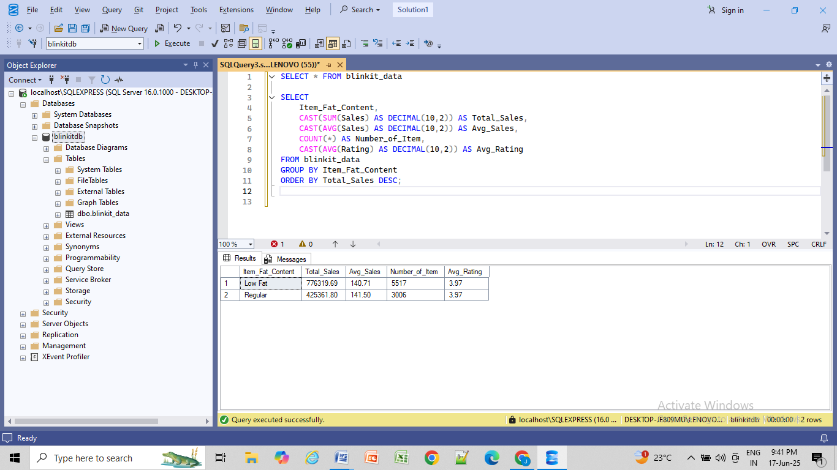

# TOTAL SALES BY ITEM TYPE :

SELECT Item_Type, CAST(SUM(Sales) AS DECIMAL(10,2)) AS Total_Sales FROM blinkit_data

GROUP BY Item_Type

ORDER BY Total_Sales DESC

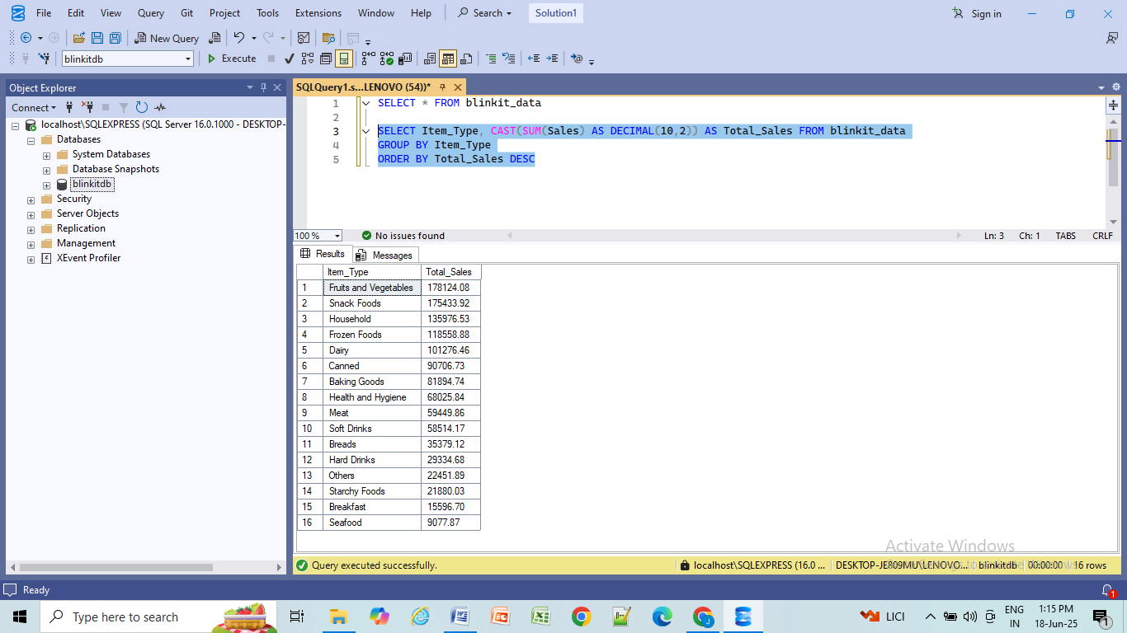

Additional KPI Metrics By Item Type:

In this section, we assess how key performance indicators (KPIs) such as **Average Sales**, **Number of Items**, and **Average Rating** vary based on the different categories of Item type.

SELECT Item_Type,

CAST(SUM(Sales) AS DECIMAL(10,2)) AS Total_Sales ,

CAST(AVG(Sales) AS DECIMAL (10,2)) AS Avg_Sales,

COUNT(*) AS Number_of_Item,

CAST(AVG(Rating) AS DECIMAL (10,1)) AS Avg_Rating

FROM blinkit_data

GROUP BY Item_Type

ORDER BY Total_Sales DESC

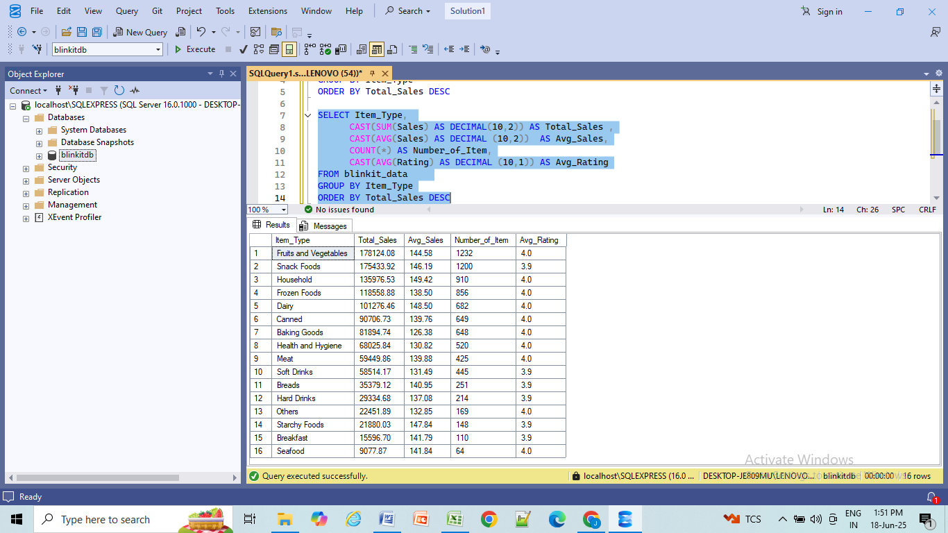

# FAT CONTENT BY OUTLET FOR TOTAL SALES :

SELECT Outlet_Location_Type,Item_Fat_Content, CAST(SUM(Sales) AS DECIMAL (10,2))

AS Total_Sales

FROM blinkit_data

GROUP BY Outlet_Location_Type,Item_Fat_Content

ORDER BY Total_Sales DESC

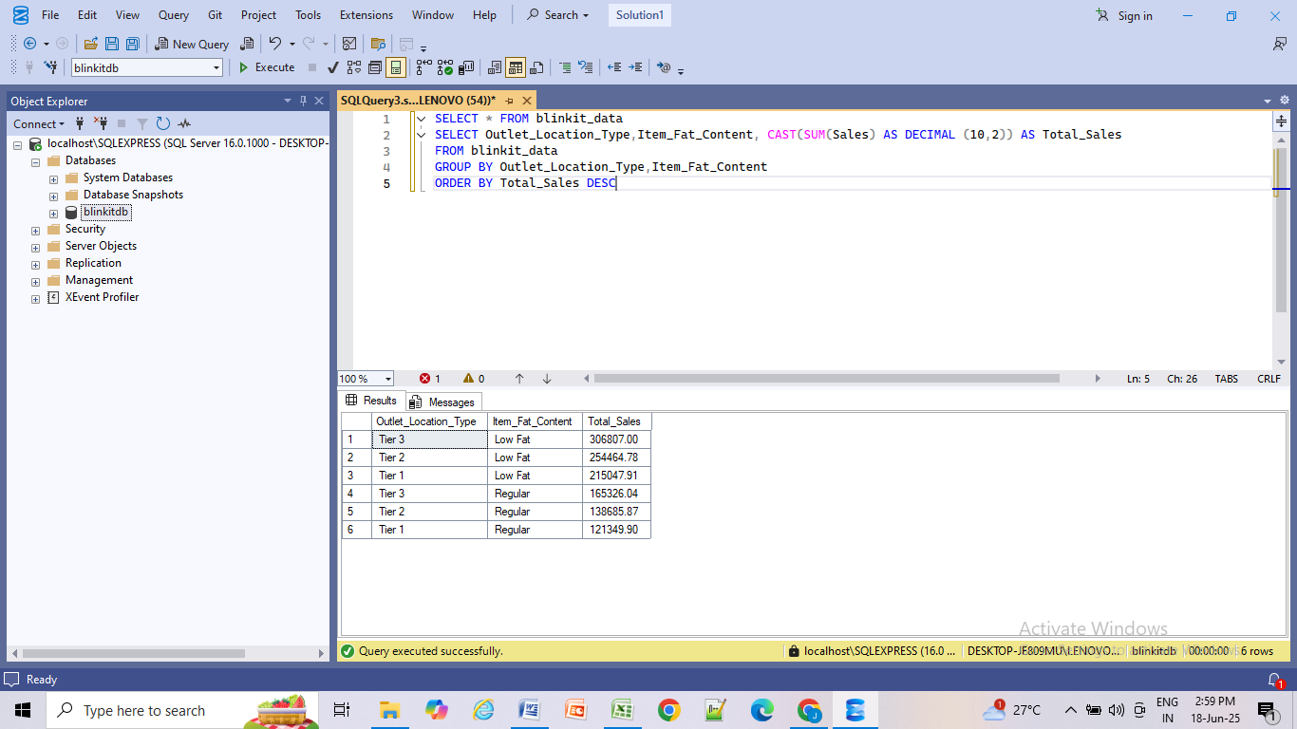

Additional KPI Metrics by Outlet Type – Total Sales Analysis:

In this section, we assess how key performance indicators (KPIs) such as **Average Sales**, **Number of Items**, and **Average Rating** vary across different outlet segments, grouped by fat content.

SELECT Outlet_Location_Type,Item_Fat_Content,

CAST(SUM(Sales) AS DECIMAL (10,2)) AS Total_Sales ,

CAST(AVG(Sales) AS DECIMAL (10,2)) AS Avg_Sales,

COUNT(*) AS Number_of_Item,

CAST(AVG(Rating) AS DECIMAL (10,1)) AS Avg_Rating

FROM blinkit_data

GROUP BY Outlet_Location_Type,Item_Fat_Content

ORDER BY Total_Sales DESC

# Screenshot (56).pngTOTAL SALES BY OUTLET ESTABLISHMENT :

SELECT Outlet_Establishment_Year, CAST(SUM(Sales) AS DECIMAL (10,2))

AS Total_Sales

FROM blinkit_data

GROUP BY Outlet_Establishment_Year

ORDER BY Outlet_Establishment_Year ASC

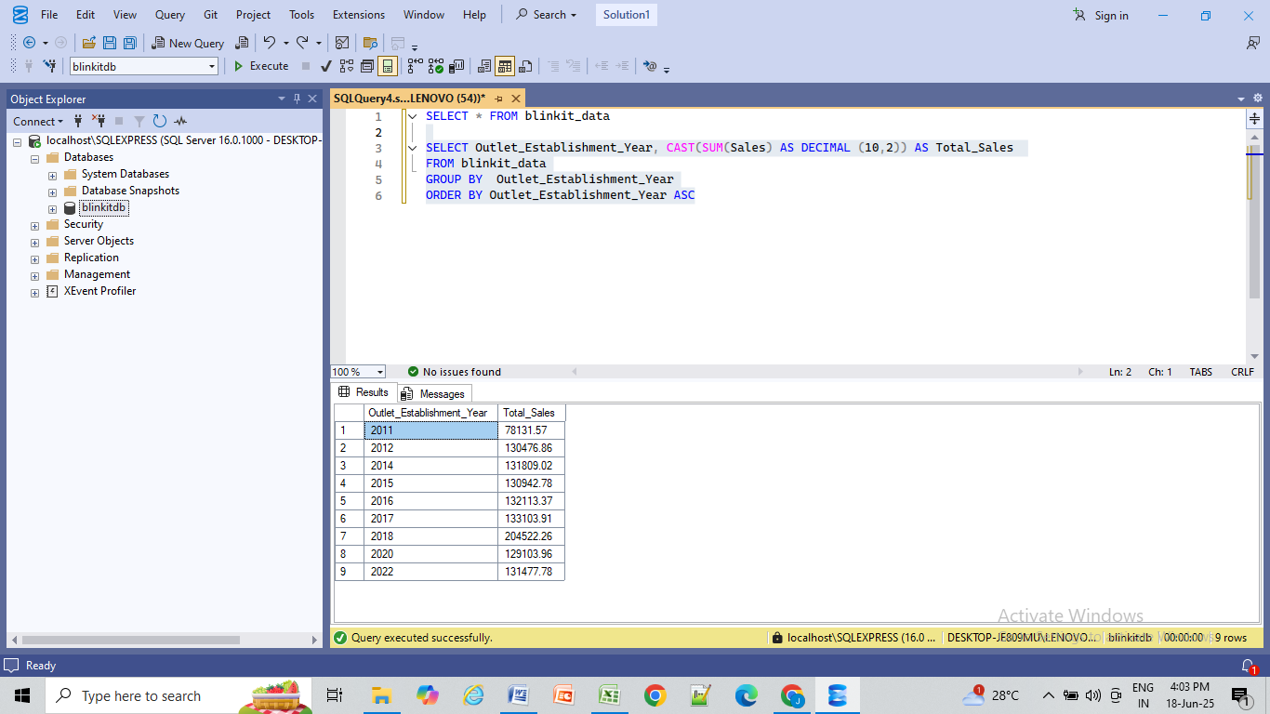

Additional KPI Metrics By Outlet Establishment:

In this section, we assess how key performance indicators (KPIs) such as **Average Sales**, **Number of Items**, and **Average Rating** vary based on the different outlet establishment year.

SELECT Outlet_Establishment_Year,

CAST(SUM(Sales) AS DECIMAL (10,2)) AS Total_Sales,

CAST(AVG(Sales) AS DECIMAL (10,2)) AS Avg_Sales,

COUNT(*) AS Number_of_Item,

CAST(AVG(Rating) AS DECIMAL (10,1)) AS Avg_Rating

FROM blinkit_data

GROUP BY Outlet_Establishment_Year

ORDER BY Outlet_Establishment_Year ASC

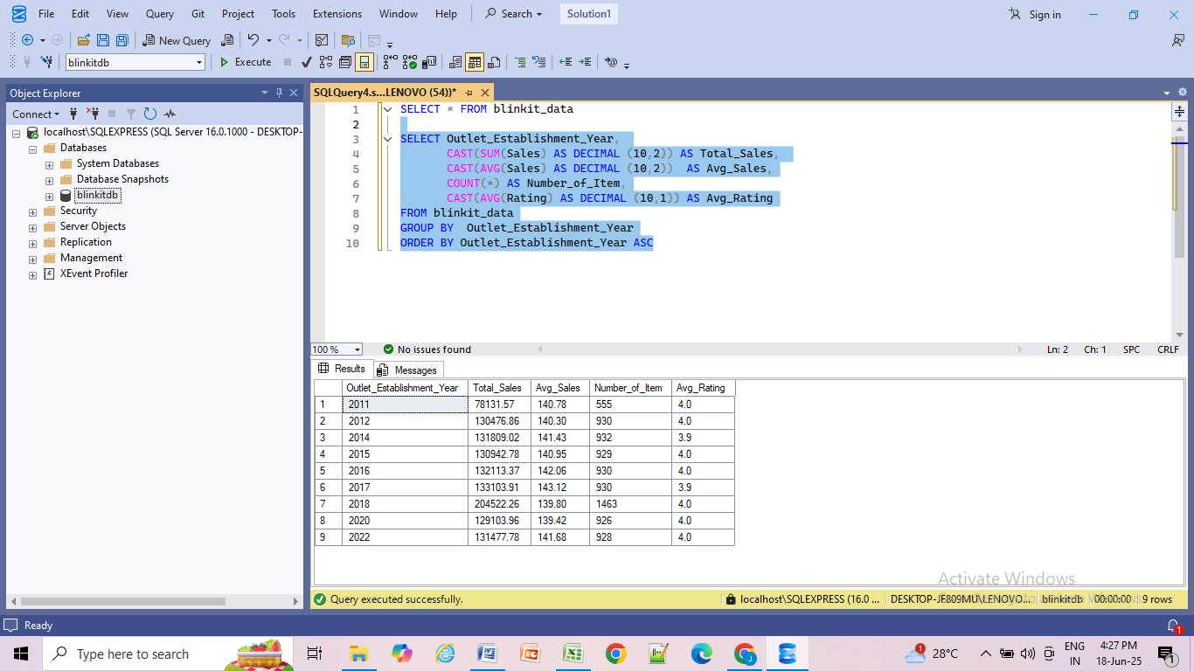

# PERCENTAGE OF SALES BY OUTLET SIZE :

SELECT Outlet_Size,

CAST(SUM(Sales) AS DECIMAL (10,2)) AS Total_Sales,

CAST((SUM(Sales)*100/SUM(SUM(Sales)) OVER()) AS DECIMAL (10,2))

AS Sales_Percentage

FROM blinkit_data

GROUP BY Outlet_Size

ORDER BY Total_Sales DESC

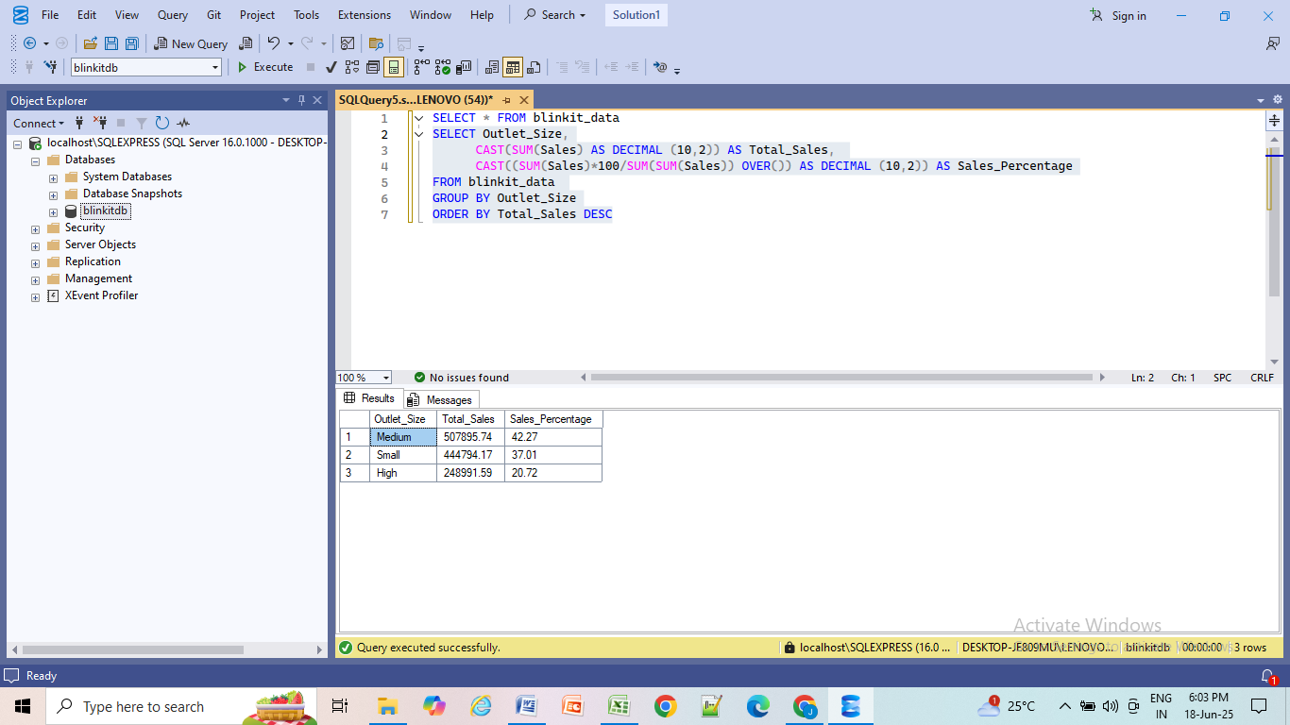

# SALES BY OUTLET LOCATION :

SELECT Outlet_Location_Type,

CAST(SUM(Sales) AS DECIMAL (10,2)) AS Total_Sales,

CAST((SUM(Sales)*100/SUM(SUM(Sales)) OVER()) AS DECIMAL (10,2)) AS Sales_Percentage,

CAST(AVG(Sales) AS DECIMAL (10,2)) AS Avg_Sales,

COUNT(*) AS Number_of_Item,

CAST(AVG(Rating) AS DECIMAL (10,1)) AS Avg_Rating

FROM blinkit_data

GROUP BY Outlet_Location_Type

ORDER BY Total_Sales DESC

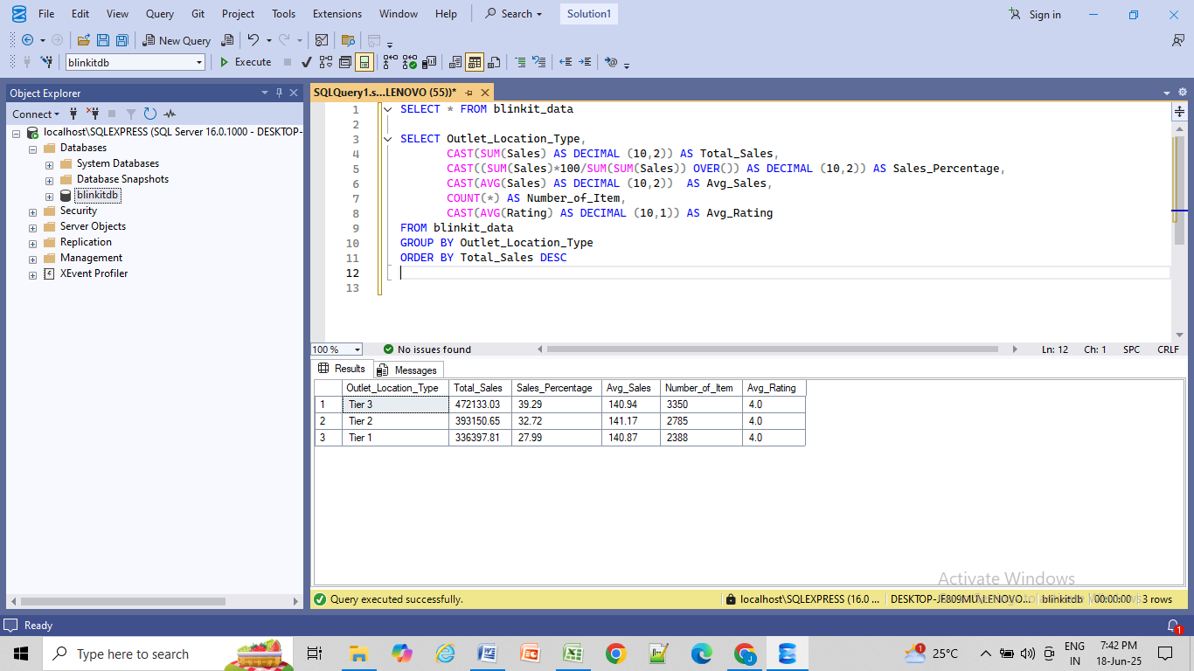

# SALES BY OUTLET TYPE :

SELECT Outlet_Type,

CAST(SUM(Sales) AS DECIMAL (10,2)) AS Total_Sales,

CAST((SUM(Sales)*100/SUM(SUM(Sales)) OVER()) AS DECIMAL (10,2)) AS Sales_Percentage,

CAST(AVG(Sales) AS DECIMAL (10,2)) AS Avg_Sales,

COUNT(*) AS Number_of_Item,

CAST(AVG(Rating) AS DECIMAL (10,1)) AS Avg_Rating

FROM blinkit_data

GROUP BY Outlet_Type

ORDER BY Total_Sales DESC

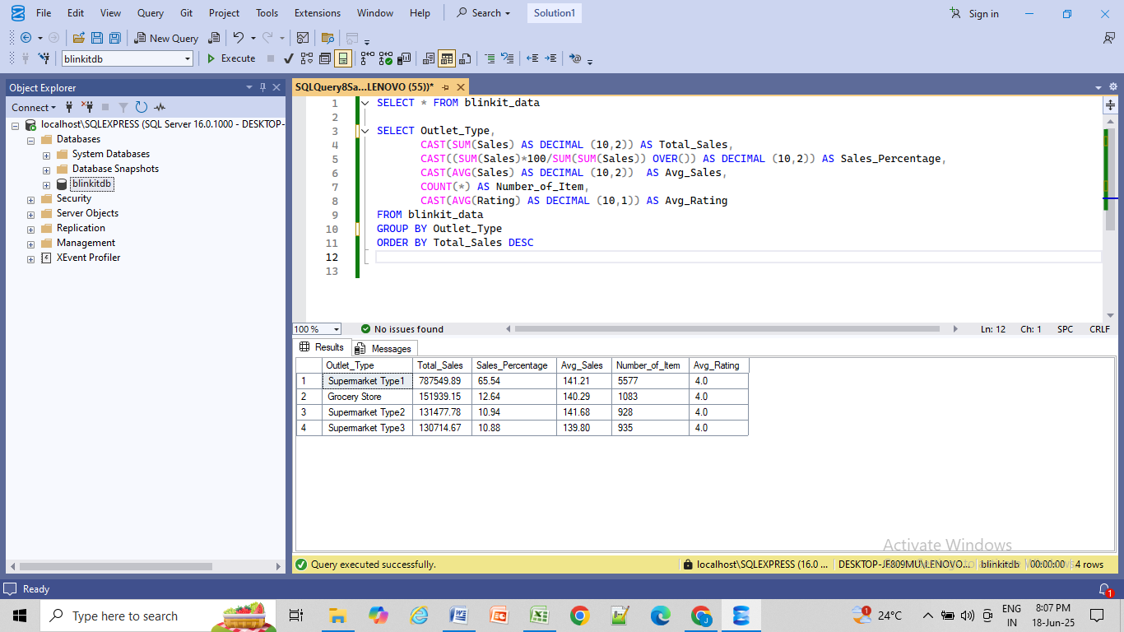

# CONCLUSION :

The analysis highlights that sales performance varies by fat content and outlet type. **Low Fat** products and **Supermarket Type1 outlets** showed strong sales, while customer ratings remained consistently high across all categories.

*Visualizations and dashboards based on this analysis are available in my separate Power BI project uploaded on GitHub.*