Customer Satisfaction Survey using SQL

Author: Jyoti Rekha Dutta

Tools Used: MS SQL Server, Excel

# Project objective:

To analyze the Customer Satisfaction Survey dataset in Google BigQuery to evaluate customer satisfaction and NPS trends across campaigns, survey languages, and years, in order to derive actionable business insights.

# Viewing imported data:

The following query is used to view the Customer Satisfaction Survey dataset after importing it into the Google BigQuery environment :

SELECT * FROM `burnished-ether-467007-j1.2.Housing` LIMIT 40

# **Satisfaction by Year**

SELECT

Year,

ROUND(AVG(CAST(NPS AS INT64)), 2) AS Avg_NPS

FROM

`burnished-ether-467007-j1.2.Housing`

GROUP BY

Year

ORDER BY

Year;

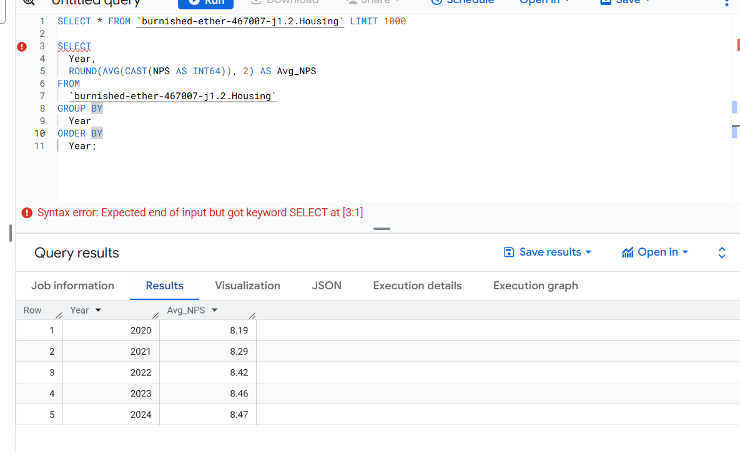

**Satisfaction by Campaign**

SELECT

Campaign,

  ROUND(AVG(CAST(NPS AS INT64)), 2) AS Avg_NPS,

  COUNT(*) AS Response_Count

FROM

  `burnished-ether-467007-j1.2.Housing`

GROUP BY

  Campaign

ORDER BY

  Avg_NPS DESC;

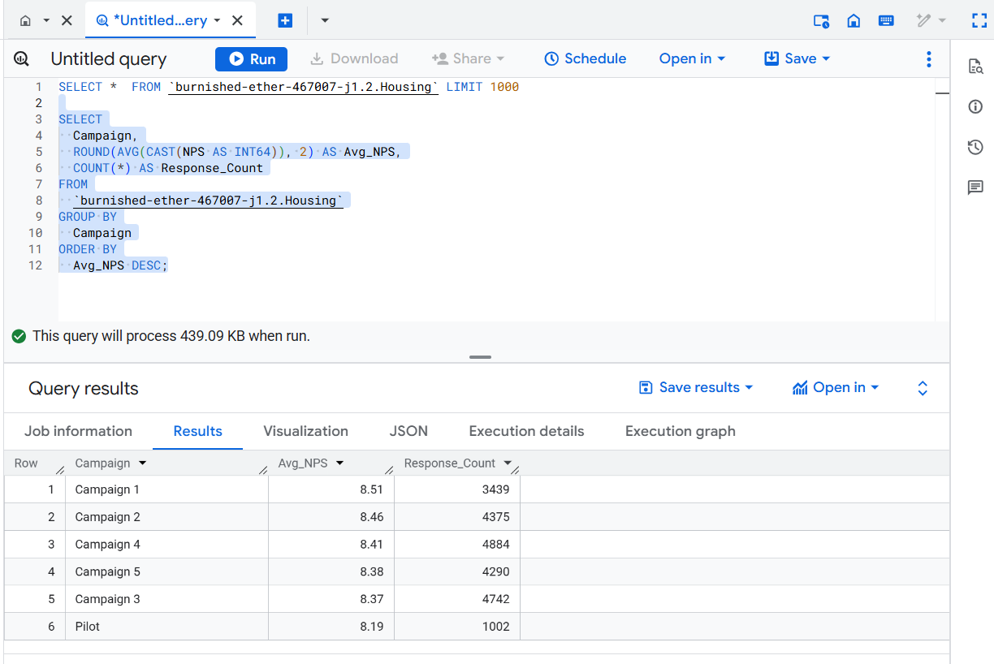

**Agent Performance (Job Knowledge)**

SELECT

  `Agent - Job Knowledge`,

  COUNT(*) AS Count,

  ROUND(COUNT(*) * 100.0 / (SELECT COUNT(*) FROM

`burnished-ether-467007-j1.2.Housing`), 2) AS Percentage

FROM

  `burnished-ether-467007-j1.2.Housing`

GROUP BY

  `Agent - Job Knowledge`

ORDER BY

  Count DESC;

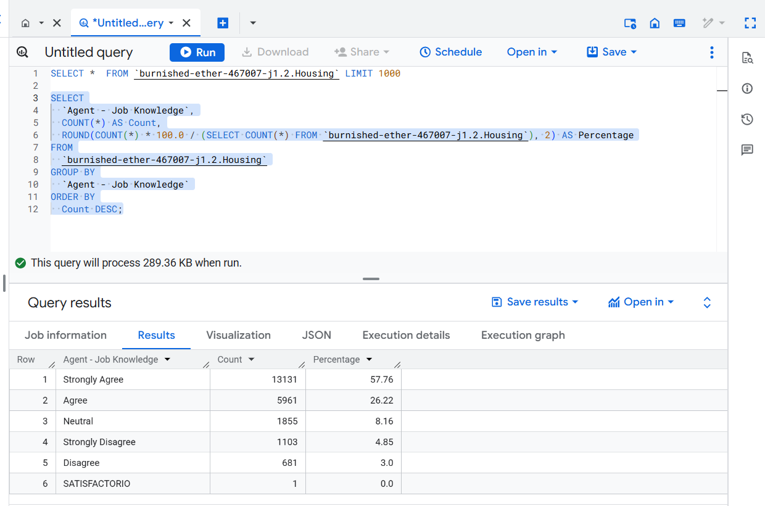

**Detractors, Passives, and Promoters (NPS Segmentation)**

WITH nps_segments AS (

  SELECT

    CASE

      WHEN CAST(NPS AS INT64) >= 9 THEN 'Promoter'

      WHEN CAST(NPS AS INT64) >= 7 THEN 'Passive'

      ELSE 'Detractor'

    END AS nps_segment

  FROM

    `burnished-ether-467007-j1.2.Housing`

)

SELECT

  nps_segment,

  COUNT(*) AS count,

  ROUND(COUNT(*) * 100.0 / (SELECT COUNT(*) FROM nps_segments), 2) AS percentage

FROM

  nps_segments

GROUP BY

  nps_segment;

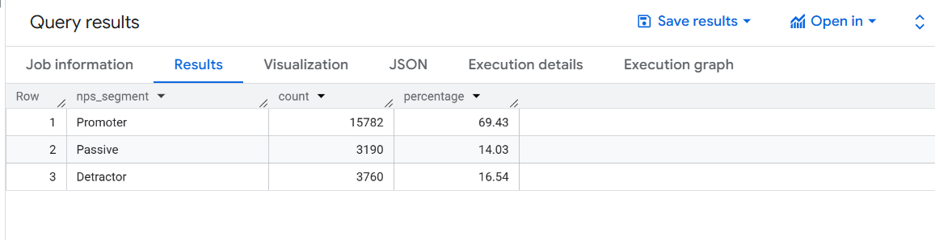

**Resolution Satisfaction Analysis**

SELECT

`Answer Satisfaction`,

ROUND(AVG(CAST(NPS AS INT64)), 2) AS Avg_NPS,

COUNT(*) AS Response_Count

FROM

`your_project.your_dataset.Customer_Satisfaction_Survey`

GROUP BY

`Answer Satisfaction`

ORDER BY

Avg_NPS DESC;

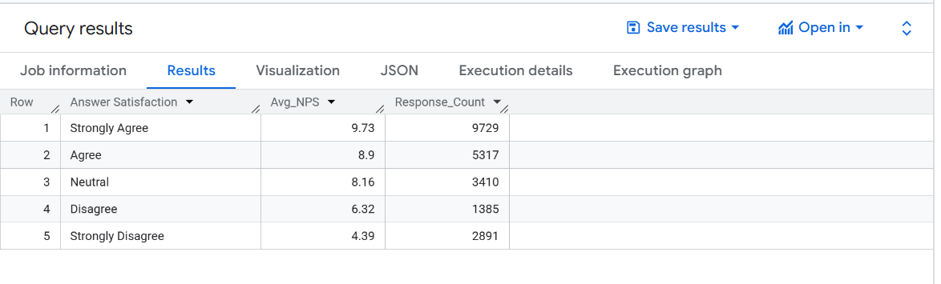

**Survey Completion Rate by Time Category**

SELECT

  `Time Category`,

  COUNT(*) AS Count,

  ROUND(COUNT(*) * 100.0 / (SELECT COUNT(*) FROM `burnished-ether-467007-j1.2.Housing`), 2) AS Percentage

FROM

  `burnished-ether-467007-j1.2.Housing`

GROUP BY

  `Time Category`

ORDER BY

  Count DESC;

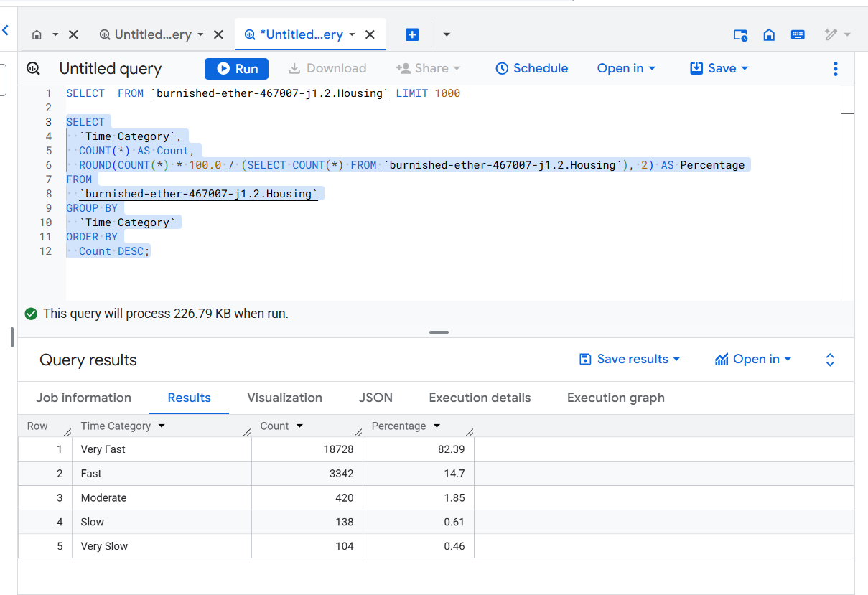

**Count of Campaigns by Year**

SELECT Year, Campaign, COUNT(*) AS survey_count

FROM `burnished-ether-467007-j1.2.Housing`

GROUP BY Year, Campaign

ORDER BY Year, survey_count DESC;

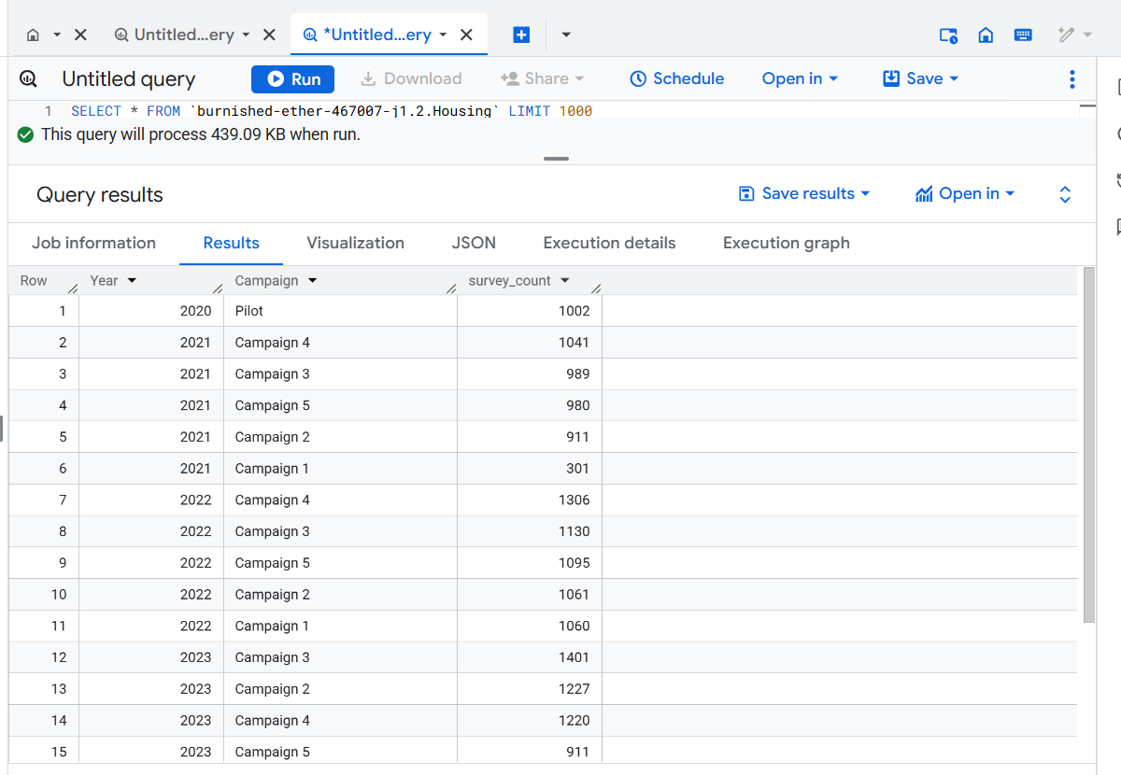

**Most Efficient & Satisfying Interactions**

SELECT

  *

FROM

  `burnished-ether-467007-j1.2.Housing`

WHERE

  `Time Category` = 'Very Fast'

  AND `Overall Satisfaction` = 'Strongly Agree'

  AND `Wait Time` = 'Strongly Agree'

  AND `Agent - Customer Service` = 'Strongly Agree'

  AND `Agent - Job Knowledge` = 'Strongly Agree'

  AND `Answer Satisfaction` = 'Strongly Agree';

**Identifying the Most Critical Feedback**

SELECT

  *

FROM

  `burnished-ether-467007-j1.2.Housing`

WHERE

  `Overall Satisfaction` IN ('Disagree', 'Strongly Disagree')

  AND `Wait Time` IN ('Disagree', 'Strongly Disagree')

  AND `Agent - Customer Service` IN ('Disagree', 'Strongly Disagree')

  AND `Agent - Job Knowledge` IN ('Disagree', 'Strongly Disagree')

  AND `Answer Satisfaction` IN ('Disagree', 'Strongly Disagree');

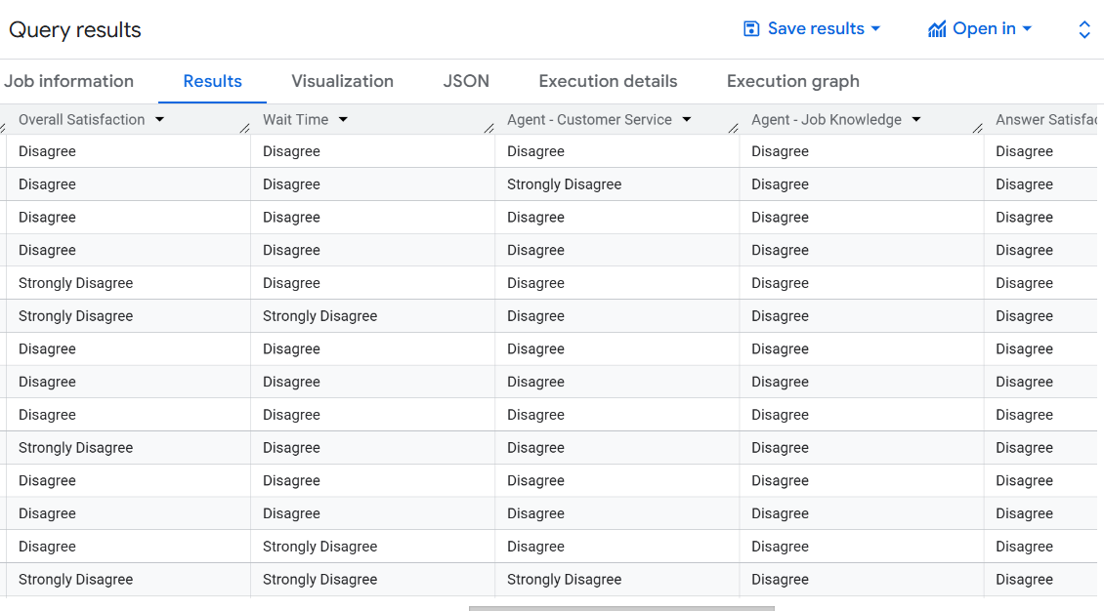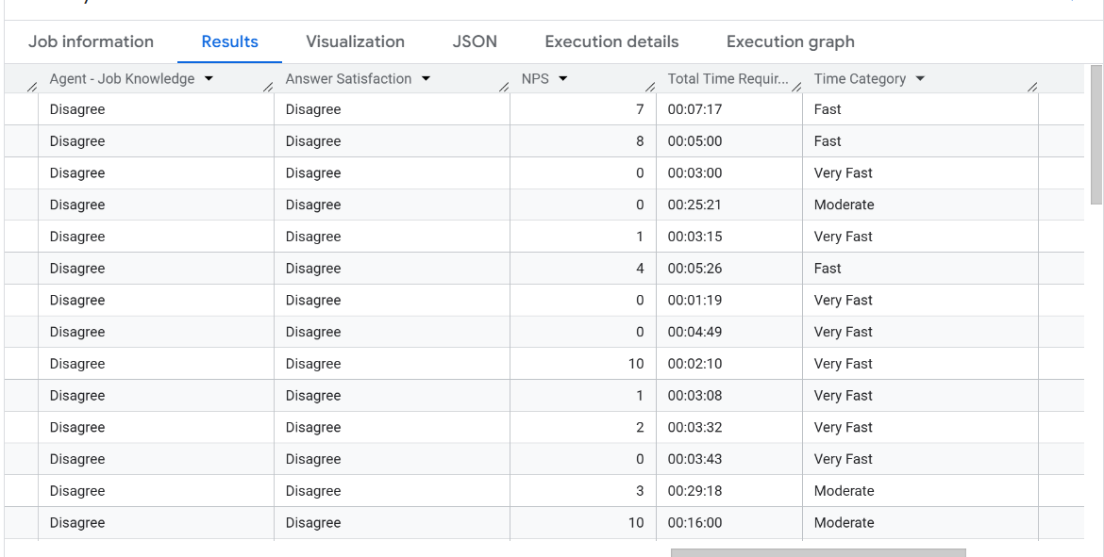

**Customer Satisfaction & NPS Analysis by Campaign and Language**

SELECT

    Campaign,

    `Survey Language` AS Language,

    COUNT(*) AS Total_Surveys,

    ROUND(AVG(CAST(NPS AS FLOAT64)), 2) AS Avg_NPS,

    ROUND(AVG(CASE

                WHEN `Overall Satisfaction` = 'Strongly Agree' THEN 5

                WHEN `Overall Satisfaction` = 'Agree' THEN 4

                WHEN `Overall Satisfaction` = 'Neutral' THEN 3

                WHEN `Overall Satisfaction` = 'Disagree' THEN 2

                WHEN `Overall Satisfaction` = 'Strongly Disagree' THEN 1

                ELSE NULL

             END), 2) AS Avg_Satisfaction_Score

FROM `burnished-ether-467007-j1.2.Housing`

WHERE `Survey Language` IS NOT NULL

GROUP BY Campaign, `Survey Language`

ORDER BY Campaign, Avg_NPS DESC;

