Netflix Data Analysis using SQL

Author: Jyoti Rekha Dutta

Tools Used: pgAdmin 4, Excel

# PROJECT OBJECTIVE:

To analyze Netflix data using SQL by cleaning the dataset and uncovering insights related to content type, ratings, release year, country distribution, and genre trends.

# CREATE TABLE:

CREATE TABLE netflix

(

show_id VARCHAR(5),

type VARCHAR(10),

title VARCHAR(250),

director VARCHAR(550),

casts VARCHAR(1050),

country VARCHAR(550),

date_added VARCHAR(55),

release_year INT,

rating VARCHAR(15),

duration VARCHAR(15),

listed_in VARCHAR(250),

description VARCHAR(550)

);

# VIEWING ALL IMPORTED DATA:

The following query is used to view the complete Netflix dataset after importing it into the SQL Server environment:

SELECT * FROM Netflix

# SELECT COUNT (*) as total_content FROM netflix

# Screenshot (84).png

SELECT DISTINCT type FROM netflix

# Screenshot (85).png

# SOLUTIONS OF BUSINESS PROBLEMS:

# 1.Count the number of Movies vs TV Shows

SELECT type, count(*) as total_content FROM netflix GROUP BY type

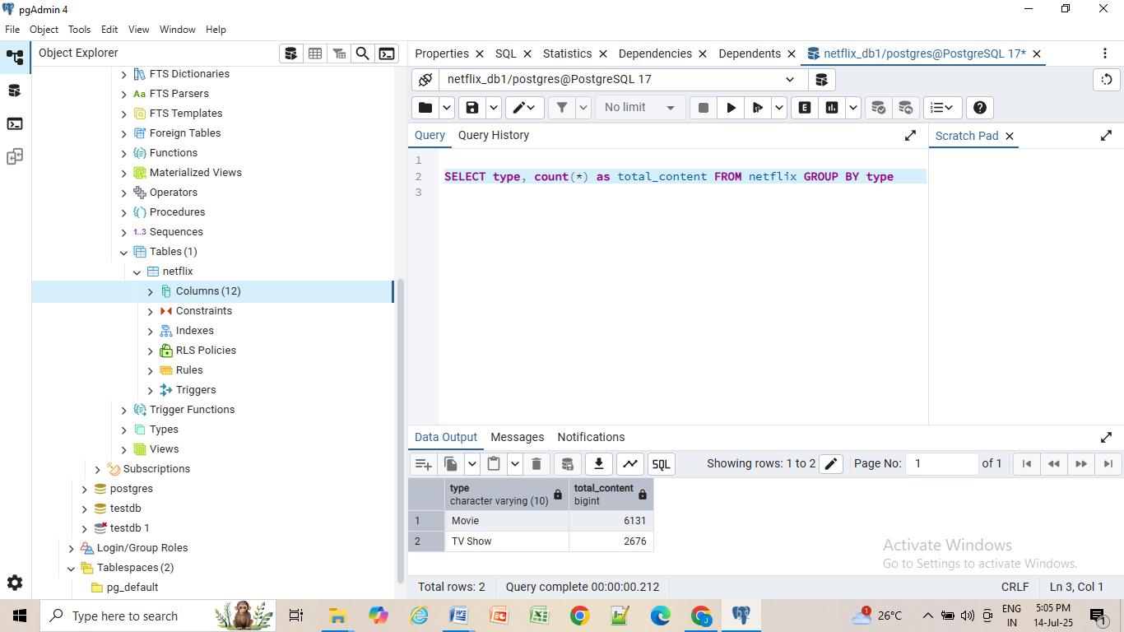

# 2. The most common rating for movies and TV shows

SELECT type,rating, count(*),

RANK() OVER(PARTITION BY type ORDER BY count(*) DESC) AS ranking

FROM netflix

GROUP BY 1,2

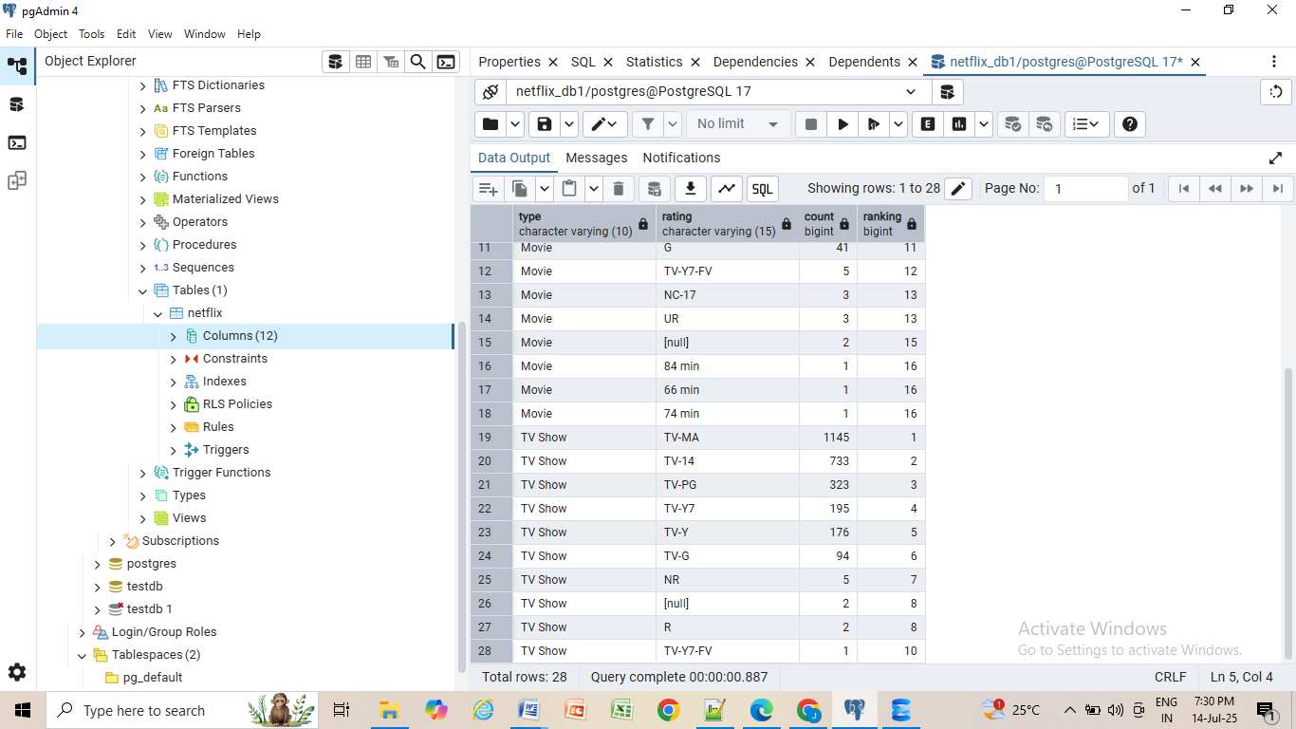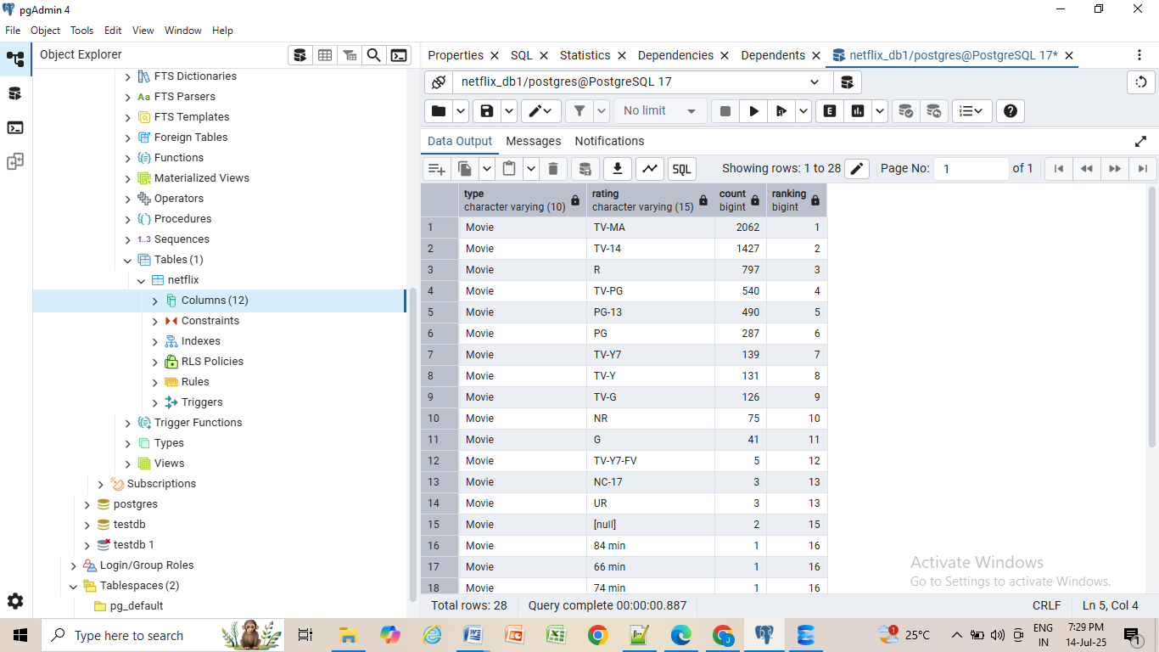

SELECT

type,

rating

FROM

(SELECT type,rating, count(*),

RANK() OVER(PARTITION BY type ORDER BY count(*) DESC) AS ranking

FROM netflix

GROUP BY 1,2) as t1

WHERE ranking=1

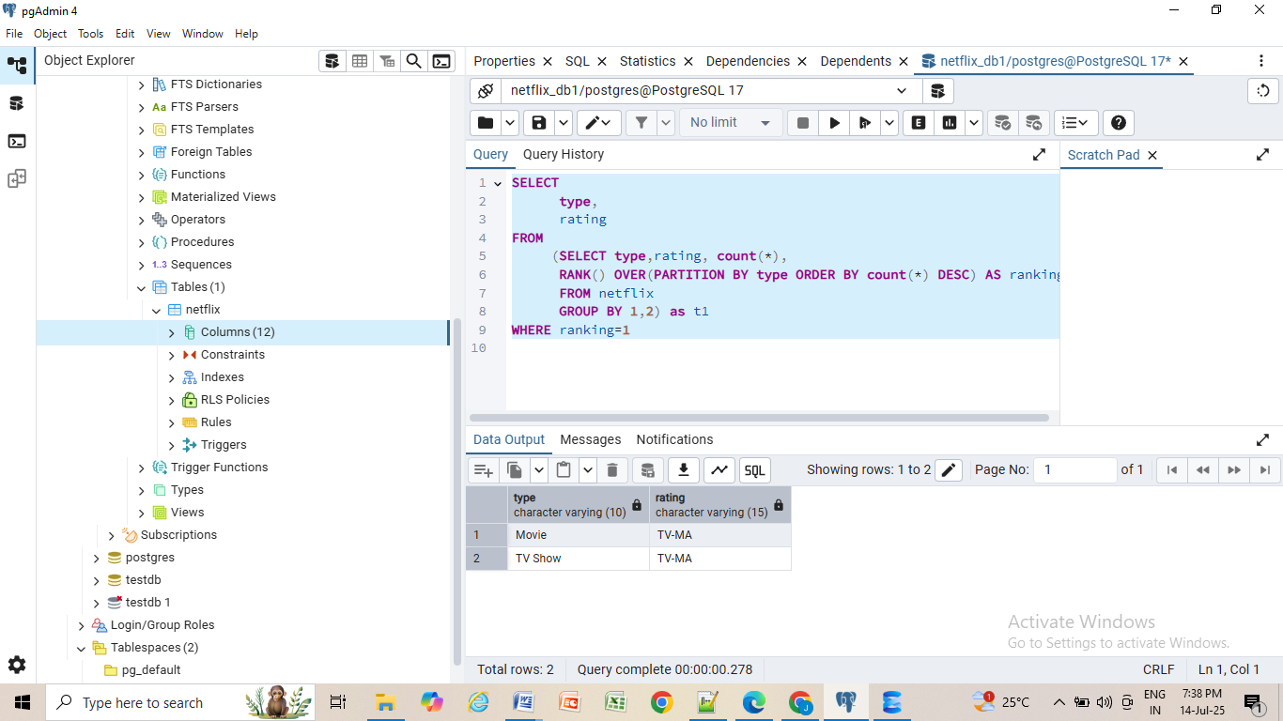

# 3. List of all movies released in a specific year (e.g., 2020)

SELECT * FROM netflix

WHERE

type= 'Movie'

AND

release_year=2020

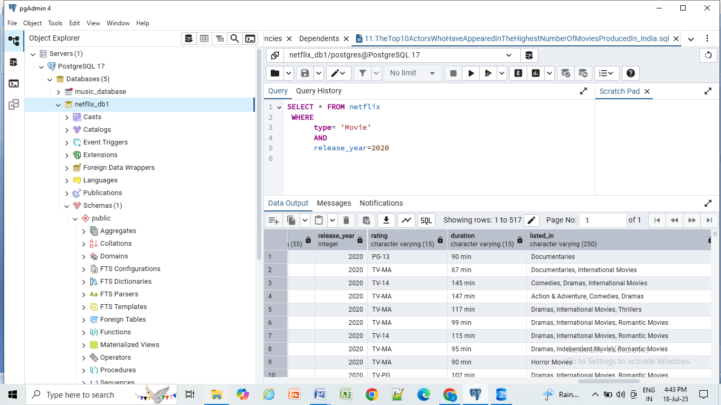

# 4.The top 5 countries with the most content on Netflix

SELECT

UNNEST(STRING_TO_ARRAY(country,',')) AS new_country,

count (show_id) as total_content

FROM netflix

GROUP BY 1

ORDER BY 2 DESC

LIMIT 5

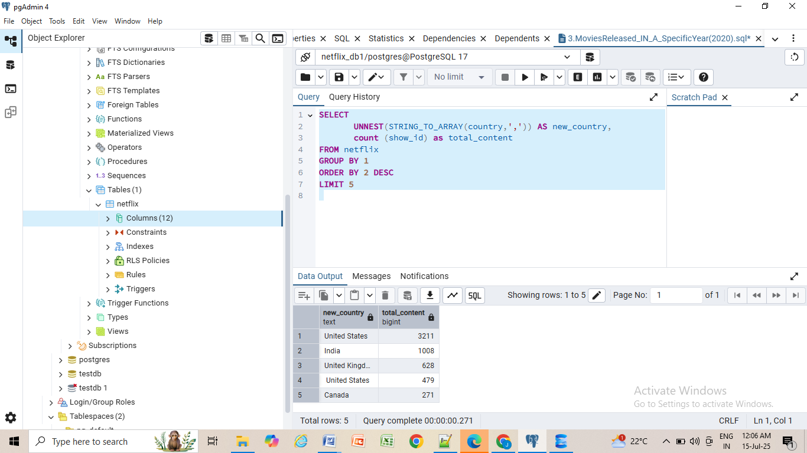

# 5. Identification of the longest movie

SELECT * FROM netflix

WHERE

type='Movie'

AND

duration= (SELECT MAX(duration) FROM netflix)

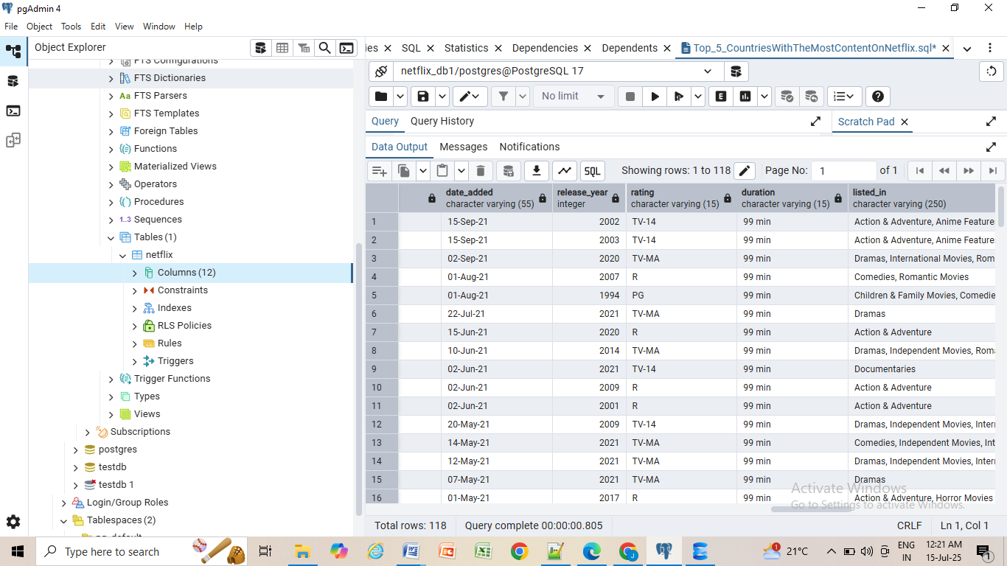

# 6. All the movies/TV shows by director 'Rajiv Chilaka'

SELECT * FROM netflix

WHERE director ILike '%Rajiv Chilaka%'

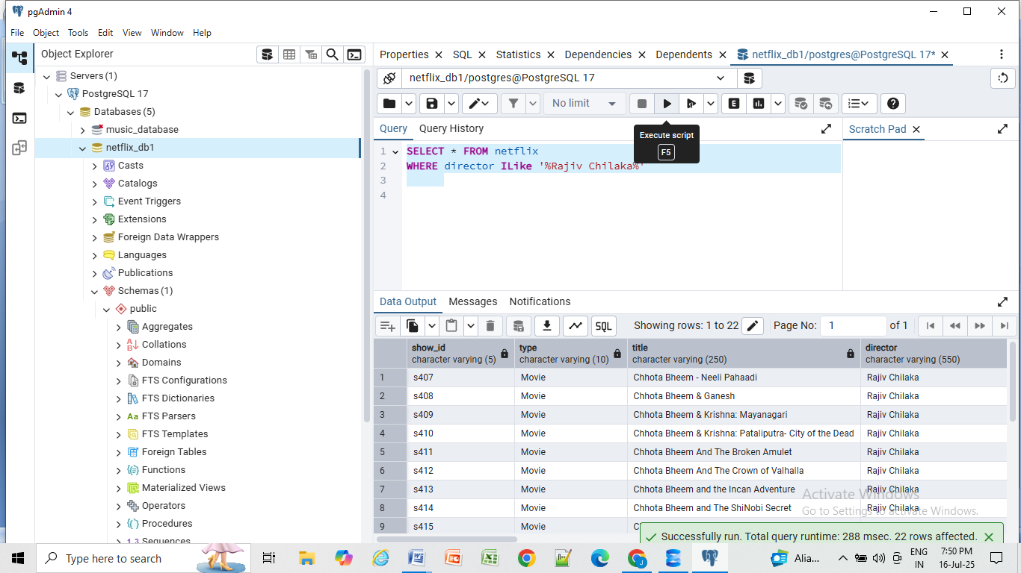

# 7. All TV shows with more than 5 seasons

SELECT *

FROM netflix

WHERE

type = 'TV Show'

AND CAST(SPLIT_PART(duration, ' ', 1) AS INTEGER) > 5;

# Screenshot (111).png8. All movies that are documentaries

SELECT * FROM netflix

WHERE listed_in ILIKE '%documentaries%'

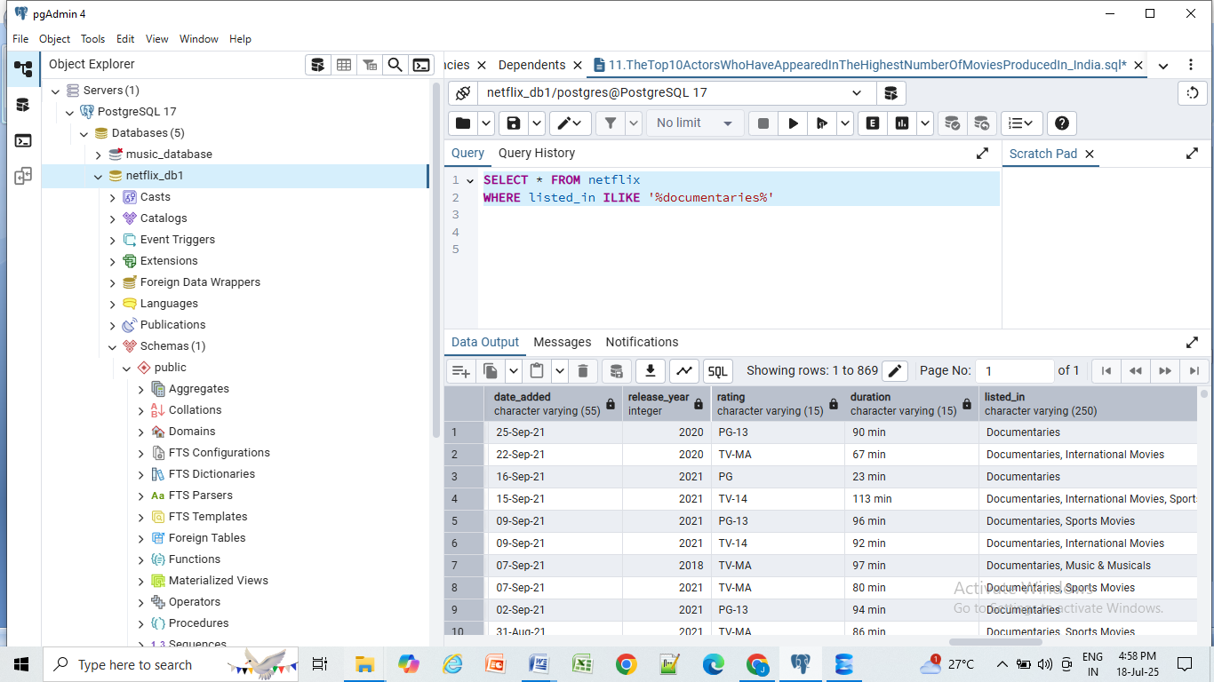

# 9. All content without a director

SELECT * FROM netflix

WHERE director is null

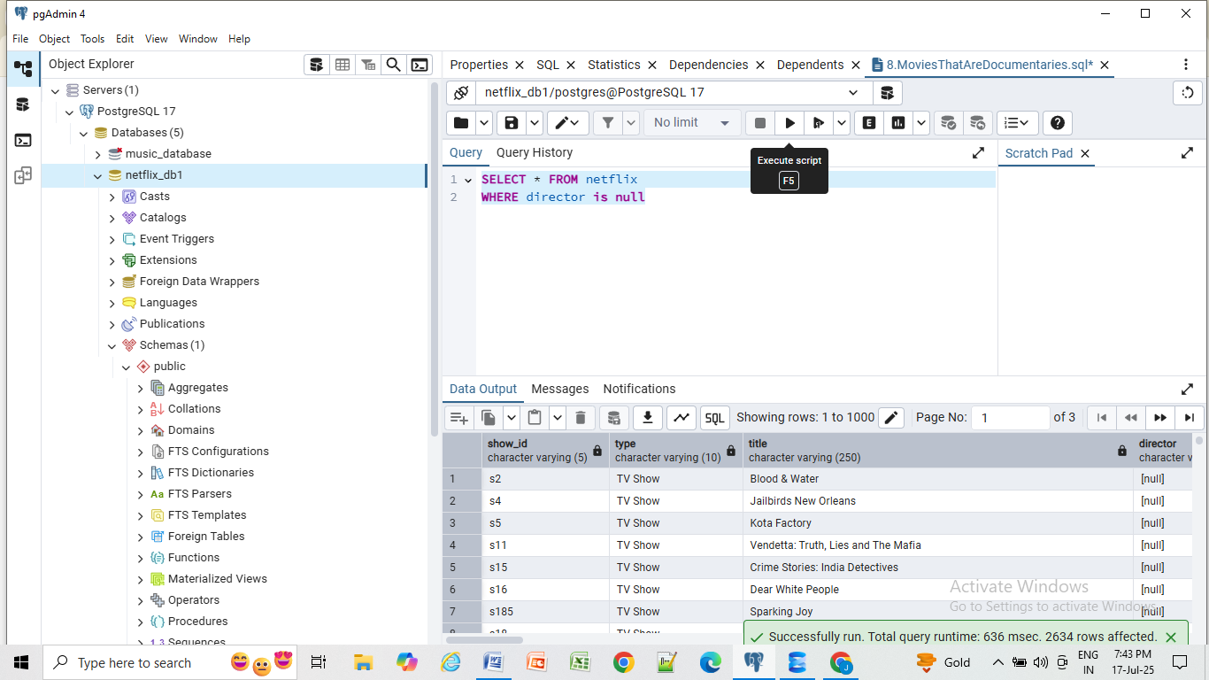

# 10. How many movies actor 'Salman Khan' appeared in last 10 years

SELECT * FROM netflix

WHERE casts ILIKE '%Salman khan%'

AND

release_year > EXTRACT(YEAR FROM CURRENT_DATE) - 10

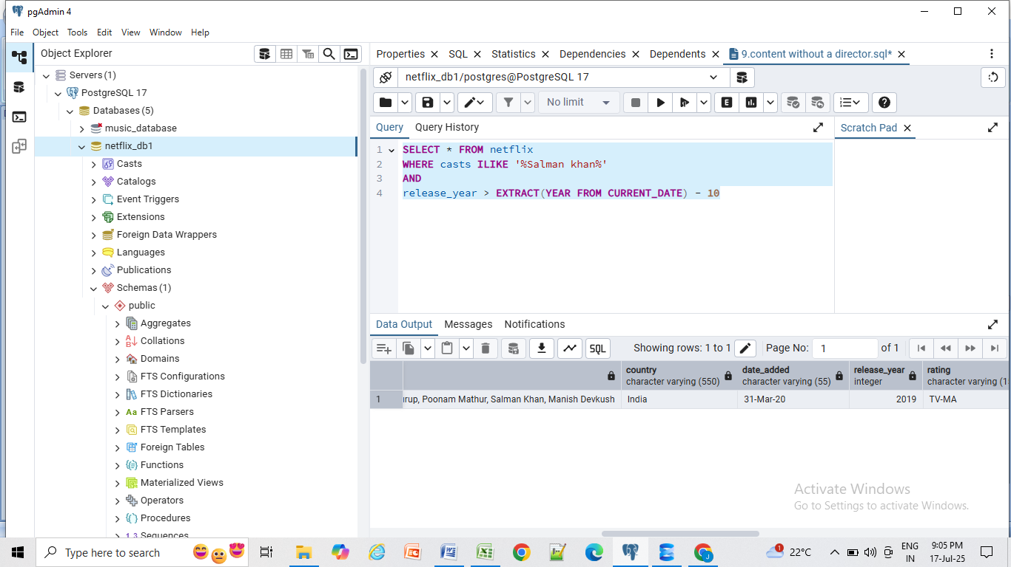

# 11. the top 10 actors who have appeared in the highest number of movies produced in India.

SELECT

UNNEST(STRING_TO_ARRAY(casts, ',')) as actor,

COUNT(*)

FROM netflix

WHERE country = 'India'

GROUP BY 1

ORDER BY 2 DESC

LIMIT 10

