***OSOC Induction Task***

1. Command for searching pattern line by line in any document

with an example.

The grep command is used for searches a file for a particular pattern of characters, and displays all

Lines that contain that pattern. The pattern that is searched in the file is referred to as the

regular expression.

Syntax: - grep [options] pattern [files]

Options Descriptions: -

1. -c: - This print only a count of the lines that match a pattern.
2. -i: - Ignores, case for matching.
3. -n: - Display the matched lines and their line numbers.
4. -v: - This prints out all the lines that do not matches the pattern.

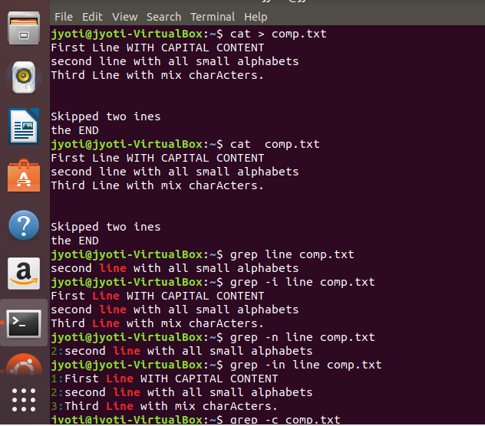 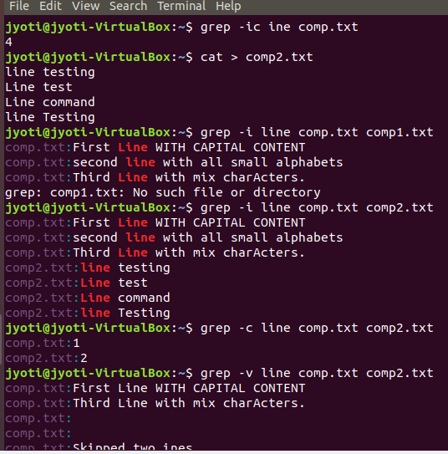

2. What all permissions are there in Linux? State all permissions and

different way of changing permissions with example.

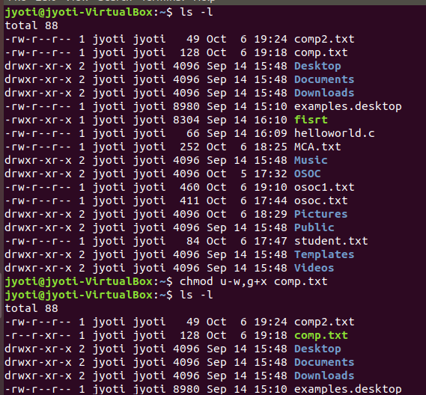 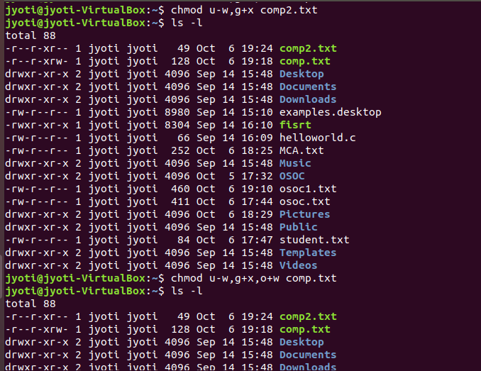

3.Create a folder **OSOC**and inside that another folder **Inductions**and

now create a file**task.txt**inside **Inductions** with some content now

copy this file into another folder **Workshop** in **OSOC.**

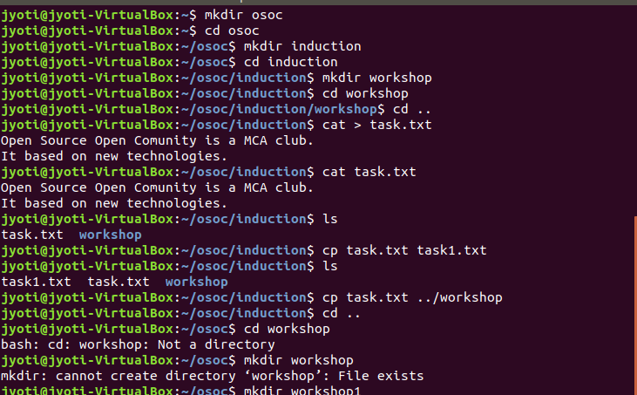 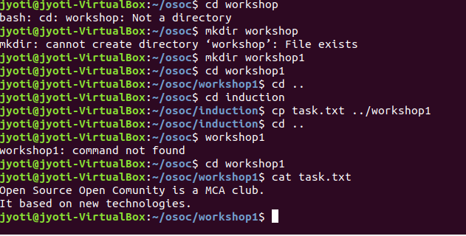

5.I want to change password of another user how will I do that?

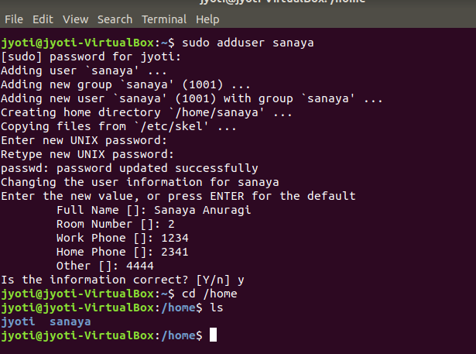

6. Using shell scripting write program for sort an Array.

Input should be taken from user.

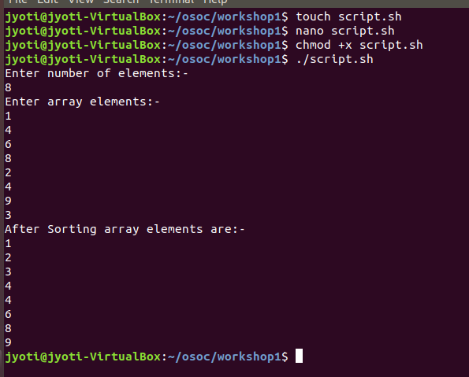 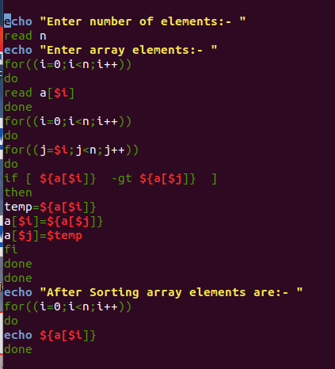

7. Using Shell scripting write a program to reverse a string. Input should

be taken from user.

