Igniting
- What is `NPM`?
- npm is the world's largest software registry. It is not an abbreviation for node package manager.
If we want to use any package in our code, we have to use a package manager.
- Open source developers from every continent use npm to share and borrow packages, and many organizations use npm to manage private development as well.
- What npm does:
- Manages dependencies: It helps developers manage the external code (dependencies) their projects rely on.
- Installs packages: It allows developers to install libraries from the npm registry with a single command, such as npm install.
- Shares code: It provides a way for developers to publish their own reusable packages of code for others to use.
- Facilitates collaboration: By handling dependency management, it makes it easy for different team members to get a project up and running quickly by simply installing the dependencies defined in the package.json file.
- Ensures version compatibility:It uses semantic versioning to help prevent package updates from breaking a project by specifying which versions of a package are compatible
- The two components of npm
- The online registry: This is a public database of millions of free, open-source JavaScript packages that developers can search and use in their projects.
- The command-line interface (CLI): This is the tool installed with Node.js that developers use in their terminal to interact with the registry, download packages, and manage their project's dependencies.

- What is `Parcel/Webpack`? Why do we need it?
Both module bundlers that package and optimize web application code for the browser.
What they do:
- Bundle code: They take many separate JavaScript, CSS, and other asset files and combine them into fewer, optimized files.
- Optimize code: They minify the code by removing unnecessary characters, rename variables, and apply advanced techniques like tree shaking to eliminate unused code.
- Support modern features: They enable the use of modern JavaScript (like ES modules), pre-processors like Sass, and transpilation tools like Babel, which are not understood by older browsers.
- Manage assets: They handle images, fonts, and other assets, ensuring they are processed and correctly linked within the bundle.
Why we need them
- Performance: By combining and minifying code, they significantly reduce the number of HTTP requests a browser needs to make, leading to much faster page load times.
- Modularity: They allow developers to write code in modular, separate files for better organization and maintenance, which is then bundled for deployment.
- Browser compatibility: They transform modern code into a format that is compatible with a wider range of browsers.
- Simplified workflow: They automate complex build processes, such as transpilation and minification, which would be tedious to do manually.

- What is `.parcel-cache?
The .parcel-cache directory is a dedicated folder created by Parcel, a web application bundler, to store cached information about your project during the build process.
The folder is used by Parcel as a temporary cache directory when building your app for development and production.
Parcel caches code all the time. It gives faster build, faster developer experience because of caching.
It subsequently reduce the build time by this .

- What is `npx` ?
- Stands for Node Package eXecute, is a command-line tool bundled with NPM that allows you to run JavaScript packages without having to install them first.
- It is useful for one-off tasks, testing different package versions, or executing commands from a project's dependencies, as it temporarily installs the package, runs the command, and then removes the package.

- What is difference between `dependencies` vs `devDependencies`?
Dependencies are packages your application needs to run in production, while devDependencies are only needed for local development, testing, and building.
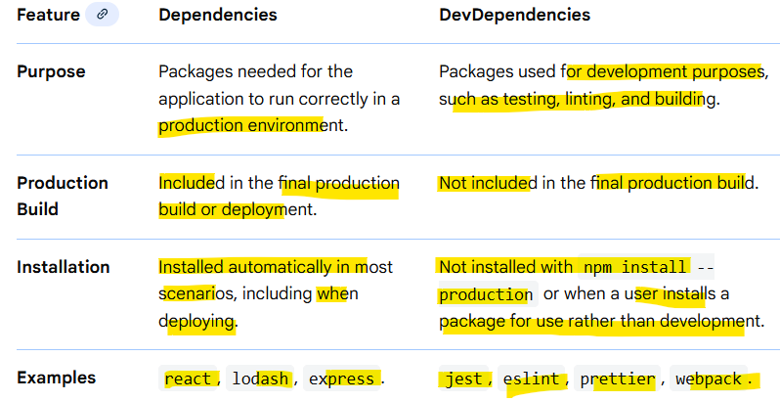
- What is Tree Shaking?
- Tree shaking is an optimization technique used in modern JavaScript development, particularly with module bundlers like Webpack, Parcel and Rollup.
- Tree shaking is a process of removing the unwanted code that we do not use while developing the application.
- Its primary purpose is to eliminate "dead code" – code that is never actually used or executed – from the final application bundle.
How it works:
- Static Analysis: Tree shaking relies on the static analysis of ES2015 (ES6) module syntax, specifically import and export statements. Bundlers analyse the dependency graph of your application to determine which parts of the code are actually imported and used.
- Dead Code Elimination: If a module, function, or variable is exported but never imported or referenced anywhere in the application, the bundler identifies it as dead code.
- Bundle Optimization: During the build process, the bundler then excludes this dead code from the final JavaScript bundle, significantly reducing its size.
Benefits of Tree Shaking:
- Reduced Bundle Size: This is the most direct benefit, leading to faster download times for users.
- Improved Performance: Smaller bundles load and execute more quickly, enhancing application performance.
- Cleaner Codebase: Encourages modular code design, as it makes it easier for bundlers to identify and remove unused parts.

- What is Hot Module Replacement?
- Hot Module Replacement (HMR) is a development feature that allows code changes to be applied to a running application without a full page reload, which significantly speeds up the development process.
- It means that parcel will keep a track of all the files which you are updating.
- Instead of refreshing the entire browser, HMR only replaces the specific modules that have been changed, while preserving the application's current state
- How it works
- Detection: A tool like webpack or Vite detects a change in a file. There is File Watcher Algorithm (written in C++). It keeps track of all the files which are changing real-time and it tells the server to reload.
- Update notification: The development server notifies the HMR runtime via a WebSocket that an update is available.
- Module replacement: The HMR runtime downloads the updated module and applies it, replacing the old one.
- State preservation: If the updated module has a specific handler (like module.hot.dispose), it can transfer any necessary state to the new version of the module, ensuring the application's state is maintained.

- List down your favourite 5 superpowers of Parcel and describe any 3 of them in your own words
- Zero Configuration: This is arguably Parcel's biggest draw. Unlike other bundlers that require extensive configuration files, Parcel works out of the box for most projects, automatically detecting and bundling common file types (JavaScript, CSS, HTML, images, etc.).
- Hot Module Replacement (HMR): Parcel includes HMR means when you make a change to your code during development, the module is updated in the running application without a full page reload, making development incredibly fast and seamless.
- Automatic Transforms: Parcel automatically handles common web development needs like transpiling (using Babel for JavaScript), compiling (using PostCSS for CSS), and optimizing assets (like images) without needing extra plugins or setup steps.
- Blazing Fast Build Times: Parcel uses a file system cache and parallel processing on multiple cores, which results in very quick initial and incremental build times, significantly speeding up the development and deployment process.
- Diagnostic Reporting: When things do go wrong (e.g., a syntax error), Parcel provides excellent, clear, and easy-to-understand error messages right in the browser and terminal, helping developers pinpoint and fix issues quickly.

- What is `.gitignore`? What should we add and not add into it?
- gitignore file is a plain text file used by the Git version control system to intentionally untrack files and directories that should not be committed to a repository.
- Rules in the file specify which files Git should ignore, preventing sensitive data, temporary files, and machine-generated code from being accidentally shared or tracked
What to Add to .gitignore
- Sensitive Data/Credentials: Files containing passwords, API keys, or security certificates (e.g., config.local.json, .env files) [1].
- Machine-Generated Code: Compiled code, build artifacts, and output directories (e.g., /dist, /build, .class files) [1, 2].
- Dependency Directories: Directories created by package managers that can be generated by others locally (e.g., /node_modules for Node.js, venv for Python) [1, 2].
- IDE/OS Configuration Files: System-specific or editor-specific configuration files (e.g., .DS_Store on macOS, Thumbs.db on Windows, .idea/ for IntelliJ/WebStorm) [1, 2].
- Logs and Temporary Files: Any log files (*.log) or temporary caches (*.tmp)
What Not to Add to .gitignore
You should not add files that are crucial for the project to function correctly or for other developers to work with the codebase. These include:
- Source Code: All primary source files needed to build and run the application .
- Essential Configuration Files: Configuration files that define the project structure or dependencies (e.g., package.json, requirements.txt, pom.xml) .
- Documentation: Project documentation files (e.g., README.md) .
- License Files: The project's license file
- What is the difference between `package.json` and `package-lock.json`?
package.json is the project blueprint and package-lock.json is the exact installation map.
package.json
- This file defines your project’s metadata and dependencies.
- It lists the packages your project needs, often with version ranges like ^1.2.0 or ~4.0.3.
- The developer edit it manually.
- Used for:
  - Project name, version, scripts
  - Declaring dependencies (but not the exact versions installed)
  - Sharing the project's requirements with others
package-lock.json
- This file is automatically generated by npm.
- It locks down the exact versions of every installed dependency — including sub-dependencies.
- Ensures the project installs identical versions across all environments (your PC, teammates’ PCs, production server).
- You should not edit it manually.
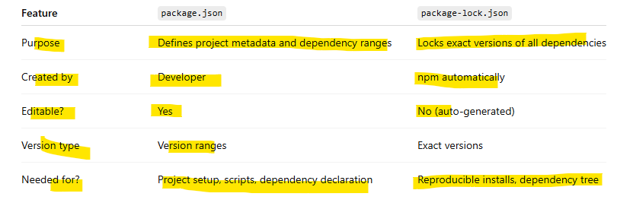
- Why should I not modify `package-lock.json?
Because it is automatically generated by npm and ensures consistent, repeatable installs. Manual changes can corrupt the file, cause mismatched dependency versions, and will get overwritten by npm anyway.
✅ 1. It is auto-generated by npm
package-lock.json is meant to be managed only by npm, not by humans. Any manual edits can break its internal structure.
✅ 2. It ensures consistent installs
It locks the exact versions of all dependencies and sub-dependencies.
If you edit it, your teammates or CI/CD may install different versions → causing bugs.
✅ 3. Manual edits can corrupt the file
The lock file contains:
- Integrity hashes
- Resolved URLs
- Nested dependency trees
These can easily become invalid if manually changed, causing installation errors.
✅ 4. It may get overwritten
Even if you edit it, running commands like npm install will overwrite your changes. So manual editing is pointless.
- What is `node_modules` ? Is it a good idea to push that on git?
- node_modules directory is a folder created by Node.js package managers like npm or Yarn within a project. It contains all the installed dependencies (external libraries and packages) that your application relies on to function.
- These dependencies are typically listed in your project's package.json file. When you run npm install (or yarn install), the package manager reads package.json and downloads these dependencies into the node_modules folder.
not a good idea to push node_modules to Git.
- The node_modules folder can become exceptionally large, often containing hundreds or even thousands of files and consuming significant disk space.
- developer can recreate the node_modules folder by simply running npm install (or yarn install) after cloning the repository.
- Because thousands of files change frequently, it will constantly cause unnecessary merge conflicts.
- What is the `dist` folder?
The dist folder (short for distribution) is the directory that contains the final, optimized, production-ready build of your application.
It usually includes:
- Minified JavaScript files
- Optimized CSS files
- Bundled assets (images, fonts, etc.)
- An index.html file or other entry points
- Production-only files
Should not put push it to Git: since is generated because source code must be Compiled, Transpiled, Bundled, Minified, Optimized. The output of all these steps goes into the dist folder.
Everything inside dist is what you deploy to any hosting service.
- What is `browserlists
browserslist is a configuration that tells frontend tools which browsers your project should support.
It is used by tools like:
- Autoprefixer (to add CSS vendor prefixes)
- Babel (to transpile JS for older browsers)
- Webpack
- Angular CLI
- React / CRA / Vite

Basically, it defines your target browsers so your build can be optimized for them.
