Inception
- What is Emmet?
Ans: Emmet is a web development toolkit that significantly speeds up writing HTML and CSS code by allowing developers to use abbreviations that expand into full code blocks with a single keystroke.

- Difference between a Library and Framework?
Library:
- A library is a collection of pre-written code (functions, classes, modules) designed to perform specific, well-defined tasks.
- Examples: jQuery, NumPy, Authlib.

Framework:
- A framework provides a structured environment and a set of guidelines for building entire applications. It dictates the overall architecture and flow of the application.
- Examples: Django, Spring, AngularJS, Vue.js.
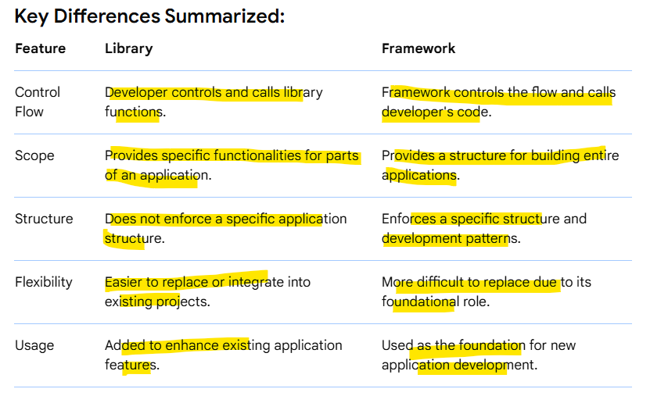

- What is CDN? Why do we use it?
A Content Delivery Network (CDN) is a geographically distributed network of servers that caches website content like images, videos, and files to deliver them faster to users by serving them from a server closer to their location.
We use CDNs to improve website performance, reliability, and security by reducing latency, handling high traffic loads, and protecting the origin server from attacks.
- Why is React known as React?
- React is named for its core principle of "reacting" to changes in data and state to efficiently update the user interface.
- The idea behind React is to build reusable components that can be rendered on the front-end, rather than writing a new piece of code every time you need to display something on the screen.
- It was developed by Facebook, and the name “React” was chosen because it is meant to help developers build user interfaces that are fast and responsive, or “reactive.” The library was designed to “react” to changes in data.
- What is crossorigin in script tag?
- The crossorigin attribute in an HTML <script> tag controls how the browser handles cross-origin requests for that script.
- This attribute is crucial for managing security and enabling Cross-Origin Resource Sharing (CORS).
- When a script is loaded from a different origin (domain, scheme, or port) than the page it's embedded in, the browser's Same-Origin Policy typically restricts access to certain resources for security reasons. The crossorigin attribute allows you to explicitly manage how the browser handles credentials (like cookies and HTTP authentication) when making these cross-origin requests, thereby enabling CORS.
- Values of crossorigin: 1. anonymous (or omitted) 2. use-credentials
- What is difference between React and ReactDOM?
React and ReactDOM are both integral parts of building web applications with React, but they serve distinct purposes:
React:
- Core Library: React is the fundamental JavaScript library for building user interfaces. It provides the core concepts of components, state management, and the Virtual DOM.
- Component-Based Architecture: It enables you to create reusable UI components, defining their structure, behavior, and how they react to changes in data.
- Virtual DOM: React uses a Virtual DOM, an in-memory representation of the actual browser DOM, to efficiently calculate and apply UI updates, minimizing direct manipulation of the real DOM for performance benefits.

ReactDOM:
- Platform-Specific Renderer: ReactDOM is a separate package that acts as the bridge between your React components and the actual browser's Document Object Model.
- Rendering to the DOM: It provides method like ReactDOM.render() (or ReactDOM.createRoot().render() in newer React versions) to take your React component tree and render it onto a specific element in the HTML page.
- Interacting with the Real DOM: ReactDOM handles the reconciliation process, comparing the Virtual DOM with the real DOM and making only the necessary changes to update the user interface efficiently.
In essence:
- React: defines what your UI should look like and how it behaves.
- ReactDOM: handles how that UI is actually displayed and updated in a web browser's DOM.

- What is difference between react.development.js and react.production.js files via CDN?
react.development.js (Development Version):
- use during the development and testing phases of your React application to leverage its robust debugging tools and informative error messages.
- Purpose: Optimized for development and debugging.
- Content: Includes extensive warnings, error messages, and debugging tools within the code. This provides helpful feedback during development to identify and resolve issues.
- Size: Larger file size due to the inclusion of development-specific features.
- Performance: May have a slight negative impact on application performance due to the added overhead of debugging tools and checks.
react.production.js (Production Version):
- Use when deploying your application to a live environment to ensure optimal performance, smaller bundle sizes, and faster loading times for your end-users.
- Purpose: Optimized for deployment to a live production environment.
- Content: Stripped of all development-specific code, warnings, and error messages. It focuses solely on the core functionality of React.
- Size: Significantly smaller file size due to minification, compression, and removal of development code. This leads to faster loading times for users.
- Performance: Optimized for maximum performance and efficiency, as it eliminates unnecessary overhead present in the development version.

- What is async and defer?
Async and defer are attributes for <script> tags that prevent JavaScript from blocking HTML parsing, allowing the page to load faster.
async
- Behavior: The script is downloaded in the background and does not block HTML parsing.
- Execution: The script executes as soon as it has finished downloading, regardless of its position in the HTML.
- Order: The order of execution is not guaranteed and depends on which script finishes downloading first.
- Use case: Best for independent scripts that don't need to interact with other scripts or the DOM, such as analytics or ad scripts.
defer
- Behavior: The script is downloaded in the background without blocking HTML parsing.
- Execution: The script is executed only after the entire HTML document has been fully parsed, but before the DOMContentLoaded event.
- Order: defer scripts are guaranteed to execute in the order they appear in the HTML document.
- Use case: Ideal for scripts that need to interact with the DOM or that have dependencies on other scripts, ensuring the DOM is fully ready before the script runs.

