**Validation**

For client side validation (to avoid network traffic In )

We have to use javascript , but javascript is so lengthy so that we used jquery.

Min.js means minified version, compressed version of js.



Bandwidth consumption is less

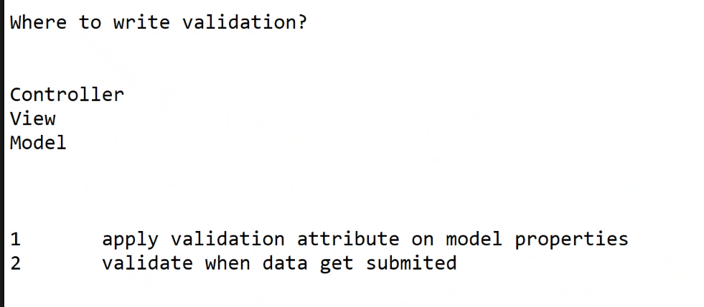

@model MVCDemoAppJLT.Models.Employee

@{

ViewBag.Title = "EmployeeForm";

}

<script src="~/Scripts/jquery-3.4.1.min.js"></script>

<script src="~/Scripts/jquery.validate.min.js"></script>

<script src="~/Scripts/jquery.validate.unobtrusive.min.js"></script>

<h2>EmployeeForm</h2>

@using (Html.BeginForm())

{

<p>Submit to the same method</p>

<input type="submit" />

}

@using (Html.BeginForm("PostEmployeeData", "Home", FormMethod.Post))

{

<p>Submit to the PostEmployeeData Method</p>

<span style="font-weight:bold">Emp ID</span>

@Html.TextBoxFor(M => M.EmpId)

@Html.ValidationMessageFor(M => M.EmpId, "", new { @class = "text-danger" })

<br />

<span style="font-weight:bold">Emp Name</span>

@Html.TextBoxFor(M => M.EmpName)

@Html.ValidationMessageFor(M => M.EmpName, "", new { @class = "text-danger" })

<br />

<span style="font-weight:bold">Emp Salary</span>

@Html.TextBoxFor(M => M.Salary)

@Html.ValidationMessageFor(M => M.Salary, "", new { @class = "text-danger" })

<br />

<input type="submit" />

}