MLOps Assignment
HEART DISEASE CLASSIFICATION
An End-to-End MLOps Pipeline

Report details | Information
Project | Heart disease classification using the Cleveland dataset
Candidate models | Logistic Regression and Random Forest
Experiment tracking | MLflow with SQLite tracking store
Inference interface | REST API implemented with FastAPI
Quality and CI | pytest, Ruff, GitHub Actions
Repository | https://github.com/Jyoti2025BITS/heart-disease-mlops

Prepared By:
Name: Jyoti Kumari
Roll Number: 2025AE05237

Abstract and Project Overview
This report documents an end-to-end machine learning operations (MLOps) project for binary classification using the Cleveland heart disease dataset. The workflow combines data inspection, exploratory data analysis (EDA), model training and comparison, experiment tracking, model persistence, REST API inference, automated testing, and continuous integration.
The project compares Logistic Regression and Random Forest using accuracy, precision, recall, and ROC-AUC. In the recorded results, both achieved 83.49% accuracy. Random Forest achieved a slightly higher ROC-AUC (0.9125) than Logistic Regression (0.9099) and was selected based on the recorded comparison.

Objectives
- Inspect dataset structure, target distribution, and missing values.
- Generate EDA plots to understand the data.
- Train and compare two classification algorithms using consistent metrics.
- Record experiment results in MLflow and preserve model artifacts.
- Expose the selected model through a REST API.
- Validate implementation with tests, linting, formatting, and GitHub Actions.

Scope
The scope is an educational ML engineering workflow. It demonstrates project organization and delivery practices rather than a clinically validated diagnostic system. The model is not intended for patient care.

Deliverables
- Source code and configuration in the Git repository.
- Dataset file and generated EDA plots.
- Saved model artifacts and model-comparison report.
- MLflow experiment records.
- REST API endpoints and tests.
- GitHub Actions workflow and this report.

1. Problem Definition and Dataset

1.1 Problem statement
The task is to predict a binary target from structured clinical attributes. The pipeline accepts feature values and produces a predicted class. The model output is intended for demonstration and evaluation in an academic project.

1.2 Dataset
The project uses the Cleveland heart disease dataset at data/raw/processed.cleveland.data. Recorded inspection showed 303 records. Initial inspection reported 14 columns before target transformation; the processed view later contained 15 columns including the target.

1.3 Target distribution
Target class | Records | Approx. share
0 | 164 | 54.1%
1 | 139 | 45.9%
Total | 303 | 100%
The two classes are relatively close in size, although not exactly balanced. The target-balance plot is stored under screenshots/eda/.

1.4 Missing data
Feature | Missing values recorded
Ca | 4
Thal | 2
Data inspection identified missing values in ca and thal. Missing or unknown values should be handled consistently during training and inference. The saved pipeline keeps preprocessing and prediction together.

1.5 Data quality considerations
- Validate column names, data types, and expected feature count.
- Treat missing or unknown markers consistently.
- Do not use target information as an input feature.
- Ensure API fields match the model's expected feature schema.
- Document data preparation to support reproducibility.

2. Exploratory Data Analysis
EDA was performed before model comparison to understand the dataset and identify patterns worth examining. Generated visualizations are stored under screenshots/eda/.

2.1 Age distribution
age_distribution.png summarizes the distribution of ages in the records. It helps reveal the represented age range and whether the dataset is concentrated in particular age bands. It describes this dataset and should not be generalized to a wider population.

2.2 Cholesterol by target
cholesterol_by_target.png compares cholesterol values across target classes. It supports visual comparison of feature distributions. Overlap between classes is common; a plot alone cannot establish causation or prove predictive value.

2.3 Correlation heatmap
correlation_heatmap.png visualizes pairwise correlations among numeric features. Correlation can identify related variables or potential redundancy, but it does not imply causation and may not capture nonlinear relationships.

2.4 Target balance
target_balance.png visualizes target counts: 164 for class 0 and 139 for class 1. This informs evaluation: accuracy should be considered alongside precision, recall, and ROC-AUC.

2.5 EDA outputs
- screenshots/eda/age_distribution.png
- screenshots/eda/cholesterol_by_target.png
- screenshots/eda/correlation_heatmap.png
- screenshots/eda/target_balance.png
EDA improves data familiarity but does not replace validation, leakage checks, or evaluation on unseen data.

3. Methodology and Model Training

3.1 Pipeline approach
Training logic is organized in src/train.py and fitted artifacts are stored in models/. Keeping preprocessing and the estimator together in a pipeline reduces the risk of applying different transformations during training and inference.

3.2 Candidate algorithms
Algorithm | Description | Reason for inclusion
Logistic Regression | Linear classifier that estimates class probabilities. | Baseline for binary classification.
Random Forest | Ensemble of decision trees using randomized samples/features. | Can model nonlinear patterns and interactions.

3.3 Evaluation metrics
- Accuracy: fraction of predictions matching true labels.
- Precision: fraction of positive predictions that are truly positive.
- Recall: fraction of actual positive cases identified.
- ROC-AUC: ranking ability across classification thresholds.
False negatives and false positives may have different implications in medical-themed classification. Metrics must therefore be interpreted together. These results do not establish clinical readiness.

3.4 Reproducibility
Recorded training metadata includes random_state=42 and five cross-validation folds. Fixed seeds and documented settings improve repeatability, although results may still depend on library versions, data preparation, and runtime environment.

3.5 Artifact storage
The selected pipeline is stored at models/heart_disease_pipeline.joblib. Separate artifacts exist for Logistic Regression and Random Forest. The comparison output is reports/model_comparison.json.

4. Results and Model Selection
The recorded model comparison is summarized below. Values are rounded for readability.
Metric | Logistic Regression | Random Forest
Accuracy | 0.8349 (83.49%) | 0.8349 (83.49%)
Precision | 0.8319 (83.19%) | 0.8415 (84.15%)
Recall | 0.8056 (80.56%) | 0.7910 (79.10%)
ROC-AUC | 0.9099 (90.99%) | 0.9125 (91.25%)

4.1 Interpretation
Both models produced the same recorded accuracy. Random Forest achieved higher precision and a slightly higher ROC-AUC, while Logistic Regression achieved higher recall. The ROC-AUC difference is small, so model choice depends on the selection criterion and the precision/recall trade-off.

4.2 Selected model
Random Forest was selected based on its slightly higher ROC-AUC and higher precision in the recorded results. This is a project-level choice, not a claim that Random Forest is always better for this task.

4.3 Limitations of comparison
- Metrics describe this experiment and are not universal performance estimates.
- Clinical use would require independent validation, calibration analysis, bias assessment, and domain-expert review.
- A decision threshold should reflect the relative costs of false positives and false negatives.
- The dataset is limited in size and may not represent broader populations or current practice.

4.4 Result artifact
The comparison is preserved in reports/model_comparison.json. Saved artifacts allow inference without retraining.

5. Experiment Tracking with MLflow

5.1 Purpose
MLflow records training experiments and metrics. Tracking helps compare candidate runs, retain metadata, and associate evaluation results with each model candidate.

5.2 Project configuration
The experiment name is heart-disease-classification. The tracking store uses the SQLite database mlflow.db, with an mlruns directory for associated run artifacts.

5.3 Recorded runs
Model / run | Status | Accuracy | ROC-AUC
random_forest | FINISHED | 0.8349 | 0.9125
logistic_regression | FINISHED | 0.8349 | 0.9099
The recorded experiment query returned two finished runs. Their metrics support comparison through the MLflow UI or programmatic queries.

5.4 Reproducibility and governance
- Log model parameters and evaluation metrics for every run.
- Record model names and configuration such as random seed and cross-validation folds.
- Keep artifacts and comparison outputs associated with the project.
- Use stable experiment naming to locate runs.
- Avoid storing credentials or sensitive patient information in tracking metadata.

5.5 Practical note
The tracking UI can be launched from the project environment using the SQLite backend. Port forwarding depends on the Prayogshala VM. If the UI is unavailable, reports/model_comparison.json provides a portable comparison summary.

6. Model Serving through REST API

6.1 API purpose
The project exposes inference through src/api.py. A REST API separates training from prediction clients and provides a consistent interface for sending feature values and receiving a response.

6.2 Health endpoint
The GET /health endpoint checks whether the service is running and whether the model has loaded. A previously verified response was:
{"status":"healthy","model_loaded":true}

6.3 Prediction endpoint
POST /predict accepts feature values as JSON. A previously tested sample returned prediction 0, interpretation 'heart disease not detected by model', and probability_class_1 0.3267.
{"prediction":0,"interpretation":"heart disease not detected by model","probability_class_1":0.3267}

6.4 Example request
curl -X POST http://localhost:8001/predict \
-H "Content-Type: application/json" \
-d '{"age":63,"sex":1,"cp":3,"trestbps":145,"chol":233,"fbs":1,"restecg":0,"thalach":150,"exang":0,"oldpeak":2.3,"slope":2,"ca":0,"thal":3}'

6.5 Safety and limitations
This API is an educational demonstration. The returned class and probability are model outputs, not a diagnosis or medical recommendation. Real-world use would require extensive validation, privacy controls, security review, monitoring, and applicable regulatory assessment.

7. Testing, Quality Checks, and Continuous Integration

7.1 Automated tests
The project includes tests/test_api.py and pytest configuration. The previously recorded local test run passed three tests. Automated tests help detect regressions in API behavior and expected application functionality.

7.2 Static checks and formatting
Ruff is used for linting and formatting checks. The project commands are:
ruff check src tests
ruff format --check src tests
python -m pytest -v

7.3 GitHub Actions workflow
The workflow is stored in .github/workflows/ci.yml. It checks out the repository, sets up Python 3.12, installs dependencies, runs Ruff linting, checks formatting, and executes the test suite.

7.4 CI value
- Runs checks automatically for pushes and pull requests targeting main.
- Provides visible pass/fail feedback in the repository Actions page.
- Reduces reliance on manual checks and helps detect regressions.
- Creates a repeatable quality gate before changes are merged.

7.5 Repository and delivery
Repository: https://github.com/Jyoti2025BITS/heart-disease-mlops. Review the latest Actions run before submission to ensure the latest commit passed. Upload the demo video to the location required by course instructions.

Docker Compose validation
Docker Compose was observed in a healthy state with host port 8001 mapped to container port 8000. The /health endpoint returned HTTP 200 with status healthy and model_loaded true. The /metrics endpoint returned Prometheus-format metrics.

Local Minikube validation
The Kubernetes deployment reached 1/1 available replicas. The pod was Running with zero restarts, and the heart-disease-api ClusterIP service exposed port 8000/TCP. Port forwarding from localhost:8002 to service port 8000 enabled health and prediction requests to be verified.
These checks establish local development-environment validation only. They do not establish a public URL, remote-cluster deployment, production security, scalability, or clinical suitability.

8. Conclusion, Limitations, and Future Work

8.1 Conclusion
This project demonstrates an end-to-end MLOps workflow for a heart disease classification use case. It combines data inspection and EDA with model comparison, MLflow experiment tracking, saved model artifacts, a REST API, automated tests, and GitHub Actions.
Random Forest was selected because it achieved slightly higher ROC-AUC and precision than Logistic Regression, while both had the same accuracy. The selected pipeline is models/heart_disease_pipeline.joblib, and the comparison is preserved in reports/model_comparison.json.

8.2 Current limitations
- The dataset contains only 303 records and may not represent other populations.
- Recorded metrics do not establish clinical validity.
- A local Minikube deployment was validated; production or externally hosted Kubernetes deployment, authentication, and load testing are not claimed here.
- Predictions should not be used for diagnosis or treatment decisions.

8.3 Future improvements
- Add explicit data and model versioning and document dataset provenance.
- Validate schema drift and data quality at inference time.
- Evaluate probability calibration and threshold selection.
- Add API integration, error-path, and load tests.
- Add structured logging, service metrics, and model-performance monitoring.
- Publish the container image to a registry and validate deployment, rollback, and operations on a remote Kubernetes cluster.
- Perform independent validation and fairness assessment before real-world use.

Supporting Screenshot Evidence

Exploratory data analysis
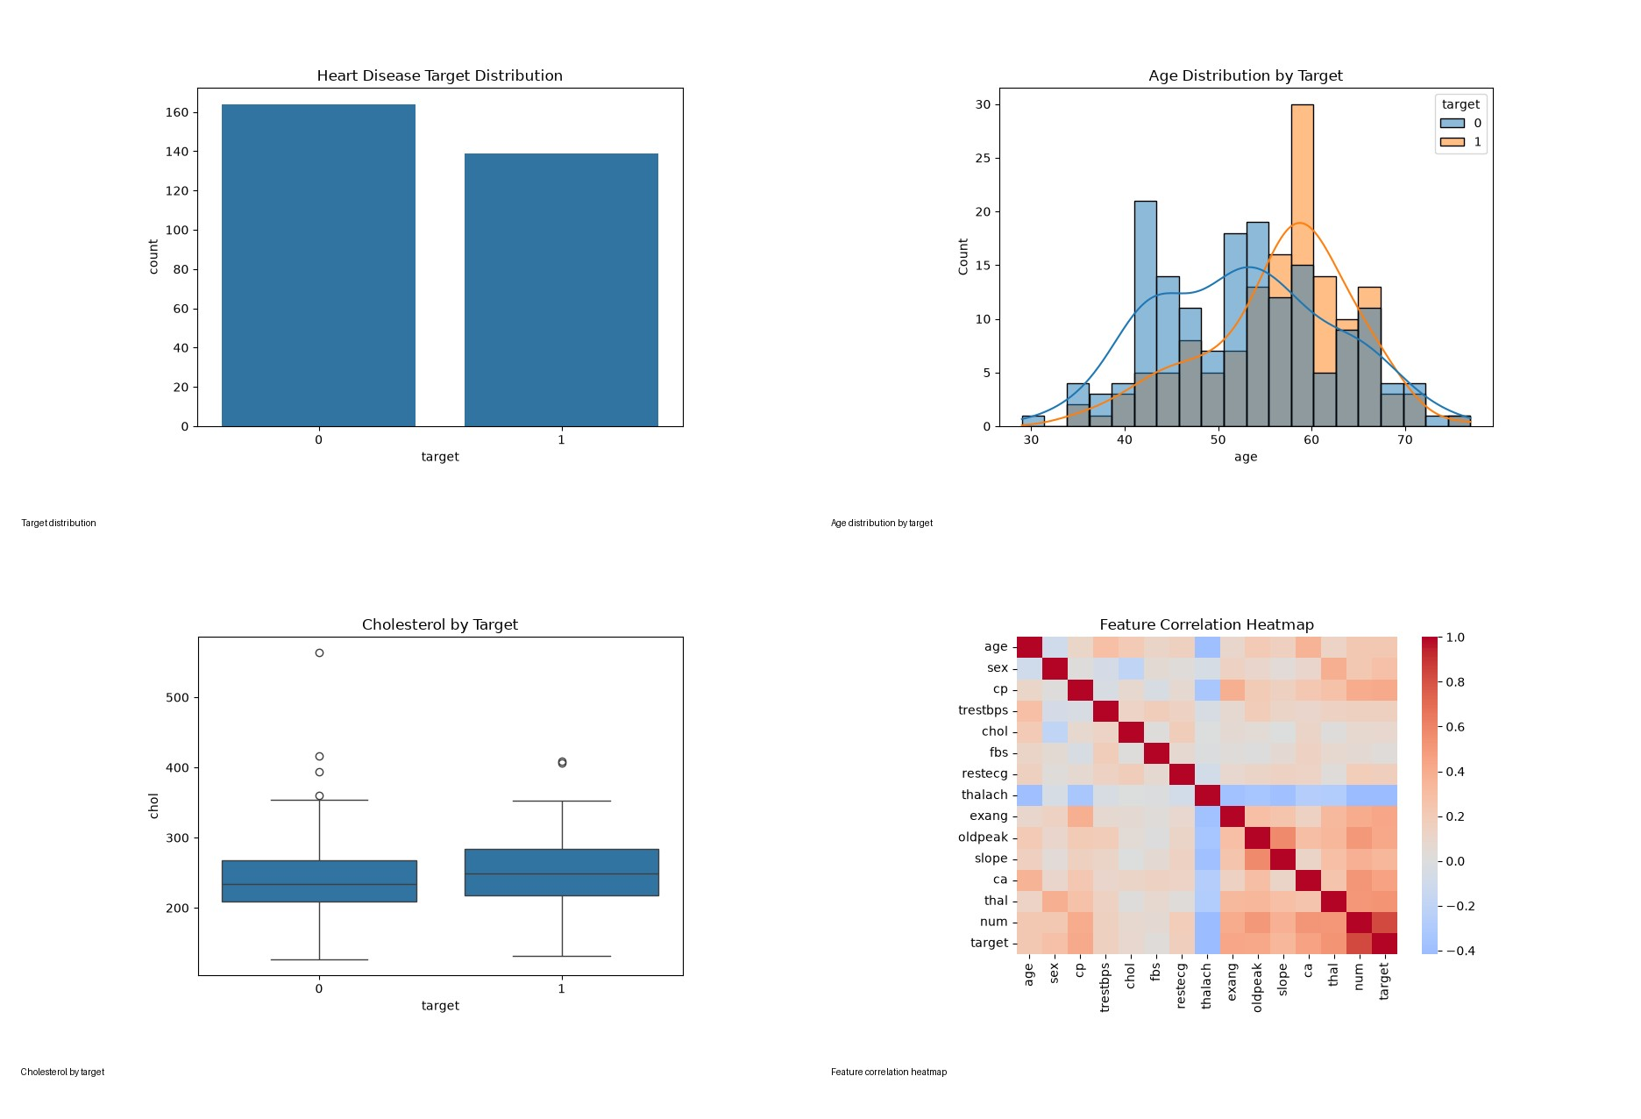

Deployment and API validation
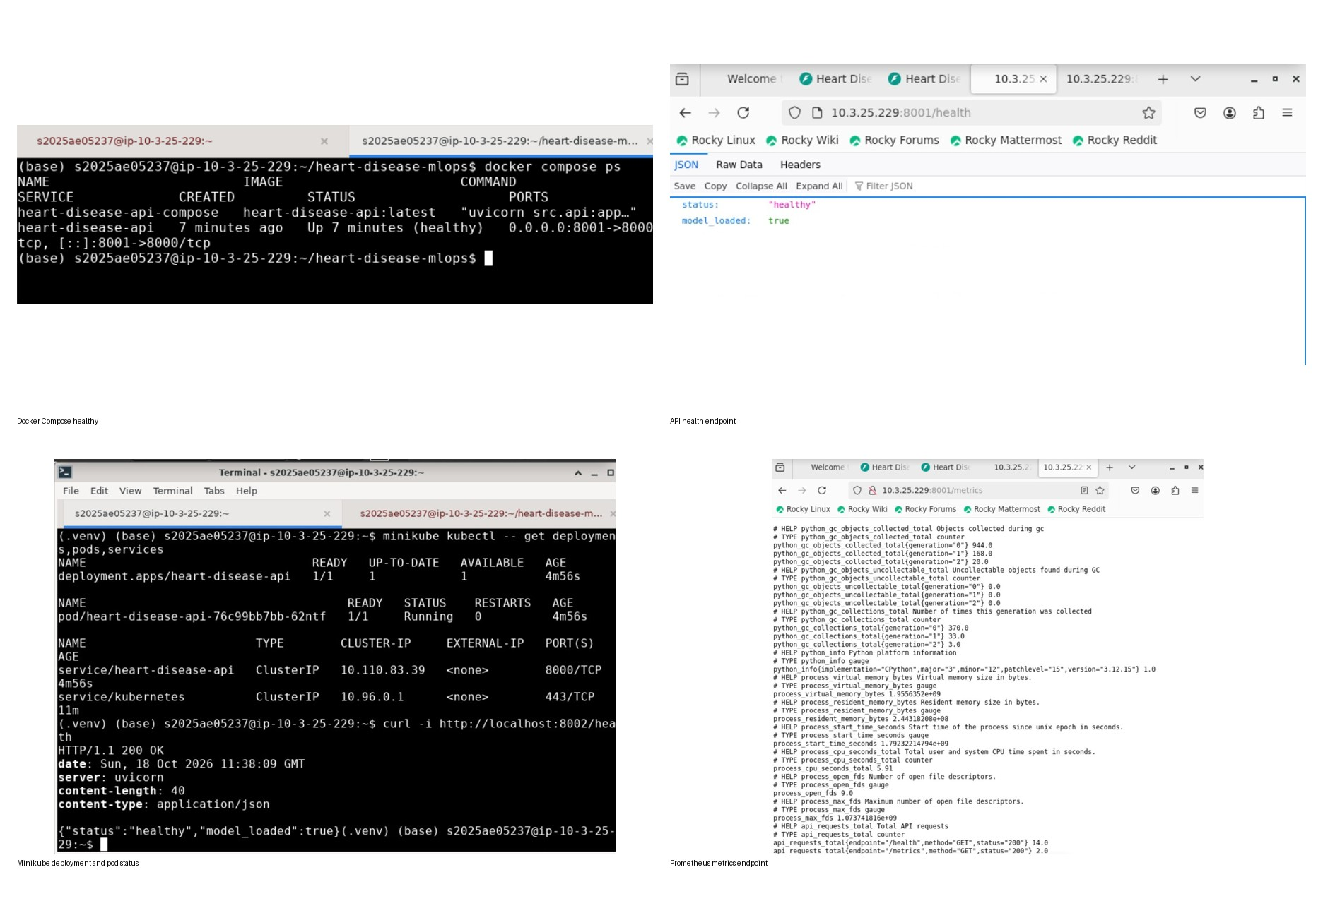

References and project artifacts
- Repository: https://github.com/Jyoti2025BITS/heart-disease-mlops
- Dataset: data/raw/processed.cleveland.data
- Training: src/train.py; API: src/api.py
- Model comparison: reports/model_comparison.json
- EDA: screenshots/eda/; CI: .github/workflows/ci.yml
Submission checklist: complete student/course details, verify that the report matches the final code and metrics, confirm the latest CI run passed, and include the demo video as required by the course rubric.

