|  |
| --- |
| **MECHATRONICS PROJECT**  **LPG GAS LEAKAGE DETECTING ALARM SYSTEM**  **By** Jyoti Sharma – 22MEB0B30 |

**Introduction**

LPG (Liquefied Petroleum Gas) is commonly used in households, restaurants, and industries, but leakage can be dangerous. This project focuses on building an LPG gas leakage detector that alerts users and can take preventive actions to avoid accidents.

**How It Works**

The system uses an MQ-5 gas sensor to detect LPG in the air. When gas levels exceed a set threshold, the Arduino microcontroller processes the data and triggers alerts:

* A buzzer sounds to notify people nearby.
* LED indicators provide a visual alert.
* An LCD display shows the current gas concentration.

**How It Was Built**

1. **Components Used:**

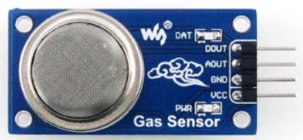 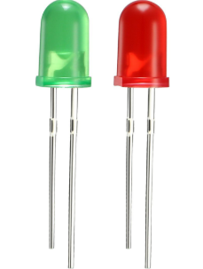

**MQ-5 Gas Sensor** **Resistors Buzzer LED**

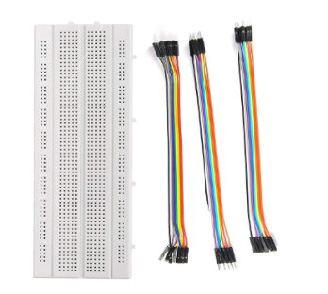 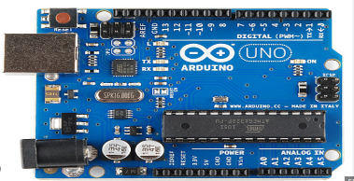 

**Breadboard with jumper wires Arduino Uno 16x2 LCD Display**

**Power Supply & Wires** – Provides necessary connections.

**2. Circuit Setup:**

* The MQ-5 sensor is connected to the Arduino, which reads the gas levels.
* If the value exceeds the threshold (1000ppm), the Arduino triggers the buzzer, red LED Blink and the LCD display “Gas Detected” level and when Arduino does not trigger buzzer, the green LED blink and LCD display “Safe air”.

1. **Programming (In tinkercad)**

Tinkercad simulation link: [link](https://www.tinkercad.com/things/hokFdUFnfjc/editel?returnTo=%2Fdashboard&sharecode=zzjBnkOFy_Zda_ymbRGigtgBTTQzXHHjFcUKAPODUfI)

Firstly, we connect the circuit in tinkercad and write the required code as follows:

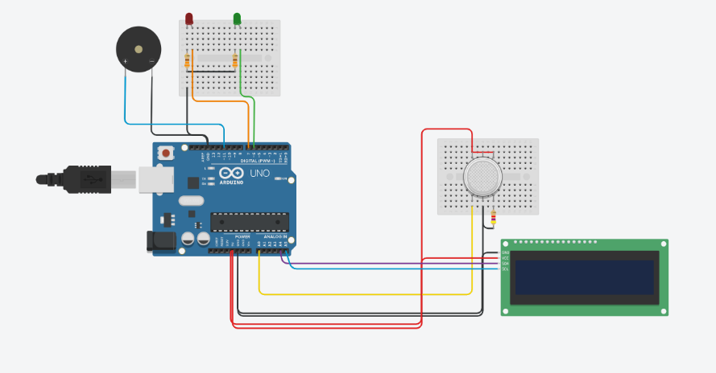

**Fig:** Circuit Diagram

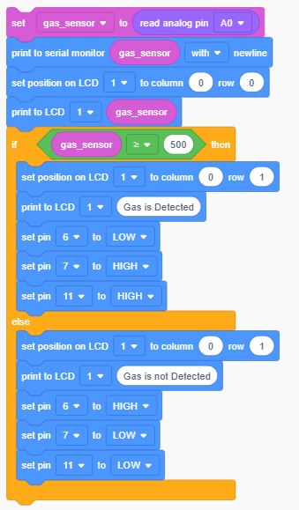We write the code according to block diagram

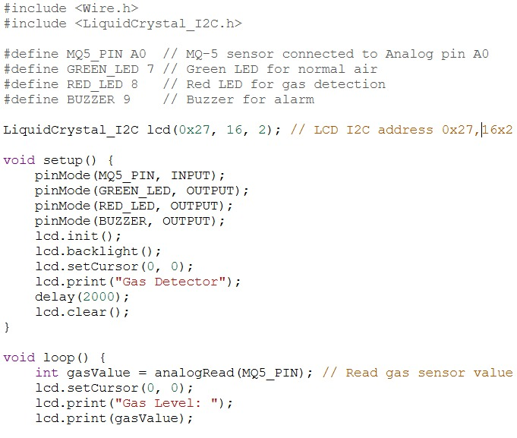

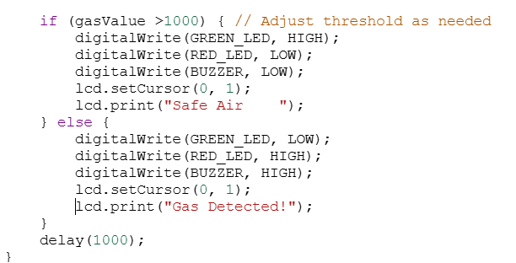

Now start the simulation, when no gas leakage is there the lcd display “Gas is not Detect” and while gas leakage is there it displays “Gas is Detected”.

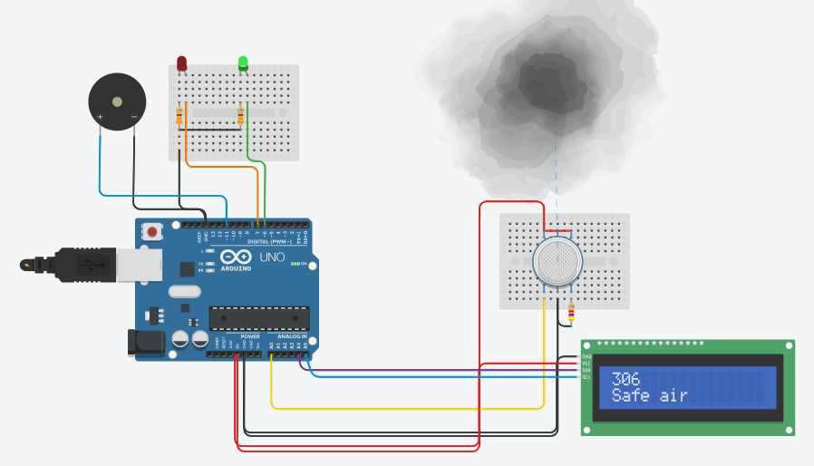

**Fig:** No gas detected

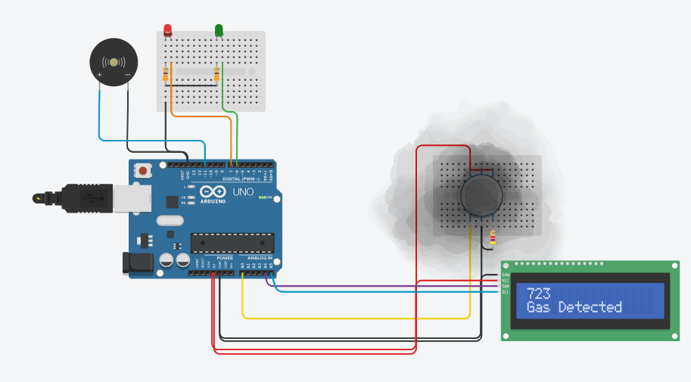

**Fig:** Gas is Detected

After that we did hardware connections and upload the code in Arduino IDE and check is it display the same or not.

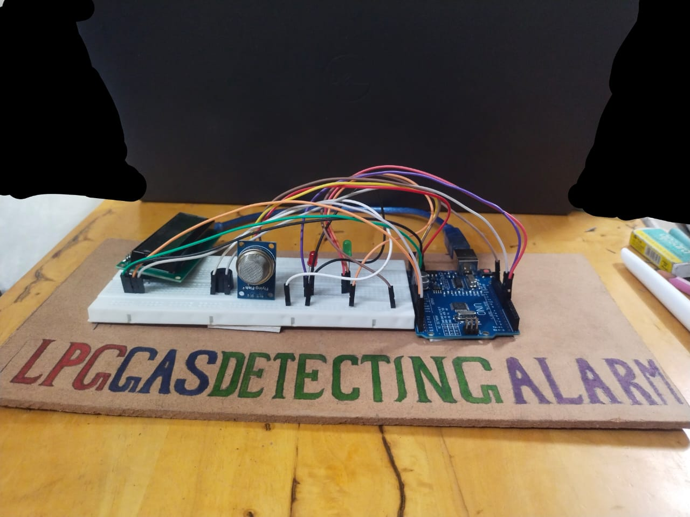

**Fig:** Final Product

**Why This Project is Useful**

* **Prevents Accidents:** Detecting gas leaks early helps prevent fires and explosions.
* **Cost-Effective:** Uses affordable components that are easy to find.
* **Scalable:** Can be upgraded with IoT features for remote monitoring.
* **Easy to Build & Modify:** Simple design allows for improvements.

**Further Advancements**

* You can change threshold value according to requirement.
* You can change the gas sensor if you want to detect another type of gas
* Connecting the system to a mobile app for remote alerts.
* Using WiFi or GSM modules for SMS notifications.
* Enhancing accuracy by integrating multiple sensors.

**Conclusion**

This LPG gas leakage detector is a simple, effective way to enhance safety in homes and industries. With further improvements, it can be adapted for large-scale applications, making it a valuable project for future advancements.