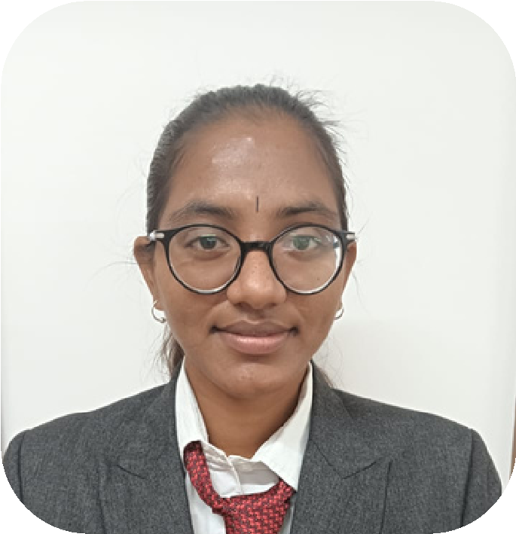

**PROFILE**

I Consider myself a

responsible and orderly

person.

I am looking forward to

my first work

experience.

**CONTACT ME**

9972544947

bsthanuja02@gmail.com

Bangalore

**ACHIVENTS**

* **CERTIFICATE IN BASIC AND TALLY**
* **CERTIFICATE IN DIGITAL**

**MARKERTING**

* **INTEGRITY PLEDGE**
* **EDUCATION TECHNOLOGY,POLICY**

**AND PLACEMENT OPPORTUNITY IN**

**FOREIGN COUNTRIES ,IN MALAYSIA**

**EDUCATION**

**SOUNDARYA INSTIUTION OF**

**MANAGEMENT AND SCIENCE**

*MBA*

*in Finance and business analytics*

**SIR RAGHAVENDRA FIRST GRADE**

**COLLEGE,TUMKUR**

**BACHELOR OF COMMERCE**

**LANGUAGE**

* Kannada
* English
* Telugu

**COMPUTER SKILLS**

* Ms Word

**THANUJA B S**

* Tallyerp9
* Excel