SET 1

------

1. create a database called **'assignment'** (Note please do the assignment tasks in this database)

Ans: CREATE DATABASE assignment;

2. Create the tables from ConsolidatedTables.sql and enter the records as specified in it.

Ans: USE assignment;

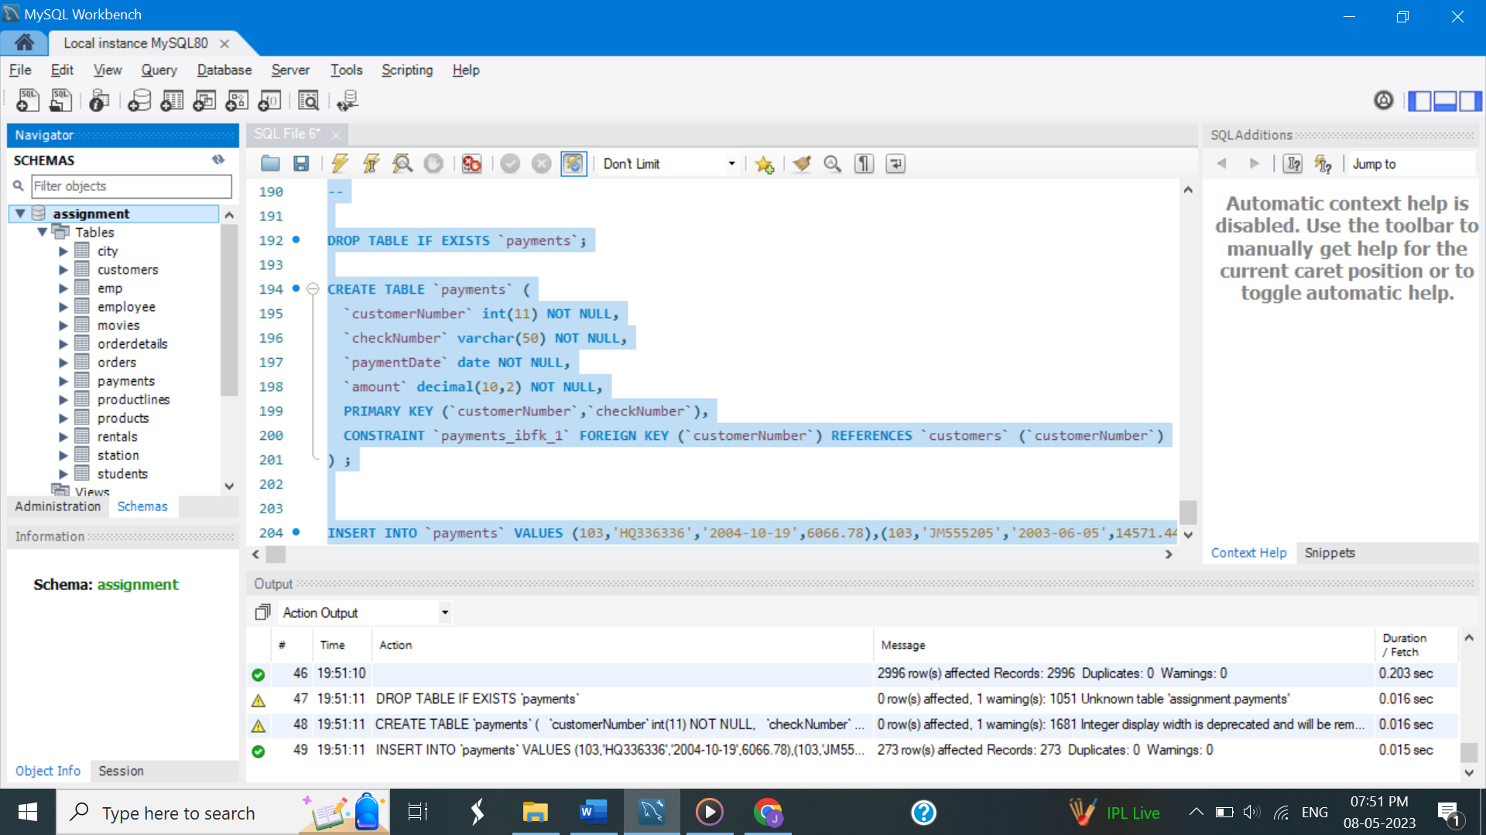

3. Create a table called **countries** with the following columns

***name, population, capital***

- choose appropriate datatypes for the columns

Ans:

CREATE TABLE countries (

name varchar(25) unique,

population int,

capital varchar(25)

);

a) Insert the following data into the table

China 1382 Beijing

India 1326 Delhi

United States 324 Washington D.C.

Indonesia 260 Jakarta

Brazil 209 Brasilia

Pakistan 193 Islamabad

Nigeria 187 Abuja

Bangladesh 163 Dhaka

Russia 143 Moscow

Mexico 128 Mexico City

Japan 126 Tokyo

Philippines 102 Manila

Ethiopia 101 Addis Ababa

Vietnam 94 Hanoi

Egypt 93 Cairo

Germany 81 Berlin

Iran 80 Tehran

Turkey 79 Ankara

Congo 79 Kinshasa

France 64 Paris

United Kingdom 65 London

Italy 60 Rome

South Africa 55 Pretoria

Myanmar 54 Naypyidaw

Ans:

INSERT INTO countries ( name, population, capital )

Values ( 'China',1382, 'Beijing' ),

('India', 1326, 'Delhi' ),

( 'United States',324, 'Washington D.C.' ),

( 'Indonesia',260, 'Jakarta' ),

( 'Brazil',209, 'Brasilia' ),

( 'Pakistan', 193,'Islamabad' ),

('Nigeria',187,'Abuja' ),

('Bangladesh',163, 'Dhaka' ),

( 'Russia', 143, 'Moscow' ),

('Mexico', 128,'Mexico City' ),

('Japan',126, 'Tokyo' ),

( 'Philippines',102,'Manila' ),

('Ethiopia', 101, 'Addis Ababa' ),

( 'Vietnam', 94, 'Hanoi' ),

('Egypt', 93,'Cairo' ),

('Germany',81, 'Berlin' ),

( 'Iran', 80, 'Tehran' ),

('Turkey', 79, 'Ankara' ),

( 'Congo',79, 'Kinshasa' ),

('France', 64, 'Paris' ),

( 'United Kingdom',65, 'London' ),

( 'Italy', 60,'Rome' ),

('South Africa',55,'Pretoria'),

('Myanmar', 54,'Naypyidaw' );

b) Add a couple of countries of your choice

Ans:

INSERT INTO countries ( name, population, capital )

Values ('Colombia', 50,'Bogota'),

('South Korea', 58, 'Seoul' ),

('Uganda', 45, 'Kampala'),

('Spain', 46,'Madrid');

c) Change ‘Delhi' to ‘New Delhi'

Ans: Update countries

set capital = 'New Delhi'

where name regexp 'India';

4. Rename the table countries to big_countries .

RENAME TABLE countries TO big_countries;

5. Create the following tables. Use auto increment wherever applicable

a. Product

product_id - primary key

product_name - cannot be null and only unique values are allowed

description

supplier_id - foreign key of supplier table

Ans: create table product(

product_id int primary key auto_increment,

product_name varchar(30) unique not null,

description varchar(500),

supplier_id int,

foreign key(supplier_id)

references Suppliers (supplier_id));

b. Suppliers

supplier_id - primary key

supplier_name

location

Ans: create table suppliers

(

supplier_id int primary key auto_increment,

supplier_name varchar(25),

location varchar(30)

);

c. Stock

id - primary key

product_id - foreign key of product table

balance_stock

Ans: create table stock

(id int primary key auto_increment,

product_id int,

balance_stock int,

foreign key(product_id)

references product(product_id)

on delete set null);

6. Enter some records into the three tables.

Ans:

INSERT INTO product (product_name, description, supplier_id )

VALUES ('Laptop', 'A laptop computer, sometimes called a notebook computer by manufacturers, is a battery- or AC-powered personal computer', Null ),

('Mobile', 'A mobile phone, portable device for connecting to a telecommunications network in order to transmit and receive voice, etc.', Null),

('Watch', 'A watch is a portable timepiece intended to be carried or worn by a person.',Null ),

('Headphone','A Headphones are a pair of padded speakers which you wear over your ears in order to listen to a recorded music.', Null );

INSERT INTO suppliers ( supplier_name, location )

Values ('HP', 'United States'),

('Oneplus', 'China'),

('MI', 'China'),

('RealMe', 'China' );

Insert into stock (product_id, balance_stock )

Values (100, 205),

(101, 156),

(102, 567),

(103, 45);

7. Modify the supplier table to make supplier name unique and not null.

Ans: Alter table suppliers

modify supplier_name varchar(25) unique not null;

8. Modify the emp table as follows

1. Add a column called deptno

Ans: alter table emp

add column dept_no int

after hire_date;

b. Set the value of deptno in the following order

deptno = 20 where emp_id is divisible by 2

deptno = 30 where emp_id is divisible by 3

deptno = 40 where emp_id is divisible by 4

deptno = 50 where emp_id is divisible by 5

deptno = 10 for the remaining records.

Ans:

UPDATE emp

SET dept_no =

case

when emp_id % 2 = 0 THEN 20

when emp_id % 3 = 0 THEN 30

when emp_id % 4 = 0 THEN 40

when emp_id % 5 = 0 THEN 50

ELSE 10

END;

9. Create a unique index on the emp_id column.

Ans: CREATE UNIQUE INDEX EMP_ID_UNIQ

ON emp ( emp_id );

10. Create a view called ***emp_sal*** on the **emp** table by selecting the following fields in the order of highest salary to the lowest salary.

emp_no, first_name, last_name, salary

Ans: CREATE VIEW emp_sal as

select emp_id as emp_no,

CONCAT( first_name, ' ', last_name) as Employee,

salary

from emp

order by salary desc;