**Practical no. 1(a)**

**Output**:

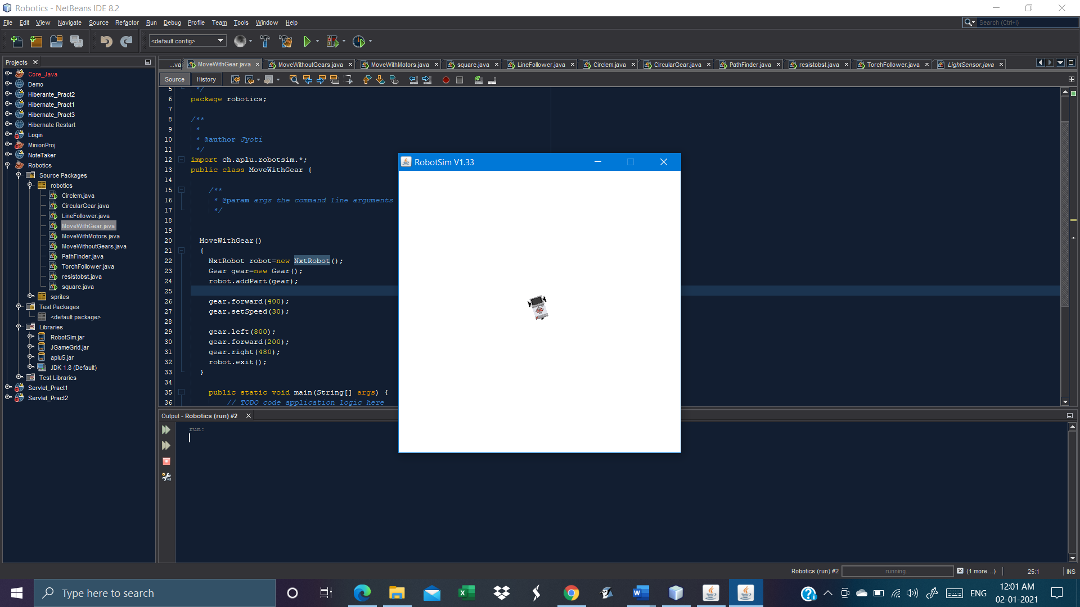

**Practical no. 1(b)**

**Output:**

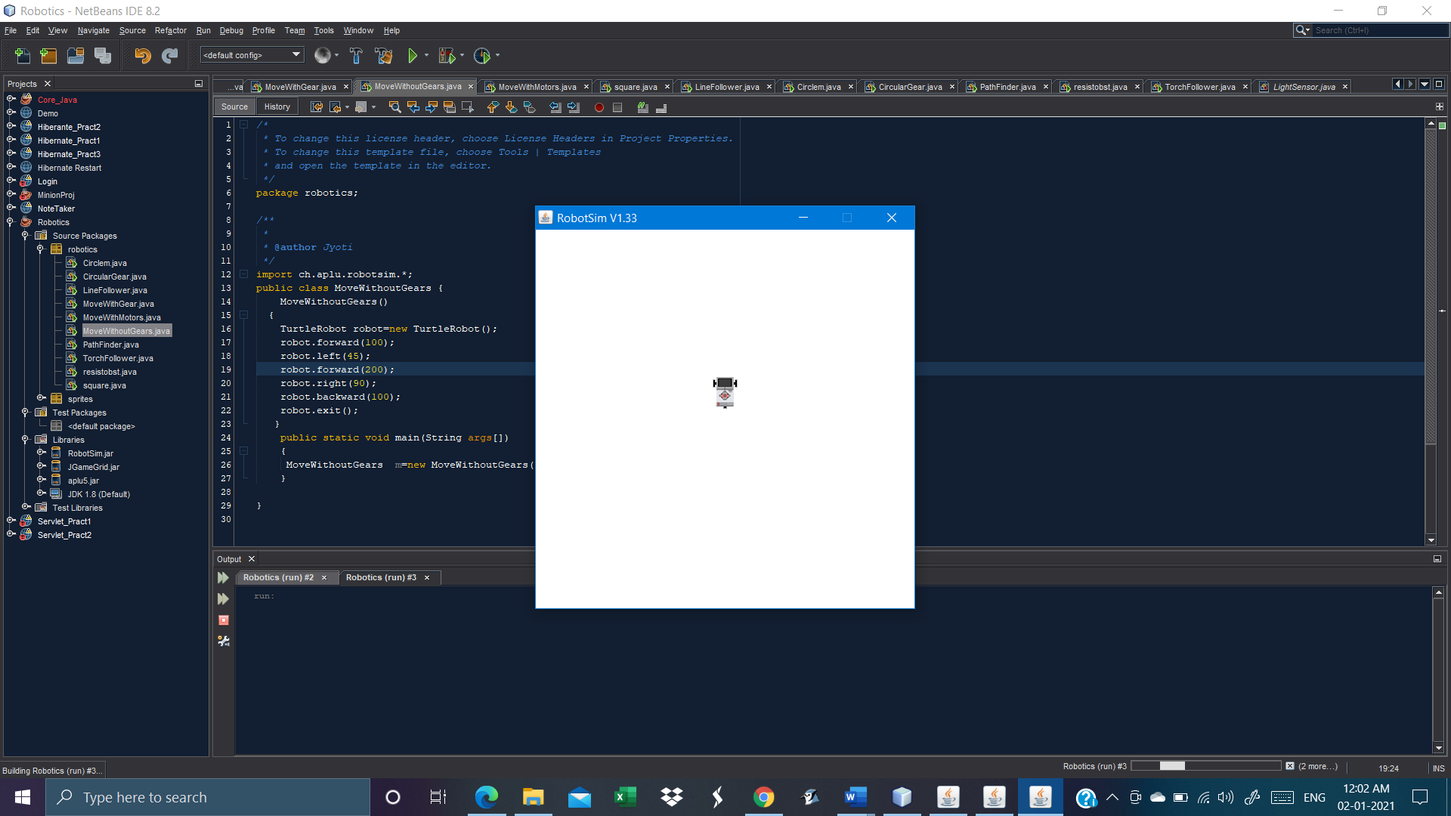

**Practical No. 2**

**Output:**

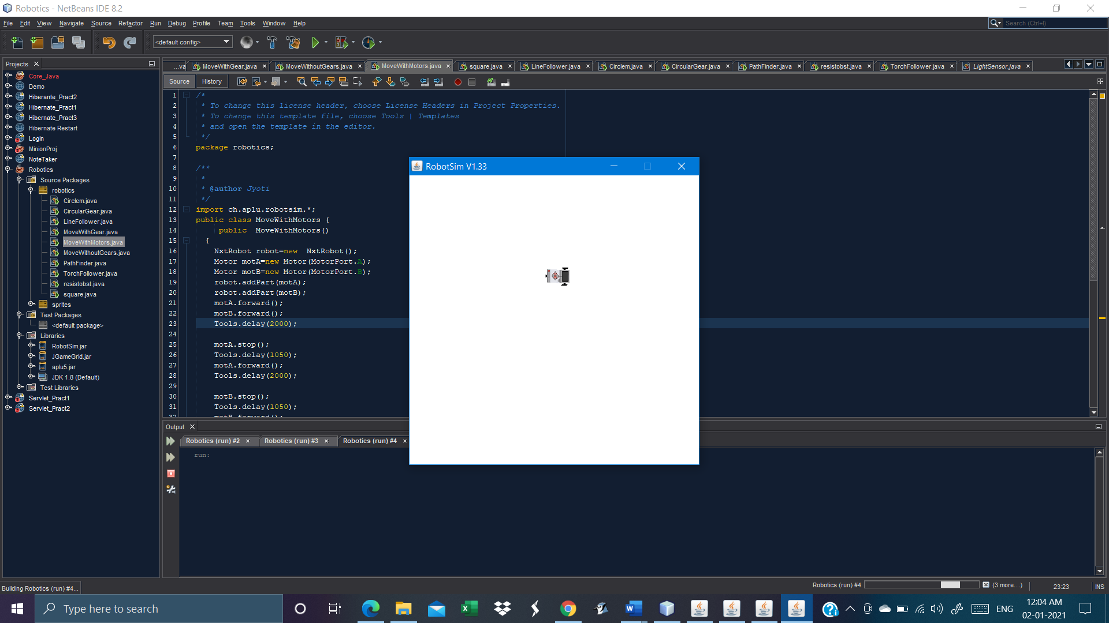

**Practical no. 3**

**Output:**

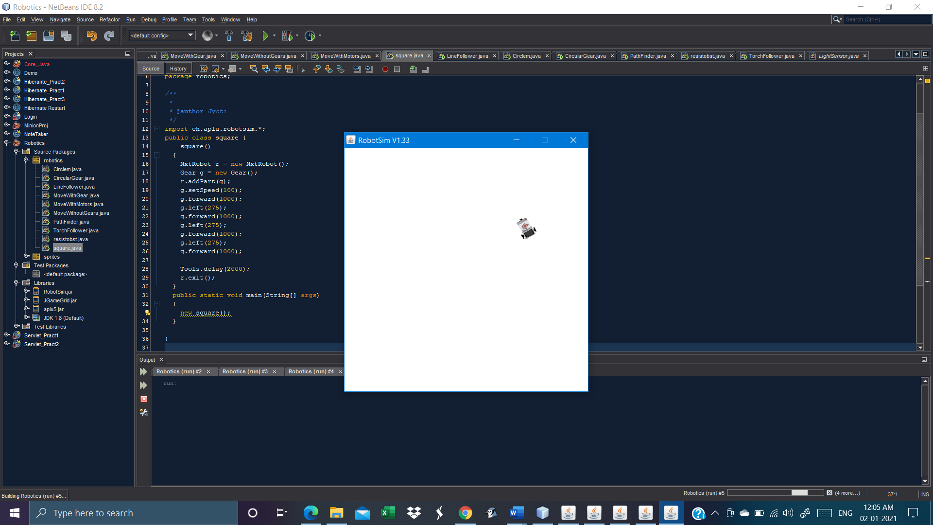

**Practical no. 4**

**Output:**

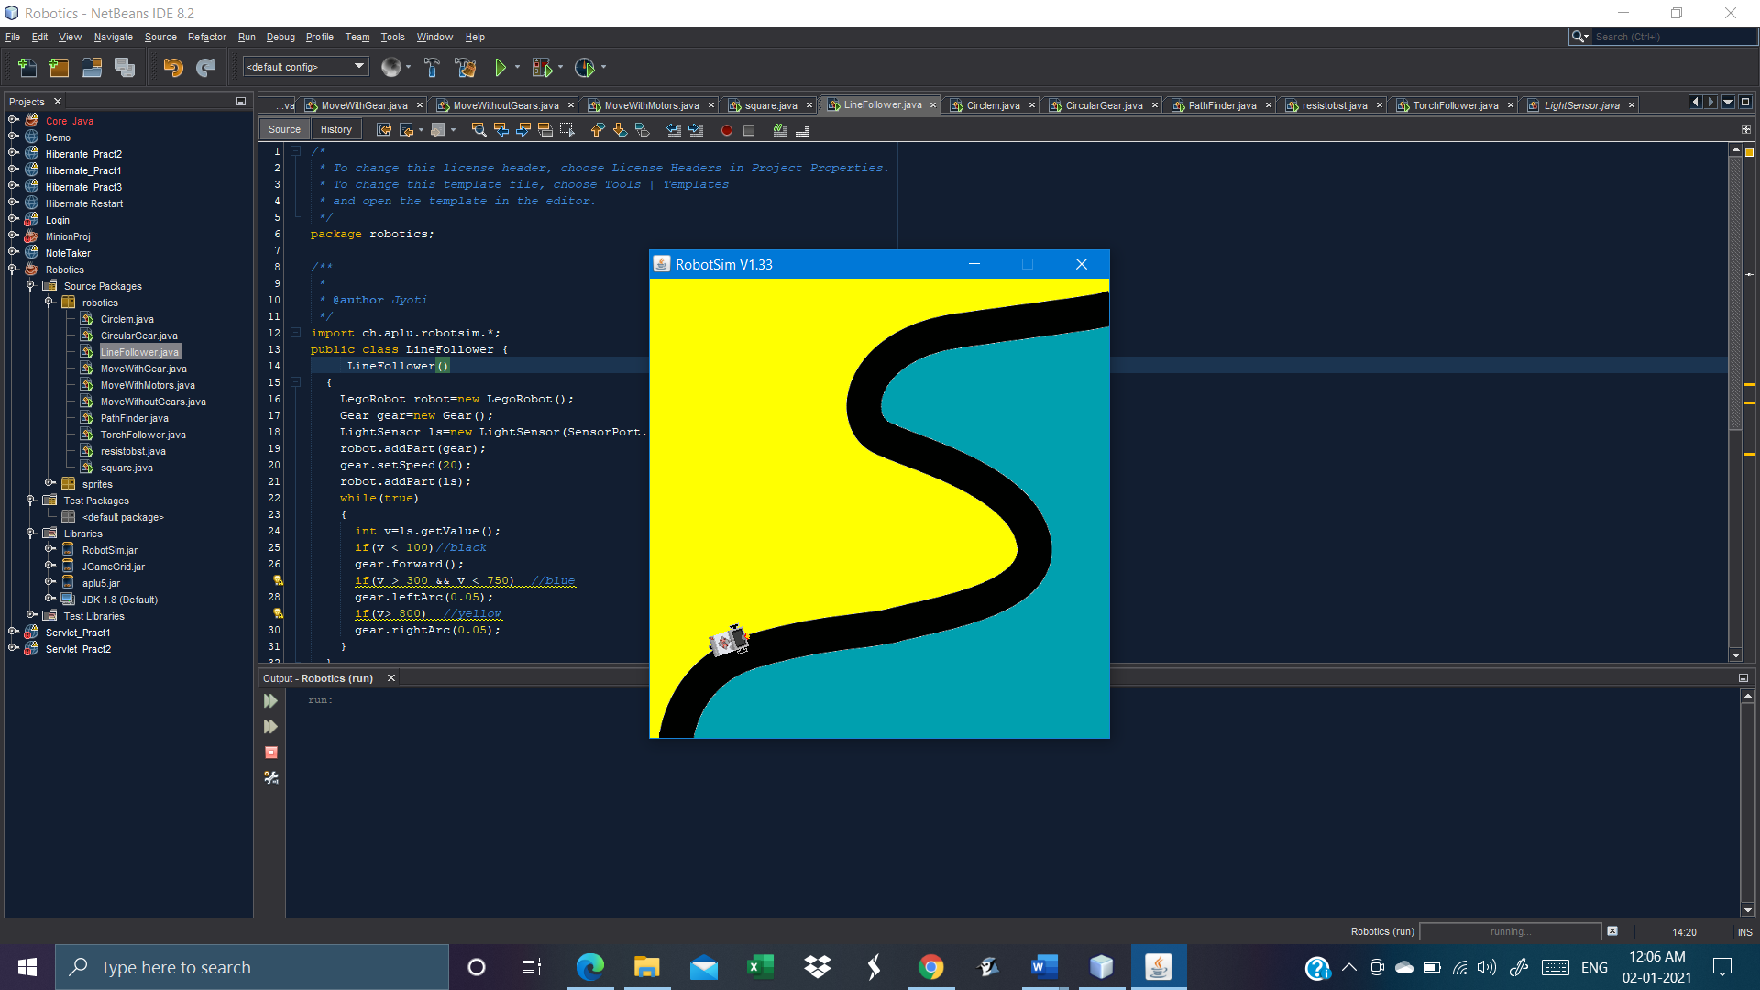

**Practical No. 5(a)**

**Output:**

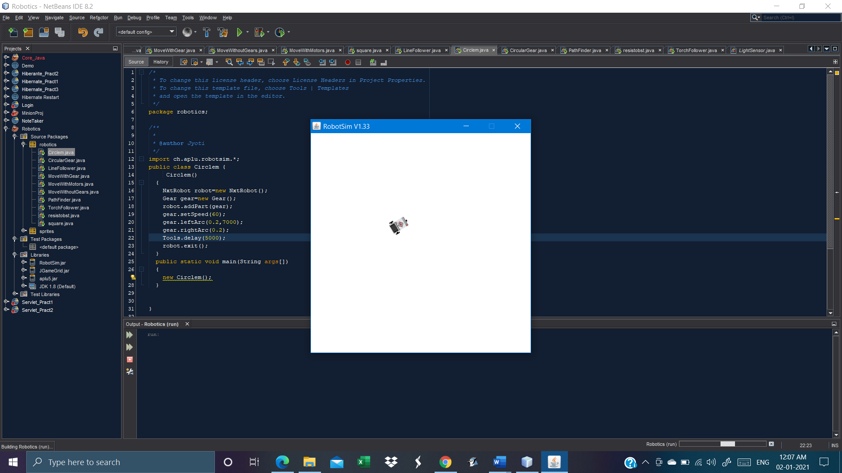

**Practical No. 5(b)**

**Output:**

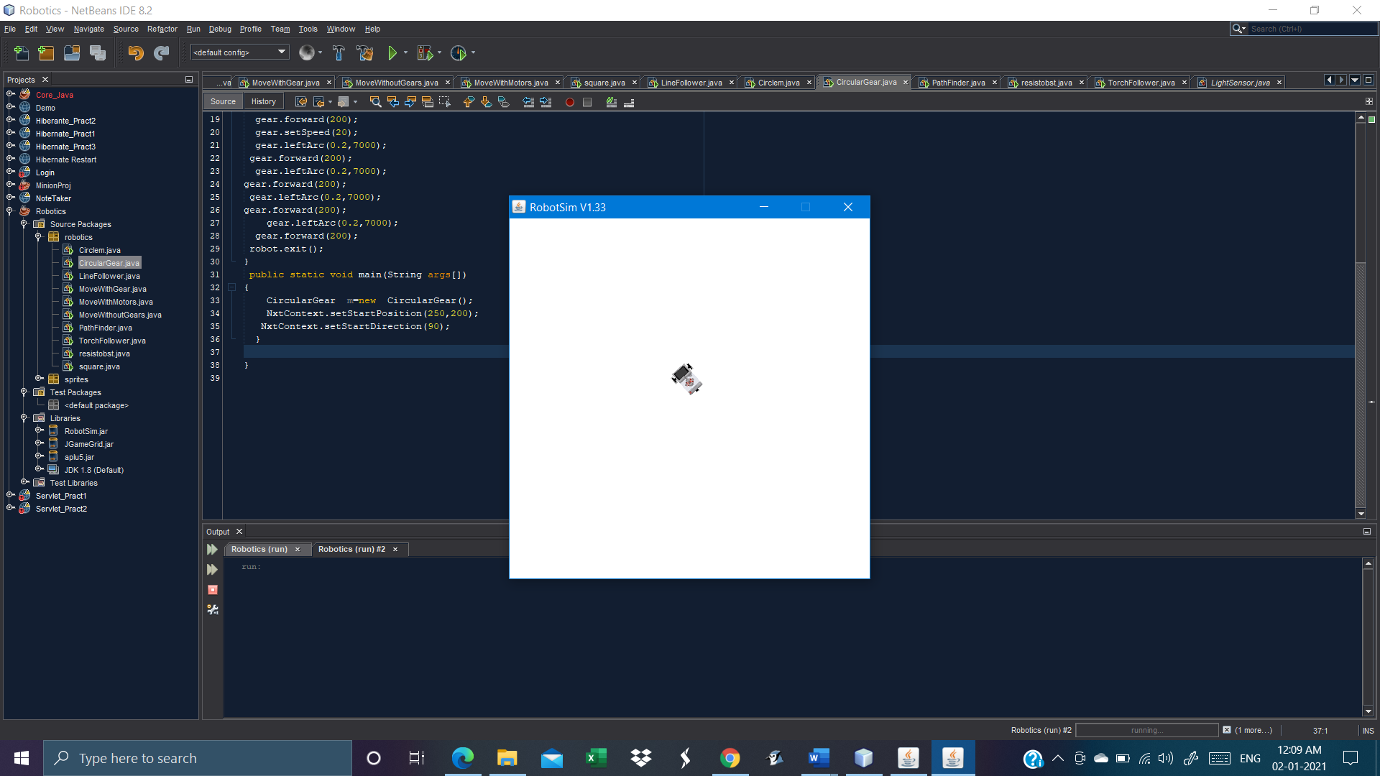

**Practical No. 6**

**Output:**

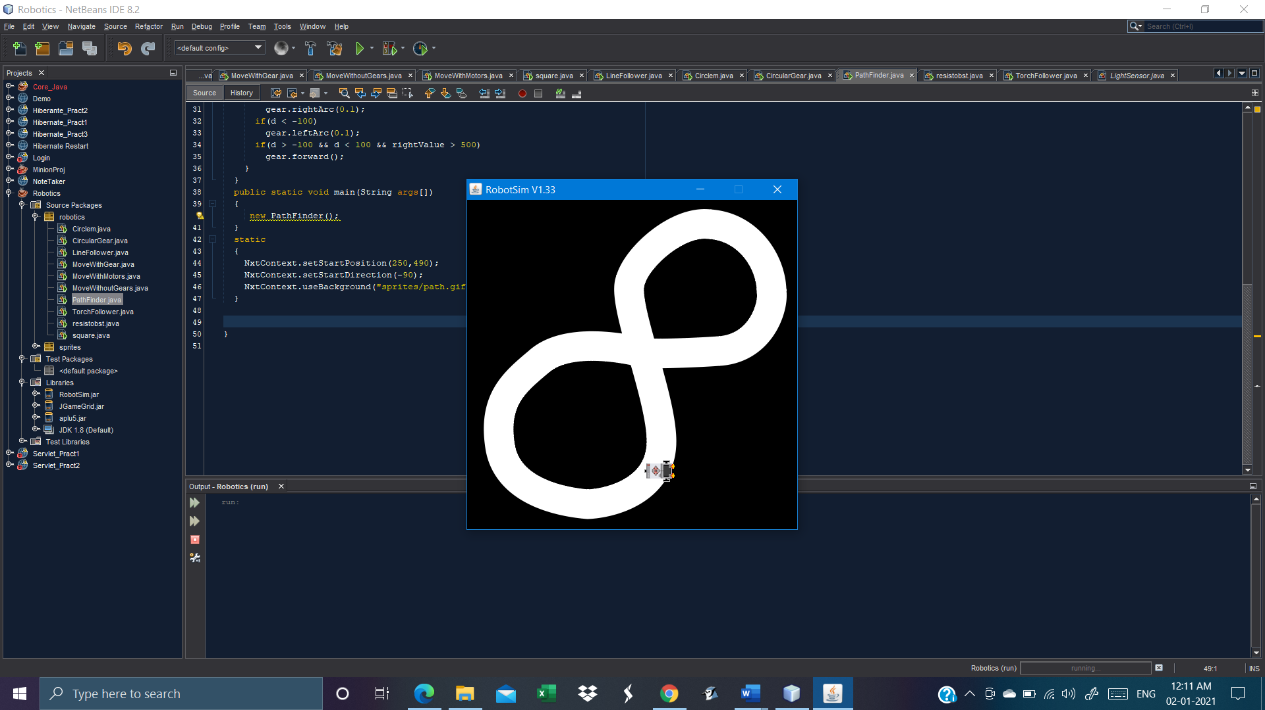

**Practical no. 7**

**Output:**

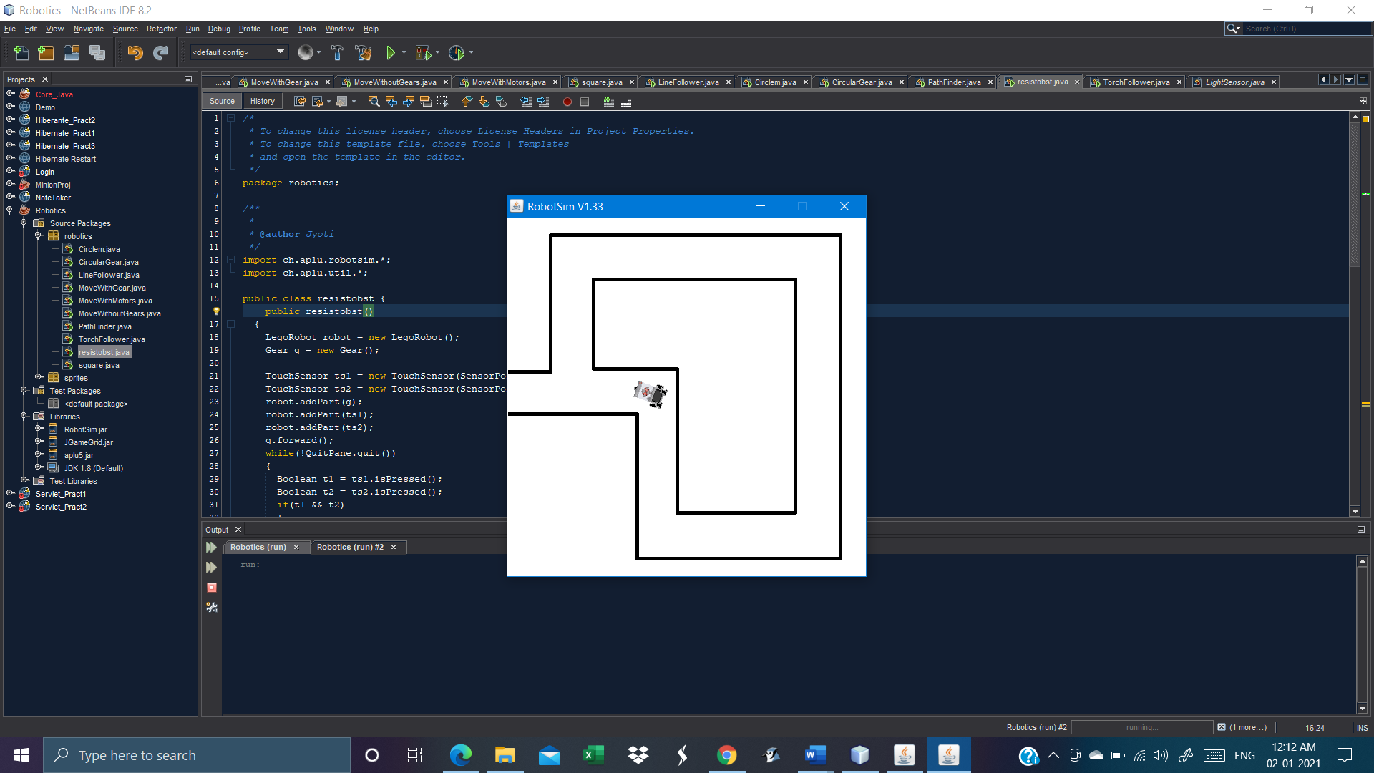

**Practical no. 8**

**Output:**

