Computer Graphics**-**Lab

**Q2- Write a program to scale a triangle about origin.**

**Solution-**

#include<stdio.h>

#include<graphics.h>

#include<math.h>

void scaling(int x1,int y1,int x2,int y2,int x3,int y3)

{

int sx,sy,xn1,yn1,xn2,xn3,yn3,yn2,gd=0,gm; printf("enter the scaling vector\n"); scanf("%d%d",&sx,&sy); xn1=x1*sx;

yn1=y1*sy;

xn2=x2*sx;

yn2=y2*sy;

xn3=x3*sx;

yn3=y3*sy;

initgraph(&gd,&gm,"");

setcolor(RED);

line(x1,y1,x2,y2);

setcolor(RED);

line(x1,y1,x3,y3);

setcolor(RED);

line(x2,y2,x3,y3);

delay(600);

setcolor(YELLOW);

line(xn1,yn1,xn2,yn2);

setcolor(YELLOW);

line(xn1,yn1,xn3,yn3);

setcolor(YELLOW);

line(xn2,yn2,xn3,yn3);

delay(600);

}

int main( )

{

int ch,x1,y1,x2,y2,x3,y3;

printf("enter the vertex co-ordinates of triangle\n");

scanf("%d %d %d %d %d %d",&x1,&y1,&x2,&y2,&x3,&y3); scaling(x1,y1,x2,y2,x3,y3);

delay(9999);

return 0;

}

**Output-**

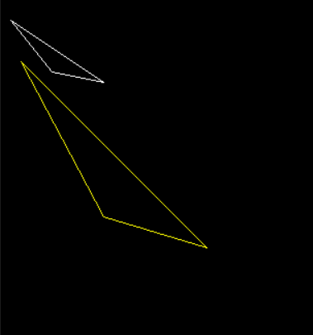

**Q3- Write a program to draw a line using DDA.**

**Solution-**

#include <graphics.h>

void main( )

{

float x,y,x1,y1,x2,y2,dx,dy,steps;

int i,gd=DETECT,gm;

printf("Enter (x1, y1) : ");

scanf("%f%f",&x1,&y1);

printf("Enter (x2,y2): ");

scanf("%f%f",&x2,&y2);

initgraph(&gd,&gm,"");

dx=abs(x2-x1);

dy=abs(y2-y1);

if(dx>=dy)

steps=dx;

else

steps=dy;

dx=dx/steps;

dy=dy/steps;

x=x1;

y=y1;

i=1;

while(i<=steps)

{

putpixel(x,y,5);

x=x+dx;

y=y+dy;

i=i+1;

delay(50);

}

delay(5000);

closegraph( );

}

**Output-**

