**MILESTONE SUBMISSION**

Name- Jyoti Bhausaheb Pawase

Employee ID- 214953

Problem 5:

For the circuit shown in Figure 3, the equation is 𝑅𝑑𝑄𝑑𝑡 + 1𝐶 𝑄 = (𝑡)

Simulate this equation for 10 seconds for 5 different initial conditions and inputs E(t)

**Integrator**

1] Initial Condition = 0

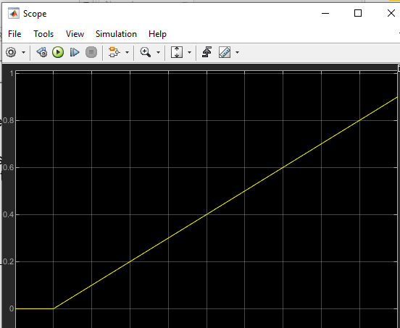

2] Initial Condition= 1

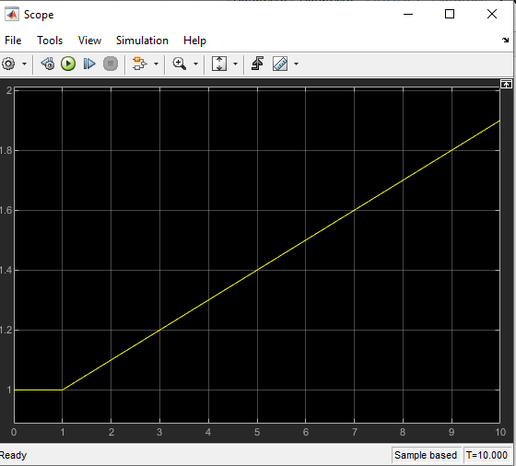

3] Initial Condition= 2 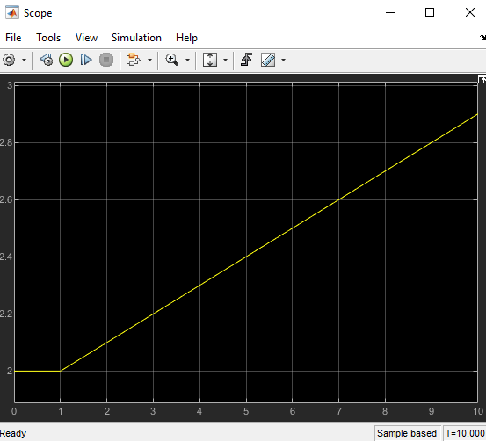

4] Initial Condition= 3

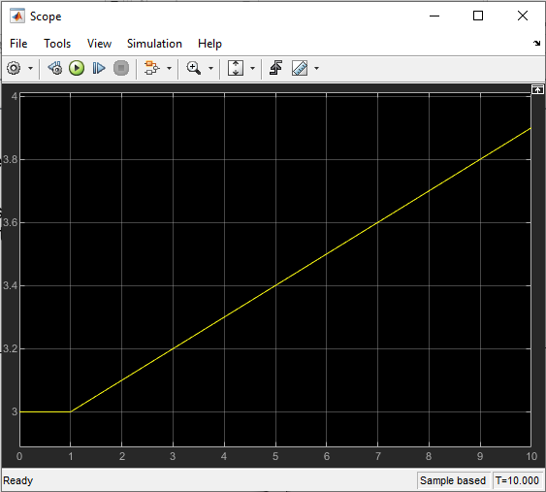

5] Initial Condition= 4

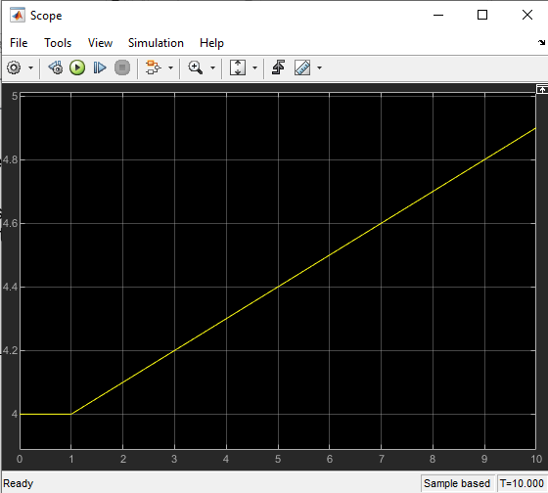

6] Initial condition = 5

