Name: Jyoti Bhausaheb Pawase

Emp-ID- 214953

**Project Report**

**On**

**Antilock Braking System**

**Introduction:**

The hydraulic unit is the central component of an ABS system. It includes valves that control braking pressure at each individual wheel, a return pump, and an electronic control unit. In addition, each of the four wheels has a wheel-speed sensor. They measure the speed of each wheel and transmit this information to the control unit. If a wheel is about to lock under heavy braking, the system reduces the braking pressure on that single wheel until the threat of locking is past. Once the wheel turns freely again, brake pressure is again increased. This increase and release of pressure continues until the driver reduces the force applied to the brake pedal, or until the tendency to lock is overcome – if there is more grip on the road surface, for instance. Depending on the particular system, the brake pedal may pulsate.

**Model of System:**

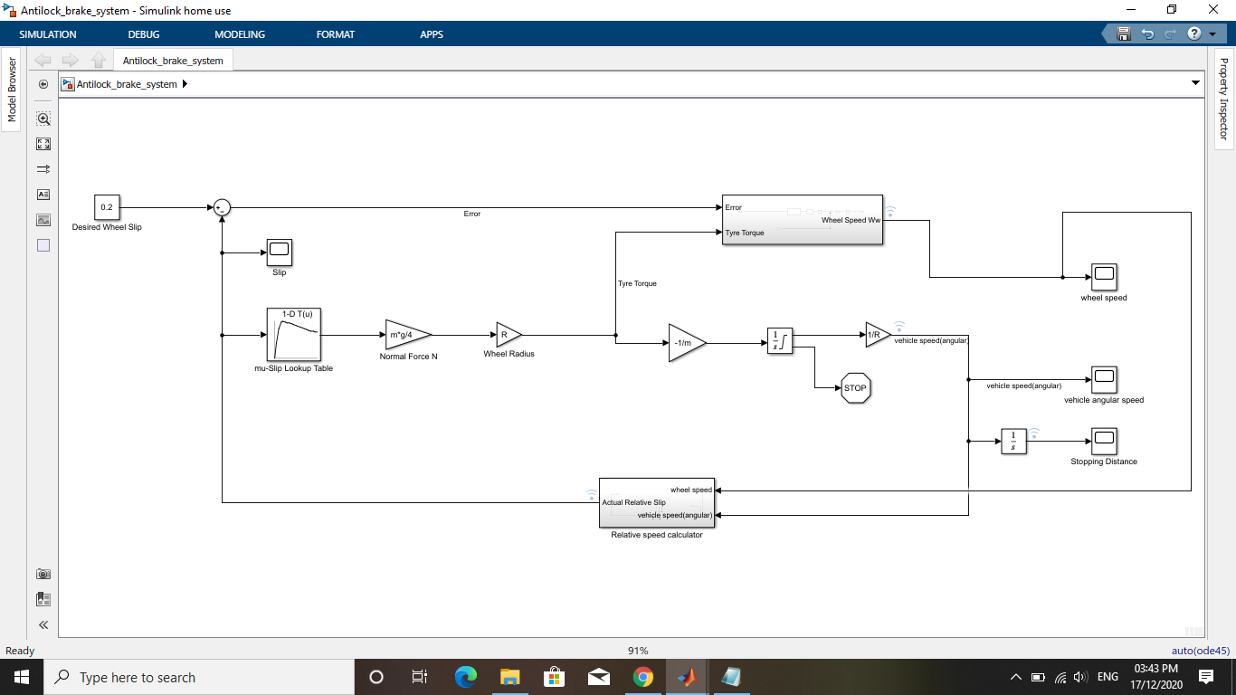

**Output on data Inspector:**

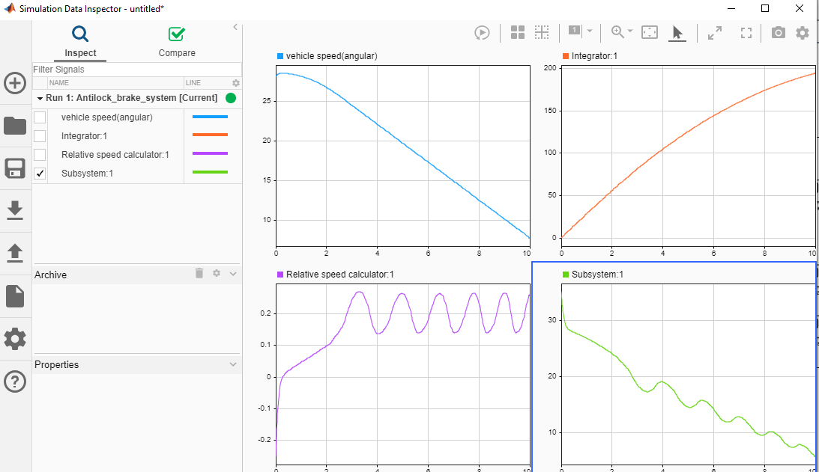

**Callback:**

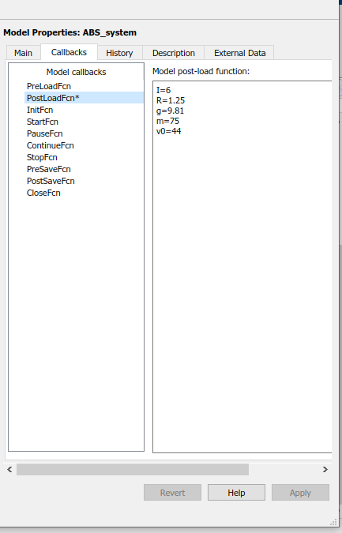

**Lookup Table values:**

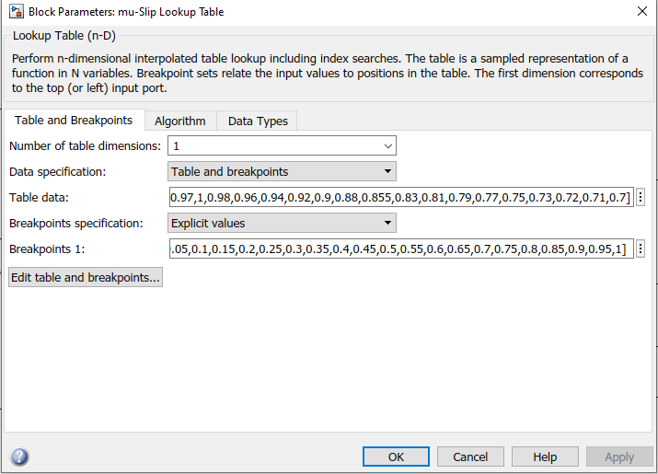

**Solver information:**

