Getting the default data of product
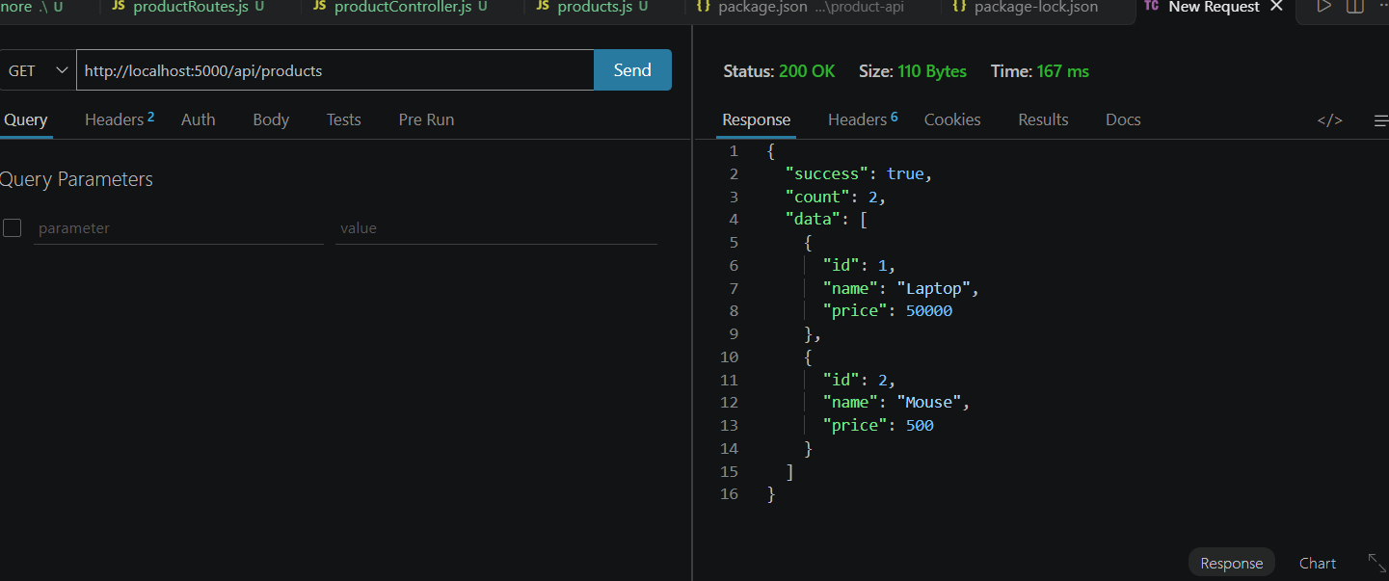
Getting the product by its ID
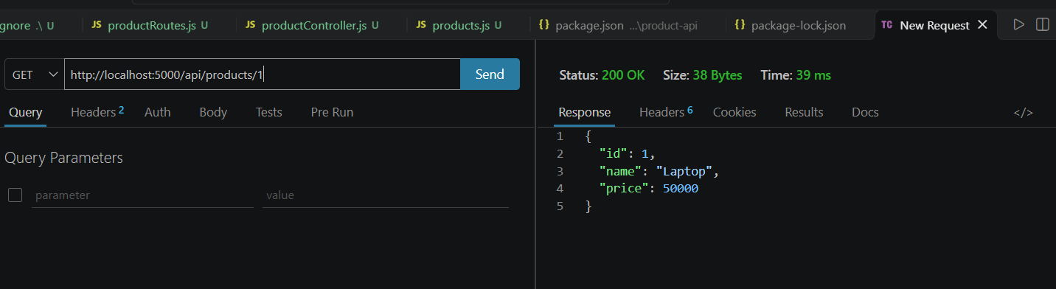
Testing the invalid product id
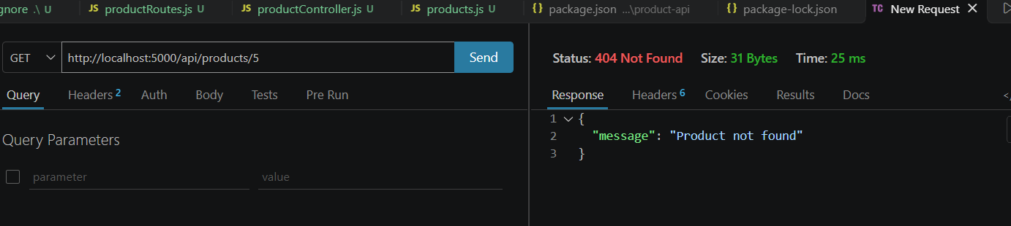

Adding a new product in the list using POST method
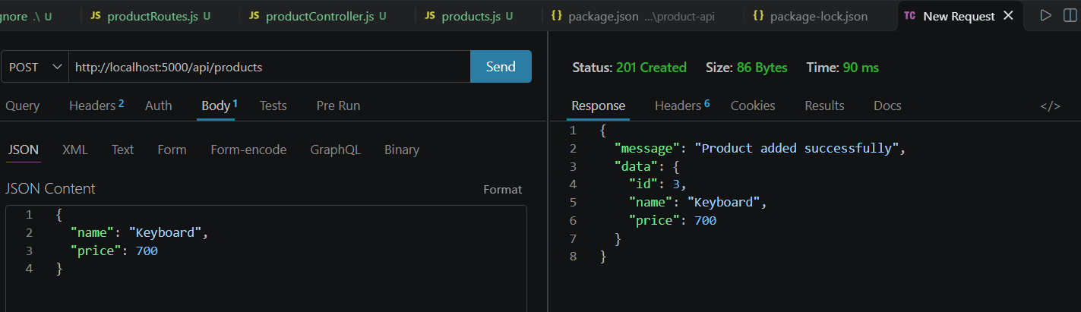
Verifying the new added products
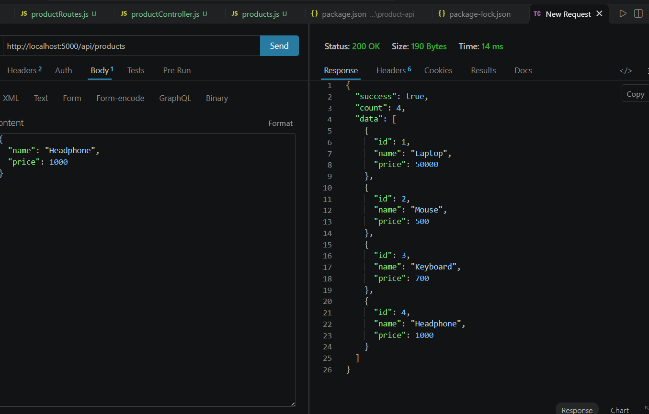

Using the updating (PUT) method
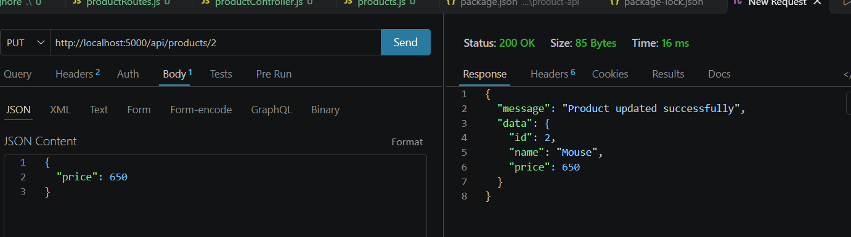
Testing delete (DELETE) method
Deleting id-9 “Power Bank”
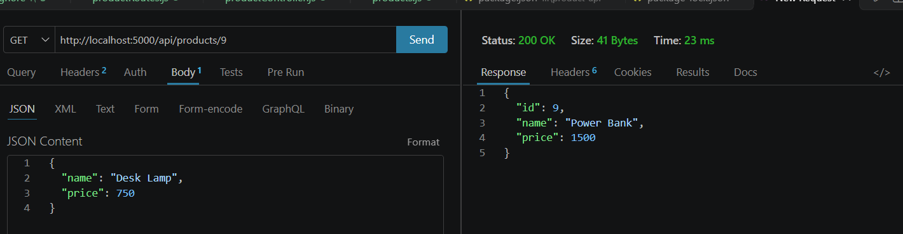

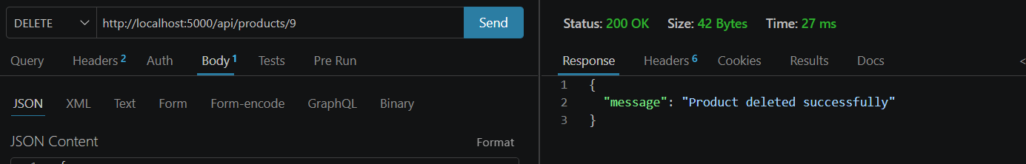
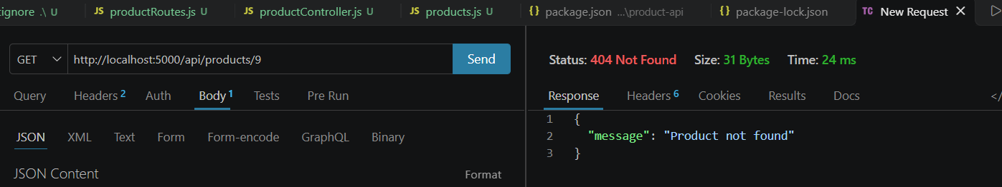

Final product


