Fetching old data
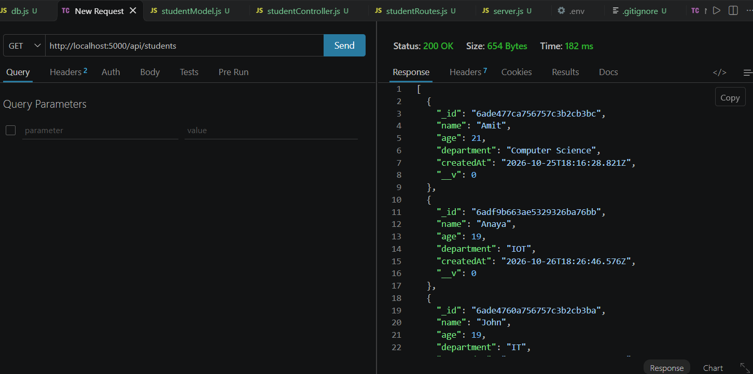
Adding a new student
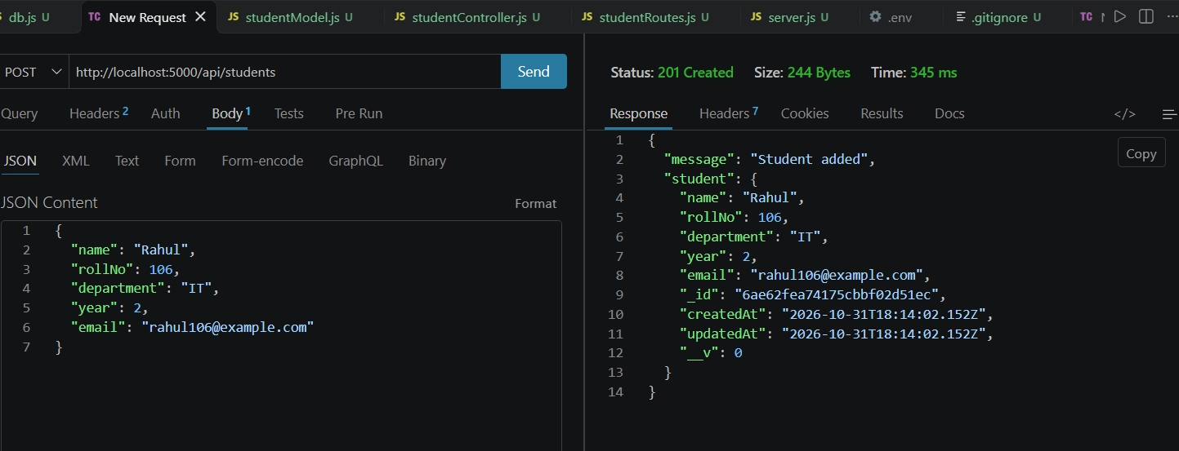

Finding the new student Rahul by his ID
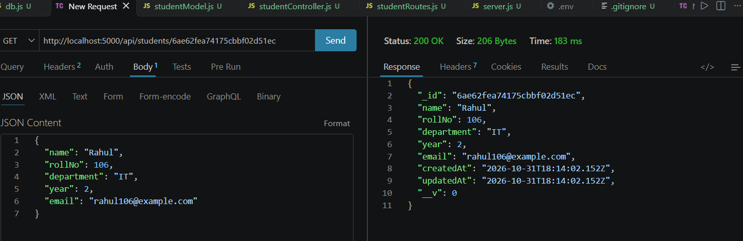
Updating Rahul’s details
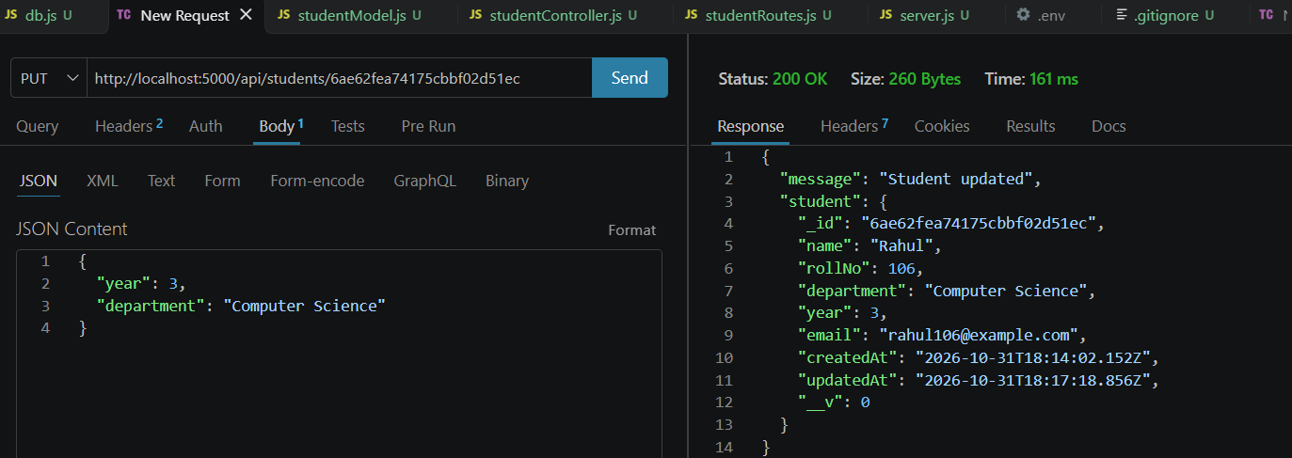
Deleting Rahul’s data
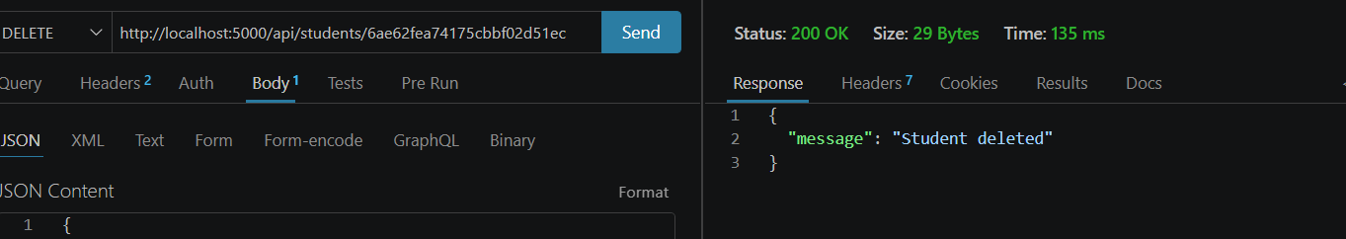

Applying Pagination
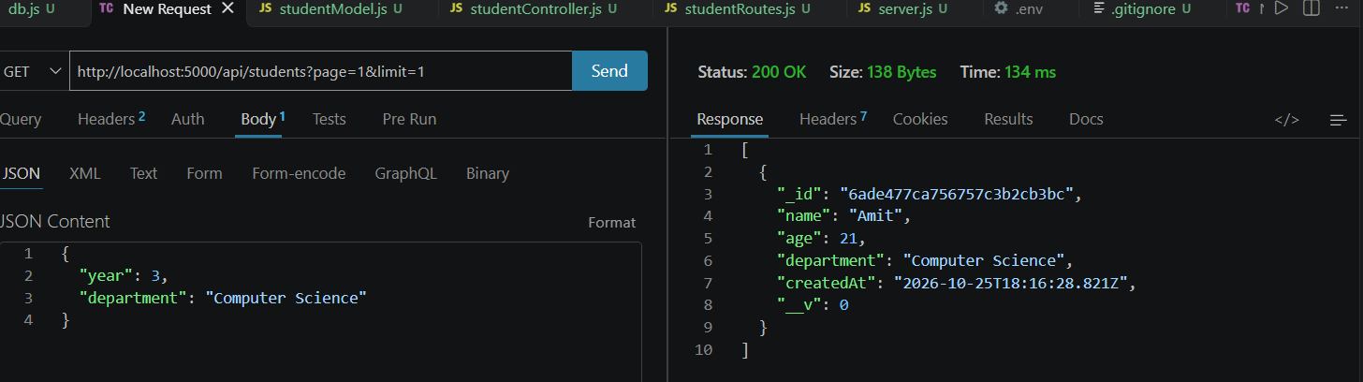
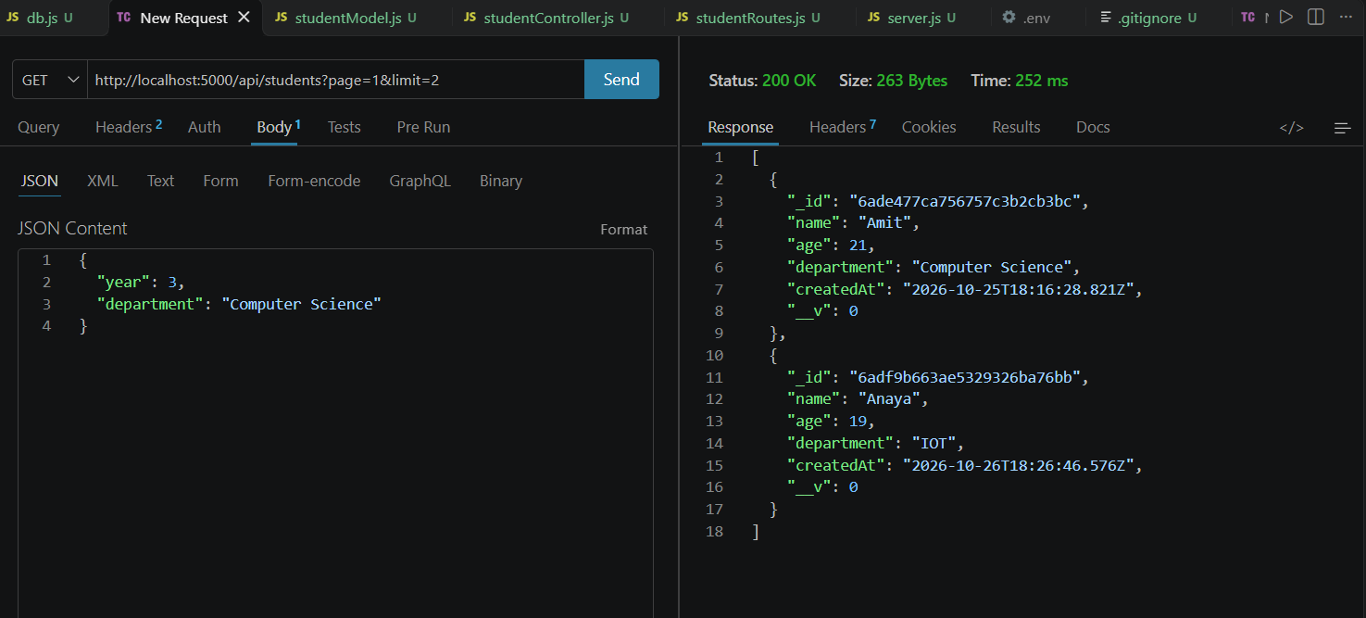
Sorting students in alphabetical order
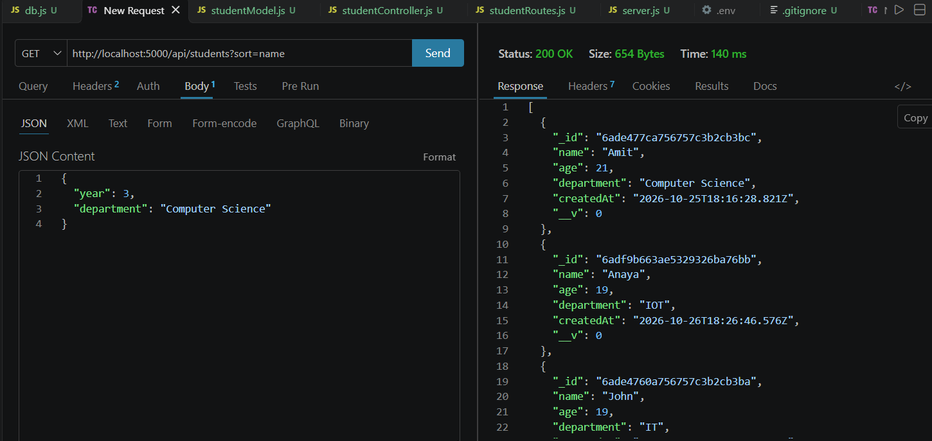
Searching the student
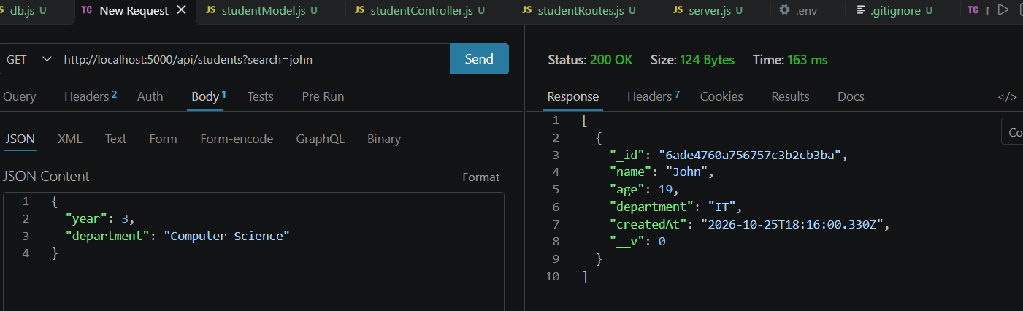
Adding the course relationship
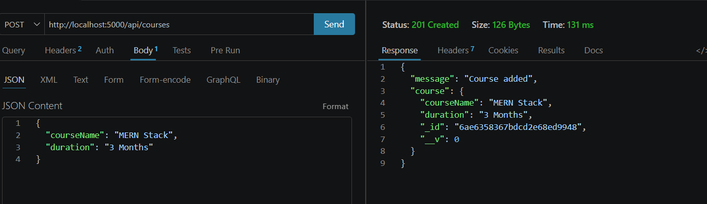
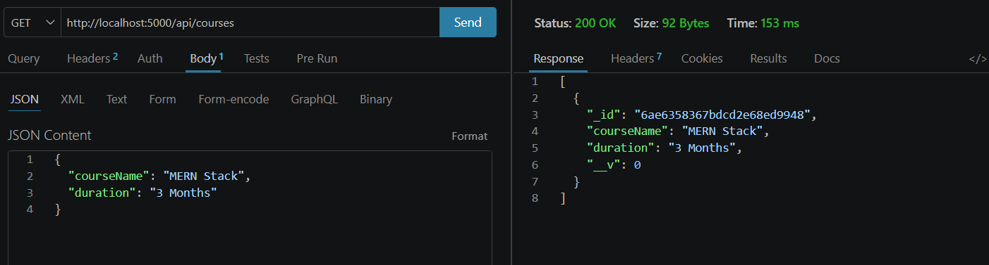

Course Relationship & Populate Testing


