**RETAIL ANALYTICS**

**Business Objective :** To understand the customer behaviour,preferences and trends using their point of sale data(POS).

**DATA AVAILABILITY**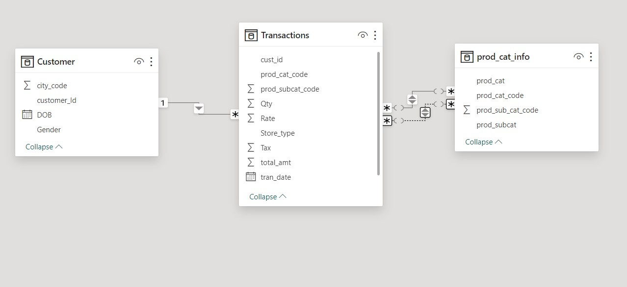

**3 datasets:**

1.CUSTOMER: contains customer information.

2.TRANSACTIONS: contains customer transactions details.

3.PRODUCT CATEGORY: contains product and sub-category information.

**Q1) What is the total no of rows in each of the three tables?**

**Select**

'customer' **as** C, **Count(*)** **as** TotalRows **From** customer

**Union**

**Select**

'prod_cat_info' **as** P, **Count(*)** **as** TotalRows **From** prod_cat_info

**Union all**

**Select**

'transactions' **as** T, **Count(*)** **as** TotalRows **From** transactions;

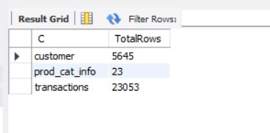

**Q2) Which product category does the sub-category DIY belongs to?**

**Select** prod_cat,prod_subcat **from** prod_cat_info

**where** prod_subcat**="DIY"**;

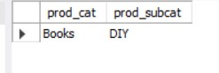

**Q3) Which Store is most frequently used for transactions?**

**Select** **count**( transaction_id**) as** trans_count,Store_type

**from** transactions

**group by** Store_type;

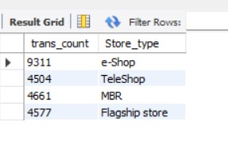

**Q4) What is the count of Male and Female customers in the database?**

**Select**

**Count**(**Case When** Gender = **'M'** **Then 1** **End**) **as** Male_Count,

**Count**(**Case When** Gender = **'F'** **Then** **1** **End**) **as** Female_Count,

**Count**(**Case When** Gender **not In** (**'M', 'F'**) **Then** **1** **End**) **as** Other

**From** customer;

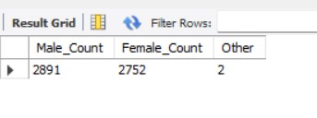

**Q5) From which city do we have the maximum no of customers?**

**Select count**(customer_Id) **as** Tot_Cust_city,city_code

**from** customer

**group by** city_code

**order by** Tot_Cust_city **desc**;

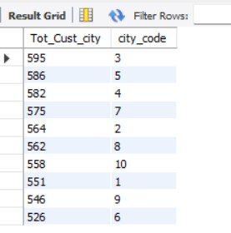

**Q6) How many sub-categories are there under the book category?**

**select** prod_cat,**count**(prod_subcat) **a**s Total_subcat

**from** prod_cat_info

**where** prod_cat=**"Electronics"**

**group by** prod_cat;

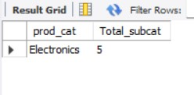

**Q7) What is the maximum quantity ordered?**

**Select** **max**(qty) **as** mx

**from** transactions;

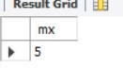

**Q8) What is the net total revenue generated in categories electronics and books?**

**Select concat**(**round**(**SUM**(total_amt - Tax)/**1000000**,**1**),"**M**") **as** net_revenue

**From** transactions

**Where** prod_cat_code **in** (**3,5**);

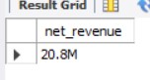

**Q9) How many customers have more than 9 transactions, excluding returns?**

**Select count**(transaction_id)-**1** as c,cust_id

**from** transactions

**where** Qty>=**0**

**group by** cust_id

**having** **count**(transaction_id)-**1**>**9**;

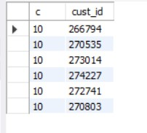

**Q10) What is the combined revenue earned from “Electronics” and “Clothing” categories from flagship stores?**

**Select** **concat**(**round**( **SUM**(t.total_amt-tax)/**1000000**,**2**),**"M"** ) **as** combined_revenue

**From** Transactions t **Join** prod_cat_info p **ON** t.prod_cat_code = p.prod_cat_code **and** t.prod_subcat_code=p.prod_sub_cat_code

**Where** p.prod_cat **in** (“**Electronics**”, **“Clothing”**) **and** t.Store_type **like** **"flag%"** ;

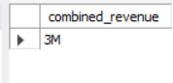

**Q11) What is the total revenue generated from Male customers in electronics category?**

**select round**(**sum**(total_amt-tax)/**1000000**,**2**) **as** Total_rev

**from** customer c inner join transactions t **on** c.customer_id=t.cust_id

**inner join** prod_cat_info p **on** p.prod_cat_code=t.prod_cat_code **and** p.prod_sub_cat_code=t.prod_subcat_code

**where** prod_cat =**"Electronics"** and gender=**"M"**;

