# What is jQuery?

jQuery is a popular open-source JavaScript library full of pre-built code solutions that make it much easier to use JavaScript on your website.

# How to Apply CSS Using JQuery, How to Add Class and Remove Class in Jquery, JQuery Animation?

* You can apply CSS styles to HTML elements using jQuery's css() method.

<!DOCTYPE html>

<html>

<head>

<script src=" https://cdnjs.cloudflare.com/ajax/libs/jquery/3.7.1/jquery.min.js"></script>

</head>

<body>

<div id="myDiv">This is a div element</div>

<script>

$(document).ready(function() {

// Apply CSS styles to the element with the id 'myDiv'

$("#myDiv").css({

"color": "blue",

"font-size": "24px",

"background-color": "yellow"

});

});

</script>

</body>

</html>

* Adding and Removing Classes Using jQuery

<!DOCTYPE html>

<html>

<head>

<script src=" https://cdnjs.cloudflare.com/ajax/libs/jquery/3.7.1/jquery.min.js "></script>

</head>

<body>

<div id="myDiv">This is a div element</div>

<script>

$(document).ready(function() {

// Add a class to the element

$("#myDiv").addClass("highlight");

// Remove a class from the element

$("#myDiv").removeClass("highlight");

});

</script>

</body>

</html>

* jQuery Animation:

<!DOCTYPE html>

<html>

<head>

<script src=" https://cdnjs.cloudflare.com/ajax/libs/jquery/3.7.1/jquery.min.js "></script>

</head>

<body>

<div id="myDiv">This is a div element</div>

<script>

$(document).ready(function() {

// Animate the element's left margin to 200px over 2 seconds

$("#myDiv").animate({

marginLeft: "200px"

}, 2000);

});

</script>

</body>

</html>

# How to create slider with animation?

Index.html File :

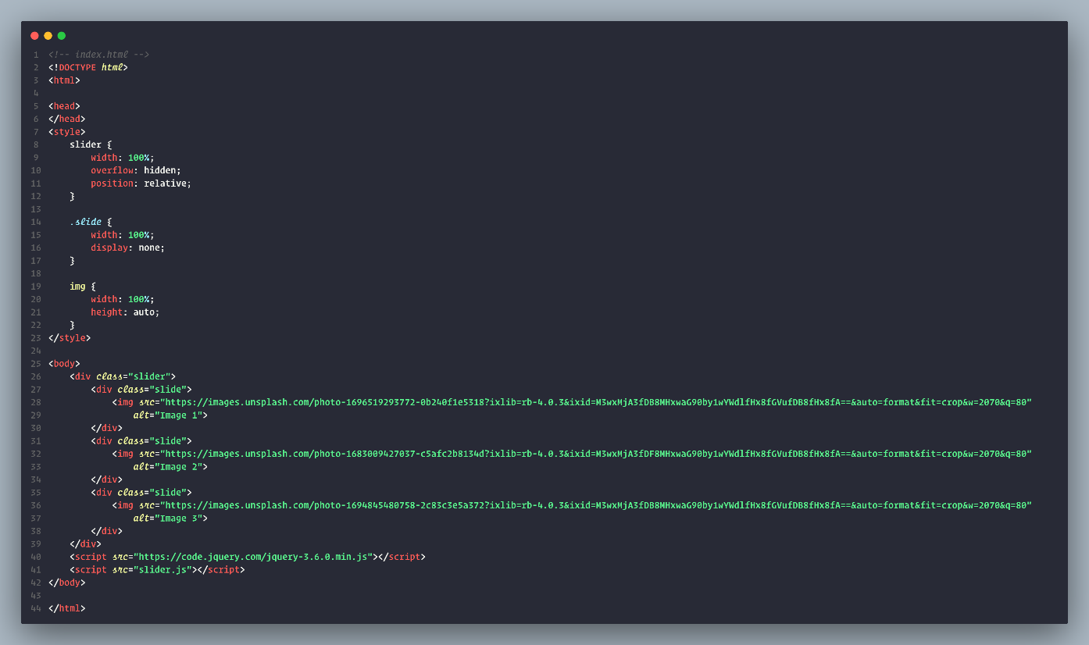

Javascript file :

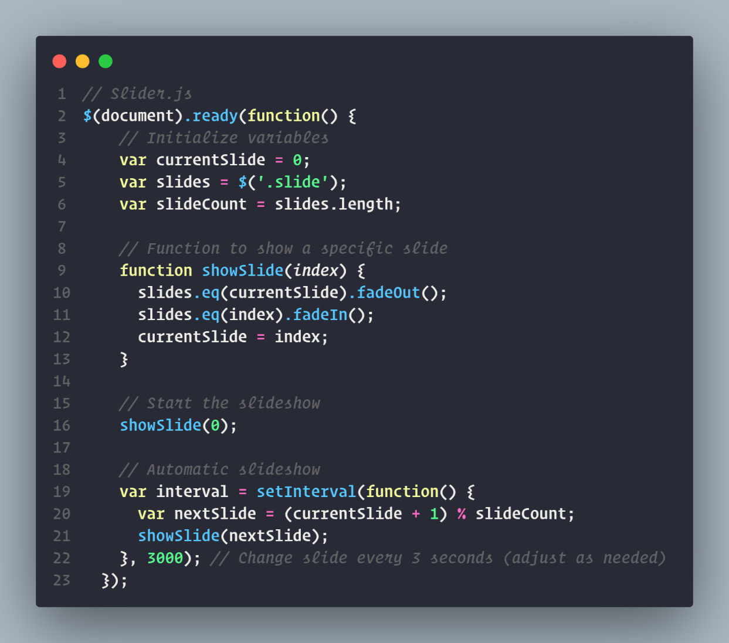

# Event bubbling tickling example

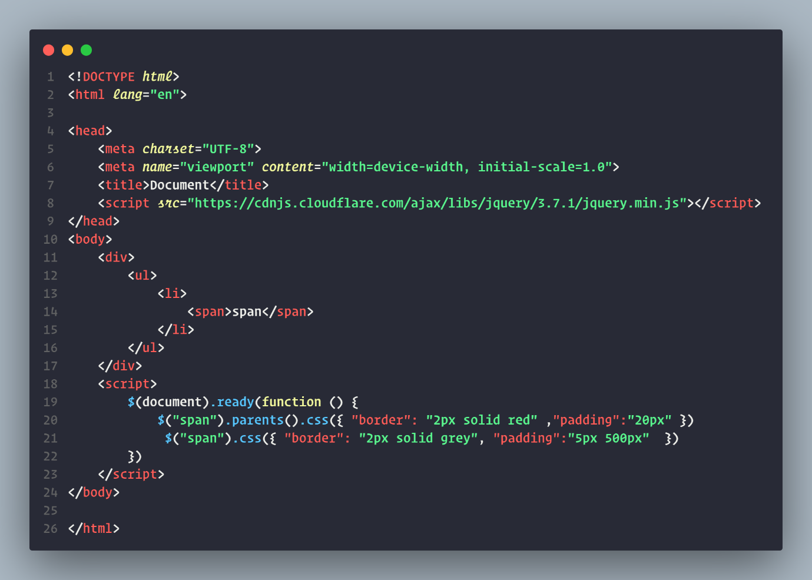

Output :

