**Module 1**

1. **Do search for web-site, http, URL etc given topics in lecture.**

**Website**

A website is a collection of web pages and web pages are digital files that are written using HTML(Hyper Text Markup language).

**HTTP**

HTTP stands for hyper Text Transfer protocol.

Communicating with client computer and web server is done by sending http Requests and receiving http Responses.

**URL**

URL stands for uniform Resource Locator . A URL is the address of given unique resource on the web.

Here are some example of URL:

<https://careercenter.tops-int.com/>

<https://careercenter.tops-int.com/course>

A URL is composed of different parts , some mandatory and others optional. The Most important parts are highlighted on the URL below :



**Module 2**

1. **Do search for domain, hosting, SEO etc.**

**Domain**

When referring on an Internet address or name , a domain or domain name is the location of website. For example , the domain name “google.com” points to the IP address “216.58.216.164”. Generally , it’s easier to remember a name rather than a long string numbers. A domain name contains a maximum of 63 characters , with one character minimum , and is entered after the protocol in the URL , as shown in the following example:



**Hosting**

Hosting refers to the process of storing and making available a website or web application on the internet. When you create a website, it consists of various files such as HTML, CSS, JavaScript, images, and databases. These files need to be stored on a server, which is a powerful computer designed to handle requests and deliver the website's content to users.

Hosting providers offer services that allow individuals and organizations to store their website files on their servers. These servers are typically connected to the internet with high-speed connections to ensure fast and reliable access to the hosted websites.

When you sign up for a hosting service, you are essentially renting space on the provider's servers to store your website files. The hosting provider takes care of managing the servers, ensuring they are up and running, and providing the necessary infrastructure to make your website accessible to users around the world.

There are various types of hosting available, including:

1. Shared hosting: Your website shares server resources with other websites. It is an affordable option suitable for small websites with low traffic.

2. Virtual Private Server (VPS) hosting: It offers a virtualized server environment where you have dedicated resources within a shared server. It provides more control and scalability compared to shared hosting.

3. Dedicated hosting: You have an entire physical server dedicated to hosting your website. It provides maximum control, flexibility, and performance but is more expensive.

4. Cloud hosting: Your website is hosted on a network of interconnected servers, offering scalability, reliability, and resource flexibility.

5. Managed hosting: The hosting provider takes care of server management tasks such as security updates, backups, and technical support, allowing you to focus on your website's content.

6. WordPress hosting: Hosting specifically optimized for WordPress websites, offering features like easy installation, automatic updates, and specialized support.

These are just a few examples, and there are many other hosting options available based on your specific needs and budget.

**SEO (Search Engine Optimization)**

SEO stands for search engine optimization , which is a set of practice designed to improve the appearance and positioning of web pages in organic search results. Because organic search is the most prominent way for people to discover and access online content, a good SEO strategy is essential for improving the quality and quantity of traffic to your website.

**Module 3**

# **Are the HTML tags and elements the same thing?**

No. HTML elements are defined by a starting tag, may contain some content and a closing tag.For example, <h1>Heading 1</h1> is a HTML element but just <h1> is a starting tag and </h1> is a closing tag.

# **What are tags and attributes in HTML?**

**T**ags are the primary component of the HTML that defines how the content will be structured/ formatted, whereas Attributes are used along with the HTML tags to define the characteristics of the element. For example, <p align=” center”>Interview questions</p>, in this the ‘align’ is the attribute using which we will align the paragraph to show in the center of the view

# **What are void elements in HTML? With Example.**

HTML elements which do not have closing tags or do not need to be closed are Void elements. For Example <br />, <img />, <hr />, etc.

# **What are HTML Entities? With Example.**

In HTML some characters are reserved like ‘<’, ‘>’, ‘/’, etc. To use these characters in our webpage we need to use the character entities called HTML Entities.

Examples: &copy; &reg; ,&amp;

# **What are different types of lists in HTML? With Example.**

There are three types of list in HTML.

1. Unordered List
2. Ordered List
3. Defination / Description list.

Examples:

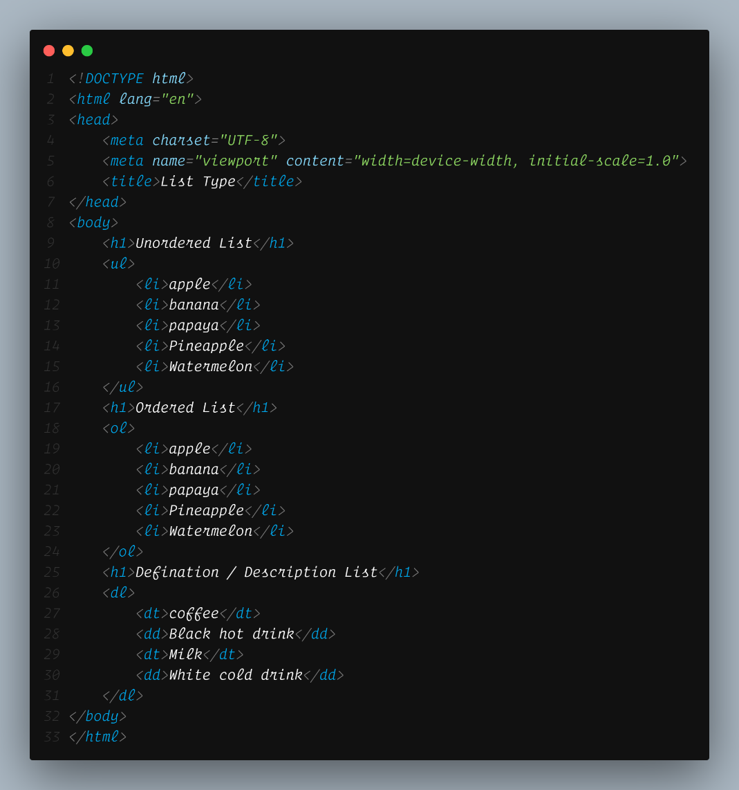

OUTPUT:

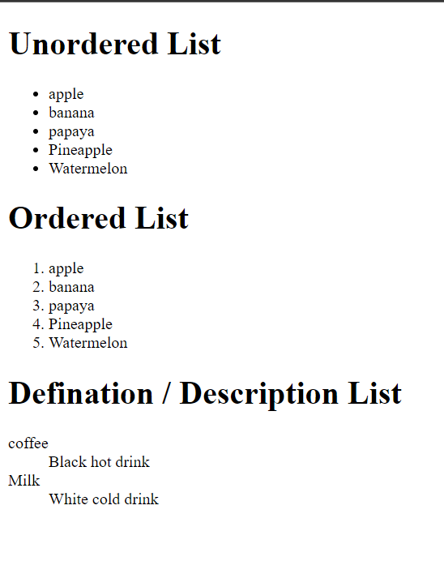

# **What is the ‘class’ attribute in HTML? With Example.**

The class attribute is used to specify the class name for an HTML element. Multiple elements in HTML can have the same class value. Also, it is mainly used to associate the styles written in the stylesheet with the HTML elements.

Example: <h1 class=”example”>Example of class </h1>

# **What is the difference between the ‘id’ attribute and the ‘class’ attribute of HTML elements? With Example.**

Multiple elements in HTML can have the same class value, whereas a value of id attribute of one element cannot be associated with another HTML element. <h1 class=example”> difference between class and id </h1>

Example :

<h1 class=example” id=”example1”> difference between class and id </h1>

<h2 class=example” id=”example2”> difference between class and id </h2>

<h3 class=example” id=”example3”> difference between class and id </h3>

<h4 class=example” id=”example4”> difference between class and id </h4>

# **What are the various formatting tags in HTML?**

HTML has various formatting tags:

* **<b>** - makes text bold
* **<i>** - makes text italic
* **<em>** - makes text italic but with added semantics importance
* **<big>** - increases the font size of the text by one unit
* **<small>** - decreases the font size of the text by one unit
* **<sub>** - makes the text a subscript
* **<sup>** - makes the text a superscript
* **<del>** - displays as strike out text
* **<strong>** - marks the text as important
* **<mark>** - highlights the text
* **<ins>** - displays as added text

# **How is Cell Padding different from Cell Spacing? With Example.**

Cell Spacing is the space or gap between two consecutive cells. Whereas, Cell Padding is the space or gap between the text/ content of the cell and the edge/ border of the cell.

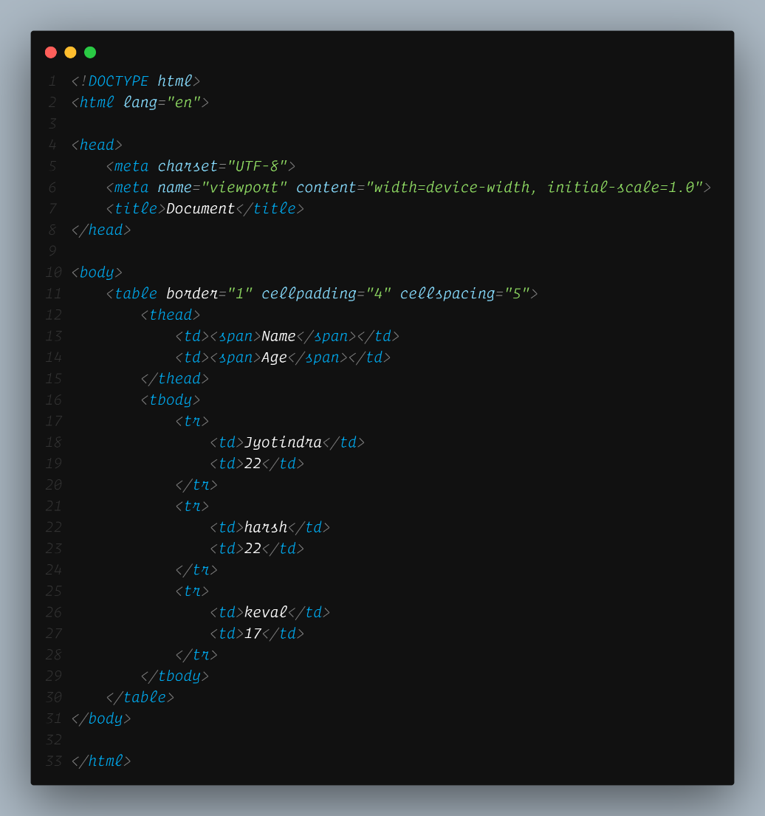

OUTPUT:

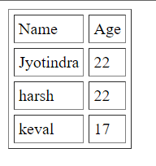

# **How can we club two or more rows or columns into a single row or column in an HTML table? With Example**

HTML provides two table attributes “rowspan” and “colspan” to make a cell span to multiple rows and columns respectively.

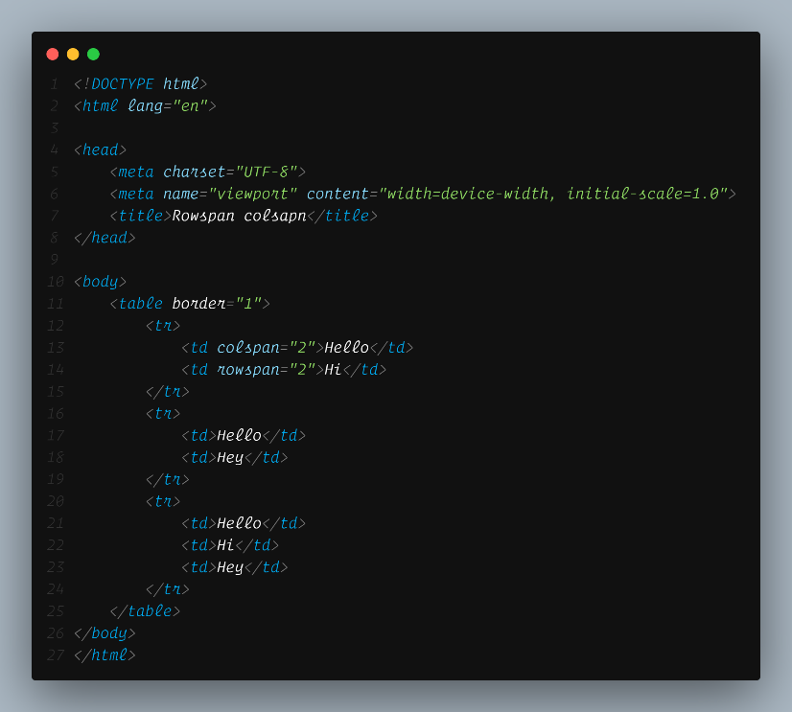

OUTPUT:

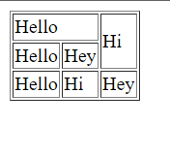

# **What is the difference between a block-level element and an inline element?**

Block elements always start from a new line while Inline elements never start from a new line.

Block level elements example : <div>Hello</div> ,<fieldset> hello</fieldset>

Inline element example : <a>hello</a> , <span> world </span>

# **How to create a Hyperlink in HTML? With Example.**

To make a hyperlink in an hHTML page, use the <a> and </a> tags, which are the tags used to define the links. The <a> tag indicates where the hyperlink starts and the </a> tag indicates where it ends. Whatever text gets added inside these tags, will work as a hyperlink. Add the URL for the link in the <a href=” ”_>.

Ex: <a herf=”hello.com”>Hello website page </a>

# **What is the use of an iframe tag? With Example.**

To display a web page inside a web page or Is nesting of webpages.

<iframe src=”url of the web page to embed”

Example:

<iframe width="560" height="315" src="https://www.youtube.com/embed/fW9qx1_X2XI" title="YouTube video player" frameborder="0" allow="accelerometer; autoplay; clipboard-write; encrypted-media; gyroscope; picture-in-picture; web-share" allowfullscreen></iframe>

# **What is the use of a span tag? Explain with example?**

The span tag is used for the grouping of inline elements & this tag does not make any visual change by itself. Span is very similar to the div tag , but div is a block-level tag and span is an inline tag.

Example :

<h1>Hello<span style="color: red;">World</span></h1>

Output:

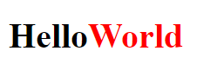

# **How to insert a picture into a background image of a web page? With Example.**

To set the background image of a webpage, use the CSS style. Under the CSS <style> tag, add the property background-image. The property sets a graphic such as jpg, png, svg, gif, etc. HTML5 do not support the <body> background attribute, so CSS is used to change set background image.

Example :

<body background-image=”path of image”> </body>

# **How are active links different from normal links?**

Recognize active links when the link has the focus. Those that do not have mouse cursor over the link is said to be normal link.

Example :  <a href="">Normal link</a> <br>

    <a href="active">Active link</a>

OUTPUT :

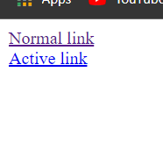

# **What are the different tags to separate sections of text?**

* <br> tag – It is used to separate the line of text. It breaks the current line and shifts the flow of the text to a new line.
* <p> tag–This tag is used to write a paragraph of text.
* <blockquote> tag–This tag is used to define large quoted sections.

# **What is svg?**

SVG stands for Scalable Vector Graphics.

SVG defines vector-based graphics in XML format.

Example:

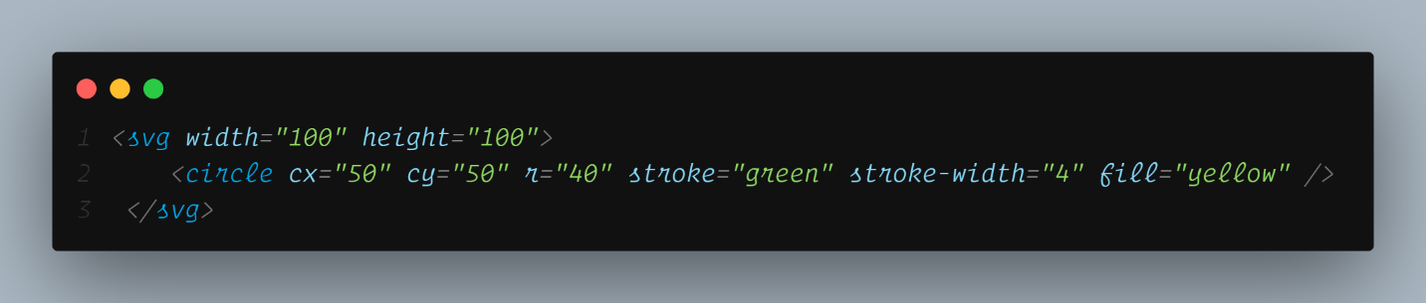

OUTPUT:



# **What is difference between HTML and XHTML?**

HTML stands for Hypertext Markup Language, whereas XHTML stands for Extensible Hypertext Markup Language. XHTML is basically an extension of HTML, which is stricter than HTML. Both languages are used to create web and Android applications. HTML is SGML based, whereas XHTML is an XML-based language.

# **What are logical and physical tags in HTML?**

**Physical tag**: These tags are used to provide the visual appearance to the text.

Example :

* <b> 🡺 This is a physical tag, which is used to bold the text written between it.
* <i> 🡺 This is a physical tag which is used to make text italic.

**Logical tag**: These tags are used to add some logical or semantic value to the text.

Example :

* <strong> 🡺 This is a logical tag, which tells the browser that the text is important.
* <em> 🡺 This is a logical tag which is used to display content in italic.

# Create below example using only HTML tags without CSS.

HTML:

<!DOCTYPE html>

<html lang="en">

<head>

    <meta charset="UTF-8">

    <meta name="viewport" content="width=device-width, initial-scale=1.0">

    <title>HTML || Assignment</title>

</head>

<body>

    <center>

        <table border="1">

            <tr align="center">

                <td rowspan="2"><a href="home">Home</a></td>

                <td rowspan="2"><a href="about">About</a></td>

                <td rowspan="2"><a href="contact">Contact</a></td>

                <td rowspan="2"><a href="store">Store</a></td>

                <td rowspan="2"><a href="help">Help</a></td>

                <td><a href="download">Download</a></td>

            </tr>

            <tr>

                <td align="center">app</td>

            </tr>

            <tr>

                <td colspan="6"><img src="house_door.jpg" alt="" height="500" width="100%"></td>

            </tr>

            <tr>

                <td colspan="6" bgcolor="pink" align="center">contact-us-page</td>

            </tr>

            <tr background="contact.jpg" height="300" align="center">

                <td colspan="6">

                    <h1><b>

                            <font color="white">Coontact Us</font>

                        </b>

                    </h1>

                </td>

            </tr>

            <tr bgcolor="skyblue" align="center">

                <td colspan="3">

                    <label for="fname">first-name </label>

                    <input type="text" id="fname" placeholder="Enter your name">

                </td>

                <td colspan="3">

                    <label for="lname">last-name </label>

                    <input type="text" id="lname" placeholder="Enter your name">

                </td>

            </tr>

            <tr align="center" bgcolor="skyblue">

                <td colspan="3">

                    <label for="email">Email-id </label>

                    <input type="email" placeholder="enter your email id">

                </td>

                <td colspan="3">

                    <label for="phone">Phone-no</label>

                    <input type="number" id="phone" placeholder="enter your phone no">

                </td>

            </tr>

            <tr align="center" bgcolor="skyblue">

                <td colspan="3">

                    <label for="city">city</label>

                    <select name="" id="">

                        <option value="" selected>Ahmedabad</option>

                        <option value="">Gandhinagar</option>

                        <option value="">Rajkot</option>

                        <option value="">Vadodra</option>

                        <option value="">Surat</option>

                    </select>

                </td>

                <td colspan="3">

                    <label for="gender">Gender</label>

                    <label for="male">MALE</label>

                    <input type="radio" name="gender" id="male">

                    <label for="female">FEMALE</label>

                    <input type="radio" name="gender" id="female">

                    <label for="other">OTHER</label>

                    <input type="radio" name="gender" id="other">

                </td>

            </tr>

            <tr>

                <td colspan="3">

                    <iframe

                        src="https://www.google.com/maps/embed?pb=!1m18!1m12!1m3!1d3672.7237387824907!2d72.60635807499001!3d22.997184179191578!2m3!1f0!2f0!3f0!3m2!1i1024!2i768!4f13.1!3m3!1m2!1s0x395e85c2fc005927%3A0x918e69150ca1c935!2sTOPS%20Technologies!5e0!3m2!1sen!2sin!4v1689230359884!5m2!1sen!2sin"

                        width="560" height="315" style="border:0;" allowfullscreen="" loading="lazy"

                        referrerpolicy="no-referrer-when-downgrade">

                    </iframe>

                </td>

                <td colspan="3">

                    <iframe width="560" height="315" src="https://www.youtube.com/embed/Y9pgsPW-KIE"

                        title="YouTube video player" frameborder="0"

                        allow="accelerometer; autoplay; clipboard-write; encrypted-media; gyroscope; picture-in-picture; web-share"

                        allowfullscreen>

                    </iframe>

                </td>

            </tr>

        </table>

    </center>

</body>

</html>

OUTPUT:

