Pocker Game

Usefull Link In Pocker Game

- https://pokerpro.in/poker-rules/ [ Easy overview ]
- https://www.adda52.com/poker/hand-rankings#:~:text=In%20a%20poker%20game%2C%20hand,4%2C3%2C%20and%202. [ Medium overview : Some rule and hand ranking. ]
- https://en.wikipedia.org/wiki/List_of_poker_hands [ Hihg overview : wikipedia ]

UseFull Resorces :

- https://www.pagat.com/poker/rules/ranking.html [ rule ]
- https://bicyclecards.com/how-to-play/basics-of-poker/ [ Basic Of Pocker ]
- https://www.youtube.com/watch?v=CpSewSHZhmo&t=17s [ how to play pocker ]

Hand Ranking Rules :

label : 1 lower – 10 higher

1. High Card :
When the player has the highest ranking card in the hand . Or The card highest numerical value .
Ex:
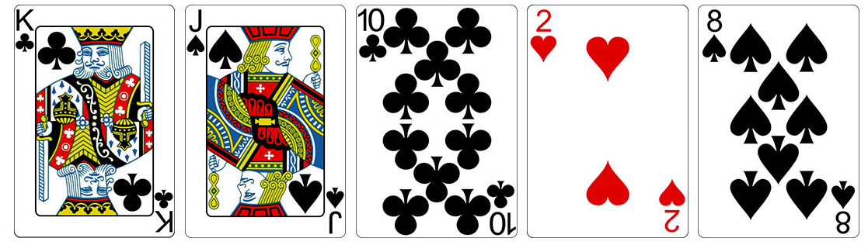

2. One Pair :
When the player has two cards of same ranks in the hand . Or Two card same numerical rank .
Ex:
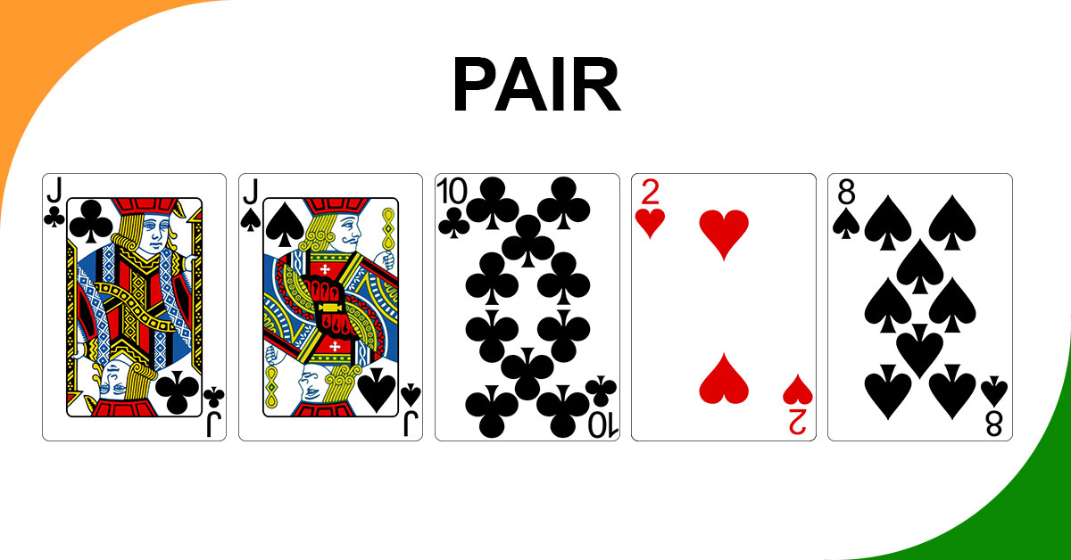

3. Two Pair :
When the player has pair of cards of same ranks in the hand . Or Two card same numerical rank .

Ex:

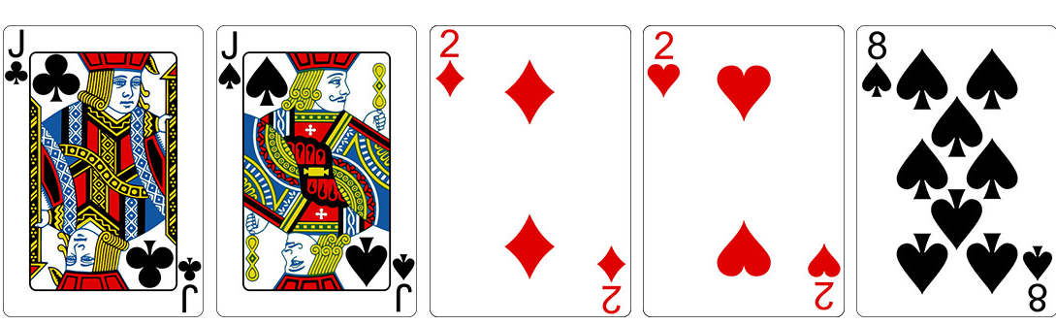

4. Three Of Kind :
When the player has 3 cards of same ranks in the hand . Or Three cards same numerical rank .
Ex:
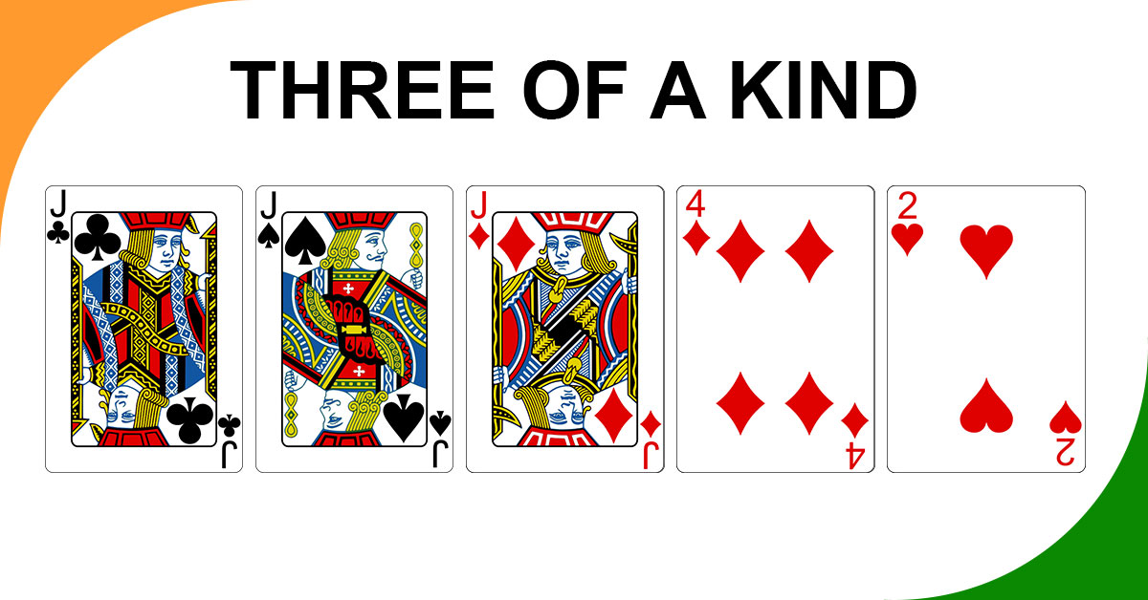

5. Straight :
When The Player has 5 cards in a staright numerical order in the hand . Or Five cards rank siquential order regardless of suite .
Ex:
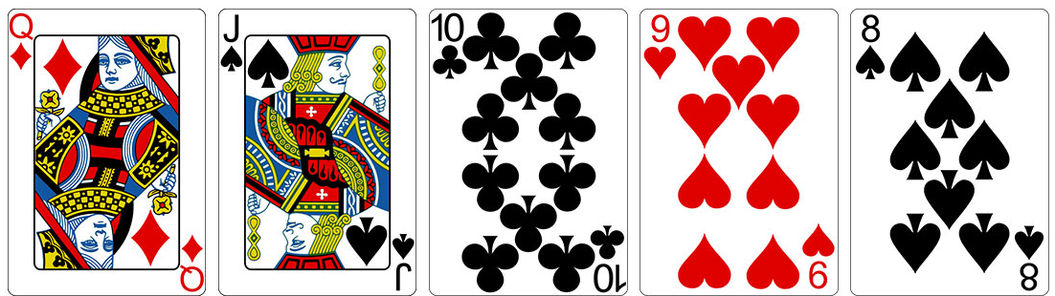

6. Flush :
When the player 5 cards same suite in the hand . Or Five cards same suit .

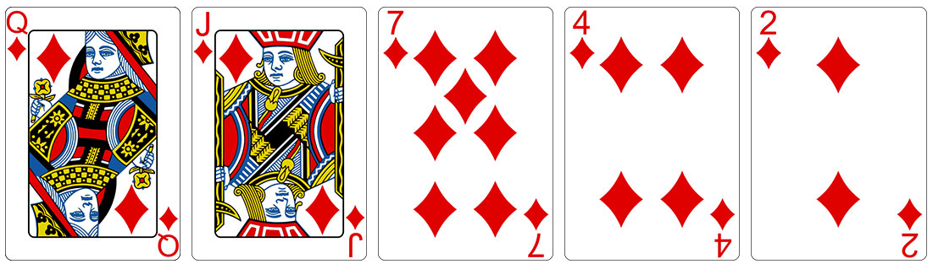
Ex:
7. Full Housh :
When the player three of kind and pair card in same hand . Or Three cards of same numerical rank combined with two other card same numerical rank .

Ex:
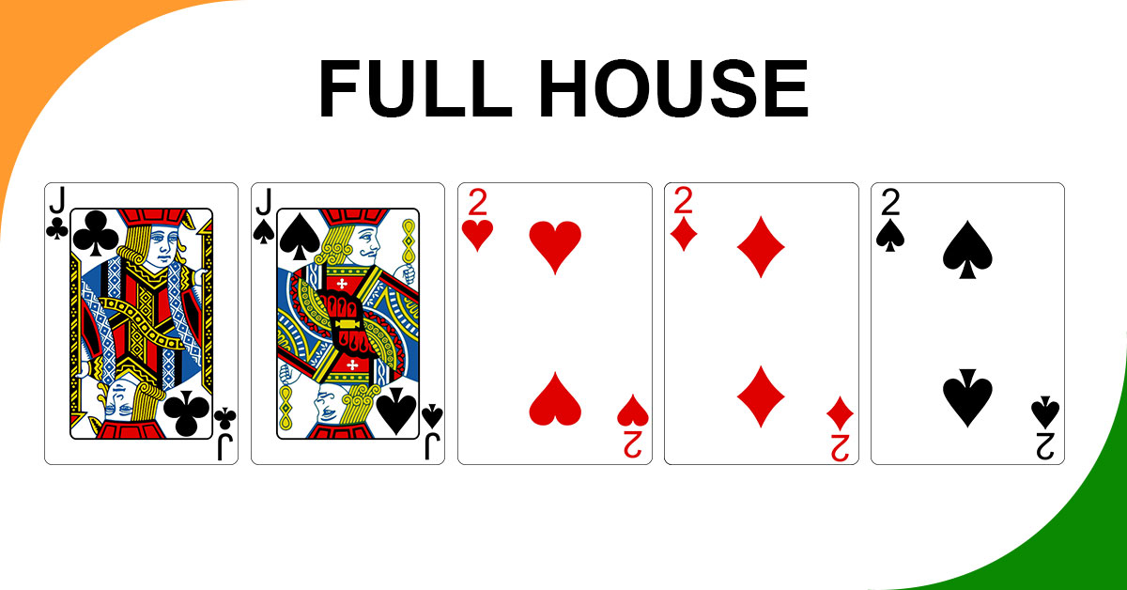
8. Four Of Kind :
When the player 4 card in same in the hand . Or Four cards same numerical value .

Ex:

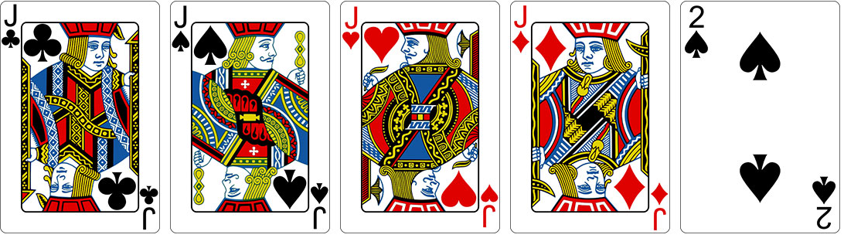
9. Straight Flush :
It is the second highest hand ranking in the game of Poker which consists of five consecutive numerical number cards of the same suit. Or Five cards same suit ranked siquentially .

Ex:
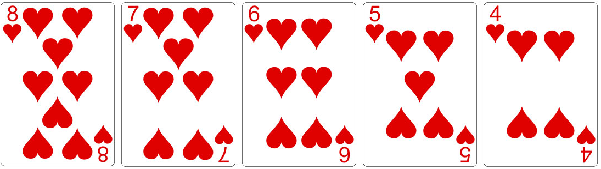
10. Royal Flush :
It is the highest hand ranking of Poker which consists of Ace, King, Queen, Jack, and 10 of the same suits. Or The highest Hand Pocker An Ace-high Staright Flush .

Ex:
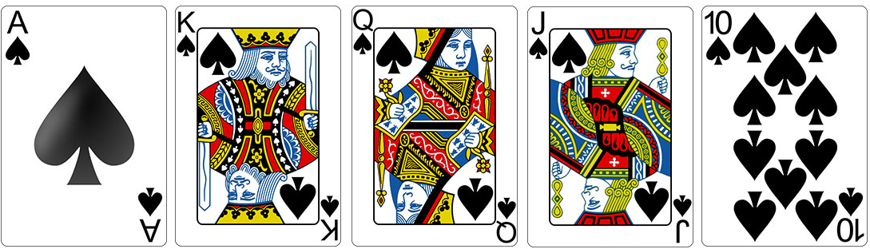

How To Play Pocker Game :

1. if two people the same hand the persion has higher card the his win .

Ex: danial of pair of 3 and maggie of pair of 9 then maggie win .

2.
i. Play the pocker fast you buy your anty which buy in bet . Minimum $1 . (samll rs ) .
ii. After every one Has Their Anty the deller give two card each persion . Keep thsese cards secreate from every one else .
Iii. Now Every One look Their Card choose bet or not bet

IMP :
Raise : raise the money bet .
Fold : not play this round .
Check : matcheing their bet .
Call : fast Bet .......

3. After every one bet the the dealer revel 3 card . ( namely Flop ) . After seeing Flop planing what hand we want to make . Keep in mind their two more card wait for reaveled .

4. After the flop every one change the bet again . Before the delear revel next card which in TURN .

5. Bet again if wnat ( optional beting round ) . After delear revel River (last card ) .
6. At this point total of 7 card 5 on table and 2 in hand .

7. Final goal to create highest hand possible out of 7 card .
- if you use one card in hand four card in table .

8. the player best hand whoes wins .
Win Scenario :
1. if every one flod other then one playr then that player win .

