Abstract

This project presents a sentiment analysis system for Amazon product reviews using Natural Language Processing (NLP) and Machine Learning techniques. The aim is to classify customer reviews into positive, neutral, or negative sentiments based on their star ratings. The methodology involves preprocessing review text, feature extraction using TF-IDF, and training a Logistic Regression classifier. The model achieves high accuracy in sentiment classification and provides insights into customer satisfaction trends. This project demonstrates the potential of sentiment analysis in improving business decision-making and customer engagement.
- Introduction
In the digital era, online reviews reflect customer opinions and play a crucial role in business improvement. Sentiment analysis, using NLP and Machine Learning, automates the classification of these reviews into positive, negative, or neutral categories. This project applies these techniques to Amazon product reviews to build an effective sentiment classification model.
  - Background
The growth of e-commerce platforms like Amazon has produced vast amounts of customer reviews, which provide valuable insights but are difficult to analyze manually due to their unstructured nature. Sentiment analysis, powered by NLP and ML, automates the classification of reviews into positive, neutral, or negative sentiments. This benefits consumers by simplifying product choices, helps businesses monitor satisfaction and improve strategies, and advances research by showcasing how technology transforms raw feedback into actionable knowledge.
1.2 Problem Statement

E-commerce platforms generate vast amounts of unstructured customer reviews that are difficult to analyze manually. Traditional methods often miss nuances like sarcasm and ambiguity, making it hard for businesses to classify sentiments effectively. Without automation, extracting actionable insights for improving customer satisfaction, products, and strategies becomes highly challenging.

• E-commerce platforms like Amazon generate millions of customer reviews daily, making manual analysis impractical.
• Reviews are unstructured text data, difficult to process and interpret without automation.
• Traditional methods of review analysis fail to capture hidden patterns, subjectivity, sarcasm, and ambiguity in language.
• Businesses lack an efficient system to automatically classify reviews into sentiments (positive, neutral, negative).
• Without automation, it is challenging to extract actionable insights that support customer satisfaction, product improvement, and market-driven decisions.
1.3 Objectives

- Primary Objective:To develop an automated system using Natural Language Processing (NLP) and Machine Learning to classify Amazon product reviews into positive, negative, or neutral sentiments, thereby enabling businesses to extract actionable insights and improve decision-making.

- Secondary Objectives:
• To preprocess and clean raw review text for effective analysis.
• To convert star ratings into sentiment categories (positive, neutral, negative).
• To apply TF-IDF vectorization for transforming text into numerical features.
• To build and train a Logistic Regression classifier for sentiment prediction.
• To evaluate the model’s performance using accuracy, classification report, and confusion matrix.
• To test the system on new/unseen reviews for real-world applicability.

1.4 Scope and Limitations

Scope:
This project analyzes Amazon product reviews using Natural Language Processing (NLP) and Machine Learning techniques. It classifies reviews into positive, negative, and neutral sentiments, providing insights into customer opinions. The project uses TF-IDF for feature extraction and Logistic Regression for classification, creating an effective baseline model. While focused on Amazon reviews, the approach can also be applied to other domains such as social media or general customer feedback. Overall, it offers a foundation that can be further enhanced with more advanced techniques.
Limitations:
This approach works only on text-based reviews and does not handle images or other formats. Detecting sarcasm and irony remains challenging, and neutral reviews are often difficult to classify accurately. The model’s performance heavily depends on the quality and size of the dataset. Additionally, it is limited to Logistic Regression, which is less powerful compared to modern deep learning models.
1.5 Dataset
Dataset: Amazon Sentiment Analysis
Size: 4915 rows × 14 columns
Types: float64(3), int64(6), object(5)

2. Design and Methodology

2.1 Design:

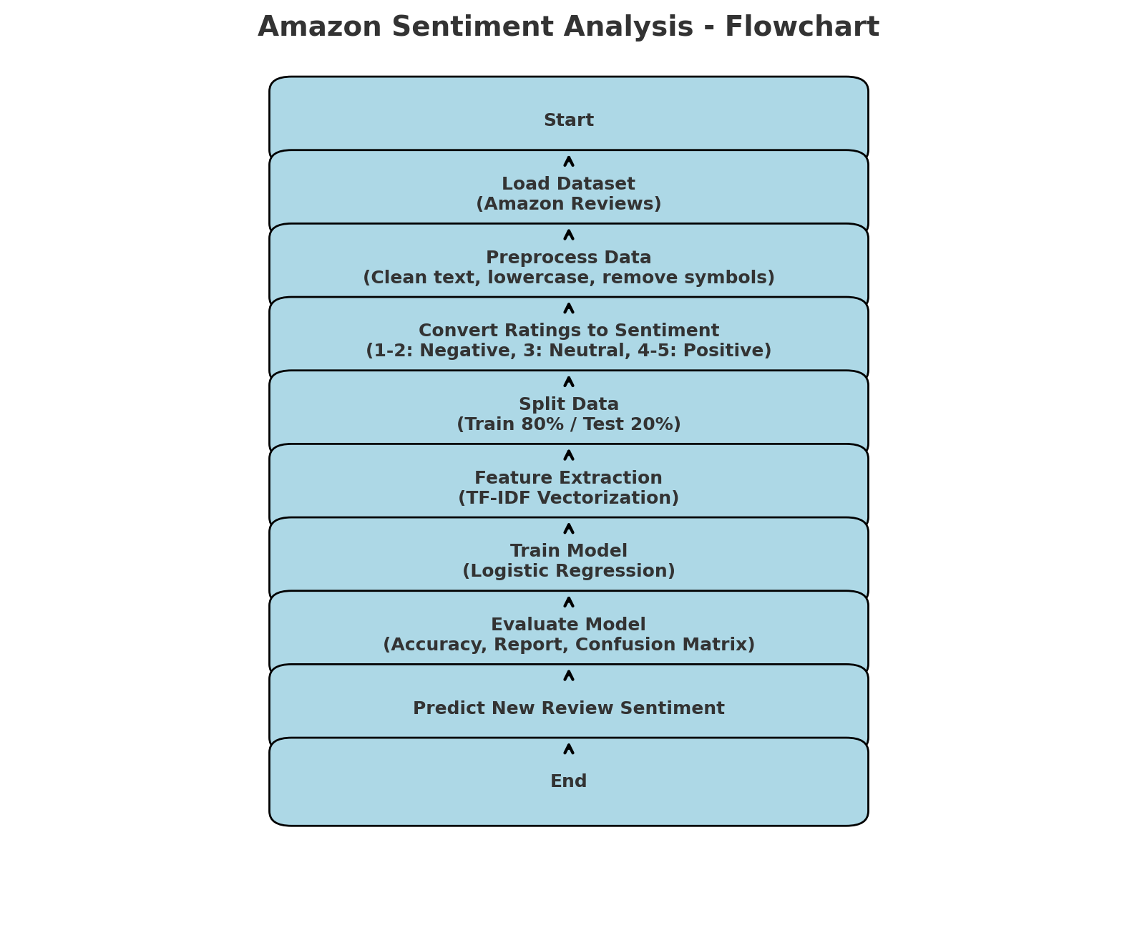
- Load Dataset:
  - Import the CSV file containing Amazon reviews with columns reviewText and overall (ratings).
- Preprocess Text:
  - Convert all review text to lowercase.
  - Remove special characters, numbers, and punctuation.
  - Store the cleaned text in a new column (cleaned_review).
- Convert Ratings to Sentiment Labels:
  - Map star ratings to sentiment categories:
    - 1–2 → Negative
    - 3 → Neutral
    - 4–5 → Positive

- Split Dataset:
  - Divide the data into training (80%) and testing (20%) sets.
- Feature Extraction:
  - Apply TF-IDF Vectorization to transform text into numerical features suitable for the model.
- Train Model:
  - Use Logistic Regression to train the model on the training dataset.
- Evaluate Model:
  - Test the model on the testing dataset.
  - Calculate accuracy, precision, recall, F1-score, and generate a confusion matrix.
- Predict New Reviews:
  - Preprocess new review text, transform it with TF-IDF, and use the trained model to predict the sentiment.

2.2 Methodology:

- Data Collection:
Data collection is the first step in building the Amazon Sentiment Analysis system. In this project, the dataset consists of Amazon product reviews stored in a CSV file named amazon_reviews.csv. The dataset includes two main columns: reviewText, which contains the text of the customer reviews, and overall, which represents the star rating given by the customer (ranging from 1 to 5).
The dataset is sourced from publicly available Amazon review datasets or scraped from the Amazon platform using appropriate APIs or tools. Each review provides insights into customer experiences, satisfaction levels, and product feedback.
Collecting a well-structured and representative dataset is crucial for training a machine learning model effectively. The collected data must cover a variety of products and sentiments to ensure the model can learn patterns for positive, neutral, and negative reviews accurately.

- Data Preprocessing:
The data preprocessing begins with lowercasing, where all review text is converted to lowercase to ensure uniformity—for example, "This Product is AMAZING!" becomes "this product is amazing!". Next, special characters and punctuation are removed, as symbols, numbers, and punctuation do not contribute meaningfully to sentiment analysis; for instance, "Great product!!! #1" is transformed into "great product". Missing values are then handled by identifying and removing any empty or missing reviews to prevent errors during model training. Finally, the cleaned text is stored in a new column called cleaned_review in the dataset, ready for further analysis.
- Sentiment Labeling:
Sentiment labeling is the process of converting numerical star ratings into categorical sentiment classes that the model can predict. In this project, the overall column in the dataset contains star ratings ranging from 1 to 5. These ratings are mapped to three sentiment categories as follows:
  - 1–2 stars → Negative: Indicates dissatisfaction or poor experience with the product.
  - 3 stars → Neutral: Represents an average or mixed experience.
  - 4–5 stars → Positive: Shows satisfaction and a good experience with the product.
By labeling the reviews in this way, the dataset becomes suitable for supervised machine learning. The model learns patterns in the review text that correspond to each sentiment class, enabling it to predict sentiments for new or unseen reviews accurately.

- Feature Extraction:
Feature extraction is the process of transforming textual data into numerical representations that a machine learning model can understand. In this project, the TF-IDF (Term Frequency–Inverse Document Frequency) Vectorizer is used for feature extraction.
TF-IDF assigns a weight to each word in the text based on how important it is in a particular review relative to the entire dataset. Words that appear frequently in a single review but rarely in other reviews get higher importance, while common words across all reviews get lower weight. This helps the model focus on words that carry meaningful information about sentiment.
After applying TF-IDF, each review is converted into a vector of numerical values representing the significance of its words. These vectors are then used as input features for the Logistic Regression classifier to train and predict sentiments.

- Model Training:
Model training is the step where the machine learning algorithm learns patterns from the input data to predict sentiments. In this project, a Logistic Regression classifier is used for training.
The dataset is first split into training (80%) and testing (20%) sets. The training set is used to teach the model the relationship between the features (TF-IDF vectors of reviews) and the sentiment labels (positive, neutral, negative). During training, the model learns to assign probabilities to each sentiment class based on the words present in a review.
Once trained, the model can predict sentiments for new, unseen reviews. Logistic Regression is chosen for its simplicity, efficiency, and good performance on text classification tasks, making it suitable for this sentiment analysis project.

- Model Evaluation:
Model evaluation is the process of assessing how well the trained machine learning model performs on unseen data. In this project, the Logistic Regression classifier is evaluated using the testing set, which contains 20% of the dataset that was not used during training.
The evaluation metrics include:

  - Accuracy: Measures the overall percentage of correctly predicted sentiments.
  - Classification Report: Provides detailed metrics such as precision, recall, and F1-score for each sentiment class (positive, neutral, negative).
  - Confusion Matrix: Shows the number of correct and incorrect predictions for each class, helping identify which sentiments are being misclassified.

- Prediction on New Reviews:
After the model has been trained and evaluated, it can be used to predict the sentiment of new or unseen Amazon reviews. The process involves first preprocessing the new review text using the same steps as the training data—converting to lowercase, removing special characters, and cleaning the text.
Next, the preprocessed review is transformed into a TF-IDF vector using the same vectorizer that was fitted on the training data. This ensures that the new review is represented in the same feature space as the training data.
Finally, the trained Logistic Regression model predicts the sentiment category (positive, neutral, or negative) based on the TF-IDF features. This allows businesses or researchers to automatically analyze customer feedback in real time and extract actionable insights without manual intervention.

- Result
3.1 Confusion Matrix:

The confusion matrix is a table that shows how well the sentiment classification model performed by comparing predicted labels with actual labels. The matrix you provided is:
[[ 25 0 45]
[ 1 0 24]
[ 2 0 886]]
• Rows represent the actual sentiment classes.
• Columns represent the predicted sentiment classes.
Assuming the order of classes is [Negative, Neutral, Positive]:
First row (Actual Negative):
- First row (Actual Negative):
  - 25 reviews were correctly predicted as Negative.
  - 0 reviews were incorrectly predicted as Neutral.
  - 45 reviews were incorrectly predicted as Positive.
→ Indicates that many negative reviews were misclassified as positive.
- Second row (Actual Neutral):
  - 1 review was incorrectly predicted as Negative.
  - 0 reviews were correctly predicted as Neutral.
  - 24 reviews were incorrectly predicted as Positive.
→ Shows that the model struggled to correctly identify Neutral reviews.
- Third row (Actual Positive):
  - 2 reviews were incorrectly predicted as Negative.
  - 0 reviews were incorrectly predicted as Neutral.
  - 886 reviews were correctly predicted as Positive.
→ Indicates that the model is very good at identifying Positive reviews.

3.2 Classification Report:

Classification Report:
precision recall f1-score support

negative 0.89 0.36 0.51 70
neutral 0.00 0.00 0.00 25
positive 0.93 1.00 0.96 888

accuracy 0.93 983
macro avg 0.61 0.45 0.49 983
weighted avg 0.90 0.93 0.90 983

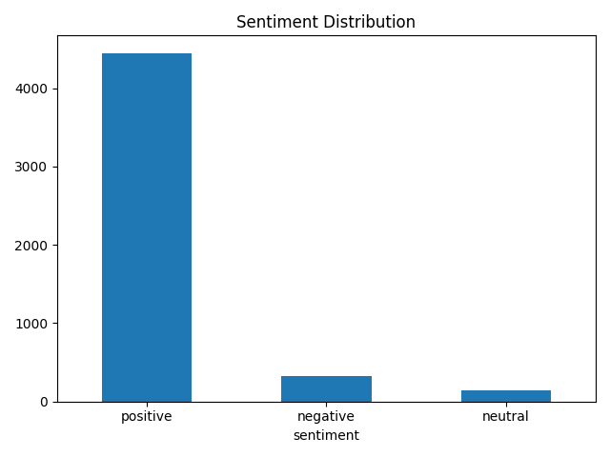
- Conclusion
The Amazon Sentiment Analysis project demonstrates how Natural Language Processing (NLP) and Machine Learning can be effectively used to classify customer reviews into positive, neutral, and negative sentiments. By preprocessing the text, extracting meaningful features using TF-IDF, and training a Logistic Regression model, the system can predict the sentiment of new reviews with reasonable accuracy.
The results show that the model performs exceptionally well on positive reviews but faces challenges in correctly identifying neutral and negative reviews, highlighting areas for potential improvement. Despite these limitations, the project provides valuable insights into customer opinions and can help businesses make informed decisions to enhance product quality and customer satisfaction.
Overall, this project illustrates the practical applications of sentiment analysis in e-commerce and lays a strong foundation for further enhancements, such as using deep learning models, aspect-based sentiment analysis, or real-time sentiment monitoring systems.

- References
- Amazon Customer Reviews Dataset: https://registry.opendata.aws/amazon-reviews/
- Pang, B., & Lee, L. (2008). Opinion Mining and Sentiment Analysis. Foundations and Trends in Information Retrieval, 2(1–2), 1–135.
- Zhang, L., Wang, S., & Liu, B. (2018). Deep Learning for Sentiment Analysis: A Survey. Wiley Interdisciplinary Reviews: Data Mining and Knowledge Discovery, 8(4), e1253.

