**PROJECT**

**PCOS DETECTION**

PROBLEM STATEMENT: **PCOS DETECTION**

**AIM:**

To develop a disease diagnostics for PCOS by classifying images as either depicting individuals diagnosed with polycystic ovary syndrome or not.

**DATASET DESCRIPTION:**

 The ultrasound photos that showed infected cysts on the ovary were given the label ‘infected’ while the ultrasound images that showed a healthy ovary were given the label ‘not infected’.

**DATA PREPROCESSING:**

ImageDataGenerator class from the Keras library to perform various preprocessing techniques like rescaling, shear transform, zoom, flip, rotate and fill mode on image data.

**MODEL USED**: InceptionV3, DenseNet and MobileNet

**CODE**

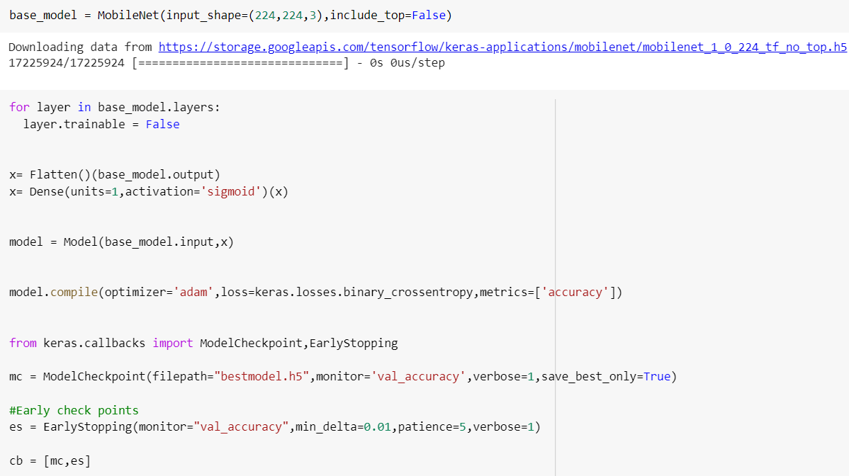

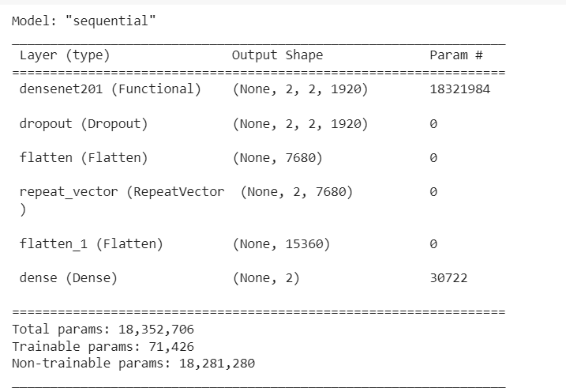

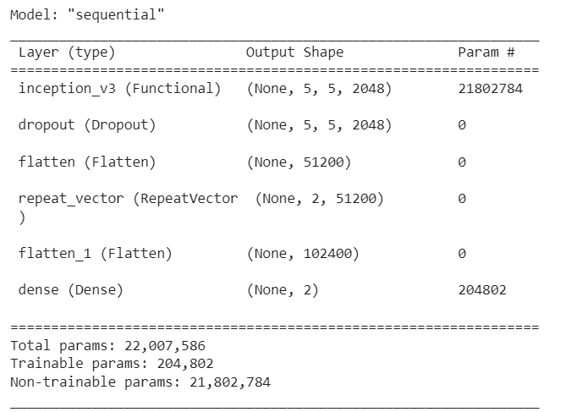

**OUTPUT:**

