OUTPUT:

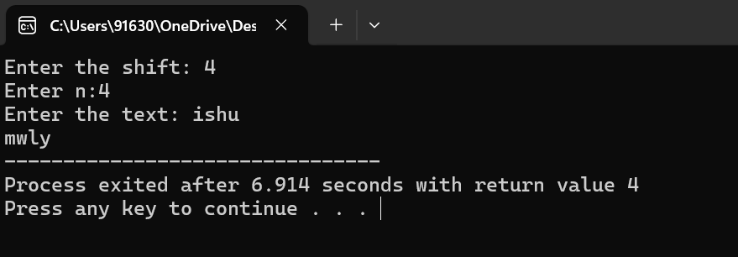

Explanation:

Once the text is entered, the alphabets are individually converted into their corresponding numbers i.e from 1 to 26 ,later the shift is added to the numbers which are stored in an array , later the new numbers in the array are individually converted into corresponding alphabets.